|  |  |
| --- | --- |
| *Course report of* | |
| **Industrial Robotics – MDP453**– Spring 2021 | |
| University: Ain Shams | Faculty: Engineering |

## Basic Information

1. Title and code :

|  |
| --- |
| **Roboticss - MDP 453** |

1. Program on which the course is given :

|  |  |
| --- | --- |
| |  | | --- | | **Chep: Manufacturing program** | |

1. Year/Level of programs :

|  |
| --- |
|  |

1. Units/Credit Hours

|  |  |
| --- | --- |
| ( i ) Lecture : | 3 |

|  |  |
| --- | --- |
| ( ii ) Tutorial: | 2 |
| ( iii ) Lab: | 0 |

|  |  |
| --- | --- |
| ( v) Total : | 5 |

1. Names of lecturers contributing to delivery of the course :

|  |  |
| --- | --- |
| i - | Dr. Shady Ahmed Maged  Dr. Ismail Hafez |
|  |  |

|  |  |
| --- | --- |
| Course coordinator: | Dr. Shady Ahmed Maged |

|  |  |
| --- | --- |
| External evaluator: | NA |

## Statistical Information

|  |  |
| --- | --- |
|  | 114 |

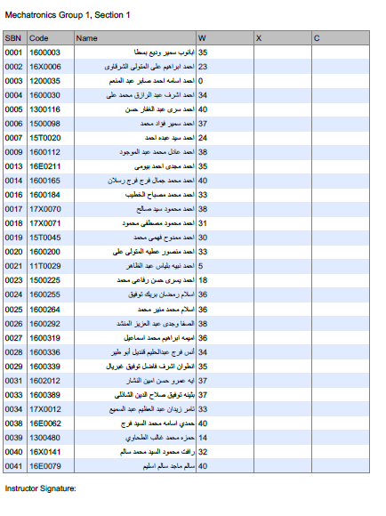

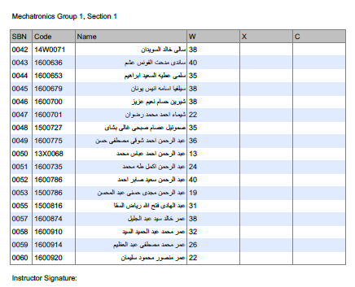

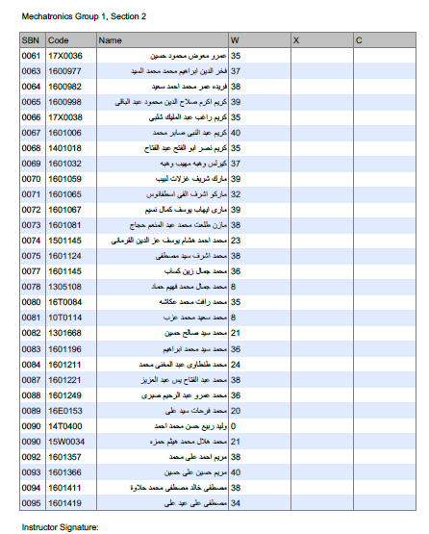

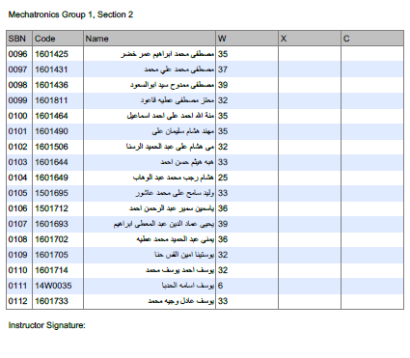

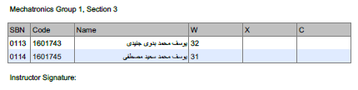

## Professional Information

1. **Course Teaching:**

|  |  |  |  |  |  |
| --- | --- | --- | --- | --- | --- |
| Course Content | No. of Hours | Lecture | Tutorial | Lab | Lecturer |
| Introduction to Robotics (Serial, parallel, humanoid, mobile) | 5 | 3 | 2 | 0 | Dr. Shady Ahmed |
| Robot kinematics (position, orientation, homogeneous transformation matrix) | 10 | 6 | 4 | 0 | Dr. Shady Ahmed Maged |
| Forward Kinematics (D-H parameters) | 10 | 6 | 4 | 0 | Dr. Shady Ahmed Maged |
| Inverse Kinematics (trigonometric method and analytical method) | 10 | 6 | 4 | 0 | Dr. Shady Ahmed Maged |
| Velocity Kinematics (Differential operator, forward instantaneous kinematics, inverse instantaneous kinematic, Jacobian) | 10 | 6 | 4 | 0 | Dr. Shady Ahmed Maged |
| Trajectory planning (path and trajectory) | 10 | 6 | 4 | 0 | Dr. Shady Ahmed Maged |
| Forward and inverse Dynamics (euler method, lagrange method) | 10 | 6 | 4 | 0 | Dr. Shady Ahmed Maged |
| Robot position and force control (Computed torque controller, PID) | 10 | 6 | 4 | 0 | Dr. Shady Ahmed Maged |
| Total |  |  |  | **0** |  |

**Topics taught as a percentage of the content specified:**

**>90 % X 70-90 % <70%**

**Reasons in detail for not teaching any topic**

All topics were taught ……………………………………….

**If any topics were taught which are not specified, give reasons in detail**

N/A………………………………………………………………………………………….

1. **Teaching and learning methods:**

Lectures: **X**

Practical training/ laboratory:

Seminar/Workshop:

Class Activity: **(Tutorials)**  **X**

Online platform (Zoom and LMS) **X**

**Case Study:**

Other assignments/homework:

If teaching and learning methods were used other than those specified, list and give reasons:

………………………………………………………………………………………………

………………………………………………………………………………………………

1. **Student assessment:**

|  |  |  |  |  |
| --- | --- | --- | --- | --- |
| Assessment method | Description | Week No | Weight (marks) |  |
| Assignment +midterm | To Assess understanding of Robotics | Week 8, 15 | 40 |
| Final Exam | Written exam | Week 15 | 110 |  |
| Total | | | 150 marks |

***\*\*The assessment methods are changed in this semester due to the COVID19***

**Members of examination committee**

II- Dr. Shady Ahmed Maged

**Role of external evaluator**

N/A………………………………………………………………………………………….

1. **Facilities and teaching materials:**

Totally adequate

**X**

Adequate to some extent

Inadequate

List any inadequacies

1. **Administrative constraints:**

List any difficulties encountered

No difficulties

1. **Student evaluation of the course:**

Student evaluation of the course: all over 50 % except the following



Instructor feedback: we will encourage and pay attention during the online sessions with students

Student Comments:

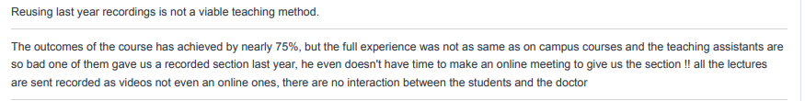

For the first comment yes I sent them a recorded video that was made before but I made an online session every week during the lecture time for them and explained all lectures live/online so I think this student didn’t attend the online sessions

Student Comments:

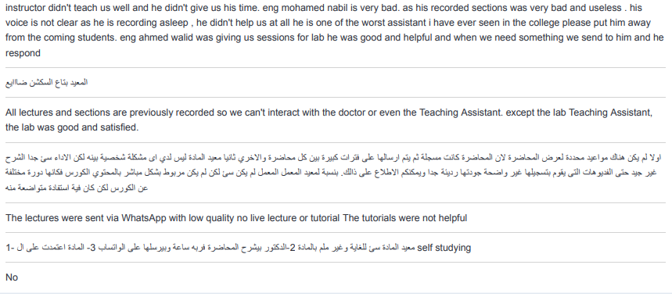

We will encourage the TA eng Mohamed nabil to be more active with students next year

1. **Comments from external evaluator(s): Response of course team**

……N/A… ………………. …………………………….

……….……………..……. …………………………….