|  |  |
| --- | --- |
| *Course report of* | |
| **Hydraulic and pneumatic control- MDP 452**– Fall2020 | |
| University: Ain Shams | Faculty: Engineering |

## Basic Information

1. Title and code :

|  |
| --- |
| **Hydraulic and pneumatic control - MDP 452** |

1. Program on which the course is given :

|  |  |
| --- | --- |
| |  | | --- | | **Mechatronic Engineering** | |

1. Year/Level of programs :

|  |
| --- |
| 5th |

1. Units/Credit Hours

|  |  |
| --- | --- |
| ( i ) Lecture : | 4 |

|  |  |
| --- | --- |
| ( ii ) Tutorial: | 2 |
| ( iii ) Lab: |  |

|  |  |
| --- | --- |
| ( v) Total : | 6 |

1. Names of lecturers contributing to delivery of the course :

|  |  |
| --- | --- |
| i - | Dr. Shady Ahmed Maged  Dr. Ismail Hafez |
|  | Dr. Mohamed Ibrahim |

|  |  |
| --- | --- |
| Course coordinator: | Dr. Shady Ahmed Maged |

|  |  |
| --- | --- |
| External evaluator: | NA |

## Statistical Information

|  |  |
| --- | --- |
|  |  |

## Professional Information

1. **Course Teaching:**

|  |  |  |  |  |  |  |  |
| --- | --- | --- | --- | --- | --- | --- | --- |
|  | No | Course Content | Lectures | Tutorial | Total |  | |
| 1 | Introduction to pneumatic and hydraulic control systems: physical principles, electrical versus hydraulic versus pneumatic systems | 4 | 2 | 6 |
|  | 2 | Applications of pneumatic and hydraulic systems, electro-hydraulic and electro-pneumatics systems. | 8 | 4 | 12 |  | |
|  | 3 | Hydraulic system: power units, reservoirs, filters, piping and hoses, accumulators | 8 | 4 | 12 |  | |
|  | 4 | Pumps (constant displacement pumps, vane pumps, gear pumps, variable displacement pumps, piston pumps, eccentric plate pumps, pumps control systems) | 8 | 4 | 12 |  | |
|  | 5 | valves (spool valve, poppet valve, pilot-operated valves, pressure control valves, flow control valves, check valves, sequence valves) | 8 | 4 | 12 |  | |
|  | 6 | Actuators (rotary (motors) and linear (cylinders), hydraulic circuits. | 8 | 4 | 12 |
|  | 7 | Pneumatic systems: service unit, compressors (piston, screw, rotary), filters, air dryers, lubricators, pressure regulation valves, control valves, actuators, pneumatic circuits. | 4 | 4 | 8 |
|  | 8 | (proportional valves, servo valves, cartridge valves, modular valves) | 12 | 4 | 16 |
|  | | Total Hours | 60 | 30 | 90 |  |

**Topics taught as a percentage of the content specified:**

**>90 % X 70-90 % <70%**

**Reasons in detail for not teaching any topic**

All topics were taught ……………………………………….

**If any topics were taught which are not specified, give reasons in detail**

N/A………………………………………………………………………………………….

1. **Teaching and learning methods:**

Lectures: **X**

Practical training/ laboratory:  **X**

Seminar/Workshop:

Class Activity: **(Tutorials)**  **X**

Online Lectures by Microsoft teams

Face to face tutorials

**Online teaching activities**

**Link for teams:** [**https://teams.microsoft.com/l/team/19%3ad780b9dee1f34bee9a992f1df6f9e5bf%40thread.tacv2/conversations?groupId=d3e564b3-ba4b-450b-962a-3116421451af&tenantId=ad2a8324-bef7-46a8-adb4-fe51b6613b24**](https://teams.microsoft.com/l/team/19%3ad780b9dee1f34bee9a992f1df6f9e5bf%40thread.tacv2/conversations?groupId=d3e564b3-ba4b-450b-962a-3116421451af&tenantId=ad2a8324-bef7-46a8-adb4-fe51b6613b24)

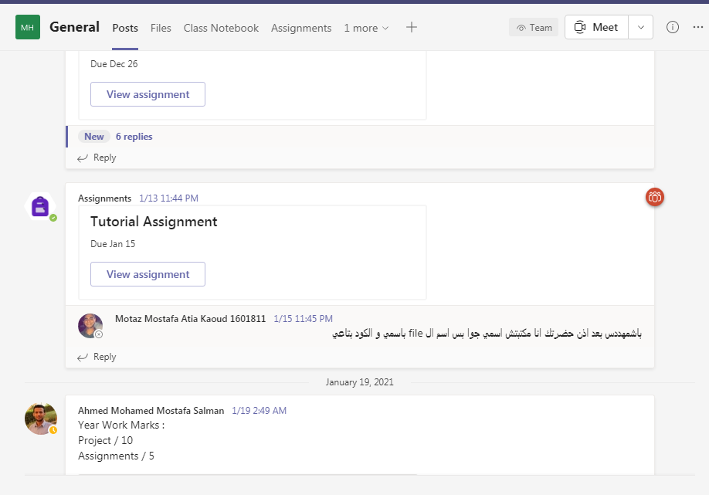

**Case Study:**

Other assignments/homework:

If teaching and learning methods were used other than those specified, list and give reasons:

………………………………………………………………………………………………

………………………………………………………………………………………………

1. **Student assessment:**

|  |  |  |  |  |
| --- | --- | --- | --- | --- |
| Assessment method | Description | Week No | Weight (%) |  |
| Attendance +Part. |  |  | 2.5 |
| Assignments and Reports | To Assess understanding of Hydraulics and pneumatics | Week 4&14 | 2.5 |
| Mid Term Exam | Written exam | Week 8 | 25 |  |
| Final Exam | Written exam | Week 15 | 70 |  |
| Total | | | 100 % |

**Members of examination committee**

I - Dr. Mohamed Ibrahim

II- Dr. Shady Ahmed Maged

**Role of external evaluator**

N/A………………………………………………………………………………………….

1. **Facilities and teaching materials:**

Totally adequate

**X**

Adequate to some extent

Inadequate

List any inadequacies

1. **Administrative constraints:**

List any difficulties encountered

No difficulties

1. **Student evaluation of the course:**

No comments

Instructor feedback:

We will try to change the TA.

1. **Comments from external evaluator(s): Response of course team**

……N/A… ………………. …………………………….

……….……………..……. …………………………….