MDP 471 Numerical Control Machines 2019-2020 Course Report
University: Ain Shams Faculty: Engineering Department: Design & Prod. Eng.

Course Report

A- Basic Information

1. Title and code: Numerical Control Machines MDP 471

2. Program(s) on which this course is given: Mech. Eng. – Production section
3. Year/ Level of programs: 5th. Year

4. Units/Credit hours: N/A

Lectures Tutorial/Practical Total
3
2
5

5. Names of lecturers contributing to the delivery of the course
i Dr. Mohamed Ahmed Awad
ii Dr. Mohamad Lotfy Attia Zamzam
Course coordinator Prof. Dr. Monir Mohamad Farid Koura
External evaluator

B- Statistical Information
50
100
No. of students attending the course: No. %
49
98
No. of students completing the course: No. %

Results:
48
96
2
4
Passed: No. % Failed: No. %

Grading of successful students:
8
16
12
24
Excellent: No. % Very Good: No. %
14
28
14
28
Good: No. % Pass: No. %
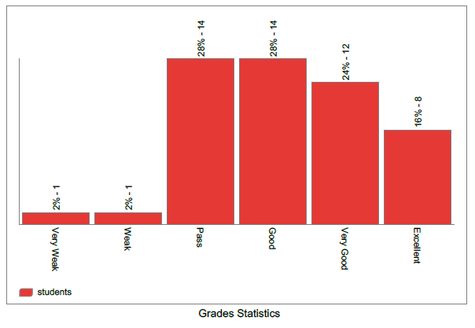

C- Professional Information

1 – Course teaching
Topics actually taught | No. of hours | Lecturer
Introduction to CNC Machine | 3 | Dr. Mohamed L. Zamzam
Advantages - Automation | 3 | Dr. Mohamed Ahmed Awad
Components of cnc machine | 3 | Dr. Mohamed L. Zamzam
Axes nomenclature and designation | 3 | Dr. Mohamed L. Zamzam
Mechanical (general - guidewayes) | 3 | Dr Mohamed L. Zamzam
Mechanical (ballscrews - TCM) | 3 | Dr. Mohamed L. Zamzam
Mechanical (couplings - guards - cooling system - lubricating) | 3 | Dr. Mohamed L. Zamzam
compensations | 3 | Dr. Mohamed Ahmed Awad
fixed cycles | 3 | Dr. Mohamed Ahmed Awad - Dr. Mohamed L. Zamzam
looping - routines - mirrors | 3 | Dr. Mohamed Ahmed Awad
linear interpolation | 3 | Dr. Mohamed L. Zamzam
circular interpolation | 3 | Dr. Mohamed L. Zamzam
Control system, Operating and control pannels | 3 | Dr. Mohamed L. Zamzam

Topics taught as a percentage of the content specified:

>90 % 70-90 % <70%
●

Reasons in detail for not teaching any topic

If any topics were taught which are not specified, give reasons in detail

2- Teaching and learning methods:
●
Online/Face to Face Lectures:
Practical training/ laboratory:
●
Seminar/Workshop:

Online/Face to Face Class Activity:
●

Case Study:
●

Other assignments/homework:
If teaching and learning methods were used other than those specified, list and give reasons:

3- Student assessment:
Method of assessment Percentage of total

Written examination
66.6

Oral examination
0

Practical/laboratory work
0
33.3
Other assignments/class work

Total 100 %
Members of examination committee
- Dr. Mohamed Ahmed Awad
- Dr. Mohamad Lotfy Attia Zamzam

Role of external evaluator

4- Facilities and teaching materials:
Totally adequate

Adequate to some extent
●

Inadequate

List any inadequacies
- Lab is in need of rehabilitation of infrastructure
- Too many students in the lab session (need to be divided into 2 classes in lab).
- A simulation system is in need.

5- Administrative constraints
List any difficulties encountered
Need funds for Lab machine maintenance.

6- Student evaluation of the course: Response of Course Team

List any criticisms
……………………………………….………………

7- Comments from external evaluator(s): Response of course team
……………………………. …………………………….

8- Course enhancement:

Progress on actions identified in the previous year’s action plan:

Action State whether or not completed and give reasons for any non-completion
……………………………. …………………………….
9- Action plan for academic year 200X – 200Y

Actions required Completion date Person responsible
……………………… ……………………… ………………………

Course coordinator: Prof. Dr. Monir Mohamad Farid Koura

Signature:
Date:

10-Sample of screen shots online activity
