Course report of
Introduction to Electronics – ECE 215 – Spring 2021
University: Ain Shams | Faculty: Engineering

Basic Information
- Title and code :
Introduction to Electronics – ECE 215
- Program on which the course is given :
Mechanical Engineering

- Year/Level of programs :
2nd Year / 1st Level
- Units/Credit Hours
( i ) Lecture : | 2

( ii ) Tutorial/Practical : | 1

( iii ) Total : | 3
- Names of lecturers contributing to delivery of the course :
i - | Dr. Hesham Omran

ii -

iii -

Course coordinator: | Dr. Hesham Omran

External evaluator: | --- --- ---

Statistical Information
Number of students attending the course: 303

 |  | Number
Students completing the course |  | 352

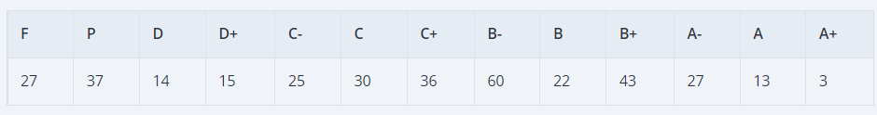

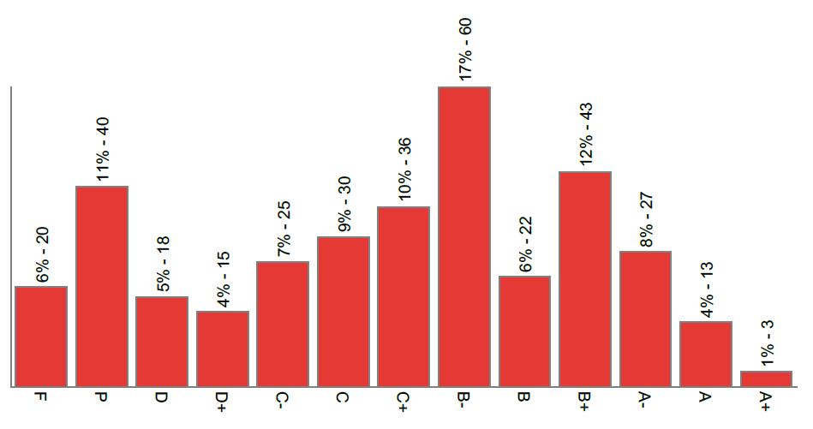

Professional Information

Course Teaching:
Course Content | Lecture  Hours | Lecturer
Introduction to electronics | 2 | Dr. Hesham Omran
Diode operation and models | 2
Diode applications (1) | 2
Diode applications (2) | 2
Transistor operation and models | 2
Transistor applications (1) | 2
Transistor applications (2) | 2
Op-amp operation and models | 2
Op-amp applications | 2
Filters | 2
Oscillators | 2
Multivibrators | 2
Analog and digital signals | -
D/A converters | -
A/D converters | -

Topics taught as a percentage of the content specified:

>90 % 70-90 % <70%

Reasons in detail for not teaching any topic
Due to the short semester and the covid-19 pandemic consequences.
………………………………………………………………………………………………
………………………………………………………………………………………………

If any topics were taught which are not specified, give reasons in detail
N/A………………………………………………………………………………………….
………………………………………………………………………………………………

Teaching and learning methods:
Lectures: X
Practical training/ laboratory: X
Seminar/Workshop:
Class Activity: (Tutorials) X

Case Study:
Other assignments/homework:
If teaching and learning methods were used other than those specified, list and give reasons:

Student assessment:
Method of assessment | Percentage of total
Written examination (Final) | 60 %
Written examination (Midterm) | 20%
Oral examination | 0 %
Practical/laboratory work | 10 %
Other assignments/class work/quizzes | 10 %
Final Design Project | 0 %

Members of examination committee
i - Dr. Hesham Omran

Role of external evaluator
N/A………………………………………………………………………………………….
………………………………………………………………………………………………

Facilities and teaching materials:
Totally adequate

Adequate to some extent

Inadequate

List any inadequacies

Administrative constraints:
List any difficulties encountered
No difficulties

Student evaluation of the course:

All indicators are above 50%.

Response of Course Team
No specific action is required since all indicators are satisfactory.

Comments from external evaluator(s): Response of course team
………N/A ………………. …………………………….
……….……………..……. …………………………….

Online activities:

MS Teams Link:
https://teams.microsoft.com/l/team/19%3a000433c2f12c4678bc53817ffa8863e3%40thread.tacv2/conversations?groupId=ba13340a-149a-4f64-88a6-12dfee8a2b4c&tenantId=ad2a8324-bef7-46a8-adb4-fe51b6613b24

