|  |  |
| --- | --- |
| *Course report of* | |
| |  | | --- | | Tool Design– MDP451 - Fall 2020-2021 | | |
| University: Ain Shams | Faculty: Engineering |

## Basic Information

1. Title and code :

|  |
| --- |
| Tool Design– MDP 451 |

1. Programme on which the course is given :

|  |  |
| --- | --- |
| |  | | --- | | B.Sc. in Mechanical Eng. - Production. | |

1. Year/Level of Program :

|  |
| --- |
| 4 Year |

1. Units/Credit Hours

|  |  |
| --- | --- |
| ( i ) Lecture : | 3 |

|  |  |
| --- | --- |
| ( ii ) Tutorial/Practical : | 3 |

|  |  |
| --- | --- |
| ( iii ) Total : | 6 |

1. Names of lecturers contributing to delivery of the course :

|  |  |
| --- | --- |
| i - | Prof. Dr. Mohammed Abdel Mohsen |

|  |  |
| --- | --- |
| ii - | Dr. Tayseer Attia |

|  |  |
| --- | --- |
| iii - | Dr. M. Adel Rizk |

|  |  |
| --- | --- |
| Course coordinator: | Dr. M. Adel Rizk |

|  |  |
| --- | --- |
| External evaluator: | --- --- --- |

## Statistical Information

**Total No of Students =51**

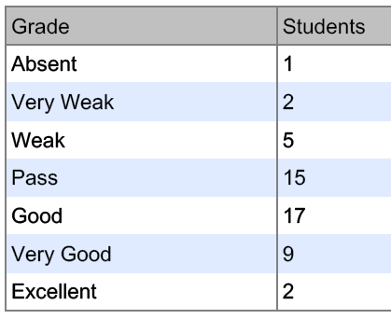

## Professional Information

1. **Course Teaching:**

|  |  |  |
| --- | --- | --- |
| Course Content | No. of Hours | Lecturer |
| Tool Design | 35 | Dr. M. Adel Rizk |
| Jigs and Fixtures | 35 | Prof. Dr. Mohammed Abdel Mohsen |
| Injection Molding | 20 | Dr. Tayseer |
| **Total** | **90** |  |

**Topics taught as a percentage of the content specified:**

**>90 % √ 70-90 % <70%**

**Reasons in detail for not teaching any topic**

All topics were taught ……………………………………….

**If any topics were taught which are not specified, give reasons in detail**

N/A………………………………………………………………………………………….

**Teaching and learning methods:**

Lectures: **√**

Practical training/ laboratory:

Seminar/Workshop:

Class Activity: **(Tutorials)**  **√**

**Online Lectures and Online Tutorial Activities**

LMS and online meeting through MS Team (suspension of studying in campus due to covid-19) .

Link to Course Group in Microsoft Teams

<https://teams.microsoft.com/l/team/19%3a73e01f34712b4543a3f2404f018e8039%40thread.tacv2/conversations?groupId=e9a29e1a-8a43-443e-b9f0-1122964f30b2&tenantId=ad2a8324-bef7-46a8-adb4-fe51b6613b24>

**Online Lectures and Attendance**

A complete copy of the given lectures, required assignments, required reports, quizzes and model answers of quizzes, mid- term exam and its model answers as well as students evaluation are available on the LMS (<https://lms.eng.asu.edu.eg/course/view.php?id=6656>)

A sample of the online meeting student attendance are available on Google drive (<https://drive.google.com/drive/folders/1tt7KLG5OfCTGY3258L6v8HpMzPYNB2aX?usp=sharing>)

And A sample of the online meeting lectures are available on Google drive (<https://drive.google.com/drive/folders/1toIeDf2Te_sx7DPTfcRISExxSIbxPJnB?usp=sharing>

)

1. **Student Assessment:**

|  |  |
| --- | --- |
| **Assessment Method** | **Weight** |
| **Class work** | **26.7** |
| **Final Exam** | **73.3%** |
| **Total** | **100%** |

**Members of examination committee**

1. Prof. Dr. Mohammed Abdel Mohsen
2. Dr. Tayseer Attia
3. Dr. M. Adel Rizk

**Role of external evaluator**

N/A………………………………………………………………………….

1. **Facilities and teaching materials:**

Totally adequate **√**

Adequate to some extent

Inadequate

List any inadequacies

1. **Administrative constraints:**

Suspension of studying in the campus results in canceling the written quizzes and replaced it by reports.

1. **Student evaluation of the course:**



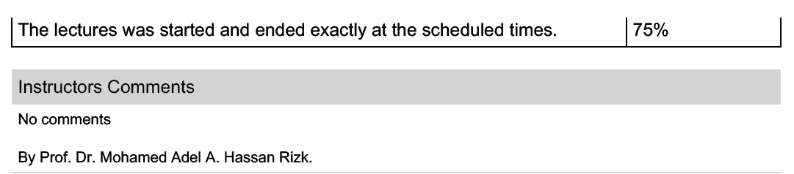

**Response of Course Team**

List any criticisms

… …….………..……………………………….

1. **Comments from external evaluator(s): Response of course team**

……………….