|  |  |
| --- | --- |
| *Course report of* | |
| |  | | --- | | **Metallurgy and Materials Testing MDP 152 -Spring 2021** | | |
| University: Ain Shams | Faculty: Engineering |

## Basic Information

1. Title and code:

|  |
| --- |
| Metallurgy and Materials Testing, MDP 152 |

1. Program on which the course is given:

|  |  |
| --- | --- |
| |  | | --- | | B.Sc. All Mechanical Eng. | |

1. Year/Level of programs:

|  |
| --- |
| 2nd Year-Level 2 |

1. Units/Credit Hours : 3 CH
2. Number of weekly Contact Hours 5

|  |  |
| --- | --- |
| ( i ) Lecture : | 3 |

|  |  |
| --- | --- |
| ( ii ) Tutorial/Practical : | 2 |

|  |  |
| --- | --- |
| ( iii ) Total : | 5 |

1. Names of lecturers contributing to delivery of the course:

|  |  |
| --- | --- |
| i - | Prof. Adel M. Badawy El-Shabasy |

|  |  |
| --- | --- |
| ii - | Prof. Talaat El-benawy |

|  |  |
| --- | --- |
| iii - | Prof. Ahmed M. Moneeb |

|  |  |
| --- | --- |
| Course coordinator: | Prof. Adel M. Badawy El-Shabasy |

|  |  |
| --- | --- |
| External evaluator: | --- --- --- |

## Statistical Information

|  |  |
| --- | --- |
| No. of students attending the course: | 382 |

|  |  |  |  |  |  |  |  |  |  |  |  |  |  |  |
| --- | --- | --- | --- | --- | --- | --- | --- | --- | --- | --- | --- | --- | --- | --- |
|  | A+ | A | A- | B+ | B | B- | C+ | C | C- | D+ | D | P | F | SUM |
| Students No. | 0 | 8 | 24 | 84 | 73 | 65 | 43 | 30 | 14 | 13 | 12 | 7 | 9 | 382 |
| Percentage (%) | 0 | 2.09 | 6.28 | 21.9 | 19.1 | 17.0 | 11.2 | 7.85 | 3.66 | 3.4 | 3.14 | 1.8 | 2.3 |  |

## Professional Information

1. **Course Teaching:**

|  |  |  |
| --- | --- | --- |
| **Course Content** | **No. of Hours** | **Lecturer** |
| Introduction to Materials Testing | **5** | Prof. Talaat El Benawy |
| Standardization & Deformation Systems | **5** | Prof. Talaat El Benawy |
| Mechanical Properties & Tension Test I | **5** | Prof. Adel B. El-Shabasy |
| Tension Test II | **6** | Prof. Adel B. El-Shabasy |
| Compression Test | **5** | Prof. Adel B. El-Shabasy |
| Bending Test | **5** | Prof. Adel B. El-Shabasy |
| Hardness Test | **5** | Prof. Adel B. El-Shabasy |
| Mid Term | **5** | Prof. Adel B. El-Shabasy |
| Shear Test & Torsion Test | **5** | Prof. Adel B. El-Shabasy |
| Strengthening Mechanisms | **5** | Prof. Adel B. El-Shabasy |
| Impact Test | **5** | Prof. Ahmed M. Moneeb |
| Fatigue Test | **5** | Prof. Adel B. El-Shabasy |
| Creep Test | **5** | Prof. Adel B. El-Shabasy |
| Non-destructive Tests | **4** | Prof. Adel B. El-Shabasy |
| General Revision | **5** | Prof. Talaat El Benawy |
| Total | **75** |  |

**Topics taught as a percentage of the content specified:**

**>90 % X 70-90 % <70%**

**Reasons in detail for not teaching any topic**

All topics were taught ……………………………………….

**If any topics were taught which are not specified, give reasons in detail**

N/A………………………………………………………………………………………….

………………………………………………………………………………………………

**Teaching and learning methods:**

Lectures online (via teams): **X**

Practical training/ laboratory( Campus) X

Seminar/Workshop:

Class Activity: **(Tutorials)**  (online) X

**Some of the student activities (lectures and tutorials are conducted lectures were online. While, laboratory activities are only in campus. The percentage of students attended lectures is 60%**

The Microsoft team link:

<https://teams.microsoft.com/l/channel/19%3a0d70ea992cba498b86f7d1913911bb87%40thread.tacv2/General?groupId=85510fa2-63b1-46bb-8c88-41c0733e7a8e&tenantId=ad2a8324-bef7-46a8-adb4-fe51b6613b24>

**Sample of online activities via teams:**

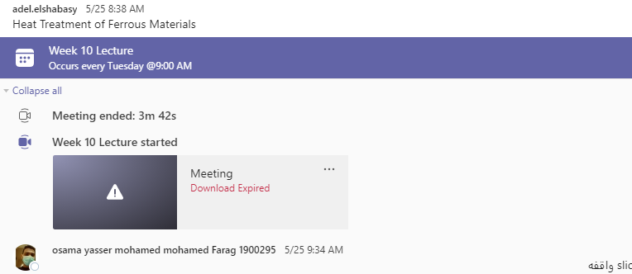

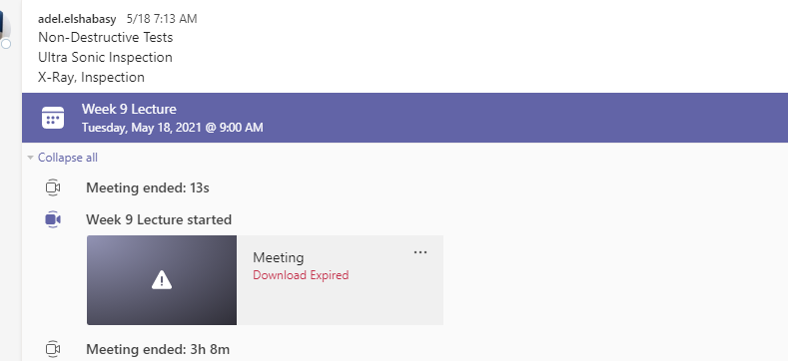

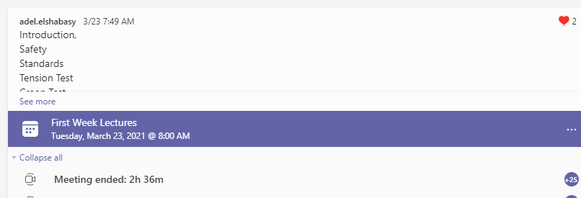

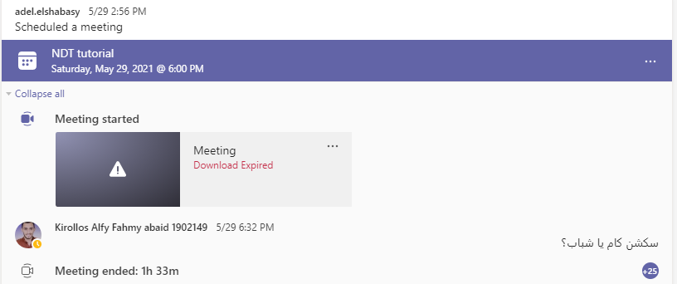

**Case Study:**

Cooperative learning

1. **Student assessment:**

|  |  |
| --- | --- |
| **Method of assessment** | **Percentage of total** |
| Written examination | 60% |
| Oral examination | 20% |
| Written Midterm examinations | 10% |
| Other assignments/class work activities | 10% |
| Total | 100% |

All assessments were held in campus.

**Members of examination committee**

i –Prof. Adel M. Badawy El-Shabasy

ii– Dr. Talaat El Benawy

iii- Prof. Ahmed M. Moneeb

**Role of external evaluator**

N/A

**Facilities and teaching materials:**

Totally adequate

Adequate to some extent **X**

Inadequate

List any inadequacies

1. **Administrative constraints:**

List any difficulties encountered

1. **Student evaluation of the course:**

**Overall course evaluation: 69%**

1. **Response of Course Team**

274 out of 383 students were participated in the Questionnaire 69 The evaluation of the Questionnaire was as follows All the Questions get score 65 Plus 12 out of 20 Questions get score more than 65 8 out of 20 Questions get score more than 70 Concerning the additional comments from students there are 23 comments 1 More than 7 out of 23 comments asked for stopping on line learning Response No Comment 2 Some of the students complain of the long duration of the online lecture 3 hrs Response The course coordinator will submit a request to the Exam Administration to make one lecture 2 hrs on a day 1 hr on another day 3 concerning the comment to reduce the of students in the class Lab Response The course coordinator Prof Adel El Shabasy already submitted a request last term to the Department council Faculty council to reduce the student in class from 50 down to 40 students

**Comments from external evaluator(s): Response of course team**

………**N/A** ……………….

