|  |  |
| --- | --- |
| *Course report of* | |
| **Mechanics of Machines – MDP 311** | |
| University: Ain Shams | Faculty: Engineering |

## Basic Information

1. Title and code:

|  |
| --- |
| **Mechanics of Machines – MDP 311** |

1. Program on which the course is given:

|  |
| --- |
| Mechatronics Engineering Program |

1. Year/Level of programs:

|  |
| --- |
| Junior |

1. Units/Credit Hours

|  |  |
| --- | --- |
| ( i ) Lecture : | 3 |

|  |  |
| --- | --- |
| ( ii ) Tutorial/ : | 2 |
| ( iii ) Practical | 1 |

|  |  |
| --- | --- |
| ( iv ) Total : | 6 |

1. Names of lecturers contributing to delivery of the course:

|  |  |
| --- | --- |
| i - | Prof. Adel Moneeeb |

|  |  |
| --- | --- |
| ii - | Dr. Mohammed Mohammed Hedaya |

|  |  |
| --- | --- |
| Course coordinator: | Prof. Adel Moneeeb |

|  |  |
| --- | --- |
| External evaluator: | --- --- --- |

## Statistical Information

|  |  |
| --- | --- |
| No. of students attending the course: | 253 |

## 



## Professional Information

1. **Course Teaching:**

|  |  |  |  |  |
| --- | --- | --- | --- | --- |
| **No.** | **Course Content** | **Lecture**  **Hours** | **Tutorial**  **Hours** | **Lab Hours** |
| 1 | Introduction | 6 | 4 | 1 |
| 2 | Free Vibration of Undamped Single Degree of Freedom Systems | 3 | 2 | 2 |
| 3 | Free Vibration of Damped Single Degree of Freedom Systems | 6 | 4 | 4 |
| 4 | Harmonically Excited Vibration of Single Degree of Freedom Systems | 9 | 6 | 4 |
| 5 | Vibration of Undamped Two-Degree of Freedom Systems: Free vibrations | 9 | 6 | 2 |
| 6 | Vibration of Undamped Multi-Degree of Freedom | 3 | 2 |  |
| 7 | Free Lateral Vibration of Beams and Critical Speeds of Rotating Shafts: Beam vibrations | 3 | 2 | 2 |
| 8 | Free Lateral Vibration of Beams and Critical Speeds of Rotating Shafts: Whirling of shafts | 3 | 2 |  |
| 9 | Balancing of Shafts | 3 | 2 |  |
| Total Number of Hours | | 45 | 30 | 15 |

**Laboratory Activities:**

|  |  |  |
| --- | --- | --- |
| **No** | **Title of Experiment** | **Laboratory**  **Hours** |
| 1 | Vibration measurements systems | 1 |
| 2 | Natural Frequency Measurement | 2 |
| 3 | Free-damped vibrations | 4 |
| 4 | Forced vibrations | 2 |
| 5 | Transmissibility | 2 |
| 6 | Two degree of freedom systems | 2 |
| Total Number of Hours | | 13 |

**Topics taught as a percentage of the content specified:**

**>90 % 70-90 % <70%**

**X**

**Reasons in detail for not teaching any topic**

The shortening of this term limited the depth of some contents.

**If any topics were taught which are not specified, give reasons in detail**

Beam experiment is cancelled

**Teaching and learning methods:**

**The teaching is done in online for lectures, and the tutorials most are in Campus and some interactive using Microsoft Teams platform. Labs are in Campus**

Lectures: **X**

Practical training/ laboratory:  **X**

Seminar/Workshop:

Class Activity: **(Tutorials)** **X**

**Lectures:**

<https://teams.microsoft.com/l/channel/19%3abed6ba66be5c43b7aad99a623fa55da3%40thread.tacv2/Lectures?groupId=3ad08697-e05f-4661-96f6-b9f4cce512bf&tenantId=ad2a8324-bef7-46a8-adb4-fe51b6613b24>

**Tutorials:**

<https://teams.microsoft.com/l/channel/19%3a07017cf684864b9a99fc4f5e96d234b6%40thread.tacv2/Tutorials?groupId=3ad08697-e05f-4661-96f6-b9f4cce512bf&tenantId=ad2a8324-bef7-46a8-adb4-fe51b6613b24>

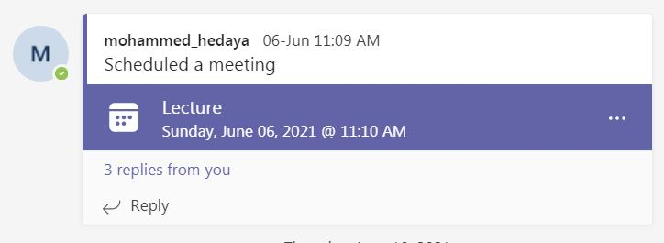

1. **Student assessment:**

|  |  |
| --- | --- |
| **Method of assessment** | **Percentage of total** |
| Quizzes | 10 % |
| Midterm | 15 % |
| Final examination | 60 % |
| Assignments | 5% |
| Practical/laboratory work | 10 % |
|  |  |

**Members of examination committee**

|  |  |
| --- | --- |
| i - | Prof. Adel Moneeeb |

|  |  |
| --- | --- |
| ii - | Dr. Mohammed Mohammed Hedaya |

**Facilities and teaching materials:**

Adequate to some extent

Inadequate

List any inadequacies:

. More stable internet and teaching platform

1. **Administrative constraints:**

**There should be a stable internet for students and instructors.**

1. **Student evaluation of the course:**

**Response of Course Team**

The student evaluation is more than 50%. There are common comments of large number of formulas to be remembered. It will be considered to reduce the essential formulas.

**Comments from external evaluator(s): Response of course team**