|  |  |
| --- | --- |
| *Course report of* | |
| |  | | --- | | Machine Construction (MDP 211) Fall 2020 | | |
| University: Ain Shams | Faculty: Engineering |

## Basic Information

1. Title and code:

|  |
| --- |
| Machine Elements Design MDP 211 (2-2-2) |

1. Programs on which the course is given:

|  |  |
| --- | --- |
| |  | | --- | | Mechanical Engineering | |

1. Year/Level of programs:

|  |
| --- |
| Juinior Level |

1. Units/Credit Hours

|  |  |
| --- | --- |
| ( i ) Lecture : | 2 |

|  |  |
| --- | --- |
| ( ii ) Tutorial/Practical : | 2/2 |

|  |  |
| --- | --- |
| ( iii ) Total : | 6 |

1. Names of lecturers contributing to delivery of the course:

|  |  |
| --- | --- |
| i - | Prof. Hisham Senbol |

|  |  |
| --- | --- |
| ii - | Prof. Tamer Elnady |

|  |  |
| --- | --- |
| iii - | Associate Prof. Ayman Aly Abd El-Wahab |
|  | Dr. Amr Shaaban |

|  |  |
| --- | --- |
| Course coordinator: | Prof. Tamer Elnady |

|  |  |
| --- | --- |
| External evaluator: |  |

## Statistical Information

## 

## Professional Information

1. **Course Teaching:**

|  |  |  |  |
| --- | --- | --- | --- |
| Course Content | No. of Hours | Lecturer | |
| Deflection | 6 | Dr. Ayman | Dr. Amr |
| Buckling | 6 | Dr. Ayman | Dr. Amr |
| Thermal Stresses | 6 | Dr. Ayman | Dr. Amr |
| Design under Fatigue Loading | 6 | Dr. Ayman | Dr. Amr |
| Machine Elements Design | 24 | Prof. Tamer | Dr. Amr |
| Rolling Bearings | 12 | Prof. Hisham | Dr. Amr |
| Power Transmission Elements Design | 24 | Prof. Hisham | Dr. Amr |
| Gearboxes Construction | 6 | Prof. Hisham | Dr. Amr |

**Topics taught as a percentage of the content specified:**

**>90 % X 70-90 % <70%**

**Reasons in detail for not teaching any topic**

All topics were taught ………………………………………………………………………

………………………………………………………………………………………………

………………………………………………………………………………………………

………………………………………………………………………………………………

**If any topics were taught which are not specified, give reasons in detail**

N/A………………………………………………………………………………………….

**Teaching and learning methods:**

Lectures: **X**

Practical training/ laboratory:  **X**

Seminar/Workshop:

Class Activity: **(Tutorials)**  **X**

**Case Study:**

Other assignments/homework:

If teaching and learning methods were used other than those specified, list and give reasons:

………………………………………………………………………………………………

1. **Student assessment:**

|  |  |  |  |
| --- | --- | --- | --- |
| **Assessment method** | **Description** | **Week No** | **Weight (%)** |
| Assignments | Assignments | 2,3, 6,7,8,10,11,12&15 | 10 |
| Lab Reports | Reports | 15 | 10 |
| Quiz | Unannounced Quizzes | 5-13 | 10 |
| Written Exam | Mid-Term Exam | 8 | 20 |
| Project | Prototype | 15 | 10 |
| Written Exam | Final Exam | 16 | 40 |
| Total | | | 100 |

**Members of examination committee**

* **Prof.** Hisham Senbol
* **Prof.** Tamer Elnady
* **Associate Prof.** Ayman Aly Abd El-Wahab
* **Dr.** Amr Shaaban

**Role of external evaluator**

N/A…………………………………………………………………………………………

1. **Facilities and teaching materials:**

Totally adequate

**X**

Adequate to some extent

Inadequate

List any inadequacies

1. **Administrative constraints:**

List any difficulties encountered

No difficulties

1. **Student evaluation of the course:**

| **Question** | **Score** | |
| --- | --- | --- |
| The course syllabus was clearly explained at the beginning of the semester | 56% |
| I am aware of the course learning outcomes (ILOs). | 69% |
| The teaching methods used helped and supported me to learn | 62% |
| Course topics are explained well in the teaching sessions. | 56% |
| The course activities helped me to achieve the learning outcomes (ILOs) efficiently. | 50% |
| The course assessments were clear and their distribution were clearly announced and organized. | 45% |
| I felt well supported on this course from instructor and teaching assistant (if any). | 58% |
| I have been able to contact instructor when I needed to. | 75% |
| The course focused on what was set out in the course specification and all are presented. | 50% |
| The instructor provided well written laboratory instructions (if any). | 62% |
| Adequate technical support and supervision were provided during the laboratory sessions (if any). | 69% |
| The laboratory was well integrated with the course pacing (if any). | 75% |
| The course digital materials on LMS are helpful in supporting my learning. | 44% |
| Overall, I was satisfied with my experience of this course. | 44% |
| I learn from online teaching activities, similar to on campus teaching activities. | 50% |
| The instructor used appropriate communication tools for online teaching. | 50% |
| The instructor pays attention to the student's achievement during online class. | 56% |
| The instructor encouraged active participation and discussion during online class. | 55% |
| I could pass the online course without any staff assistance. | 30% |
| The instructor respected to start / finish online lectures on scheduled times | 56% |

**Response of Course Team**

All comments shaded by yellow color are not correct. The assessment is clear and is according to the bylaw. Also, all materials resources are uploaded to LMS continuously. Moreover, I think the reason for the third & fourth comments refer to that the course contents need more efforts and practice from the students to understand.

Screen shot from an online lecture as an example

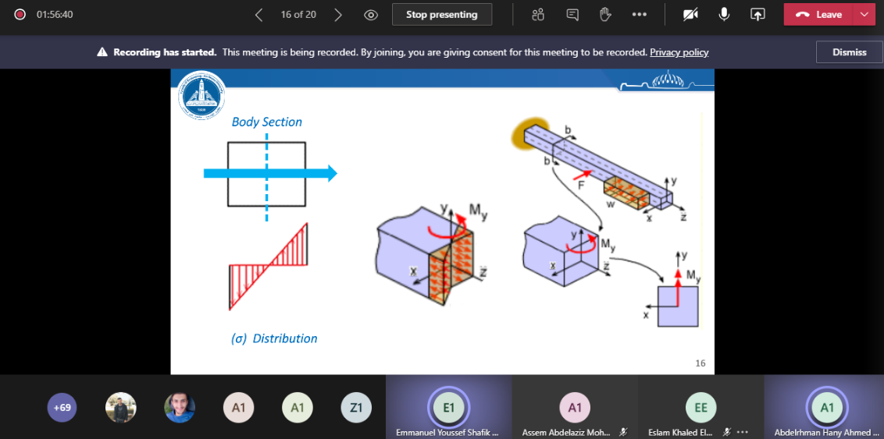

1. **Comments from external evaluator(s): Response of course team**

………**N/A** ………………. …………………………….

……….……………..……. …………………………….