Course report of
Quality control –MDP 422 Fall 2020
University: Ain Shams | Faculty: Engineering

Basic Information
- Title and code :
MDP 422: Quality control
- Program on which the course is given :
Design and Production Engineering Program

- Year/Level of programs :
Fall 2018/ 4th Production
- Units/Credit Hours
( i ) Lecture : | 2

( ii ) Tutorial/Practical : | 2

( iii ) Total : | 4
- Names of lecturers contributing to delivery of the course :
Dr. Ghada Essam Eldeen Shedeed
Dr. Ismail Hafez

Course coordinator: | Dr. Ghada Essam Eldeen Shedeed

External evaluator: | N/A

Statistical Information

Total number of students | 52

Grade | Number | Percentage
Excellent
Very good
Good
Acceptable
Weak
Very weak
Total | 52

Professional Information

Course Teaching:

No | Course Content | Lecture  (hours) | Tutorial | Lecturer
1 | Introduction to quality (introducing new terminologies, quality definitions and concepts.) | 3 | 4 | Dr. Ghada Shedeed
2 | Why statistics is so important to quality? estimation theory, and test of hypothesis | 2 | 2 | Dr. Ghada Shedeed
3 | Statistical Process Control Philosophy and Techniques (the Magnificent Seven SPC problem-solving tools) | 4 | 4 | Dr. Ghada Shedeed
4 | Theory of control charts and variations | 4 | 4 | Dr. Ghada Shedeed
5 | Control Charts for Variables | 5 | 4 | Dr. Ghada Shedeed
6 | Control Charts for Attributes | 4 | 4 | Dr. Ghada Shedeed
7 | Acceptance Sampling | 4 | 4 | Dr. Ghada Shedeed
 | Total | 26 | 26

Lecture and tutorial Microsoft Teams, sample of recorded activities
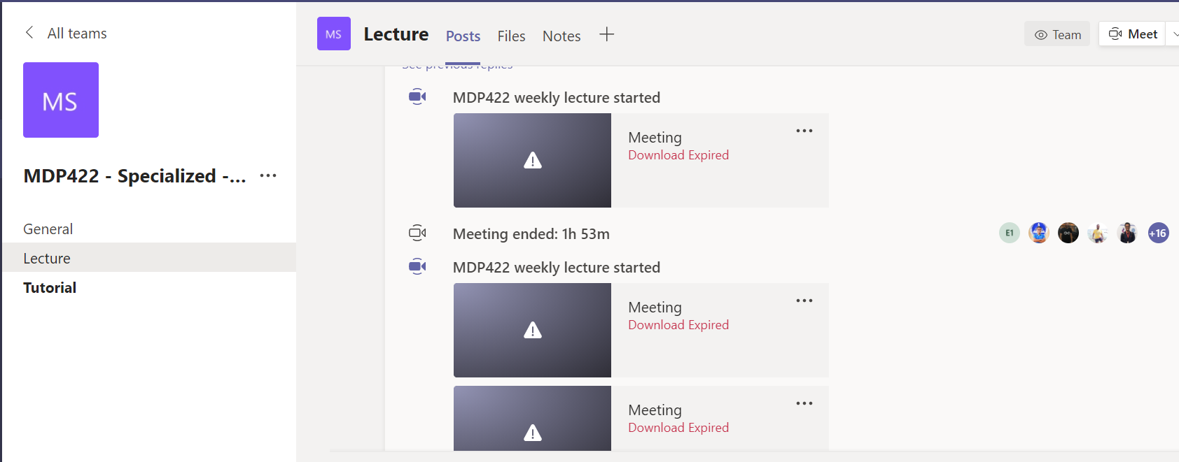
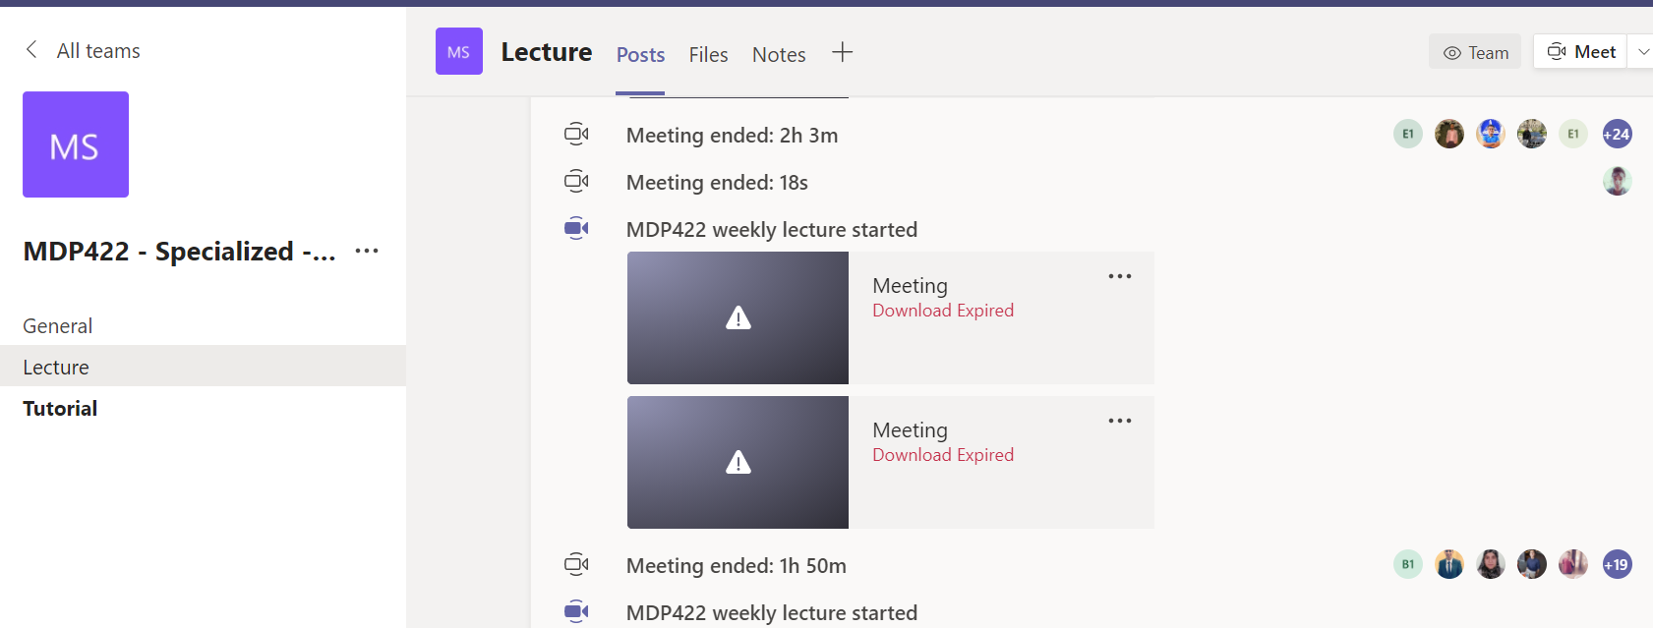

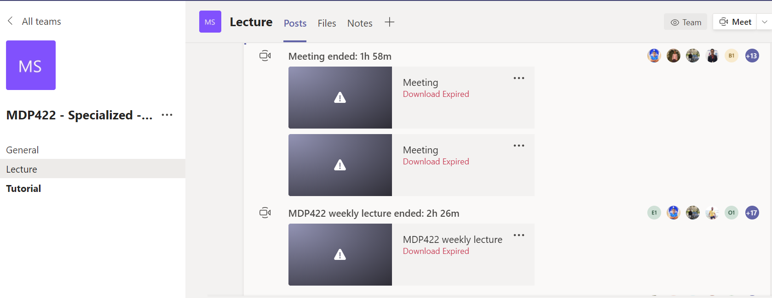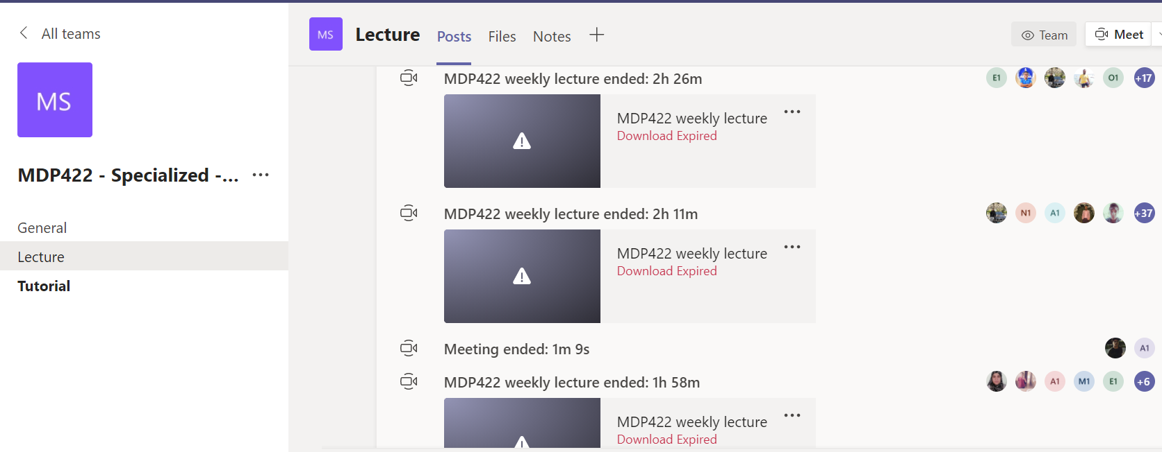

For more details, you can access the course team:
https://teams.microsoft.com/l/team/19%3a73c0dba06efb458182d97d32fa1be734%40thread.tacv2/conversations?groupId=c35d4b47-bcaf-4417-aa50-fcf1a9fb7f3c&tenantId=ad2a8324-bef7-46a8-adb4-fe51b6613b24
Sample of student attandence
Attached at the end

Topics taught as a percentage of the content specified:

>90 % yes 70-90 % <70%

Reasons in detail for not teaching any topic
Acceptance sampling for attributes but not for variable has been given since this semester had 13 weeks instead of the usual 15 weeks.

If any topics were taught which are not specified, give reasons in detail

Teaching and learning methods:
Lectures: X
Practical training/ laboratory:
Seminar/Workshop:
Class Activity: X
(online and oncampus Tutorials)

- Interactive online sessions (lectures and tutorials) using Microsoft Teams, and video links to the recorded videos beside using the LMS.
If teaching and learning methods were used other than those specified, list and give reasons:
- Students were asked to use an available software trial version to solve what they have learned during the semester. So they can utilize the most widely used statistics and quality control software in solving industry and service quality related real case studies.

Student assessment:
Assessment method | Description | Week No | Weight (%)
Written exam | Online LMS and on-campus quizzes |  | 15%
Written exam | Mid-Term Exam
Assignments and reports | In class activity, reports, assignments |  | 15%
Written exam | Final Exam |  | 70%
Total |  |  | 100%

Members of examination committee
Dr. Ghada E. Shedeed

Role of external evaluator
N/A

Facilities and teaching materials:
Totally adequate

Adequate to some extent X

Inadequate

List any inadequacies:

Student evaluation of the course:
Not available on the IMS

Action plan, for next year, can be summarized as follows:

Comments from external evaluator(s): Response of course team
………N/A ………………. …………………………….
……….……………..……. …………………………….

8- Course enhancement:

Progress on actions identified in the previous year’s action plan:

Action
A time, at the beginning of the course, has been dedicated to the needed probability and statistics background.

Sample of student attandence

Full Name | User Action | Timestamp
Ghada E. Shedid | Joined | 11/14/2020, 8:59:44 AM
Mohamed Ali Saber Mahran 1809843 | Joined before | 11/14/2020, 8:59:44 AM
Abdelrahman Mahmoud Fathelbab Abdrabo 1809710 | Joined before | 11/14/2020, 8:59:44 AM
Abdelrahman Mahmoud Fathelbab Abdrabo 1809710 | Left | 11/14/2020, 10:56:16 AM
Abdulrahman Mohamed Awad Sorour 1808435 | Joined before | 11/14/2020, 8:59:44 AM
Abdulrahman Mohamed Awad Sorour 1808435 | Left | 11/14/2020, 9:40:12 AM
Abdulrahman Mohamed Awad Sorour 1808435 | Joined | 11/14/2020, 9:40:46 AM
Hossam Saad Taha Mohamed Ali 1809311 | Joined before | 11/14/2020, 8:59:44 AM
Ahmed Kamel Waeer Abdalhalim 1801591 | Joined before | 11/14/2020, 8:59:44 AM
Kerolos Melad Anwar Azmy Noaman 1802829 | Joined before | 11/14/2020, 8:59:44 AM
Ahmed Hamdy Ibrahiem Abdelaziz Hussien 1802810 | Joined before | 11/14/2020, 8:59:44 AM
Ahmed Hamdy Ibrahiem Abdelaziz Hussien 1802810 | Left | 11/14/2020, 9:53:34 AM
Ahmed Hamdy Ibrahiem Abdelaziz Hussien 1802810 | Joined | 11/14/2020, 10:04:27 AM
Ahmed Hamdy Ibrahiem Abdelaziz Hussien 1802810 | Left | 11/14/2020, 10:56:05 AM
Omar Mohmed Ibrahim Mohmed 1809250 | Joined before | 11/14/2020, 8:59:44 AM
Omar Mohmed Ibrahim Mohmed 1809250 | Left | 11/14/2020, 9:02:23 AM
Omar Mohmed Ibrahim Mohmed 1809250 | Joined | 11/14/2020, 9:02:36 AM
Omar Mohmed Ibrahim Mohmed 1809250 | Left | 11/14/2020, 9:31:42 AM
Omar Mohmed Ibrahim Mohmed 1809250 | Joined | 11/14/2020, 9:32:17 AM
Omar Mohmed Ibrahim Mohmed 1809250 | Left | 11/14/2020, 9:52:11 AM
Omar Mohmed Ibrahim Mohmed 1809250 | Joined | 11/14/2020, 10:02:39 AM
Ahmed Mohamed Ibrahim Khamis 1808452 | Joined before | 11/14/2020, 8:59:44 AM
Omar Diaa Abdrabou Abdalmageed 1804450 | Joined before | 11/14/2020, 8:59:44 AM
Mikel Emad Saad Salama 1809423 | Joined before | 11/14/2020, 8:59:44 AM
Mahmoud Hosney Ahmed Hassan Ahmed El-Hanouny 1808605 | Joined before | 11/14/2020, 8:59:44 AM
Mina Wahed Eshak Farag Ghatas 1801617 | Joined before | 11/14/2020, 8:59:44 AM
Mina Wahed Eshak Farag Ghatas 1801617 | Left | 11/14/2020, 8:59:49 AM
Mina Wahed Eshak Farag Ghatas 1801617 | Joined | 11/14/2020, 9:00:33 AM
Mina Wahed Eshak Farag Ghatas 1801617 | Left | 11/14/2020, 9:01:11 AM
Mina Wahed Eshak Farag Ghatas 1801617 | Joined | 11/14/2020, 9:01:32 AM
Mina Wahed Eshak Farag Ghatas 1801617 | Left | 11/14/2020, 9:43:43 AM
Mina Wahed Eshak Farag Ghatas 1801617 | Joined | 11/14/2020, 9:51:08 AM
Mario Ibrahim Nasrallah Yousef 1807545 | Joined before | 11/14/2020, 8:59:44 AM
Ahmed Abd Elrahman Mahmoud Moselhy Ali 1805200 | Joined before | 11/14/2020, 8:59:44 AM
Ahmed Abd Elrahman Mahmoud Moselhy Ali 1805200 | Left | 11/14/2020, 10:02:59 AM
Ahmed Abd Elrahman Mahmoud Moselhy Ali 1805200 | Joined | 11/14/2020, 10:03:16 AM
Ahmed Abd Elrahman Mahmoud Moselhy Ali 1805200 | Left | 11/14/2020, 10:24:51 AM
حازم حسام ابراهيم ابو سريع 1700422 | Joined before | 11/14/2020, 8:59:44 AM
حازم حسام ابراهيم ابو سريع 1700422 | Left | 11/14/2020, 9:27:36 AM
حازم حسام ابراهيم ابو سريع 1700422 | Joined | 11/14/2020, 9:27:49 AM
حازم حسام ابراهيم ابو سريع 1700422 | Left | 11/14/2020, 10:01:00 AM
حازم حسام ابراهيم ابو سريع 1700422 | Joined | 11/14/2020, 10:07:11 AM
حازم حسام ابراهيم ابو سريع 1700422 | Left | 11/14/2020, 10:41:55 AM
حازم حسام ابراهيم ابو سريع 1700422 | Joined | 11/14/2020, 10:42:18 AM
حازم حسام ابراهيم ابو سريع 1700422 | Left | 11/14/2020, 10:54:06 AM
حسام حمدى عبد الواحد موسى 1700439 | Joined before | 11/14/2020, 8:59:44 AM
Bishoy Saad Shehata Saadallah 1809808 | Joined before | 11/14/2020, 8:59:44 AM
Bishoy Saad Shehata Saadallah 1809808 | Left | 11/14/2020, 9:34:39 AM
Bishoy Saad Shehata Saadallah 1809808 | Joined | 11/14/2020, 9:41:03 AM
Bishoy Saad Shehata Saadallah 1809808 | Left | 11/14/2020, 9:48:28 AM
Ahmed Osama Ahmed Khalaf Aql 1804878 | Joined before | 11/14/2020, 8:59:44 AM
Ahmed Osama Ahmed Khalaf Aql 1804878 | Left | 11/14/2020, 10:55:59 AM
Omar Alaa Mostafa Ezz Elden 1805559 | Joined before | 11/14/2020, 8:59:44 AM
Omar Alaa Mostafa Ezz Elden 1805559 | Left | 11/14/2020, 9:47:41 AM
Omar Alaa Mostafa Ezz Elden 1805559 | Joined | 11/14/2020, 9:47:51 AM
Omar Alaa Mostafa Ezz Elden 1805559 | Left | 11/14/2020, 10:56:23 AM
Omar Alaa Mostafa Ezz Elden 1805559 | Joined | 11/14/2020, 10:56:35 AM
Ziad Tarek Mohamed Abd Elwahab Enawy 1803906 | Joined before | 11/14/2020, 8:59:44 AM
Ziad Tarek Mohamed Abd Elwahab Enawy 1803906 | Left | 11/14/2020, 9:12:22 AM
Ziad Tarek Mohamed Abd Elwahab Enawy 1803906 | Joined | 11/14/2020, 9:13:17 AM
Ziad Tarek Mohamed Abd Elwahab Enawy 1803906 | Left | 11/14/2020, 9:16:26 AM
Ziad Tarek Mohamed Abd Elwahab Enawy 1803906 | Joined | 11/14/2020, 9:16:31 AM
Ziad Tarek Mohamed Abd Elwahab Enawy 1803906 | Left | 11/14/2020, 9:42:24 AM
Ziad Tarek Mohamed Abd Elwahab Enawy 1803906 | Joined | 11/14/2020, 9:45:48 AM
Ziad Tarek Mohamed Abd Elwahab Enawy 1803906 | Left | 11/14/2020, 9:48:02 AM
Ziad Tarek Mohamed Abd Elwahab Enawy 1803906 | Joined | 11/14/2020, 9:49:53 AM
Ziad Tarek Mohamed Abd Elwahab Enawy 1803906 | Left | 11/14/2020, 10:15:21 AM
Ziad Tarek Mohamed Abd Elwahab Enawy 1803906 | Joined | 11/14/2020, 10:16:31 AM
Ziad Tarek Mohamed Abd Elwahab Enawy 1803906 | Left | 11/14/2020, 10:16:44 AM
Ziad Tarek Mohamed Abd Elwahab Enawy 1803906 | Joined | 11/14/2020, 10:16:51 AM
Yousef Ahmed Kamal Mokhtar 18Q3684 | Joined before | 11/14/2020, 8:59:44 AM
Omnia Hussain Mohamed Hassan Hassan 1700290 | Joined before | 11/14/2020, 8:59:44 AM
Omnia Yehia Gharib Abd Elkader 1801595 | Joined before | 11/14/2020, 8:59:44 AM
Omnia Yehia Gharib Abd Elkader 1801595 | Left | 11/14/2020, 9:19:20 AM
Omnia Yehia Gharib Abd Elkader 1801595 | Joined | 11/14/2020, 9:19:24 AM
Omnia Yehia Gharib Abd Elkader 1801595 | Left | 11/14/2020, 9:56:53 AM
Omnia Yehia Gharib Abd Elkader 1801595 | Joined | 11/14/2020, 9:58:00 AM
Yousef Reda Ahmed Elsayed Refaie 1801929 | Joined before | 11/14/2020, 8:59:44 AM
Abdullah Hany Mahmoud Abdelgelil 1808177 | Joined before | 11/14/2020, 8:59:44 AM
Fahmy Reda Fahmy Abdelghany 1805387 | Joined before | 11/14/2020, 8:59:44 AM
Khaled Elsayed Abdullah Mosallam Dyab 1801460 | Joined before | 11/14/2020, 8:59:44 AM
Bassem Mohammed Sayed Abdelhamed Aly 1805412 | Joined before | 11/14/2020, 8:59:44 AM
Bassem Mohammed Sayed Abdelhamed Aly 1805412 | Left | 11/14/2020, 10:55:07 AM
Yousef Tamer Magdy Amin Ghaly 1806334 | Joined before | 11/14/2020, 8:59:44 AM
Karim Nour Ahmed Said Adam 1808079 | Joined before | 11/14/2020, 8:59:44 AM
Karim Nour Ahmed Said Adam 1808079 | Left | 11/14/2020, 9:52:14 AM
Karim Nour Ahmed Said Adam 1808079 | Joined | 11/14/2020, 9:52:29 AM
Mahmoud Khaled Mohamed Gamal El Din Mohamed 1802938 | Joined before | 11/14/2020, 8:59:44 AM
Abdul Rahman Mahmoud Hassan Mahmoud 1700766 | Joined before | 11/14/2020, 8:59:44 AM
Abdul Rahman Mahmoud Hassan Mahmoud 1700766 | Left | 11/14/2020, 9:40:08 AM
Abdul Rahman Mahmoud Hassan Mahmoud 1700766 | Joined | 11/14/2020, 10:01:39 AM
Abdul Rahman Mahmoud Hassan Mahmoud 1700766 | Left | 11/14/2020, 10:47:44 AM
Hesham Ayman Ibrahim Sayed Ahmrd 1801626 | Joined before | 11/14/2020, 8:59:44 AM
Mostafa Helmy Farouk Ahmed Al-Shazly 18T9169 | Joined before | 11/14/2020, 8:59:44 AM
Mohamed Magdy Shalaby Ahmed 1803359 | Joined before | 11/14/2020, 8:59:44 AM
حسام حسن محمد حسين على 16T0042 | Joined before | 11/14/2020, 8:59:44 AM
حسام حسن محمد حسين على 16T0042 | Left | 11/14/2020, 9:50:38 AM
حسام حسن محمد حسين على 16T0042 | Joined | 11/14/2020, 9:50:56 AM
حسام حسن محمد حسين على 16T0042 | Left | 11/14/2020, 10:07:06 AM
حسام حسن محمد حسين على 16T0042 | Joined | 11/14/2020, 10:07:17 AM
حسام حسن محمد حسين على 16T0042 | Left | 11/14/2020, 10:09:16 AM
حسام حسن محمد حسين على 16T0042 | Joined | 11/14/2020, 10:09:32 AM
حسام حسن محمد حسين على 16T0042 | Left | 11/14/2020, 10:55:07 AM
Omar Ehab Mahmoud Elmaghraby 1801933 | Joined before | 11/14/2020, 8:59:44 AM
Jailan Hesham Mohamed Mokhtar Mohamed El Meligy 1801545 | Joined before | 11/14/2020, 8:59:44 AM
Mohamed Khalid Mohamed elsayed Abdalgalil 1701188 | Joined before | 11/14/2020, 8:59:44 AM
Rogeih Emad Shokry Abdelmalek 1804753 | Joined | 11/14/2020, 8:59:45 AM
Rogeih Emad Shokry Abdelmalek 1804753 | Left | 11/14/2020, 10:43:37 AM
Rogeih Emad Shokry Abdelmalek 1804753 | Joined | 11/14/2020, 10:45:02 AM
Rogeih Emad Shokry Abdelmalek 1804753 | Left | 11/14/2020, 10:55:49 AM
Ahmed Belal Mohamed Elbasiony Abdelhamid 1802625 | Joined | 11/14/2020, 9:00:04 AM
Ahmed Belal Mohamed Elbasiony Abdelhamid 1802625 | Left | 11/14/2020, 10:35:28 AM
Mohamed Atef Mohamed Ashour Ahmed 1809791 | Joined | 11/14/2020, 9:00:21 AM
Mohamed Atef Mohamed Ashour Ahmed 1809791 | Left | 11/14/2020, 9:26:31 AM
Feryal Osama Abd Elsamea Farag 1803848 | Joined | 11/14/2020, 9:00:37 AM
Feryal Osama Abd Elsamea Farag 1803848 | Left | 11/14/2020, 9:38:50 AM
Feryal Osama Abd Elsamea Farag 1803848 | Joined | 11/14/2020, 9:39:19 AM
Feryal Osama Abd Elsamea Farag 1803848 | Left | 11/14/2020, 9:42:07 AM
Feryal Osama Abd Elsamea Farag 1803848 | Joined | 11/14/2020, 9:42:08 AM
Feryal Osama Abd Elsamea Farag 1803848 | Left | 11/14/2020, 9:43:07 AM
Feryal Osama Abd Elsamea Farag 1803848 | Joined | 11/14/2020, 9:43:15 AM
Feryal Osama Abd Elsamea Farag 1803848 | Left | 11/14/2020, 10:05:33 AM
Feryal Osama Abd Elsamea Farag 1803848 | Joined | 11/14/2020, 10:05:39 AM
Mohamed Saber Mohamed Saber Atallah 1807128 | Joined | 11/14/2020, 9:00:37 AM
Mohamed Saber Mohamed Saber Atallah 1807128 | Left | 11/14/2020, 9:18:06 AM
Amir Samy Saad Jaidi 1807249 | Joined | 11/14/2020, 9:00:38 AM
Ahmed Saied Mohamed Mostafa Kishka 1806385 | Joined | 11/14/2020, 9:00:51 AM
Noran Ayman Elhosiny Mohamed 18Q4186 | Joined | 11/14/2020, 9:00:53 AM
Mohamed Emad Ahmed Ali 1808180 | Joined | 11/14/2020, 9:00:58 AM
Amiir Saad Eldin Hassan Saad Eldin 1808980 | Joined | 11/14/2020, 9:01:12 AM
Amiir Saad Eldin Hassan Saad Eldin 1808980 | Left | 11/14/2020, 9:52:02 AM
Amiir Saad Eldin Hassan Saad Eldin 1808980 | Joined | 11/14/2020, 10:00:51 AM
Ziad Tariq Ahmed Rageb Mohammed 1807806 | Joined | 11/14/2020, 9:01:19 AM
Ziad Tariq Ahmed Rageb Mohammed 1807806 | Left | 11/14/2020, 10:55:09 AM
Mohanad Sayed Abdelbaqi Abdelmomen 1806788 | Joined | 11/14/2020, 9:01:37 AM
Ahmed Mohamed Naguib Gouda Abdel Megid 1805990 | Joined | 11/14/2020, 9:01:45 AM
Marina Nabil Wanis Mawad 1803951 | Joined | 11/14/2020, 9:01:47 AM
Abdelrhman Hossam El-Din Helmy Mohamed 1809000 | Joined | 11/14/2020, 9:01:47 AM
Abdelrahman Samir Abdelmooty Mohamed 1805644 | Joined | 11/14/2020, 9:01:49 AM
Abdelrahman Samir Abdelmooty Mohamed 1805644 | Left | 11/14/2020, 10:57:03 AM
Abdullah Mohamed Sabrin Mohamed 1808590 | Joined | 11/14/2020, 9:01:50 AM
Abdullah Mohamed Sabrin Mohamed 1808590 | Left | 11/14/2020, 10:54:35 AM
Mohamed Mostafa Ahmed Salem 1804705 | Joined | 11/14/2020, 9:01:51 AM
Mohamed Mostafa Ahmed Salem 1804705 | Left | 11/14/2020, 10:03:09 AM
Mohamed Mostafa Ahmed Salem 1804705 | Joined | 11/14/2020, 10:03:22 AM
Makram Nageh Hassan Rahim 18T1649 | Joined | 11/14/2020, 9:01:56 AM
George Anis Abomarin Mousa 1809452 | Joined | 11/14/2020, 9:02:00 AM
Abdelrahman Abdel Wahab Wahba Abdel Mawla 1803757 | Joined | 11/14/2020, 9:02:10 AM
Abanoub kamal dawoud 1902148 | Joined | 11/14/2020, 9:02:12 AM
Haitham Hassan Saleh Hussein 1807898 | Joined | 11/14/2020, 9:02:33 AM
Haitham Hassan Saleh Hussein 1807898 | Left | 11/14/2020, 9:23:55 AM
Haitham Hassan Saleh Hussein 1807898 | Joined | 11/14/2020, 9:24:07 AM
Philopateer Ehab Fakhry Zaki Hanna 1804021 | Joined | 11/14/2020, 9:02:51 AM
Ahmed Elsayed Mohamed Abdelraouf 1803539 | Joined | 11/14/2020, 9:03:01 AM
Mayar Yehia Hatem Ammar 1808012 | Joined | 11/14/2020, 9:03:11 AM
Mayar Yehia Hatem Ammar 1808012 | Left | 11/14/2020, 10:55:05 AM
Hussein Abdelazim Hussein Abdelazim Kandil 1809888 | Joined | 11/14/2020, 9:03:13 AM
Abdelrahman Mohamed Moawad Awadallah 1809154 | Joined | 11/14/2020, 9:03:18 AM
Ahmed Nasr Mohamed Ebraheem Mostaffa 18Q2730 | Joined | 11/14/2020, 9:03:39 AM
Eslam mahmoud mohamed 1902235 | Joined | 11/14/2020, 9:03:50 AM
Aly Yasser Mahmoud Zaki 1806059 | Joined | 11/14/2020, 9:04:12 AM
Abanoub Atef Abd El Gayd Gergeus 1802674 | Joined | 11/14/2020, 9:04:59 AM
Abanoub Atef Abd El Gayd Gergeus 1802674 | Left | 11/14/2020, 9:05:32 AM
Abanoub Atef Abd El Gayd Gergeus 1802674 | Joined | 11/14/2020, 9:05:39 AM
Mohammed Osama Ibrahim Mohammed 18Q8487 | Joined | 11/14/2020, 9:05:02 AM
Mohammed Osama Ibrahim Mohammed 18Q8487 | Left | 11/14/2020, 9:41:48 AM
Mostafa Ali Ahmed Abd Elslam 1809367 | Joined | 11/14/2020, 9:05:20 AM
Mostafa Ali Ahmed Abd Elslam 1809367 | Left | 11/14/2020, 9:51:31 AM
Mostafa Ali Ahmed Abd Elslam 1809367 | Joined | 11/14/2020, 9:51:43 AM
Mostafa Ali Ahmed Abd Elslam 1809367 | Left | 11/14/2020, 10:13:13 AM
Mostafa Ali Ahmed Abd Elslam 1809367 | Joined | 11/14/2020, 10:13:39 AM
Mahmoud Ahmed Hamdy Ahmed Morsy 1806990 | Joined | 11/14/2020, 9:05:21 AM
Roshdy Magdy Ibrahem Mohamed 1808205 | Joined | 11/14/2020, 9:05:27 AM
Roshdy Magdy Ibrahem Mohamed 1808205 | Left | 11/14/2020, 9:52:05 AM
Roshdy Magdy Ibrahem Mohamed 1808205 | Joined | 11/14/2020, 10:02:17 AM
Roshdy Magdy Ibrahem Mohamed 1808205 | Left | 11/14/2020, 10:09:33 AM
Amr Elsayed Nasser Elsayed 18Q1525 | Joined | 11/14/2020, 9:06:12 AM
Mohamed Ahmed Gamal Mohamed Abdelfattah 1806423 | Joined | 11/14/2020, 9:06:21 AM
Mohamed Ahmed Gamal Mohamed Abdelfattah 1806423 | Left | 11/14/2020, 9:52:08 AM
Mohamed Ahmed Gamal Mohamed Abdelfattah 1806423 | Joined | 11/14/2020, 10:06:01 AM
Abdullah Ashraf Abdullah Morsy 1808640 | Joined | 11/14/2020, 9:07:05 AM
Abdullah Ashraf Abdullah Morsy 1808640 | Left | 11/14/2020, 9:12:31 AM
Abdullah Ashraf Abdullah Morsy 1808640 | Joined | 11/14/2020, 9:15:33 AM
Hagar Ahmed Mohamed Ahmed Mohamed 1807678 | Joined | 11/14/2020, 9:07:12 AM
Hagar Ahmed Mohamed Ahmed Mohamed 1807678 | Left | 11/14/2020, 9:52:04 AM
Hagar Ahmed Mohamed Ahmed Mohamed 1807678 | Joined | 11/14/2020, 10:02:18 AM
Omar Hassan Sabry Abdelrahem Emam 1806866 | Joined | 11/14/2020, 9:07:28 AM
Nada Mahmoud El Sayed Osman 18T5261 | Joined | 11/14/2020, 9:08:14 AM
Nada Mahmoud El Sayed Osman 18T5261 | Left | 11/14/2020, 9:08:56 AM
Fatma Tarek Sayed Mahmoud 1805867 | Joined | 11/14/2020, 9:08:29 AM
Fatma Tarek Sayed Mahmoud 1805867 | Left | 11/14/2020, 9:52:03 AM
Fatma Tarek Sayed Mahmoud 1805867 | Joined | 11/14/2020, 10:03:48 AM
Mohamed Amer Labib Elsayed 1802043 | Joined | 11/14/2020, 9:08:31 AM
Mohamed Amer Labib Elsayed 1802043 | Left | 11/14/2020, 10:08:34 AM
Karim Ahmed Said Abdelmajid Owais 18T5106 | Joined | 11/14/2020, 9:08:39 AM
Karim Ahmed Said Abdelmajid Owais 18T5106 | Left | 11/14/2020, 10:50:56 AM
Mohammed Ehab Mohammed Izzat Mahni 1804329 | Joined | 11/14/2020, 9:08:46 AM
Omar Yasser Gamal Mahmoud Abdel Ghafar 1802324 | Joined | 11/14/2020, 9:09:09 AM
Omar Yasser Gamal Mahmoud Abdel Ghafar 1802324 | Left | 11/14/2020, 9:37:47 AM
Omar Yasser Gamal Mahmoud Abdel Ghafar 1802324 | Joined | 11/14/2020, 9:42:02 AM
Omar Yasser Gamal Mahmoud Abdel Ghafar 1802324 | Left | 11/14/2020, 9:42:34 AM
Omar Yasser Gamal Mahmoud Abdel Ghafar 1802324 | Joined | 11/14/2020, 9:42:48 AM
Omar Yasser Gamal Mahmoud Abdel Ghafar 1802324 | Left | 11/14/2020, 9:46:12 AM
Hazem Ebrahim Mohamad Ebrahim 1805545 | Joined | 11/14/2020, 9:10:00 AM
Hazem Ebrahim Mohamad Ebrahim 1805545 | Left | 11/14/2020, 9:28:34 AM
Abdalrhman Hussien Amein Hussien 1809787 | Joined | 11/14/2020, 9:11:42 AM
Abdalrhman Hussien Amein Hussien 1809787 | Left | 11/14/2020, 9:54:01 AM
Abdalrhman Hussien Amein Hussien 1809787 | Joined | 11/14/2020, 10:02:36 AM
Abdalrhman Hussien Amein Hussien 1809787 | Left | 11/14/2020, 10:54:18 AM
Cyrils Nader Maher Michael Sallib 1805115 | Joined | 11/14/2020, 9:11:58 AM
Cyrils Nader Maher Michael Sallib 1805115 | Left | 11/14/2020, 9:25:01 AM
Cyrils Nader Maher Michael Sallib 1805115 | Joined | 11/14/2020, 9:27:09 AM
Ahmed Emad Mohammed Ahmed Mansour 1801691 | Joined | 11/14/2020, 9:14:21 AM
Ahmed Emad Mohammed Ahmed Mansour 1801691 | Left | 11/14/2020, 9:34:05 AM
Ahmed Emad Mohammed Ahmed Mansour 1801691 | Joined | 11/14/2020, 9:37:36 AM
Ahmed Emad Mohammed Ahmed Mansour 1801691 | Left | 11/14/2020, 9:53:15 AM
Ahmed Emad Mohammed Ahmed Mansour 1801691 | Joined | 11/14/2020, 10:02:37 AM
Ibrahim Hamed Saleh Mohamed Abo El-Naga 1808740 | Joined | 11/14/2020, 9:15:46 AM
Ibrahim Hamed Saleh Mohamed Abo El-Naga 1808740 | Left | 11/14/2020, 10:56:28 AM
Waleed Ahmed Ismail Abdallah 1802848 | Joined | 11/14/2020, 9:16:02 AM
Waleed Ahmed Ismail Abdallah 1802848 | Left | 11/14/2020, 9:26:17 AM
Peter Saber Thapet Ghaly 1807548 | Joined | 11/14/2020, 9:16:12 AM
Ahmed Hany Mohamed Mohamed 1803529 | Joined | 11/14/2020, 9:16:29 AM
Ahmed Hany Mohamed Mohamed 1803529 | Left | 11/14/2020, 9:23:03 AM
Ahmed Hany Mohamed Mohamed 1803529 | Joined | 11/14/2020, 9:23:15 AM
Ahmed Hany Mohamed Mohamed 1803529 | Left | 11/14/2020, 9:36:48 AM
Alaa Eddien Hasan Mahmoud Husein 1805563 | Joined | 11/14/2020, 9:18:38 AM
Alaa Eddien Hasan Mahmoud Husein 1805563 | Left | 11/14/2020, 9:20:39 AM
Ahmed Mohamed Kamal Abdelmotti 1806246 | Joined | 11/14/2020, 9:19:00 AM
Ahmed Mohamed Kamal Abdelmotti 1806246 | Left | 11/14/2020, 9:22:28 AM
Yousef Abdallah Moustafa Ali 1808110 | Joined | 11/14/2020, 9:19:19 AM
Yousef Abdallah Moustafa Ali 1808110 | Left | 11/14/2020, 9:52:59 AM
Yousef Abdallah Moustafa Ali 1808110 | Joined | 11/14/2020, 10:01:57 AM
Ali Mohamed Ali Hasanen Beker 1807660 | Joined | 11/14/2020, 9:21:10 AM
Ali Mohamed Ali Hasanen Beker 1807660 | Left | 11/14/2020, 9:25:44 AM
Hanya Atef Muhammed Saleh 1806076 | Joined | 11/14/2020, 9:22:08 AM
Pavly Ayman Sobhy Garas 1803938 | Joined | 11/14/2020, 9:24:15 AM
Pavly Ayman Sobhy Garas 1803938 | Left | 11/14/2020, 9:52:28 AM
Pavly Ayman Sobhy Garas 1803938 | Joined | 11/14/2020, 10:06:06 AM
Pavly Ayman Sobhy Garas 1803938 | Left | 11/14/2020, 10:54:33 AM
Ziad Mohammed Helmy 1700567 | Joined | 11/14/2020, 9:24:45 AM
Ziad Mohammed Helmy 1700567 | Left | 11/14/2020, 9:25:31 AM
Ziad Mohammed Helmy 1700567 | Joined | 11/14/2020, 10:46:57 AM
Ziad Mohammed Helmy 1700567 | Left | 11/14/2020, 10:47:18 AM
Emad lewis Adly Eskandr 16T0067 | Joined | 11/14/2020, 9:24:53 AM
Emad lewis Adly Eskandr 16T0067 | Left | 11/14/2020, 9:42:22 AM
Aya Hassan Younes Gad Alla 1804997 | Joined | 11/14/2020, 9:26:34 AM
Aya Hassan Younes Gad Alla 1804997 | Left | 11/14/2020, 9:28:26 AM
Omar Nagy Ashour Mohamed Elmalky 1808082 | Joined | 11/14/2020, 9:28:52 AM
Omar Nagy Ashour Mohamed Elmalky 1808082 | Left | 11/14/2020, 9:47:00 AM
Omar Nagy Ashour Mohamed Elmalky 1808082 | Joined | 11/14/2020, 9:47:05 AM
Abdelrahman Ali Ibrahem Mahmoud 1803509 | Joined | 11/14/2020, 9:35:16 AM
Abdelrahman Ali Ibrahem Mahmoud 1803509 | Left | 11/14/2020, 10:24:50 AM
Ibrahem Hussein Abdalaty Bayomy 1809040 | Joined | 11/14/2020, 9:42:49 AM
Ibrahem Hussein Abdalaty Bayomy 1809040 | Left | 11/14/2020, 10:55:46 AM
Abdel Rahman Hamdy Mohamed Mohamed Elewa Hussain 1809523 | Joined | 11/14/2020, 9:43:29 AM
Abdel Rahman Hamdy Mohamed Mohamed Elewa Hussain 1809523 | Left | 11/14/2020, 9:43:47 AM
Noha Usama Mohamed Salman 18Q8362 | Joined | 11/14/2020, 9:52:20 AM
Noha Usama Mohamed Salman 18Q8362 | Left | 11/14/2020, 10:07:48 AM
Noha Usama Mohamed Salman 18Q8362 | Joined | 11/14/2020, 10:07:59 AM
Ahmed Emad Farag Shorbagy 1808636 | Joined | 11/14/2020, 9:52:48 AM
Ahmed Emad Farag Shorbagy 1808636 | Left | 11/14/2020, 10:23:10 AM
Mohamed Adel Mohamed Abd-El Samie 1804712 | Joined | 11/14/2020, 10:00:17 AM
Mohamed Adel Mohamed Abd-El Samie 1804712 | Left | 11/14/2020, 10:37:50 AM
Mohamed Adel Mohamed Abd-El Samie 1804712 | Joined | 11/14/2020, 10:49:59 AM
Mohamed Adel Mohamed Abd-El Samie 1804712 | Left | 11/14/2020, 10:53:25 AM
Kirollos Abd El Nasser Nasser Gamal Taoudros 1805006 | Joined | 11/14/2020, 10:04:07 AM
Kirollos Abd El Nasser Nasser Gamal Taoudros 1805006 | Left | 11/14/2020, 10:05:48 AM
Ahmed Nadi Abdelrazek Qarny 1700208 | Joined | 11/14/2020, 10:10:29 AM
Mohamed Hassan Ahmed Ahmed Ragab 1805539 | Joined | 11/14/2020, 10:13:46 AM
Mohamed Hassan Ahmed Ahmed Ragab 1805539 | Left | 11/14/2020, 10:17:56 AM
Ahmed Othman Shawky | Joined | 11/14/2020, 10:13:55 AM
Ahmed Othman Shawky | Left | 11/14/2020, 10:15:16 AM
Hatem Mohammed Ali Mohammed 1807666 | Joined | 11/14/2020, 10:14:33 AM
Hatem Mohammed Ali Mohammed 1807666 | Left | 11/14/2020, 10:18:19 AM
Abdel Rahman Tarek Ahmed Abdel Salam 1806606 | Joined | 11/14/2020, 10:16:47 AM
Abdel Rahman Tarek Ahmed Abdel Salam 1806606 | Left | 11/14/2020, 10:19:20 AM
Fathi Omar Abusrera Srour 1700976 | Joined | 11/14/2020, 10:19:04 AM
Fathi Omar Abusrera Srour 1700976 | Left | 11/14/2020, 10:19:20 AM
Fathi Omar Abusrera Srour 1700976 | Joined | 11/14/2020, 10:19:23 AM

