|  |  |
| --- | --- |
| *Course report of* | |
| |  | | --- | | Machine Construction (MDP 112) Spring 2021 | | |
| University: Ain Shams | Faculty: Engineering |

## Basic Information

1. Title and code:

|  |
| --- |
| Machine Construction MDP 112 (2-2-0) |

1. Programs on which the course is given:

|  |  |
| --- | --- |
| |  | | --- | | Mechanical Engineering | |

1. Year/Level of programs:

|  |
| --- |
| Sophomore Level |

1. Units/Credit Hours

|  |  |
| --- | --- |
| ( i ) Lecture : | 2 |

|  |  |
| --- | --- |
| ( ii ) Tutorial/Practical : | 2/0 |

|  |  |
| --- | --- |
| ( iii ) Total : | 4 |

1. Names of lecturers contributing to delivery of the course:

|  |  |
| --- | --- |
| i - | Associate Prof. Wagdi Eldesouki |

|  |  |
| --- | --- |
| ii - | Prof. Tamer Elnady |

|  |  |
| --- | --- |
| iii - | Associate Prof. Ayman Aly Abd El-Wahab |
|  | Dr. Amr Shaaban |

|  |  |
| --- | --- |
| Course coordinator: | Prof. Tamer Elnady |

|  |  |
| --- | --- |
| External evaluator: |  |

## Statistical Information

## 

## Professional Information

1. **Course Teaching:**

|  |  |  |
| --- | --- | --- |
| Course Content | No. of Hours | Lecturer |
| Principles of statics and its application on deformable bodies. | 4 | Dr. Wagdy |
| Loading Diagrams | 4 | Dr. Wagdy |
| Stress and Strain | 4 | Dr. Wagdy |
| Normal Stresses | 4 | Dr. Wagdy |
| Shear Stresses | 4 | Dr. Wagdy |
| Combined stresses | 4 | Dr. Wagdy |
| Theories of Elastic Failure | 4 | Dr. Wagdy |
| Safety Factor | 4 | Dr. Ayman/ Dr. Amr |
| Construction Details | 8 | Dr. Ayman/ Dr. Amr |
| Connections | 8 | Dr. Ayman/ Dr. Amr |
| Power Screw | 4 | Dr. Tamer |
| Stress Concentration | 4 | Dr. Tamer |
| Reverse Engineering | 4 | Dr. Tamer |

Teaching and Learning Methods

* Lectures (online using Microsoft Teams platform)
* Tutorial (on campus & online using Microsoft Teams platform)

**Topics taught as a percentage of the content specified:**

**>90 % X 70-90 % <70%**

**Reasons in detail for not teaching any topic**

All topics were taught ………………………………………………………………………

………………………………………………………………………………………………

………………………………………………………………………………………………

………………………………………………………………………………………………

**If any topics were taught which are not specified, give reasons in detail**

N/A………………………………………………………………………………………….

**Teaching and learning methods:**

Lectures: **X**

Practical training/ laboratory:

Seminar/Workshop:

Class Activity: **(Tutorials)**  **X**

**Case Study:**

Other assignments/homework:

If teaching and learning methods were used other than those specified, list and give reasons:

………………………………………………………………………………………………

1. **Student assessment:**

|  |  |  |  |
| --- | --- | --- | --- |
| **Assessment method** | **Description** | **Week No** | **Weight (%)** |
| Assignments | Assignments | 2,3, 6,7,8,10,11,12&13 | 10 |
| Quiz | Unannounced Quizzes | 5-13 | 10 |
| Written Exam | Mid-Term Exam | 8 | 25 |
| Participation | In Class Activity | 1-13 | 5 |
| Written Exam | Final Exam | 14 | 50 |
| Total | | | 100 |

Assessment and Feedback Strategy

* Assignments and project reports (online & written)
* Quizzes (online & written)
* Written examinations (midterm & final term)

**Members of examination committee**

* **Associate Prof.** Associate Prof. Wagdi Eldesouki
* **Prof.** Tamer Elnady
* **Associate Prof.** Ayman Aly Abd El-Wahab
* **Dr.** Amr Shaaban

**Role of external evaluator**

N/A…………………………………………………………………………………………

1. **Facilities and teaching materials:**

Totally adequate

**X**

Adequate to some extent

Inadequate

List any inadequacies

1. **Administrative constraints:**

List any difficulties encountered

No difficulties

1. **Student evaluation of the course:**

|  |  |
| --- | --- |
| The course syllabus was clearly explained at the beginning of the semester | 64% |
| I am aware of the course learning outcomes (LOs) | 66% |
| The teaching methods used helped and supported me to learn | 63% |
| Course topics are explained well in the teaching sessions. | 66% |
| The course activities helped me to achieve the learning outcomes (LOs) efficiently. | 63% |
| The course assessments were clear and their distribution were clearly announced and organized | 62% |
| I felt well supported on this course from instructor and teaching assistant (if any). | 63% |
| I have been able to contact instructor when I needed to. | 62% |
| The course focused on what was set out in the course specification and all are presented. | 66% |
| The instructor provided well written laboratory instructions (if any). | 59% |
| Adequate technical support and supervision were provided during the laboratory sessions (if any). | 58% |
| The laboratory was well integrated with the course pacing (if any). | 59% |
| The course digital materials on LMS are helpful in supporting my learning. | 59% |
| Overall, I was satisfied with my experience of this course. | 62% |
| I learn from online teaching activities, similar to on campus teaching activities. | 59% |
| The instructor used appropriate communication tools for online teaching. | 66% |
| The instructor pays attention to the student's achievement during online class. | 65% |
| The instructor encouraged active participation and discussion during online class. | 67% |
| I could pass the online course without any staff assistance. | 52% |
| The instructor respected to start / finish online lectures on scheduled times | 64% |

**Response of Course Team**

This survey is satisfactory as all scores are above 50%. All scores are between 50% to 70% this may be due to the tough nature of the course which required more effort exerted by the students

**Team Link for the course:**

<https://teams.microsoft.com/l/team/19%3afJbmav2H01cM5YJBK8CgyynAQmy73Mll7ImkFFPLdD81%40thread.tacv2/conversations?groupId=a774072c-ad7a-4bf7-b20c-3e0589a1dc64&tenantId=ad2a8324-bef7-46a8-adb4-fe51b6613b24>

**Screen shot from an online lecture as an example**

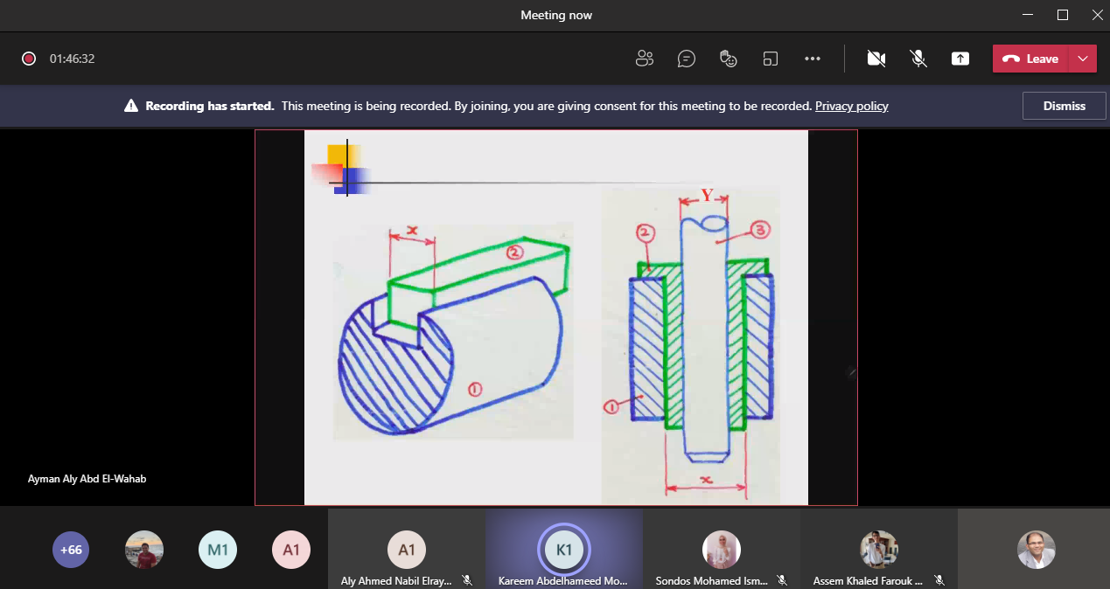

1. **Comments from external evaluator(s): Response of course team**

………**N/A** ………………. …………………………….

……….……………..……. …………………………….