Course Report of
Mechanical Engineering Drawing– MDP 111 – Spring 2021
University: Ain Shams Faculty: Engineering

A- Basic Information
- Title and code:
Mechanical Engineering Drawing– MDP 111

- Program(s) on which this course is given:
Sophomore - Mechanical Engineering

3. Year/ Level of Programs : | Sophomore Level

4. Units/Credit Hours:
i. Lecture: | 1 Hrs/week

ii. Tutorial/Practical: | 3 / 2 Hrs/week

iii. Total: | 6 Hrs/week

iv. Credit Hours: | 3 Credit Hours

5. Names of lecturers contributing to the delivery of the course:
i. | Dr. Ibrahim Omran
ii. | Dr. Fady Naiem
ii i | Dr. Mohamed Abdelwahab

6. Course Coordinator: | Dr. Fady Ibrahim

7. External Evaluator:

B- Statistical Information

No. of Students attending the course: | 77

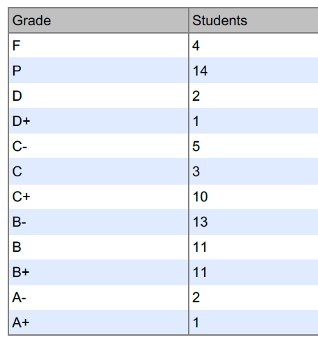
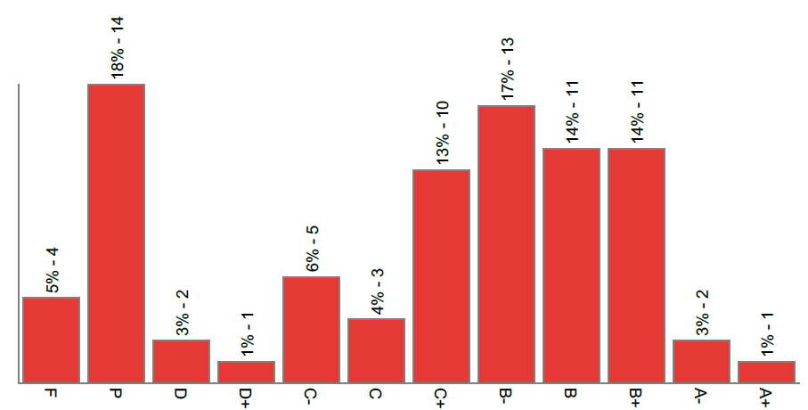 | 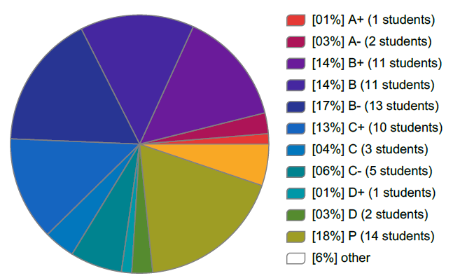

- Professional Information

1 – Course Teaching:
Topics actually taught | No. of Hrs | Lecturer
Introduction | 6 | Dr. Ibrahim Omran
Fasteners | 6 | Dr. Fady Naiem
Couplings | 6 | Dr. Ibrahim Omran
Transmission Shafts | 6 | Dr. Ibrahim Omran
Flexible Couplings | 6 | Dr. Ibrahim Omran
Pulleys Brackets | 6 | Dr. Ibrahim Omran
Introduction to Power Screws | 6 | Dr. Ibrahim Omran
Machine Vice and Pipe Vice | 6 | Dr. Ibrahim Omran
Screw Jacks | 6 | Dr. Fady Naiem
Safety Valve | 6 | Dr. Ibrahim Omran
Non-return valve | 6 | Dr. Ibrahim Omran
Stop Valve | 6 | Dr. Fady Naiem
Air cock valve | 6 | Dr. Fady Naiem
Total | 78

Experiments List :

Experiment Title | Hours
Introduction to Autodesk Inventor | 2
2D Sketches and 3D Features (1) | 2
2D Sketches and 3D Features (2) | 2
Sketched Secondary Features (1) | 2
Sketched Secondary Features (2) | 2
Assembly Principles | 2
Assembly Tools (1) | 2
Assembly Tools (2) | 2
Creating Working and Construction Drawings | 4
Creating Motion and Video | 2
Project Coordination (1) | 2
Project Coordination (2) | 2
Total Hours | 26

Topics taught as a percentage of the content specified:
>90 % | √ | 70-90 % |  | <70%

Spring 2021 semester was 13 weeks based on the decision of higher education council, some topics were merged together.

If any topics were taught which are not specified, give reasons in detail
N/A………………………………………

2- Teaching and learning methods:
On Campus Lectures: | √
laboratory: | √
Seminar/Workshop:
On Campus / Online Class Activity: | √

Case Study: N/A
Other assignments/homework:
If teaching and learning methods were used other than those specified, list and give reasons:

MS teams link :

https://teams.microsoft.com/dl/launcher/launcher.html?url=%2F_%23%2Fl%2Fchannel%2F19%3A8ac805e518e24c159b97bd901e360c6b%40thread.tacv2%2FGeneral%3FgroupId%3Df83ac020-fff2-4d9e-a144-a72d5e31d1df%26tenantId%3Dad2a8324-bef7-46a8-adb4-fe51b6613b24&type=channel&deeplinkId=8ee69fa9-32c2-48d0-8ae7-b8d3843dfcaa&directDl=true&msLaunch=true&enableMobilePage=true&suppressPrompt=true

3- Student assessment:
Method of assessment | Percentage of total
Written examination (On Campus) | 40 %
Mid-term exam (On Campus) | 25 %
Quizzes (On Campus) | 10%
Practical/laboratory work (On Campus) | 10%
Other assignments/class work (On Campus) | 15 %

Members of examination committee
- Dr. Ibrahim Omran
- Dr Fady Naiem
- Dr. Mohamed Abdelwahab
Role of external evaluator
………………………………………

4- Facilities and teaching materials:
Totally adequate | √
Adequate to some extent
Inadequate
List any inadequacies
……………………………………………

5- Administrative constraints
Many computers in the lab have technical problems and many input devices are malfunctioned also some computers have “unknown” passwords.
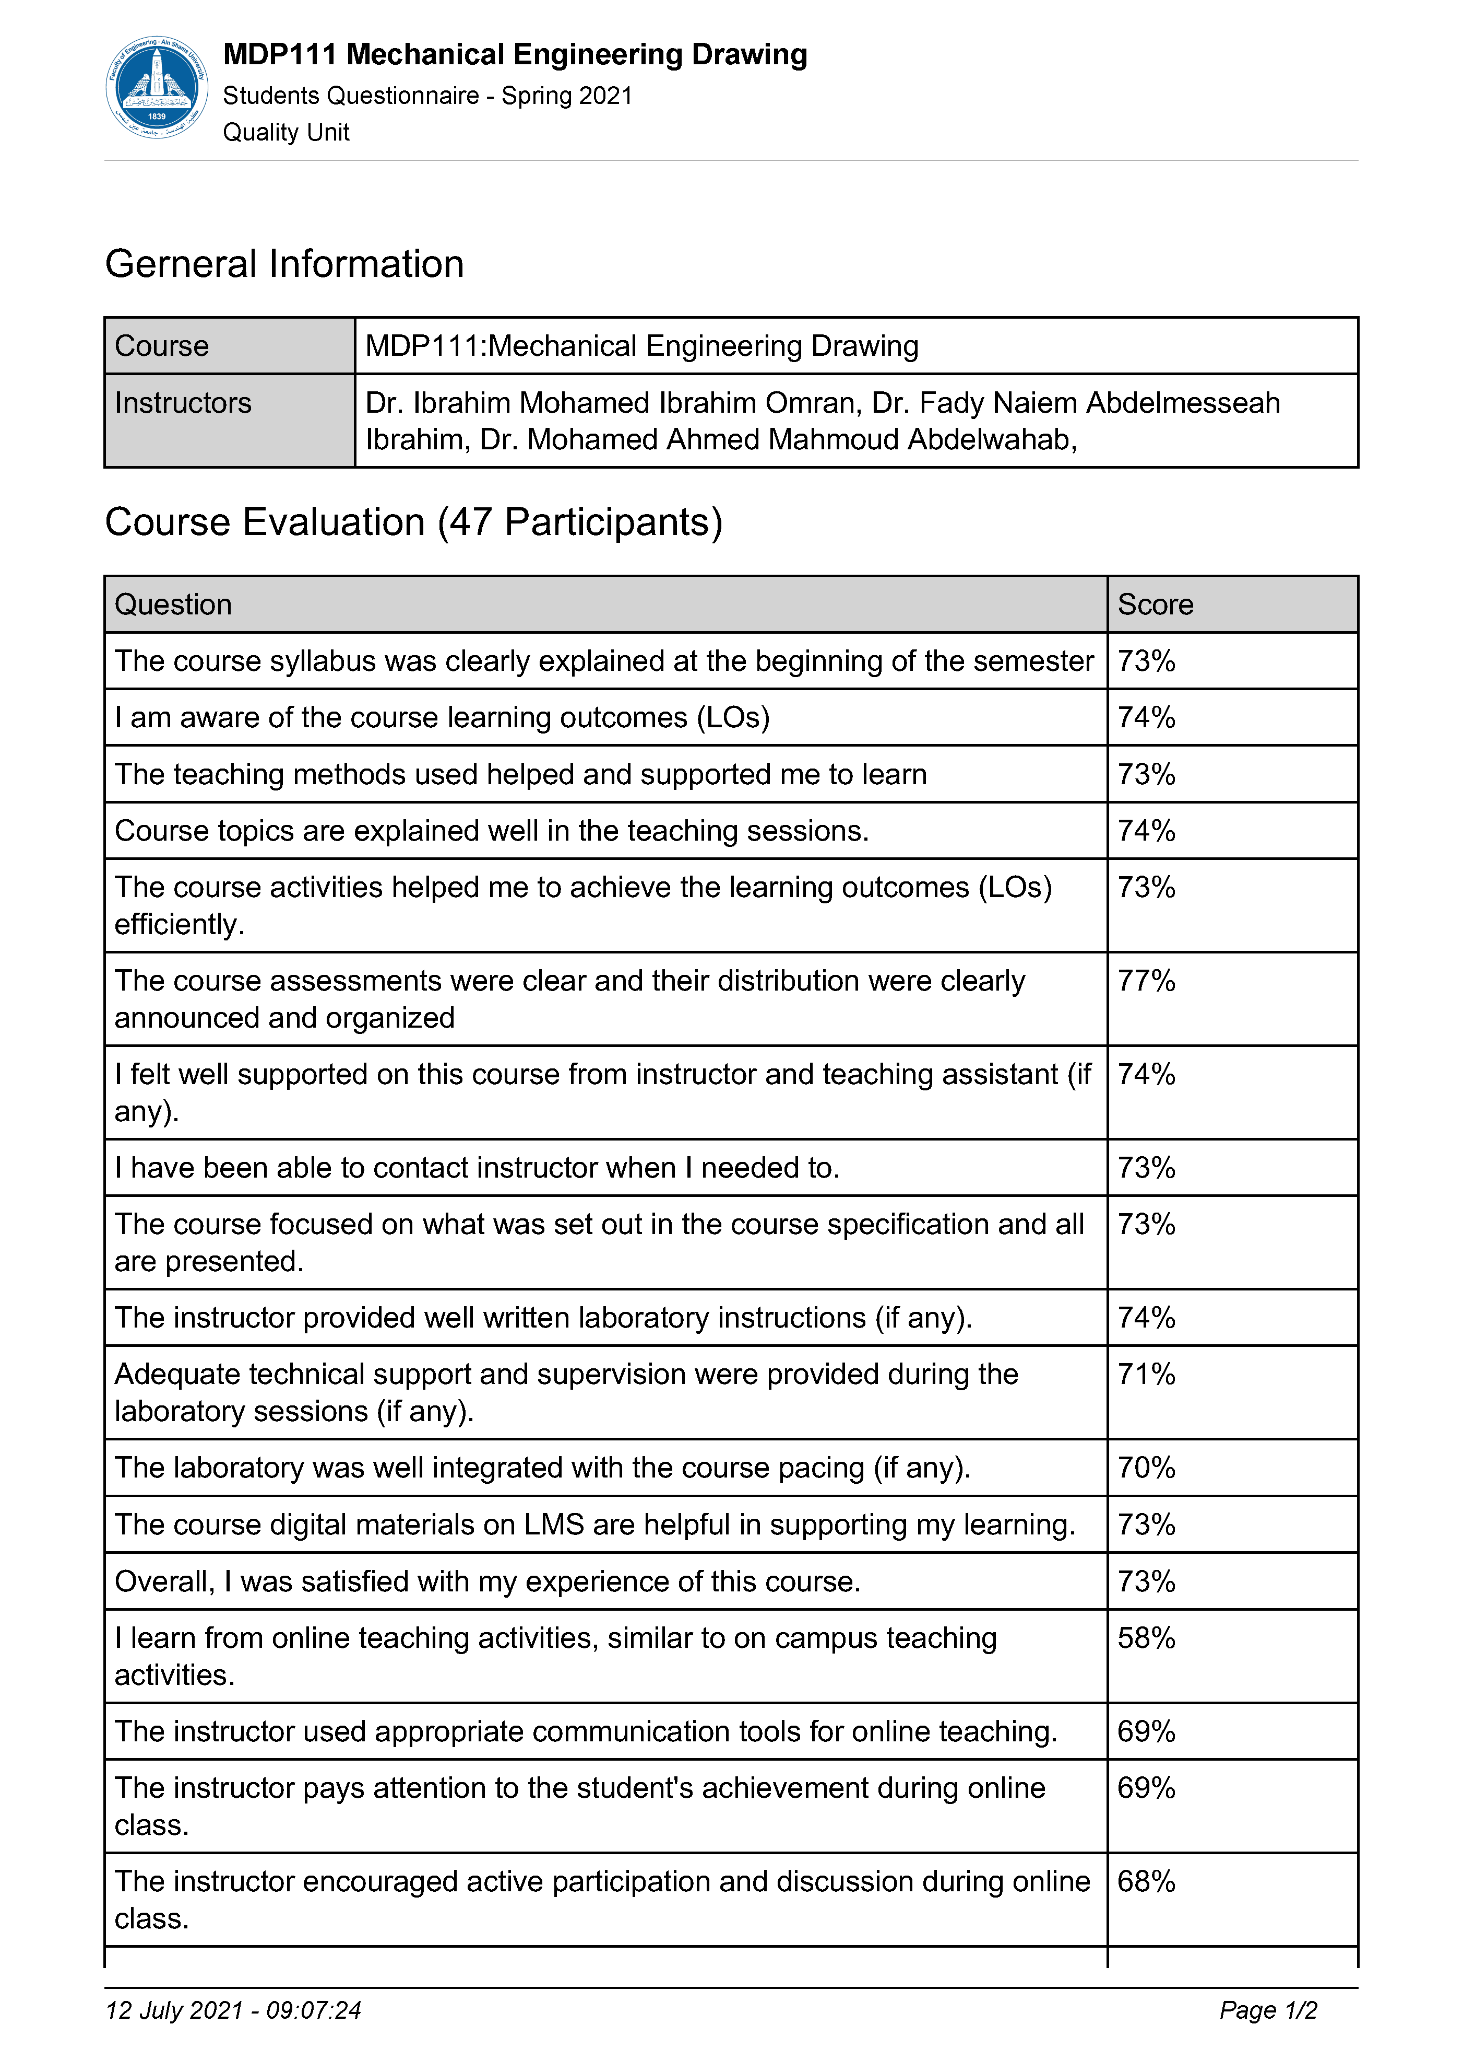
6- Student evaluation of the course: Response of Course Team

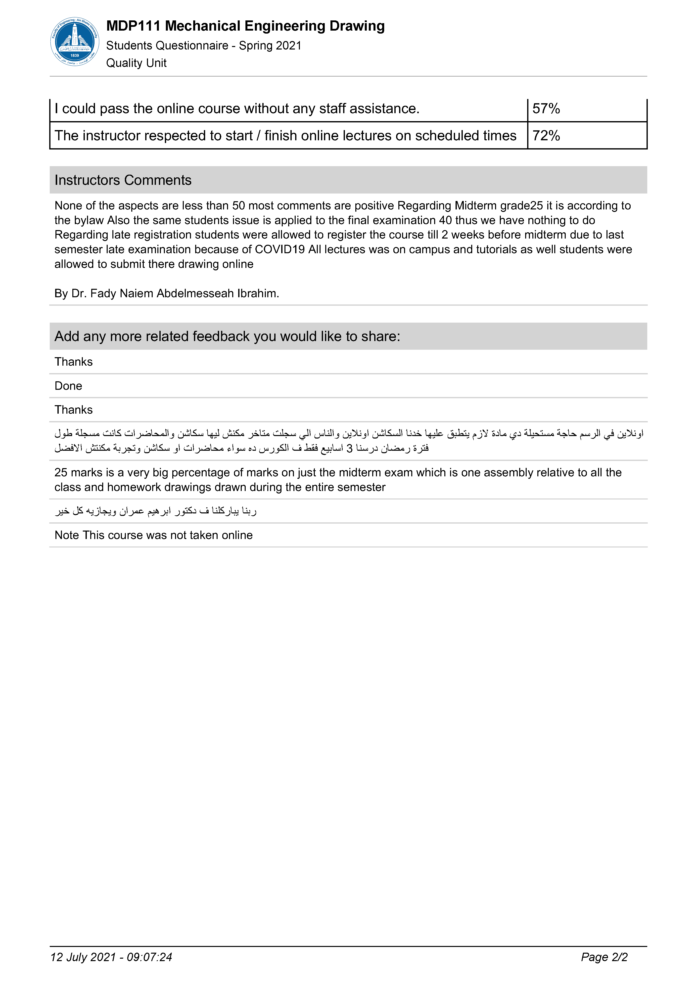

7- Comments from external evaluator(s): Response of course team
……………………………. …………………………….
……….……………..……. …………………………….
…………………………… …………………………….
……………………………. …………………………….
…………………………… …………………………….
8- Course enhancement:

……………………………. …………………………….
……………………………. …………………………….
……………………………. …………………………….
9- Action plan for academic year 2021 – 2022
Actions required Completion date Person responsible
……………………… ……………………… ………………………
……………………… ……………………… ………………………
……………………… ……………………… ………………………
……………………… ……………………… ………………………
Course coordinator: Dr. Fady Ibrahim
Signature: Fady Ibrahim

Date: July 13, 2021

