Course report of
Introduction to Marketing –HUMx21 – Fall 2020
University: Ain Shams | Faculty: Engineering

Basic Information
- Title and code:
Introduction to Management and Marketing – HUMx21
- Department Offering the Course:
Design and Production Engineering

- Year/Level of programs:
3rd year Design and Production Engineering Program (Level 3)
- Units/Credit Hours
( i ) Lecture : | 2

( ii ) Tutorial/Practical : | 1

( iii ) Total : | 3
- Names of lecturers contributing to delivery of the course :
Prof.Dr. Eng. Nahid Hussein Afia Abdel Halim
Dr. Mohamed El-Beheiry
Dr. Ismail Hafez

Course coordinator: | Prof.Dr. Eng. Nahid Hussein Afia Abdel Halim

External evaluator: | N/A

Statistical Information
Not Available Yet

Professional Information
No | Course Content | Lecture | Tutorials | Total | Lecturer
1 | Introduction to marketing | 2 | 2 | 4 | Prof.Dr. Nahid H. Afia
2 | Market segmentation positioning | 4 | 2 | 6 | Prof.Dr. Nahid H. Afia
3 | Marketing plan | 2 | 2 | 4 | Prof.Dr. Nahid H. Afia
4 | Marketing mix: product& pricing | 6 | 2 | 8 | Prof.Dr. Nahid H. Afia
5 | Marketing mix: place& promotion | 6 | 2 | 8 | Prof.Dr. Nahid H. Afia
6 | Introduction to Management | 3 | 1 | 4 | Dr. Mohamed Elbeheiry
7 | Managerial processes, levels, roles and skills. | 4 | 2 | 6 | Dr. Mohamed Elbeheiry
8 | The human Element in Management | 1 | 1 | 2 | Dr. Mohamed Elbeheiry
9 | Introduction to organization structures and responsibility, accountability and delegation | 2 | 1 | 3 | Dr. Mohamed Elbeheiry
 | Total Hours | 30 | 15 | 45

Course Teaching:
Topics taught as a percentage of the content specified:

>90 % x 70-90 % <70%

Reasons in detail for not teaching any topic

Teaching and learning methods:

Online Lectures: X
Practical training/ laboratory:
Seminar/Workshop:
Class Activity: (Tutorials) X

Teams Link: https://teams.microsoft.com/l/team/19%3acc7b96b4ab284727be6d8ab70ede1470%40thread.tacv2/conversations?groupId=e743f324-f7be-4f71-86c8-275f1361119a&tenantId=ad2a8324-bef7-46a8-adb4-fe51b6613b24

Microsoft Team Samples:
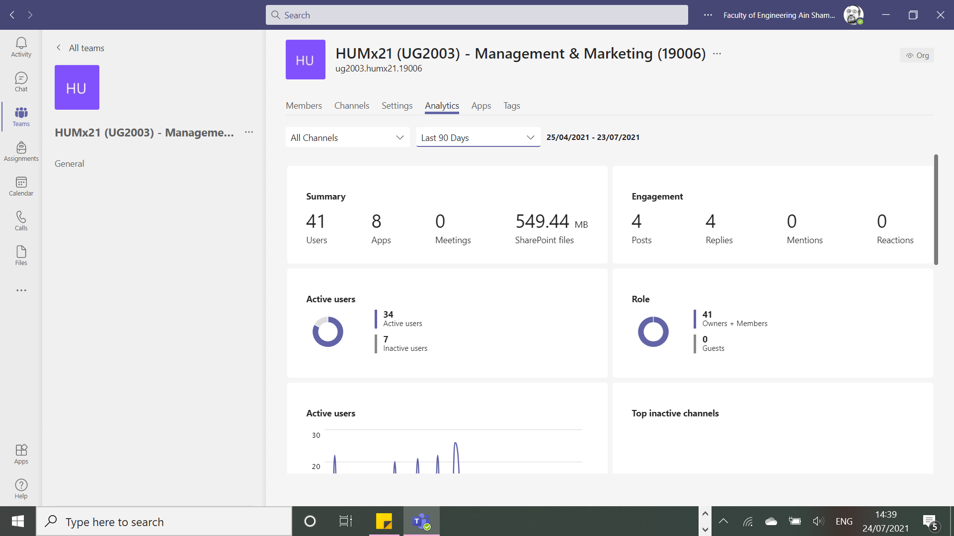
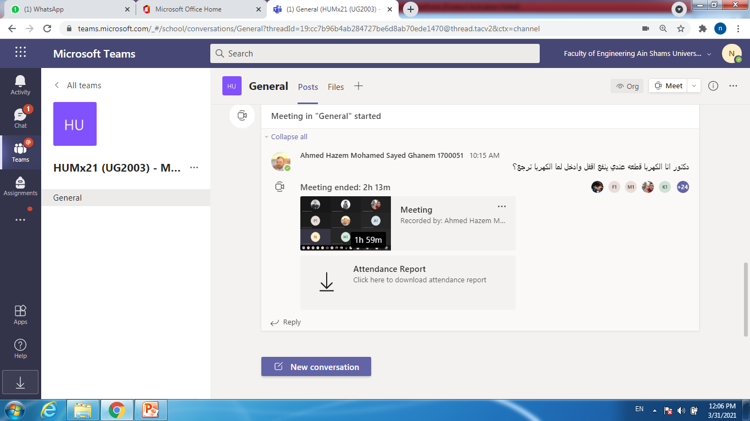
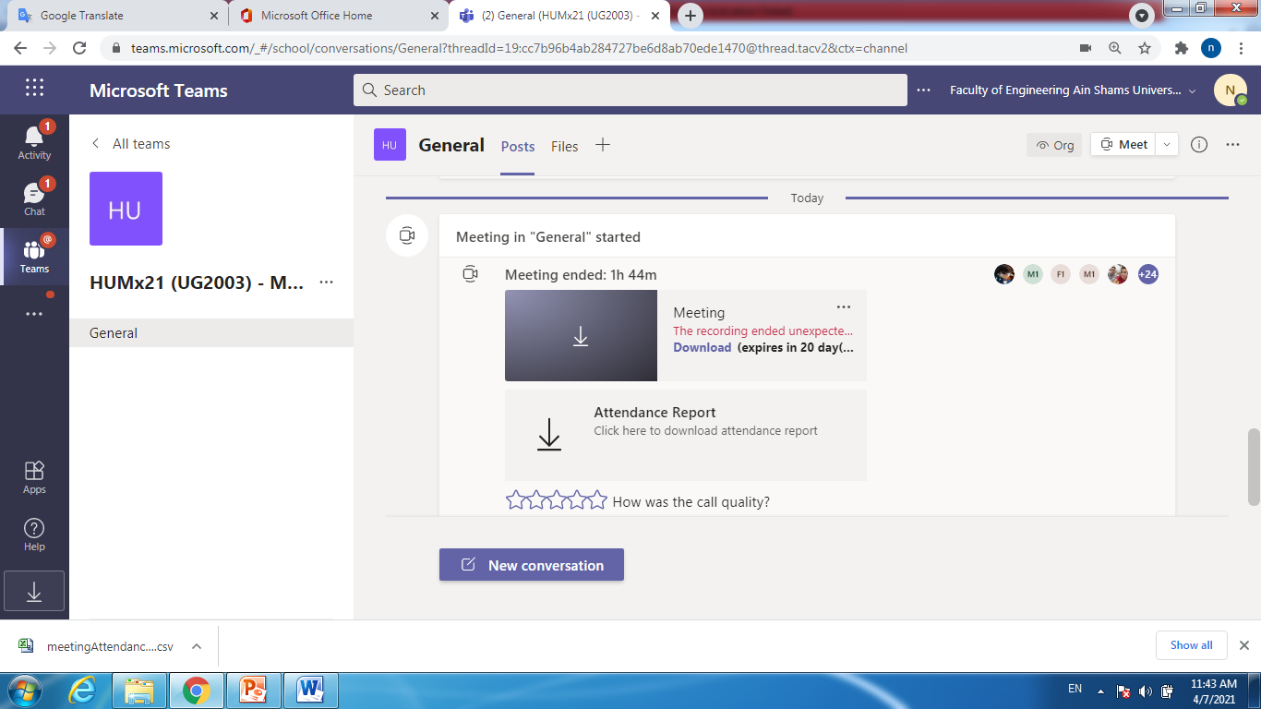
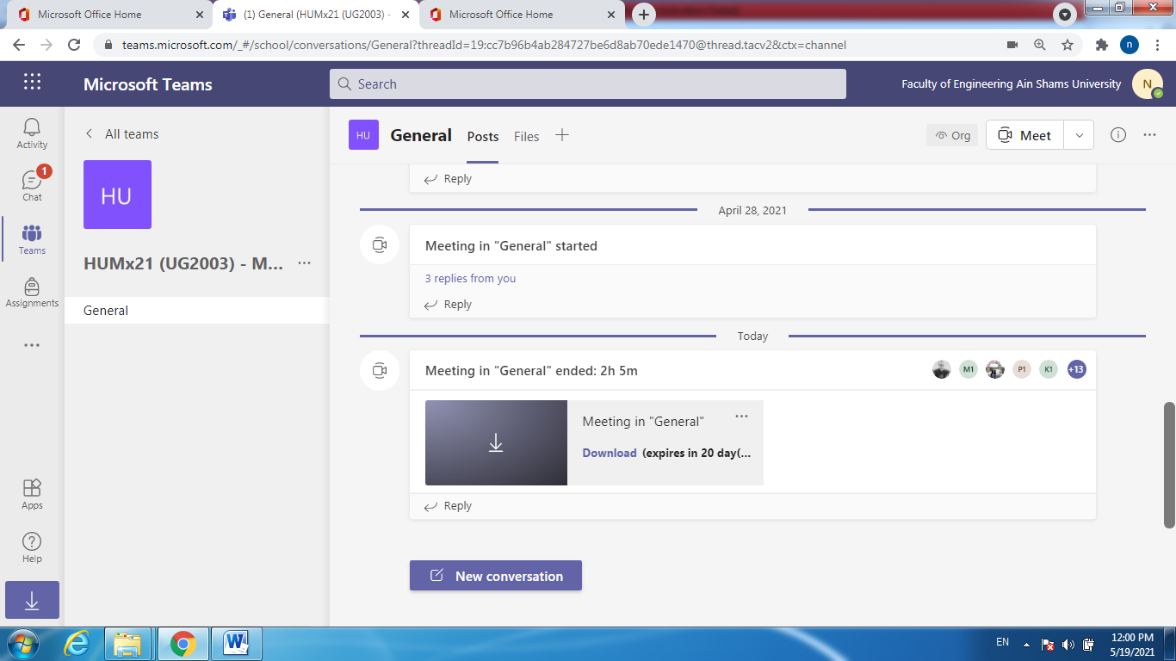
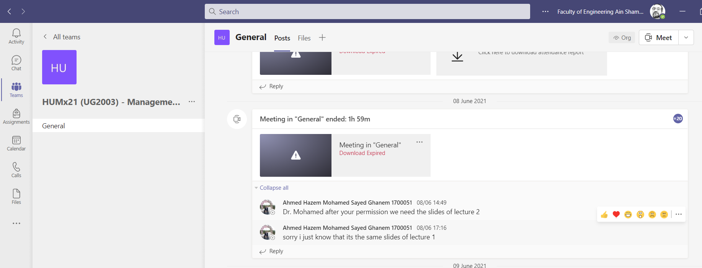
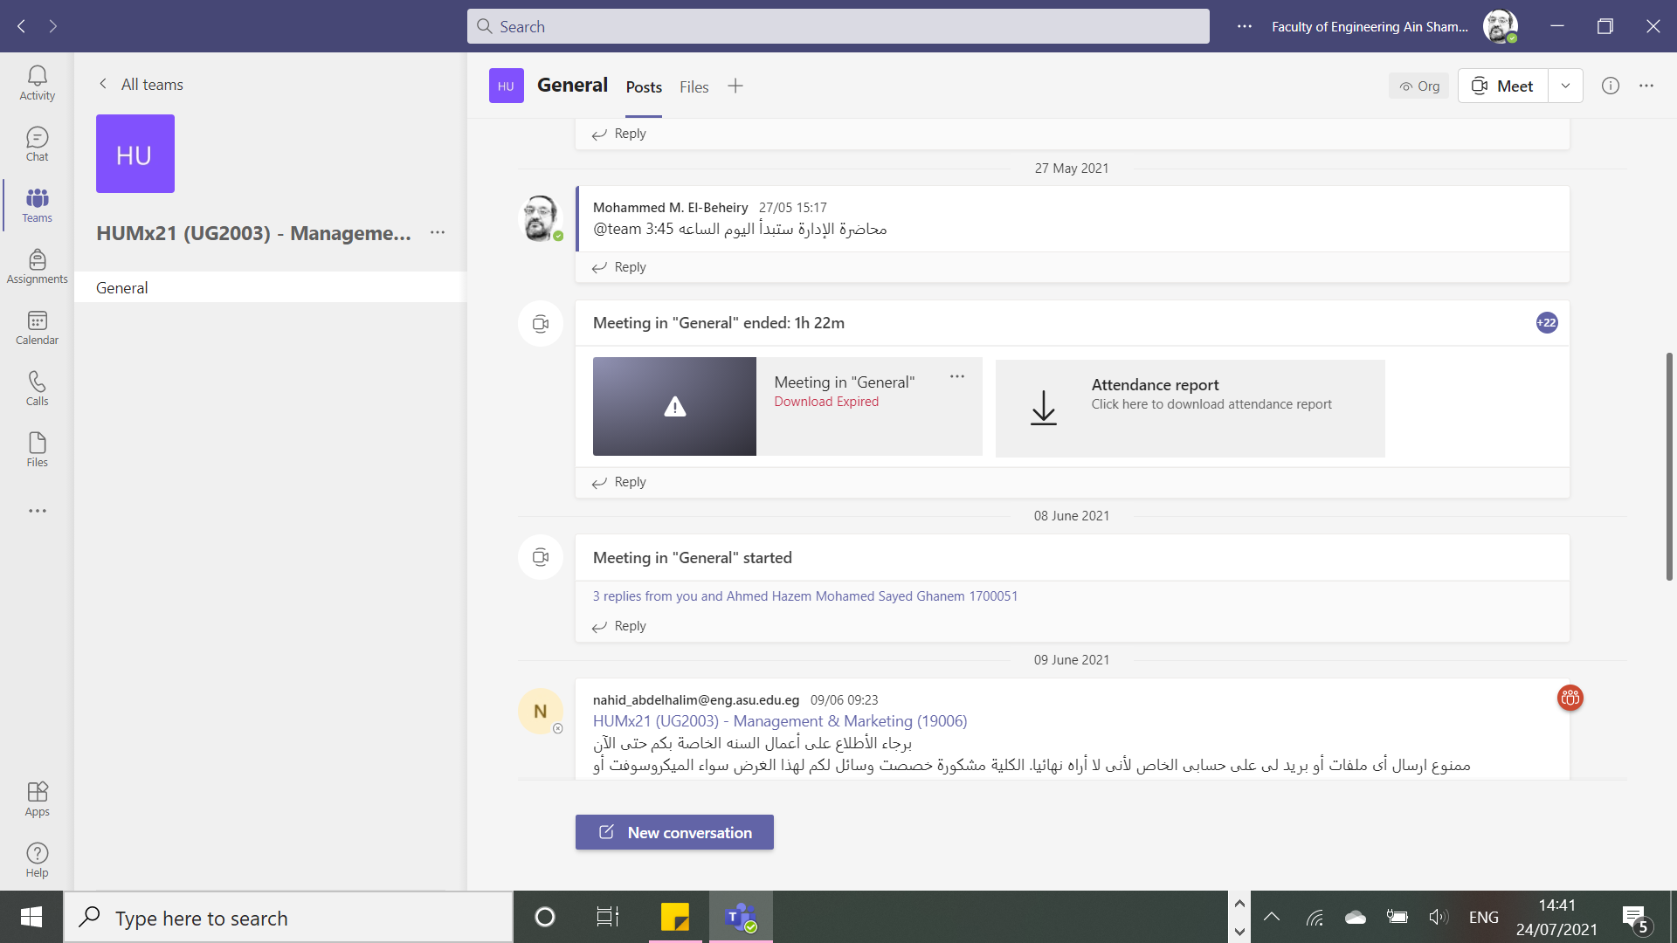

Student assessment:

Method of assessment | Percentage of total
Written examination | 95%
Oral examination | 0 %
Practical/laboratory work | 0 %
Other assignments/class work | 5 %

Only one Quiz is performed as the TA got COVID-19 and the semester is reduced by one week, this quiz is replaced by the assignments.

Members of examination committee
Prof.Dr.Eng. Nahid Hussein Afia Abdel Halim
Dr.Eng. Mohammed El Beheiry

Role of external evaluator
N/A

Facilities and teaching materials:
Totally adequate

Adequate to some extent X

Inadequate

List any inadequacies: NA

Administrative constraints:
List any difficulties encountered
NA

Student evaluation of the course:

All evaluation items are above 60% except the lab item 58% and the course has no lab work.

Response of Course Team

List any criticisms
Comments from external evaluator(s): Response of course team
………N/A ………………. …………………………….
……….……………..……. …………………………….

7. Action Plan
No action as this is the last time this course will be taught due to changes in the bylaws.

