# Course Report of

# Fluid Mechanics and Turbomachinery – MEP 211– Spring 2021

**University:** Ain Shams **Faculty:** Engineering

# Basic Information

## Title and code:

Fluid Mechanics and Turbomachinery – MEP 221

## Program on which the course is given:

Mechatronics Engineering Program

* 1. **Year / Level of program(s)**2020-2021 / Mechatronics Engineering Program Students – Level 1

## Units / Credit Hours:

|  |  |  |
| --- | --- | --- |
| i. | Lecture: | 3 |
| ii. Tutorial / Practical: 2/1 | | |
| iii. Total: 4 CH | | |

1. **Names of lecturers contributing to the delivery of the course:**

Dr. Walid Aboelsoud

**Course coordinator:** Dr. Yasser ELfangary

**External evaluator:** -------------

1

# Statistical Information

No of students attending the course: 245

|  |  |  |  |
| --- | --- | --- | --- |
|  |  | **Number** | **Percentage (%)** |
| **Students completing the course** | |  |  |
| **Results** | Passed | 213 | 87 |
| Failed | 33 | 13 |

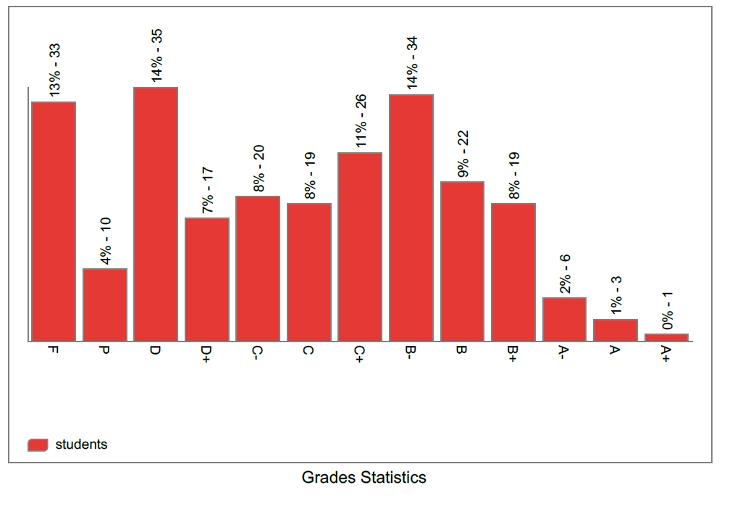









# Professional Information

## 1- Course Teaching:

|  |  |  |  |  |
| --- | --- | --- | --- | --- |
| **Week** | **Course Content** | **Lecture**  **Hours** | **Tutorial**  **Hours** | **Lab Hours** |
| 1 | Properties of Fluids | **3** | **2** | **1** |
| 2 | Fluid Statics: Forces on Submerged Bodies | **3** | **2** | **1** |
| 3 | Reynolds Transport Theorem: Conservation of Mass | **3** | **2** | **1** |
| 4 | Reynolds Transport Theorem: Conservation of Momentum | **3** | **2** | **1** |
| 5 | Reynolds Transport Theorem: Conservation of Energy | **3** | **2** | **1** |
| 6 | Similitude and Dimensional Analysis | **3** | **2** | **1** |
| 7 | Viscous Flow in Ducts: Bernoulli Equation | **3** | **2** | **1** |
| 8 | Viscous Flow in Ducts: Major and Minor Losses | **3** | **2** | **1** |
| 9 | Classification of Turbomachines, Operation of Pumps, Series and Parallel Operation, Selection of Pumps | **3** | **2** | **1** |
| 10 | Compressible Flow: Thermodynamics | **3** | **2** | **1** |
| 11 | Compressible Flow: Convergent Nozzle | **3** | **2** | **1** |
| 12 | Compressible Flow: Convergent Divergent Nozzle – Shock Wave | **3** | **2** | **1** |
| 13 | Flow over Immersed Bodies: Lift and Drag | **3** | **2** | **1** |
| 14 | Flow over Immersed Bodies: Boundary Layer Theory | **3** | **2** | **1** |
| 15 | Naiver-Stokes Equation | **3** | **2** | **1** |
| Total Number of Hours | | **45** | **30** | **15** |

# List of Experiments

|  |  |
| --- | --- |
| **Week** | **Course Content** |
| 1 | Introduction to lab experiments |
| 2 | Determination of water density at room temperature |
| 3 | Determination of water surface tension at room temperature |
| 4 | Determination of hydrostatic pressure forces on a submerged plane surface |
| 5 | Determination of hydrostatic pressure forces on a partially submerged plane surface |
| 6 | Determination of the coefficient of discharge of a venturi-meter |
| 7 | Measurement of actual pressure distribution along a venturi-meter |
| 8 | Calculation pressure distribution along a venturi-meter |
| 9 | Impact of a water jet on a perpendicular flat surface |
| 10 | Laminar flow in a pipe |
| 11 | Friction losses in pipe |
| 12 | Measurements of losses in pipe fittings (bends, elbows) |
| 13 | Pump characteristics: Head versus discharge of a pump demonstration |
| 14 | Unsteady flow demonstration |
| 15 | Revision on all experiments |

**Topics taught as percentage of the content specified:**

**ʘ > 90%**  **70% - 90%**

 **< 70%**

**Reasons in details for not teaching any topic:**

**If any topics were taught which are not specified, give reasons in details:**

## None

* 1. **Teaching and learning methods:**

Lectures



Practical training/laboratory

Seminar / workshop

Class activity 

# Case study:

Other assignments / homework

If teaching and learning methods were used other than those specified, list and give reasons:

**Due to the pandemic of COVID 19, online teaching was mandatory. Communication with students was accomplished using the LMS. Recorded lectures and tutorials were uploaded to the LMS as well as the final assessment project. The ILOs of the course were covered in the project as illustrated in final examination of the course file. The ILOs of the lab were performed in the project too.**

# Student assessment:

|  |  |
| --- | --- |
| **Method of assessment** | **Percentage of total** |
| Assignments | 25% |
| Lab | 10% |
| Quizzes | 0 % |
| Midterm exam | 25 % |
| Final assessment project | 40% |
| Total | 100% |

**Members of examination committee:**

Dr. Yasser Elfangary

Dr. Walid Aboelsoud

# Role of the external evaluator

To express his views on the course - - - - - - - - - - - NONE- - - - - - - - - - - -

- - - - - - - - - - - - - - - - - - - - - - - - - - - - - - - - - - - - - - - - - - - - - - - - - - - - - - - - - - - - - - - -

# Facilities and teaching materials:

Totally adequate

Adequate to some extent 

Inadequate

## List any inadequacies

* 1. **Administrative constraints**

**List any difficulties encountered**

None - - - - - - - - - - - - - - - - - - - - - - - - - - - - - - - - - - - - - - - - - - - - - - - - - -

- - - - - - - - - - - - - - - - - - - - - - - - - - - - - - - - - - - - - - - - - - - - - - - - - - - - - -

# Student evaluation of the course:

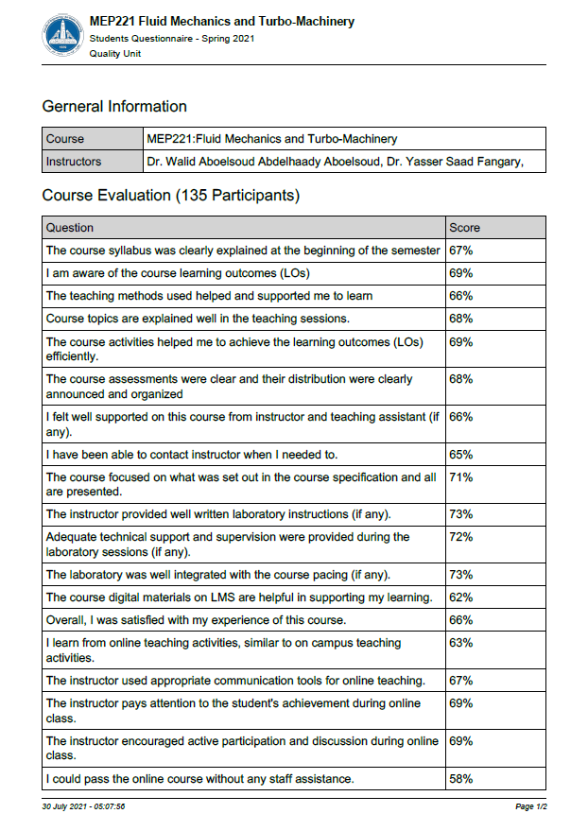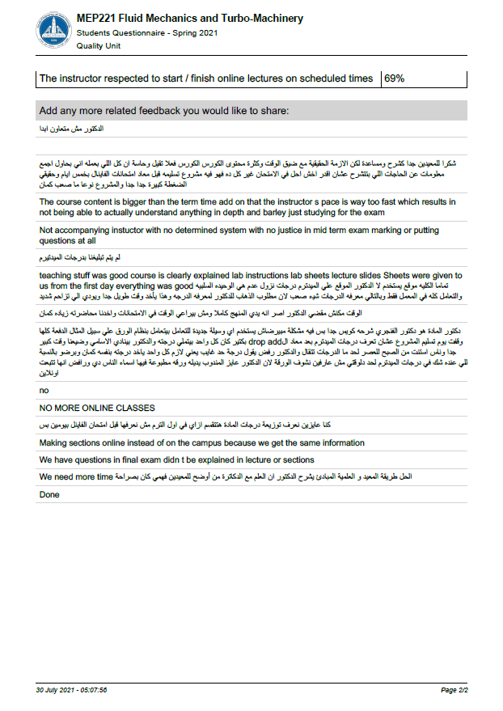

# Comments from external evaluator(s)

|  |  |
| --- | --- |
| **Comments** | **Response of Course team** |
| - - - - - - - - - - - - - - - - - - - - - - - - - - - | - - - - - - - - - - - - - - - - - - - - - - - - - - - |
| - - - - - - - - - - - - - - - - - - - - - - - - - - - | - - - - - - - - - - - - - - - - - - - - - - - - - - - |
| - - - - - - - - - - - - - - - - - - - - - - - - - - - | - - - - - - - - - - - - - - - - - - - - - - - - - - - |
| - - - - - - - - - - - - - - - - - - - - - - - - - - - | - - - - - - - - - - - - - - - - - - - - - - - - - - - |
| - - - - - - - - - - - - - - - - - - - - - - - - - - - | - - - - - - - - - - - - - - - - - - - - - - - - - - - |
| - - - - - - - - - - - - - - - - - - - - - - - - - - - | - - - - - - - - - - - - - - - - - - - - - - - - - - - |
| - - - - - - - - - - - - - - - - - - - - - - - - - - - | - - - - - - - - - - - - - - - - - - - - - - - - - - - |
| - - - - - - - - - - - - - - - - - - - - - - - - - - - | - - - - - - - - - - - - - - - - - - - - - - - - - - - |

# Course enhancement:

**Progress on actions identified in the previous year's action plane:**

|  |  |
| --- | --- |
| **Action** | **State whether or not completed and give reasons for any non-completion** |
| N/A - - - - - - - - - - - - - - - - - - - - - -  - **- - - - - - - - - - - - - - - - - - - - - - - - -**  **- - - - - - - - - - - - - - - - - - - - - - - - - -** | - - - - - - - - - - - - - - - - - - - - - - - **- - - -**  **- - - - - - - - - - - - - - - - - - - - - - - - - - -**  **- - - - - - - - - - - - - - - - - - - - - - - - - - -** |

* 1. **Action plan for academic year 2016-2017**

|  |  |  |
| --- | --- | --- |
| **Actions required** | **Completion date** | **Person responsible** |
| - - - - - - - - - - - - - - - - - - **- -**  **- - - - - - - - - - - - - - - - -** | - - - - - - - - - - - - - - - - - -  - - - - - - - - - - - - - - - - - - - -  - - - - - - - - - - - - - - - - - - | - - - - - - - - - - - - - - - - - -  - - - - - - - - - - - - - - - - - - - -  - - - - - - - - - - - - - - - - - |

**Course Content/ILO Matrix**

|  |  |  |  |  |
| --- | --- | --- | --- | --- |
| Wk | Course Content | 1 | 2 | 3 |
| 1 | Properties of Fluids |  |  | • |
| 2 | Fluid Statics: Forces on Submerged Bodies | • |  | • |
| 3 | Reynold Transport Theorem: Conservation of Mass | • |  | • |
| 4 | Reynold Transport Theorem: Conservation of Momentum | • |  | • |
| 5 | Reynold Transport Theorem: Conservation of Energy | • |  | • |
| 6 | Similitude and Dimensional Analysis | • |  |  |
| 7 | Viscous Flow in Ducts: Bernoulli Equation |  |  | • |
| 8 | Viscous Flow in Ducts: Major and Minor Losses |  | • | • |
| 9 | Classification of Turbomachines, Operation of Pumps, Series and Parallel Operation, Selection of Pumps |  | • |  |
| 10 | Compressible Flow: Thermodynamics | • |  |  |
| 11 | Compressible Flow: Convergent Nozzle |  | • |  |
| 12 | Compressible Flow: Convergent Divergent Nozzle – Shock Wave |  | • |  |
| 13 | Flow over Immersed Bodies: Lift and Drag | • |  |  |
| 14 | Flow over Immersed Bodies: Boundary Layer Theory |  |  | • |
| 15 | Naiver-Stokes Equation |  |  | • |