# Course Report of

# Thermodynamics – MEP 211– Fall 2020

**University:** Ain Shams **Faculty:** Engineering

# Basic Information

## Title and code:

Thermodynamics– MEP 211

## Program on which the course is given:

Mechanical Power Engineering

* 1. **Year / Level of program(s)** 2019-2020 / Mechanical Engineering Students – Level 1

## Units / Credit Hours:

|  |  |  |
| --- | --- | --- |
| i. | Lecture (online through Microsoft Teams): | 3 |
| ii. Tutorial / Practical: 2/1 | | |
| iii. Total: 4 CH | | |

Link to the meeting:

<https://teams.microsoft.com/l/channel/19%3a9754fea023974ca19ced8453a5f7c217%40thread.tacv2/Lecture?groupId=fef520f0-da65-4830-8bd8-1daec2e9f563&tenantId=ad2a8324-bef7-46a8-adb4-fe51b6613b24>

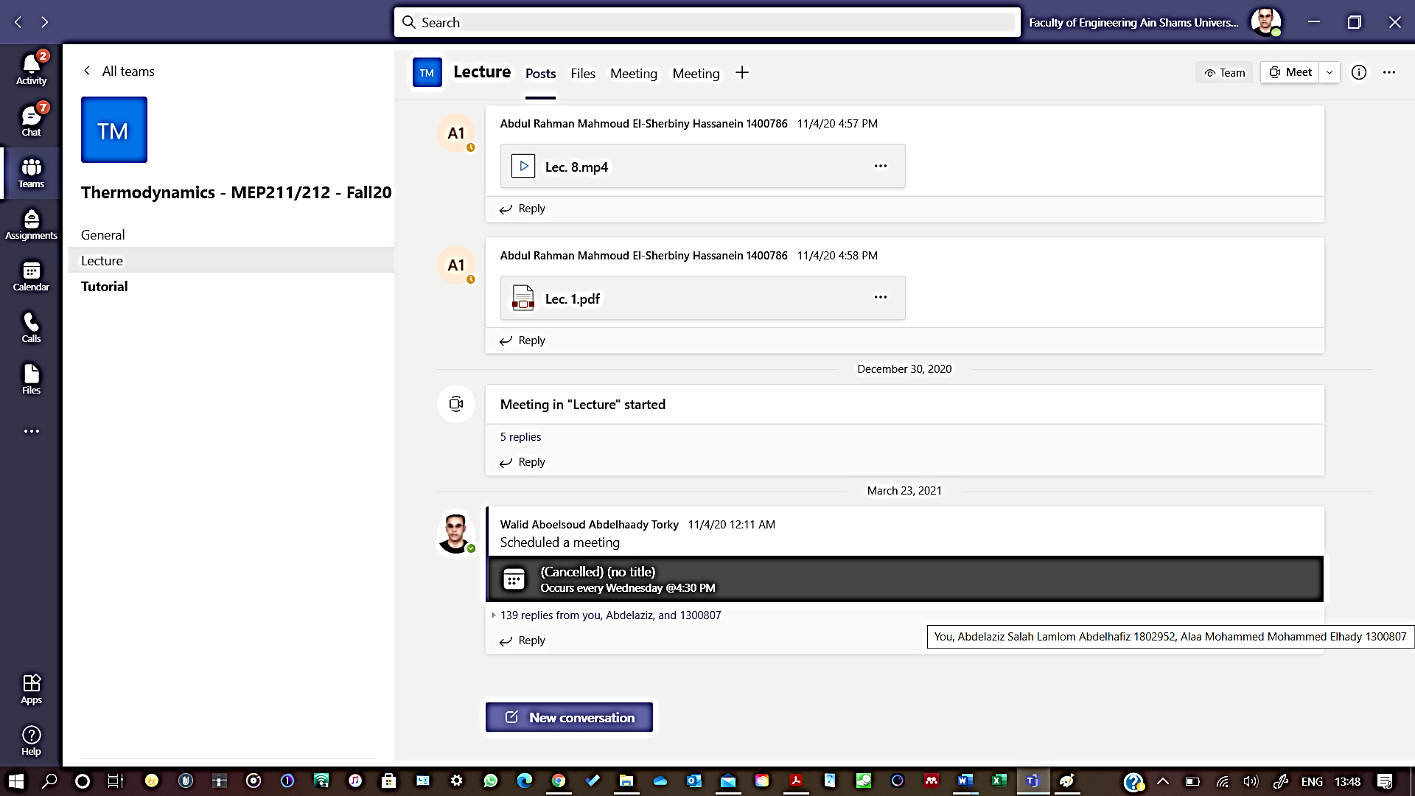

1. **Names of lecturers contributing to the delivery of the course:**

Dr. Walid Aboelsoud

Dr. Nashwa Abbas

**Course coordinator:** Dr. Walid Aboelsoud

**External evaluator:** -------------

# Statistical Information

No of students attending the course: 51

|  |  |  |  |
| --- | --- | --- | --- |
|  |  | **Number** | **Percentage (%)** |
| **Students completing the course** | |  |  |
| **Results** | Passed | 35 | 69 |
| Failed | 16 | 31 |

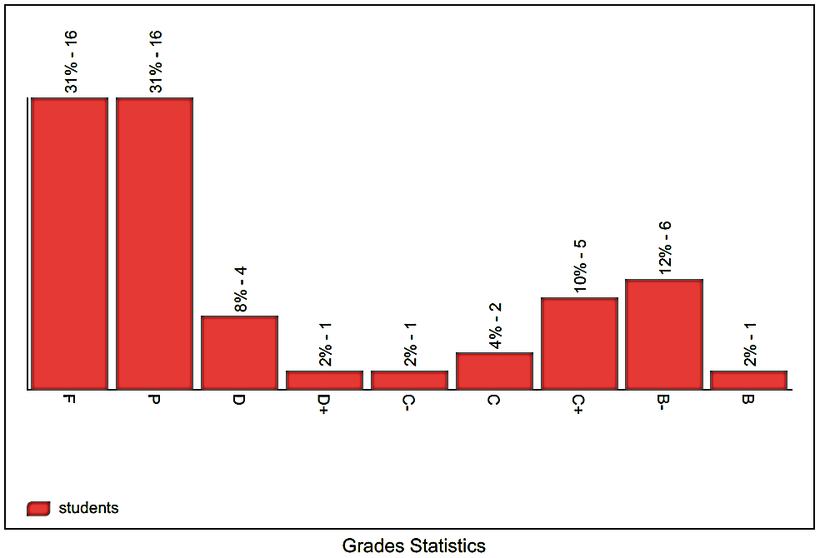

# Professional Information

## 1- Course Teaching:

|  |  |  |  |  |
| --- | --- | --- | --- | --- |
| **Week** | **Course Content** | **Lecture**  **Hours** | **Tutorial**  **Hours** | **Lab Hours** |
| 1 | Review of the first law of thermodynamics | **3** | **2** | **-** |
| 2 | Heat engines, heat pumps, and refrigerators | **3** | **2** | **-** |
| 3 | Thermal efficiency and coefficient of performance (COP) | **3** | **2** | **-** |
| 4 | Carnot cycle | **3** | **2** | **-** |
| 5 | The Second law of thermodynamics | **3** | **2** | **-** |
| 6 | Entropy | **3** | **2** | **-** |
| 7 | Clausius inequality | **3** | **2** | **-** |
| 8 | Entropy generation principle | **3** | **2** | **-** |
| 9 | Exergy | **3** | **2** | **-** |
| 10 | Exergy destruction principle and the second law efficiency | **3** | **2** | **-** |
| 11 | Brayton cycle | **3** | **2** | **3** |
| 12 | Rankine cycle | **3** | **2** | **3** |
| 13 | Otto cycle | **3** | **2** | **3** |
| 14 | Diesel cycle | **3** | **2** | **3** |
| 15 | Refrigeration cycle | **3** | **2** | **3** |
| Total Number of Hours | | **45** | **30** | **15** |

**Topics taught as percentage of the content specified:**

**ʘ > 90%**  **70% - 90%**

 **< 70%**

**Reasons in details for not teaching any topic:**

**If any topics were taught which are not specified, give reasons in details:**

## None

* 1. **Teaching and learning methods:**

Lectures



Practical training/laboratory

Seminar / workshop

Class activity 

# Case study:

Other assignments / homework

If teaching and learning methods were used other than those specified, list and give reasons:

**Due to the pandemic of COVID 19, online teaching was mandatory. Communication with students was accomplished using the LMS. Recorded lectures and tutorials were uploaded to the LMS as well as the final assessment project. The ILOs of the course were covered in the project as illustrated in final examination of the course file. The ILOs of the lab were performed in the project too. I have got an acceptance from the vice dean of students’ affairs to replace the lab by a project at the beginning of this semester.**

# Student assessment:

|  |  |
| --- | --- |
| **Method of assessment** | **Percentage of total** |
| Assignments | 0% |
| Lab | 0% |
| Quizzes | 0 % |
| Midterm exam | 0 % |
| Final assessment project | 100% |
| Total | 100% |

**Members of examination committee:**

Dr. Walid Aboelsoud

Dr. Nashwa Abbas

# Role of the external evaluator

To express his views on the course - - - - - - - - - - - NONE- - - - - - - - - - - -

- - - - - - - - - - - - - - - - - - - - - - - - - - - - - - - - - - - - - - - - - - - - - - - - - - - - - - - - - - - - - - - -

# Facilities and teaching materials:

Totally adequate

Adequate to some extent 

Inadequate

## List any inadequacies

* 1. **Administrative constraints**

**List any difficulties encountered**

None - - - - - - - - - - - - - - - - - - - - - - - - - - - - - - - - - - - - - - - - - - - - - - - - - -

- - - - - - - - - - - - - - - - - - - - - - - - - - - - - - - - - - - - - - - - - - - - - - - - - - - - - -

# Student evaluation of the course:

# Comments from external evaluator(s)

|  |  |
| --- | --- |
| **Comments** | **Response of Course team** |
| - - - - - - - - - - - - - - - - - - - - - - - - - - - | - - - - - - - - - - - - - - - - - - - - - - - - - - - |
| - - - - - - - - - - - - - - - - - - - - - - - - - - - | - - - - - - - - - - - - - - - - - - - - - - - - - - - |
| - - - - - - - - - - - - - - - - - - - - - - - - - - - | - - - - - - - - - - - - - - - - - - - - - - - - - - - |
| - - - - - - - - - - - - - - - - - - - - - - - - - - - | - - - - - - - - - - - - - - - - - - - - - - - - - - - |
| - - - - - - - - - - - - - - - - - - - - - - - - - - - | - - - - - - - - - - - - - - - - - - - - - - - - - - - |
| - - - - - - - - - - - - - - - - - - - - - - - - - - - | - - - - - - - - - - - - - - - - - - - - - - - - - - - |
| - - - - - - - - - - - - - - - - - - - - - - - - - - - | - - - - - - - - - - - - - - - - - - - - - - - - - - - |
| - - - - - - - - - - - - - - - - - - - - - - - - - - - | - - - - - - - - - - - - - - - - - - - - - - - - - - - |

# Course enhancement:

**Progress on actions identified in the previous year's action plane:**

|  |  |
| --- | --- |
| **Action** | **State whether or not completed and give reasons for any non-completion** |
| N/A - - - - - - - - - - - - - - - - - - - - - -  - **- - - - - - - - - - - - - - - - - - - - - - - - -**  **- - - - - - - - - - - - - - - - - - - - - - - - - -** | - - - - - - - - - - - - - - - - - - - - - - - **- - - -**  **- - - - - - - - - - - - - - - - - - - - - - - - - - -**  **- - - - - - - - - - - - - - - - - - - - - - - - - - -** |

* 1. **Action plan for academic year 2016-2017**

|  |  |  |
| --- | --- | --- |
| **Actions required** | **Completion date** | **Person responsible** |
| - - - - - - - - - - - - - - - - - - **- -**  **- - - - - - - - - - - - - - - - -** | - - - - - - - - - - - - - - - - - -  - - - - - - - - - - - - - - - - - - - -  - - - - - - - - - - - - - - - - - - | - - - - - - - - - - - - - - - - - -  - - - - - - - - - - - - - - - - - - - -  - - - - - - - - - - - - - - - - - |

**Course Content/ILO Matrix**

|  |  |  |  |  |  |  |  |  |  |  |  |  |  |
| --- | --- | --- | --- | --- | --- | --- | --- | --- | --- | --- | --- | --- | --- |
| Wk | Course Content | a1 | a2 | a3 | a4 | b1 | b2 | b3 | c1 | c2 | d1 | d2 | d3 |
| 1 | Review of the first law of thermodynamics |  |  |  | • |  |  |  |  |  | • |  |  |
| 2 | Heat engines, heat pumps, and refrigerators |  |  |  | • |  |  |  |  |  | • |  |  |
| 3 | Thermal efficiency and coefficient of performance (COP) |  |  |  | • |  |  |  |  |  | • |  |  |
| 4 | Carnot cycle |  |  |  | • |  |  |  |  |  | • |  |  |
| 5 | The Second law of thermodynamics |  |  |  | • |  |  |  |  |  | • |  |  |
| 6 | Entropy | • |  |  |  |  |  |  |  |  | • |  | • |
| 7 | Clausius inequality | • | • |  |  | • | • |  |  |  | • |  | • |
| 8 | Entropy generation principle | • | • |  |  | • | • | • |  |  | • |  | • |
| 9 | Exergy | • | • |  |  |  |  |  |  |  | • |  | • |
| 10 | Exergy destruction principle and the second law efficiency | • | • |  |  | • |  | • | • |  | • |  | • |
| 11 | Brayton cycle |  |  | • | • | • | • | • | • | • | • | • | • |
| 12 | Rankine cycle |  |  | • | • | • | • | • | • | • | • | • | • |
| 13 | Otto cycle |  |  | • | • | • | • | • | • | • | • | • | • |
| 14 | Diesel cycle |  |  | • | • | • | • | • | • | • | • | • | • |
| 15 | Refrigeration cycle |  |  | • | • | • | • | • | • | • | • | • | • |