|  |  |
| --- | --- |
| *Course report of* | |
| |  | | --- | | **Machine Design – MDP 361 – 2020-2021** | | |
| University: Ain Shams | Faculty: Engineering |

## Basic Information

1. Title and code:

|  |
| --- |
| **Machine Design - MDP361** |

1. Programme on which the course is given:

|  |  |
| --- | --- |
| |  | | --- | | B. Sc. Mechanical Engineering (Production Engineering) | |

1. Year/Level of programmes:

|  |
| --- |
| 4th year, First/Second semesters |

1. Units/Credit Hours

|  |  |
| --- | --- |
| ( i ) Lecture: | 2 |

|  |  |
| --- | --- |
| ( ii ) Tutorial/Practical: | 2/0 |

|  |  |
| --- | --- |
| ( iii ) Total: | 4 |

1. Names of lecturers contributing to delivery of the course:

|  |  |
| --- | --- |
| i - | Prof. Samy J. Ebeid |

|  |  |
| --- | --- |
| ii - | Dr. Moustafa M. Sayed |

|  |  |
| --- | --- |
| Course coordinator: | Prof. Samy J. Ebeid |

|  |  |
| --- | --- |
| External evaluator: | --- --- --- |

## Statistical Information

|  |  |
| --- | --- |
| No. of students attending the course: | 37 |

|  |  |  |  |  |  |  |  |
| --- | --- | --- | --- | --- | --- | --- | --- |
|  | Excellent | Very Good | Good | Pass | Weak | Very Weak | SUM |
| Students No. | 4 | 11 | 9 | 6 | 3 | 4 | **37** |
| Percentage (%) | 10.8 | 29.7 | 24.3 | 16.2 | 8 | 10.8 |  |

## Professional Information

1. **Course Teaching:**

|  |  |  |  |  |  |
| --- | --- | --- | --- | --- | --- |
| **No** | **Course Content** | **Lecture**  **(hrs)** | **Tutorial**  **(hrs)** | **Total**  **(hrs)** | **Lecturer** |
| **1** | Clutches | **9** | **9** | **18** | Prof. SJ Ebeid |
| **2** | Flat Belt Drives | **2** | **2** | **4** | Prof. SJ Ebeid |
| **3** | V-Belt Drives | **2** | **2** | **4** | Prof. SJ Ebeid |
| **4** | Belt Drives - Tensioning Devices | **3** | **3** | **6** | Prof. SJ Ebeid |
| **5** | Variable Speed Drives | **10** | **10** | **20** | Prof. SJ Ebeid |
| **6** | Antifriction Bearings | **6** | **6** | **12** | Prof. SJ Ebeid |
| **7** | Sliding Bearings | **6** | **6** | **12** | Dr. M Mahmoud |
| **8** | Gearing | **2** | **2** | **4** | Dr. M Mahmoud |
| **9** | Gearing - Spur Gears | **5** | **5** | **10** | Dr. M Mahmoud |
| **10** | Gearing - Helical Gears | **3** | **3** | **6** | Dr. M Mahmoud |
| **11** | Gearing - Bevel Gears | **5** | **5** | **10** | Dr. M Mahmoud |
| **12** | Gearing - Worm Drives | **3** | **3** | **6** | Dr. M Mahmoud |
| **13** | Gear Units | **4** |  | **4** | Prof. SJ Ebeid |
| **13** | Computer Aided Design | **0** | **4** | **4** | Prof. SJ Ebeid |
|  | Total | **60** | **60** | **120** |  |

**MS Teams Link:** <https://teams.microsoft.com/l/team/19%3a3b40299334334371bc8d2a84a71ff9f7%40thread.tacv2/conversations?groupId=9f621182-7a3a-409b-8226-e4640ed434d9&tenantId=ad2a8324-bef7-46a8-adb4-fe51b6613b24>

**MS Teams Code:** w34xriu

|  |  |  |
| --- | --- | --- |
|  | **Lecture** | **Video Link** |
| 1 | Rolling Bearings – Part 1_1 | <https://youtu.be/TM6EvpCd3Dw> |
| 2 | Rolling Bearings – Part 1_2 | <https://youtu.be/zHHsXlVOnAM> |
| 3 | Rolling Bearings – Tut 1 | <https://youtu.be/U8eUflP-gP0> |
| 4 | V1 Spherical Roller Bearings | <https://youtu.be/WHQqsf87yQM> |
| 5 | V2 Tapered Roller Bearing | <https://youtu.be/d-2VAR9nGTw> |
| 6 | V3 Taper Roller Bearings | <https://youtu.be/En-64Dstmxo> |
| 7 | V6 Introduction to SKF Rolling Bearings | <https://youtu.be/cky5ockNQKU> |
| 8 | Rolling Bearings – Part 1_3 | <https://youtu.be/zVA3z9xcJiU> |
| 9 | Rolling Bearings – Tut 2 | <https://youtu.be/HPMPL54oLiw> |
| 10 | Rolling Bearings – Part 2 | <https://youtu.be/iGs5Ip1_nEY> |
| 11 | Rolling Bearings – Tut 3 | <https://youtu.be/QJpy9Y7n5TY> |
| 12 | Clutches – Part 1 | Sent to students due to problem with LMS |
| 13 | V9 Anti-Friction Bearings (Ball and Roller Bearings) | <https://youtu.be/vRtzL1oKY14> |
| 14 | V10 Tapered roller bearings installation | <https://youtu.be/lA1913OUaGs> |
| 15 | Flat Belts_1 - 15 Dec 2020 | <https://youtu.be/vKudWyP9vBQ> |
| 16 | Tutorial Clutches – 15 Dec 2020 | <https://youtu.be/JiF1KfUp-wk> |
| 17 | Flat Belts_2 - 22 Dec 2020 | <https://youtu.be/PSib2g0nVk8> |
| 18 | Flat Belts_3 - 22 Dec 2020 | <https://youtu.be/cGbK11kk9cE> |
| 19 | Tutorial Flat Belts_4 - 22 Dec 2020 | <https://youtu.be/ufyS3oFj7mE> |
| 20 | V03 Flat belt compressor | <https://youtu.be/zsoLcC3ir4A> |
| 21 | V04 Antique Drill Press with Flat Belt Drive | <https://youtu.be/UaNxcHpjsbw> |
| 22 | V05 Mercedes Unimog 411 Flat Belt Pulley | <https://youtu.be/fvcqDv_c5CE> |
| 23 | V2 V Belts double angled | <https://youtu.be/O0GgC8Yt3-w> |
| 24 | V5 Banded V Belts | <https://youtu.be/--csxq9U30k> |
| 25 | V1 Timing Belt | <https://youtu.be/AqL7k54JO68> |
| 26 | V7 C3 Timing Belt Drive for Ski Doo | <https://youtu.be/q30gxVAOGaU> |
| 27 | V Belts 29 Dec 2020 | <https://youtu.be/VRbYfwmykC8> |
| 28 | Tutorial Flat Belts_5 - 29 Dec 2020 | <https://youtu.be/S7SrvSWCtHg> |
| 29 | VSD_1 - 5 Jan 2021 | <https://youtu.be/BkwLHNA2aZM> |
| 30 | VSD_2 - 5 Jan 2021 | <https://youtu.be/gj0Yt0UODXM> |
| 31 | Tut 5 Jan 2021 | <https://youtu.be/ZWoS_nT04cI> |
| 32 | V10 Gearless Scooter Transmission System Animation | <https://youtu.be/XF9rkzbFtm4> |
| 33 | VSD 3 12 Jan 2021 | <https://youtu.be/wZyIUgFdSe8> |
| 34 | Tutorial - 12 Jan 2021 | <https://youtu.be/HLDWI8bA-wM> |
| 35 | Tutorial Project Submission 20 Apr 2021 | <https://youtu.be/r_U622FYdEk> |
| 36 | Lect1Journal Bearings_part1 | <https://youtu.be/sbbwm4FT5e0> |
| 37 | Lect1Journal Bearings_part2 | <https://youtu.be/UVKoT94JnyQ> |
| 38 | Lecture 2_Introduction to Gear Drives_Part1_1 | <https://youtu.be/9cS7DVMW9VY> |
| 39 | Lecture 2_Introduction to Gear Drives_Part2 | <https://youtu.be/c5WxfAX9Hys> |
| 40 | Lecture 2_spur gear design_part3 | <https://youtu.be/7kM18sgj0N0> |
| 41 | Lecture 2_spur gear design_part4 | <https://youtu.be/H4DgnQL5C34> |
| 42 | Lecture 2_spur gear design_part5 | <https://youtu.be/9jzsKYhr1Yg> |
| 43 | Lecture 4_Helical Gear Design | <https://youtu.be/J0XXiV4kmi4> |
| 44 | Lecture 6_Bevel gears | <https://youtu.be/J0hvGd6zuio> |
| 45 | Lect7_worm drives_part1 | <https://youtu.be/MbElEHG2Flg> |
| 46 | Tutorial – 27 Apr 2021 | <https://youtu.be/kSe9hDWUM44> |
| 47 | Tutorial - 18 May 2021 | <https://youtu.be/gLWbQNCJRtQ> |
| 48 | Tutorial - 25 May 2021 | <https://youtu.be/HyKinizOeWw> |
| 49 | Lec 01 Jun 2021 | <https://youtu.be/N-QWZKePfnw> |
| 50 | Lec contd 01 Jun 2021 | <https://youtu.be/TSlLKmb7Bng> |
| 51 | Tutorial 01 Jun 2021 | <https://youtu.be/TSlLKmb7Bng> |
| 52 | Lec 08 Jun 2021 | <https://youtu.be/KLx8cUKwmzc> |

**MS Teams Meeting Links**

|  |  |
| --- | --- |
| **Date** | **MS Teams Meeting Links** |
| 20 Oct 2020 | <https://teams.microsoft.com/l/meetup-join/19%3a3b40299334334371bc8d2a84a71ff9f7%40thread.tacv2/1603139665952?context=%7b%22Tid%22%3a%22ad2a8324-bef7-46a8-adb4-fe51b6613b24%22%2c%22Oid%22%3a%221846db9e-46dd-4eda-85a9-f893b5060690%22%7d>  <https://teams.microsoft.com/meetingOptions/?organizerId=1846db9e-46dd-4eda-85a9-f893b5060690&tenantId=ad2a8324-bef7-46a8-adb4-fe51b6613b24&threadId=19_3b40299334334371bc8d2a84a71ff9f7@thread.tacv2&messageId=1603139665952&language=en-US> |
| 27 Oct 2020 | <https://teams.microsoft.com/meetingOptions/?organizerId=1846db9e-46dd-4eda-85a9-f893b5060690&tenantId=ad2a8324-bef7-46a8-adb4-fe51b6613b24&threadId=19_3b40299334334371bc8d2a84a71ff9f7@thread.tacv2&messageId=1603745971180&language=en-US> |
| 27 Oct 2020 | <https://teams.microsoft.com/meetingOptions/?organizerId=1846db9e-46dd-4eda-85a9-f893b5060690&tenantId=ad2a8324-bef7-46a8-adb4-fe51b6613b24&threadId=19_3b40299334334371bc8d2a84a71ff9f7@thread.tacv2&messageId=1603746082560&language=en-US> |
| 03 Nov 2020 | <https://teams.microsoft.com/meetingOptions/?organizerId=1846db9e-46dd-4eda-85a9-f893b5060690&tenantId=ad2a8324-bef7-46a8-adb4-fe51b6613b24&threadId=19_3b40299334334371bc8d2a84a71ff9f7@thread.tacv2&messageId=1604350072952&language=en-US> |
| 03 Nov 2020 | <https://teams.microsoft.com/meetingOptions/?organizerId=1846db9e-46dd-4eda-85a9-f893b5060690&tenantId=ad2a8324-bef7-46a8-adb4-fe51b6613b24&threadId=19_3b40299334334371bc8d2a84a71ff9f7@thread.tacv2&messageId=1604350414314&language=en-US> |
| 10 Nov 2020 | <https://teams.microsoft.com/meetingOptions/?organizerId=1846db9e-46dd-4eda-85a9-f893b5060690&tenantId=ad2a8324-bef7-46a8-adb4-fe51b6613b24&threadId=19_3b40299334334371bc8d2a84a71ff9f7@thread.tacv2&messageId=1604956197363&language=en-US> |
| 10 Nov 2020 | <https://teams.microsoft.com/meetingOptions/?organizerId=1846db9e-46dd-4eda-85a9-f893b5060690&tenantId=ad2a8324-bef7-46a8-adb4-fe51b6613b24&threadId=19_3b40299334334371bc8d2a84a71ff9f7@thread.tacv2&messageId=1604956327801&language=en-US> |
| 17 Nov 2020 | <https://teams.microsoft.com/meetingOptions/?organizerId=ae9db12d-e882-4036-92a4-7d86bd12ce1a&tenantId=ad2a8324-bef7-46a8-adb4-fe51b6613b24&threadId=19_3b40299334334371bc8d2a84a71ff9f7@thread.tacv2&messageId=1605551745088&language=en-US> |
| 17 Nov 2020 | <https://teams.microsoft.com/meetingOptions/?organizerId=ae9db12d-e882-4036-92a4-7d86bd12ce1a&tenantId=ad2a8324-bef7-46a8-adb4-fe51b6613b24&threadId=19_3b40299334334371bc8d2a84a71ff9f7@thread.tacv2&messageId=1605600066873&language=en-US> |
| 24 Nov 2020 | <https://teams.microsoft.com/meetingOptions/?organizerId=ae9db12d-e882-4036-92a4-7d86bd12ce1a&tenantId=ad2a8324-bef7-46a8-adb4-fe51b6613b24&threadId=19_3b40299334334371bc8d2a84a71ff9f7@thread.tacv2&messageId=1606144742384&language=en-US> |
| 24 Nov 2020 | <https://teams.microsoft.com/meetingOptions/?organizerId=ae9db12d-e882-4036-92a4-7d86bd12ce1a&tenantId=ad2a8324-bef7-46a8-adb4-fe51b6613b24&threadId=19_3b40299334334371bc8d2a84a71ff9f7@thread.tacv2&messageId=1606144871230&language=en-US> |
| 8 Dec 2020 | <https://teams.microsoft.com/meetingOptions/?organizerId=ae9db12d-e882-4036-92a4-7d86bd12ce1a&tenantId=ad2a8324-bef7-46a8-adb4-fe51b6613b24&threadId=19_3b40299334334371bc8d2a84a71ff9f7@thread.tacv2&messageId=1607368749405&language=en-US> |
| 8 Dec 2020 | <https://teams.microsoft.com/meetingOptions/?organizerId=ae9db12d-e882-4036-92a4-7d86bd12ce1a&tenantId=ad2a8324-bef7-46a8-adb4-fe51b6613b24&threadId=19_3b40299334334371bc8d2a84a71ff9f7@thread.tacv2&messageId=1607368791783&language=en-US> |
| 15 Dec 2020 | <https://teams.microsoft.com/meetingOptions/?organizerId=1846db9e-46dd-4eda-85a9-f893b5060690&tenantId=ad2a8324-bef7-46a8-adb4-fe51b6613b24&threadId=19_3b40299334334371bc8d2a84a71ff9f7@thread.tacv2&messageId=1607948302810&language=en-US> |
| 22 Dec 2020 | <https://teams.microsoft.com/meetingOptions/?organizerId=1846db9e-46dd-4eda-85a9-f893b5060690&tenantId=ad2a8324-bef7-46a8-adb4-fe51b6613b24&threadId=19_3b40299334334371bc8d2a84a71ff9f7@thread.tacv2&messageId=1608568861588&language=en-US> |
| 22 Dec 2020 | <https://teams.microsoft.com/meetingOptions/?organizerId=1846db9e-46dd-4eda-85a9-f893b5060690&tenantId=ad2a8324-bef7-46a8-adb4-fe51b6613b24&threadId=19_3b40299334334371bc8d2a84a71ff9f7@thread.tacv2&messageId=1608628461834&language=en-US> |
| 29 Dec 2020 | <https://teams.microsoft.com/meetingOptions/?organizerId=1846db9e-46dd-4eda-85a9-f893b5060690&tenantId=ad2a8324-bef7-46a8-adb4-fe51b6613b24&threadId=19_3b40299334334371bc8d2a84a71ff9f7@thread.tacv2&messageId=1609152603841&language=en-US> |
| 5 Jan 2021 | <https://teams.microsoft.com/meetingOptions/?organizerId=1846db9e-46dd-4eda-85a9-f893b5060690&tenantId=ad2a8324-bef7-46a8-adb4-fe51b6613b24&threadId=19_3b40299334334371bc8d2a84a71ff9f7@thread.tacv2&messageId=1609780001418&language=en-US> |
| 5 Jan 2021 | <https://teams.microsoft.com/meetingOptions/?organizerId=1846db9e-46dd-4eda-85a9-f893b5060690&tenantId=ad2a8324-bef7-46a8-adb4-fe51b6613b24&threadId=19_3b40299334334371bc8d2a84a71ff9f7@thread.tacv2&messageId=1609836860171&language=en-US> |
| 12 Jan 2021 | <https://teams.microsoft.com/meetingOptions/?organizerId=1846db9e-46dd-4eda-85a9-f893b5060690&tenantId=ad2a8324-bef7-46a8-adb4-fe51b6613b24&threadId=19_3b40299334334371bc8d2a84a71ff9f7@thread.tacv2&messageId=1610386953740&language=en-US> |
| 23 Mar 2021 | <https://teams.microsoft.com/meetingOptions/?organizerId=ae9db12d-e882-4036-92a4-7d86bd12ce1a&tenantId=ad2a8324-bef7-46a8-adb4-fe51b6613b24&threadId=19_3b40299334334371bc8d2a84a71ff9f7@thread.tacv2&messageId=1616316497162&language=en-US> |
| 30 Mar 2021 | <https://teams.microsoft.com/meetingOptions/?organizerId=ae9db12d-e882-4036-92a4-7d86bd12ce1a&tenantId=ad2a8324-bef7-46a8-adb4-fe51b6613b24&threadId=19_3b40299334334371bc8d2a84a71ff9f7@thread.tacv2&messageId=1617023564677&language=en-US> |
| 30 Mar 2021 | <https://teams.microsoft.com/meetingOptions/?organizerId=d752578d-6dcb-401d-bffb-28ee8881bc06&tenantId=ad2a8324-bef7-46a8-adb4-fe51b6613b24&threadId=19_3b40299334334371bc8d2a84a71ff9f7@thread.tacv2&messageId=1617097100514&language=en-US> |
| 06 Apr 2021 | <https://teams.microsoft.com/meetingOptions/?organizerId=ae9db12d-e882-4036-92a4-7d86bd12ce1a&tenantId=ad2a8324-bef7-46a8-adb4-fe51b6613b24&threadId=19_3b40299334334371bc8d2a84a71ff9f7@thread.tacv2&messageId=1617634113974&language=en-US> |
|  | <https://teams.microsoft.com/meetingOptions/?organizerId=d752578d-6dcb-401d-bffb-28ee8881bc06&tenantId=ad2a8324-bef7-46a8-adb4-fe51b6613b24&threadId=19_3b40299334334371bc8d2a84a71ff9f7@thread.tacv2&messageId=1617097100514&language=en-US> |
| 13 Apr 2021 | <https://teams.microsoft.com/meetingOptions/?organizerId=ae9db12d-e882-4036-92a4-7d86bd12ce1a&tenantId=ad2a8324-bef7-46a8-adb4-fe51b6613b24&threadId=19_3b40299334334371bc8d2a84a71ff9f7@thread.tacv2&messageId=1618047208172&language=en-US> |
| 20 Apr 2021 | <https://teams.microsoft.com/meetingOptions/?organizerId=d752578d-6dcb-401d-bffb-28ee8881bc06&tenantId=ad2a8324-bef7-46a8-adb4-fe51b6613b24&threadId=19_3b40299334334371bc8d2a84a71ff9f7@thread.tacv2&messageId=1618885484396&language=en-US> |
| 27 Apr 2021 | <https://teams.microsoft.com/meetingOptions/?organizerId=ae9db12d-e882-4036-92a4-7d86bd12ce1a&tenantId=ad2a8324-bef7-46a8-adb4-fe51b6613b24&threadId=19_3b40299334334371bc8d2a84a71ff9f7@thread.tacv2&messageId=1619467324685&language=en-US> |
| 18 May 2021 | <https://teams.microsoft.com/meetingOptions/?organizerId=ae9db12d-e882-4036-92a4-7d86bd12ce1a&tenantId=ad2a8324-bef7-46a8-adb4-fe51b6613b24&threadId=19_3b40299334334371bc8d2a84a71ff9f7@thread.tacv2&messageId=1621264621234&language=en-US> |
| 25 May 2021 | <https://teams.microsoft.com/meetingOptions/?organizerId=d752578d-6dcb-401d-bffb-28ee8881bc06&tenantId=ad2a8324-bef7-46a8-adb4-fe51b6613b24&threadId=19_3b40299334334371bc8d2a84a71ff9f7@thread.tacv2&messageId=1621930671361&language=en-US> |
| 01 Jun 2021 | <https://teams.microsoft.com/meetingOptions/?organizerId=1846db9e-46dd-4eda-85a9-f893b5060690&tenantId=ad2a8324-bef7-46a8-adb4-fe51b6613b24&threadId=19_3b40299334334371bc8d2a84a71ff9f7@thread.tacv2&messageId=1622450572089&language=en-US> |
| 08 Jun 2021 | <https://teams.microsoft.com/meetingOptions/?organizerId=1846db9e-46dd-4eda-85a9-f893b5060690&tenantId=ad2a8324-bef7-46a8-adb4-fe51b6613b24&threadId=19_3b40299334334371bc8d2a84a71ff9f7@thread.tacv2&messageId=1623059966305&language=en-US> |

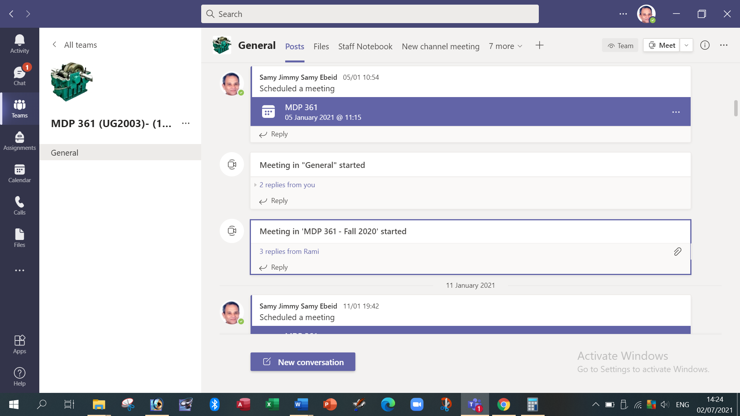

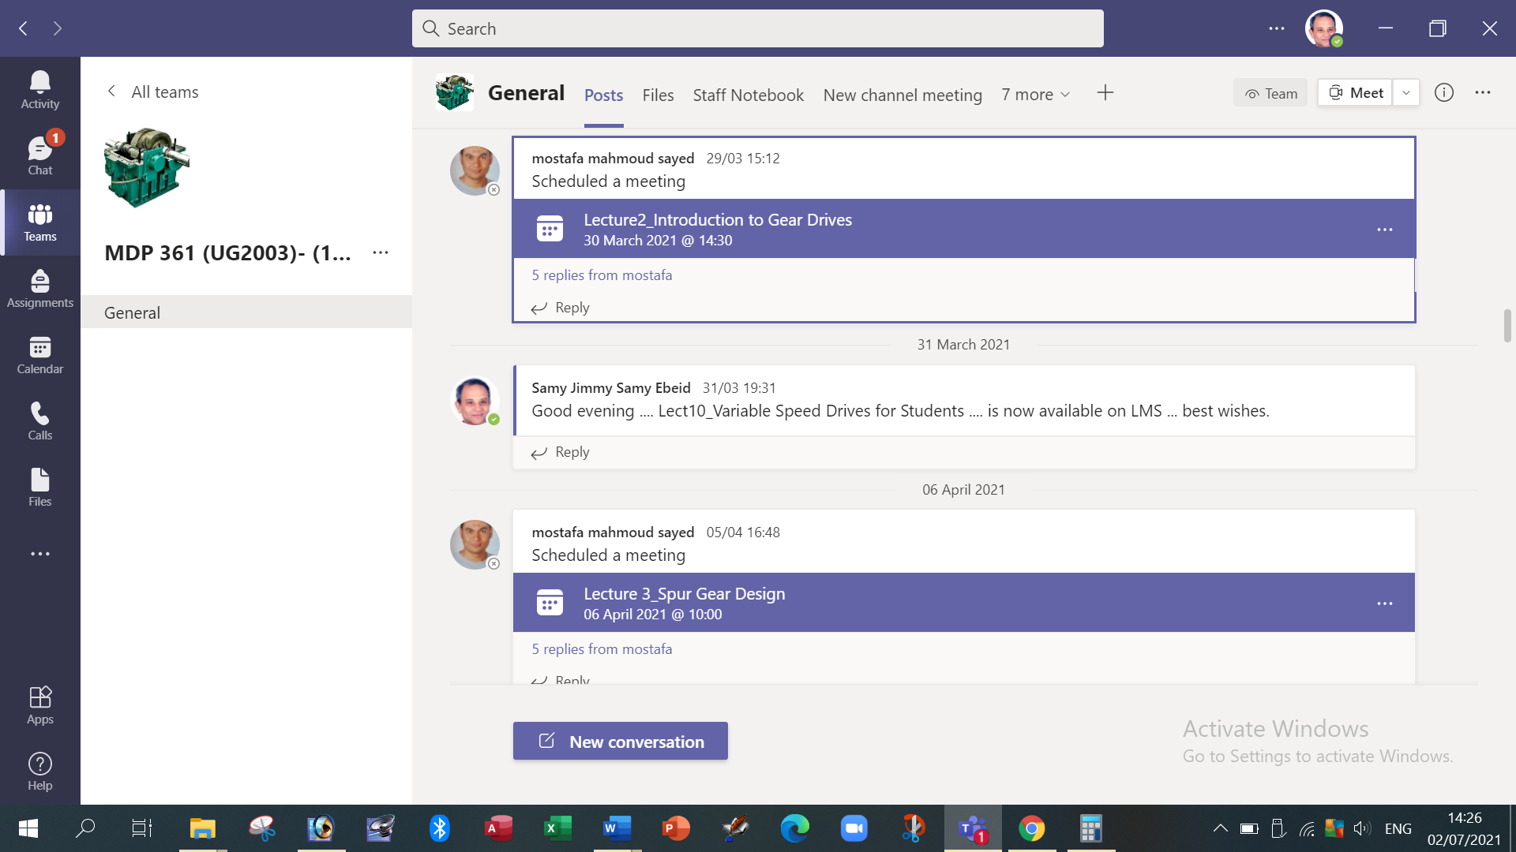



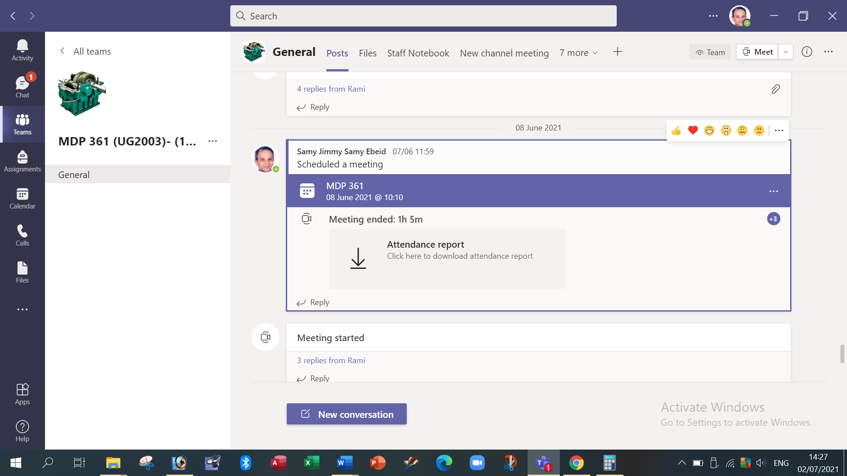

**Due to the pandemic of COVID19 during 2020-2021, the lectures were conducted on MS Teams platform. In addition, the lectures were recorded as videos and added on LMS. Nearly all topics were taught.**

**Topics taught as a percentage of the content specified:**

**>90 % X 70-90 % <70%**

**Reasons in detail for not teaching any topic**

Nearly all topics were taught.

**If any topics were taught which are not specified, give reasons in detail**

……………………………………………………………………………

**Teaching and learning methods:**

Lectures: **X**

Practical training/ laboratory:

Seminar/Workshop: **X**

Class Activity: **(Tutorials)**  **X**

**Case Study:**

Other assignments/homework:

If teaching and learning methods were used other than those specified, list and give reasons:

1. **Student assessment:**

|  |  |
| --- | --- |
| **Method of assessment** | **Percentage of total** |
| Written examination | 60 % |
| Oral examination | 0 % |
| Practical/laboratory work | 0 % |
| Other assignments/class work | 40 % |

**Members of examination committee**

i - Prof. Samy J. Ebeid

ii - Dr. Moustafa M. Sayed

**Role of external evaluator**

N/A……………….

1. **Facilities and teaching materials:**

Totally adequate

**X**

Adequate to some extent

Inadequate

List any inadequacies:

**Due to the pandemic of COVID19 during 2020-2021, the lectures were conducted on MS Teams platform. In addition, the lectures were recorded as videos and added on LMS. Nearly all topics were taught.**

**Teaching Lectures during 2020-2021 were fully 100 % Online Teaching.**

1. **Administrative constraints:**

List any difficulties encountered

No difficulties

1. **Student evaluation of the course:**

**The student’s evaluation of Spring 2020/2021 is not available on the system.**

**Response of Course Team**

List any criticisms

Teaching facilities: The available facilities were the computer, MS Teams and LMS.

1. **Comments from external evaluator(s): Response of course team**

N/A………………. …………………………….

……….……………..……. …………………………….