# Course Report of

# Thermal Physics – MEP 111– Fall 2020

**University:** Ain Shams **Faculty:** Engineering

# Basic Information

## Title and code:

Thermal Physics – MEP 111

## Program on which the course is given:

Mechanical Power Engineering

* 1. **Year / Level of program(s)** 2019-2020 / Mechanical Engineering Students – Level 1

## Units / Credit Hours:

|  |  |  |
| --- | --- | --- |
| i. | Lecture (online through Microsoft Teams) | 1 |
| ii. Tutorial / Practical: 2 | | |
| iii. Total: 2 CH | | |

Link to the meeting:

<https://teams.microsoft.com/l/meetup-join/19%3a3e118ffb5a0d4d96b8cf9922682d9efd%40thread.tacv2/1607248224635?context=%7b%22Tid%22%3a%22ad2a8324-bef7-46a8-adb4-fe51b6613b24%22%2c%22Oid%22%3a%226555c604-e2f9-4c8d-adbd-46dcf3328ace%22%7d>

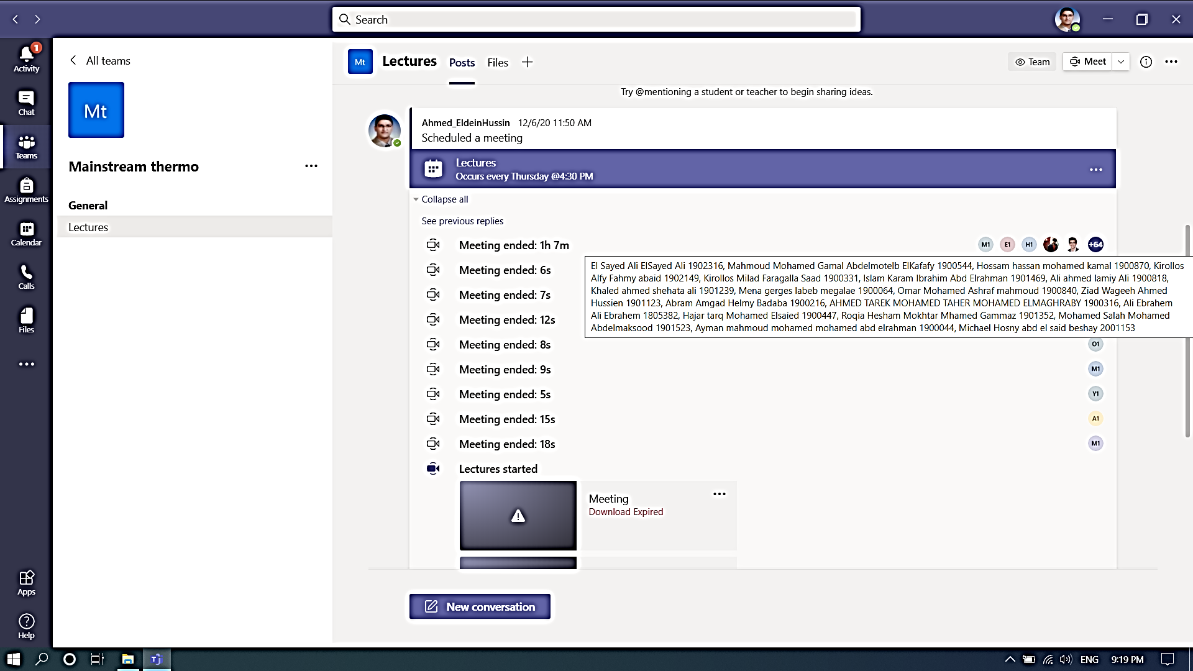

1. **Names of lecturers contributing to the delivery of the course:**

Dr. Walid Aboelsoud

Dr. Nashwa Abbas

Dr. Ahmed Taher

**Course coordinator:** Dr. Walid Aboelsoud

**External evaluator:** -------------

# Statistical Information

No of students attending the course:383

|  |  |  |  |
| --- | --- | --- | --- |
|  |  | **Number** | **Percentage (%)** |
| **Students completing the course** | |  |  |
| **Results** | Passed | 370 | 97 |
| Failed | 13 | 3 |

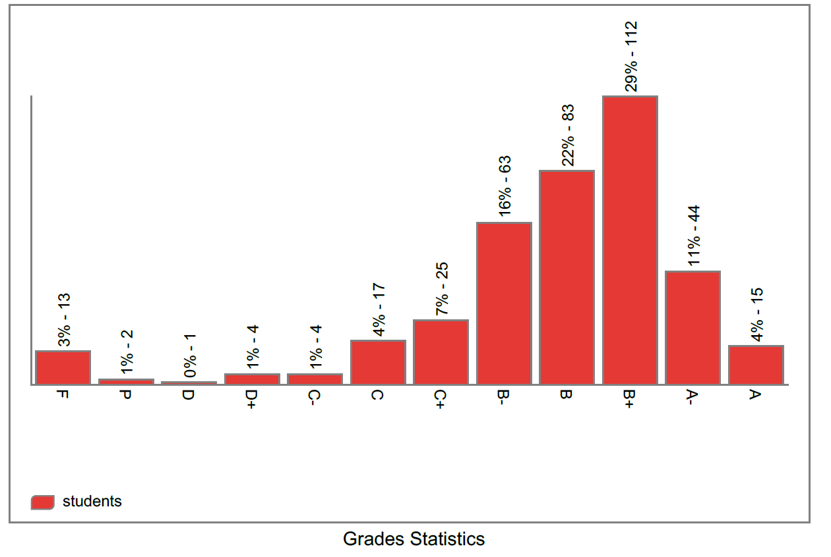

# Professional Information

## 1- Course Teaching:

|  |  |  |  |
| --- | --- | --- | --- |
| **Week** | **Course Content** | **Lecture**  **Hours** | **Tutorial**  **Hours** |
| 1 | Introduction ***(Chapter 1).*** | **1** | **2** |
| 2 | Basic concepts: Temperature and pressure ***(Chapter 1).*** | **1** | **2** |
| 3 | Energy, energy transfer ***(Chapter 2).*** | **1** | **2** |
| 4 | Energy analysis: Work and heat ***(Chapter 2).*** | **1** | **2** |
| 5 | First law of thermodynamics ***(Chapter 2).*** | **1** | **2** |
| 6 | Properties of pure substances: phase change, property diagrams ***(Chapter 3).*** | **1** | **2** |
| 7 | Properties of pure substances: property tables, EES software and the ideal gas equation of state ***(Chapter 3).*** | **1** | **2** |
| 8 | Energy analysis of closed systems: energy balance, internal energy, enthalpy ***(Chapter 4).*** | **1** | **2** |
| 9 | Energy analysis of closed systems: specific heats ***(Chapter 4).*** | **1** | **2** |
| 10 | Mass and energy analysis of control volumes: conservation of mass, flow work, energy analysis of steady-flow systems ***(Chapter 5).*** | **1** | **2** |
| 11 | Thermodynamics’ applications: Nozzles & Diffusers ***(Chapter 5).*** | **1** | **2** |
| 12 | Thermodynamics’ applications: Turbines & Compressors ***(Chapter 5).*** | **1** | **2** |
| 13 | Thermodynamics’ applications: Mixing & Heat exchangers ***(Chapter 5).*** | **1** | **2** |
| 14 | Simple-ideal power cycles: Brayton cycle ***(Chapter 9&10).*** | **1** | **2** |
| 15 | Simple-ideal power cycles: Rankine cycle ***(Chapter 9&10).*** | **1** | **2** |
| Total Number of Hours | | **15** | **30** |

**Topics taught as percentage of the content specified:**

**ʘ > 90%**  **70% - 90%**

 **< 70%**

**Reasons in details for not teaching any topic:**

**If any topics were taught which are not specified, give reasons in details:**

## None

* 1. **Teaching and learning methods:**

Lectures



Practical training/laboratory

Seminar / workshop

Class activity 

# Case study:

Other assignments / homework

If teaching and learning methods were used other than those specified, list and give reasons: N/A - - - - - - - - - - - - - - - - - - - - - - - - - - - - - - - - - - - - - - - - - - - - - - - - - - - - - - - - - - - - -

# Student assessment:

|  |  |
| --- | --- |
| **Method of assessment** | **Percentage of total** |
| Assignments | 10% |
| Quizzes | 20% |
| Written midterm exam | 25 % |
| Participation in class | 5 % |
| Written final exam | 40% |
| Total | 100% |

**Members of examination committee:**

Dr. Walid Aboelsoud

Dr. Nashwa Abbas

# Role of the external evaluator

To express his views on the course - - - - - - - - - - - NONE- - - - - - - - - - - -

- - - - - - - - - - - - - - - - - - - - - - - - - - - - - - - - - - - - - - - - - - - - - - - - - - - - - - - - - - - - - - - -

# Facilities and teaching materials:

Totally adequate

Adequate to some extent 

Inadequate

## List any inadequacies

* 1. **Administrative constraints**

**List any difficulties encountered**

None - - - - - - - - - - - - - - - - - - - - - - - - - - - - - - - - - - - - - - - - - - - - - - - - - -

- - - - - - - - - - - - - - - - - - - - - - - - - - - - - - - - - - - - - - - - - - - - - - - - - - - - - -

# Student evaluation of the course:

# Comments from external evaluator(s)

|  |  |
| --- | --- |
| **Comments** | **Response of Course team** |
| - - - - - - - - - - - - - - - - - - - - - - - - - - - | - - - - - - - - - - - - - - - - - - - - - - - - - - - |
| - - - - - - - - - - - - - - - - - - - - - - - - - - - | - - - - - - - - - - - - - - - - - - - - - - - - - - - |
| - - - - - - - - - - - - - - - - - - - - - - - - - - - | - - - - - - - - - - - - - - - - - - - - - - - - - - - |
| - - - - - - - - - - - - - - - - - - - - - - - - - - - | - - - - - - - - - - - - - - - - - - - - - - - - - - - |
| - - - - - - - - - - - - - - - - - - - - - - - - - - - | - - - - - - - - - - - - - - - - - - - - - - - - - - - |
| - - - - - - - - - - - - - - - - - - - - - - - - - - - | - - - - - - - - - - - - - - - - - - - - - - - - - - - |
| - - - - - - - - - - - - - - - - - - - - - - - - - - - | - - - - - - - - - - - - - - - - - - - - - - - - - - - |
| - - - - - - - - - - - - - - - - - - - - - - - - - - - | - - - - - - - - - - - - - - - - - - - - - - - - - - - |

# Course enhancement:

**Progress on actions identified in the previous year's action plane:**

|  |  |
| --- | --- |
| **Action** | **State whether or not completed and give reasons for any non-completion** |
| N/A - - - - - - - - - - - - - - - - - - - - - -  - **- - - - - - - - - - - - - - - - - - - - - - - - -**  **- - - - - - - - - - - - - - - - - - - - - - - - - -** | - - - - - - - - - - - - - - - - - - - - - - - **- - - -**  **- - - - - - - - - - - - - - - - - - - - - - - - - - -**  **- - - - - - - - - - - - - - - - - - - - - - - - - - -** |

* 1. **Action plan for academic year 2016-2017**

|  |  |  |
| --- | --- | --- |
| **Actions required** | **Completion date** | **Person responsible** |
| - - - - - - - - - - - - - - - - - - **- -**  **- - - - - - - - - - - - - - - - -** | - - - - - - - - - - - - - - - - - -  - - - - - - - - - - - - - - - - - - - -  - - - - - - - - - - - - - - - - - - | - - - - - - - - - - - - - - - - - -  - - - - - - - - - - - - - - - - - - - -  - - - - - - - - - - - - - - - - - |

**Course Content/ILO Matrix**

|  |  |  |  |  |  |  |  |  |  |  |  |  |  |
| --- | --- | --- | --- | --- | --- | --- | --- | --- | --- | --- | --- | --- | --- |
| Wk | Course Content | a1 | a2 | a3 | a4 | b1 | b2 | b3 | c1 | c2 | d1 | d2 | d3 |
| 1 | Introduction. | • |  |  |  |  | • |  |  |  |  |  |  |
| 2 | Basic concepts: Temperature and pressure. | • |  |  |  |  | • |  |  |  |  |  |  |
| 3 | Energy, energy transfer. |  | • |  |  | • |  |  |  |  |  |  |  |
| 4 | Energy analysis: Work and heat. |  | • |  |  | • |  |  |  | • |  |  |  |
| 5 | First law of thermodynamics. |  |  |  | • | • |  |  |  |  | • | • |  |
| 6 | Properties of pure substances: phase change, property diagrams. | • |  |  |  |  | • |  | • | • |  |  |  |
| 7 | Properties of pure substances: property tables, EES software and the ideal gas equation of state. | • |  | • |  |  | • |  | • | • | • |  |  |
| 8 | Energy analysis of closed systems: energy balance, internal energy, enthalpy. | • | • | • |  | • |  | • |  | • |  |  | • |
| 9 | Energy analysis of closed systems: specific heats. | • | • | • |  | • |  | • |  |  |  |  | • |
| 10 | Mass and energy analysis of control volumes: conservation of mass, flow work, energy analysis of steady-flow systems. |  | • | • | • | • |  | • |  |  | • |  | • |
| 11 | Thermodynamics’ applications: Nozzles & Diffusers. |  |  |  | • | • |  | • | • |  |  |  | • |
| 12 | Thermodynamics’ applications: Turbines & Compressors |  |  |  | • | • |  | • | • |  |  |  | • |
| 13 | Thermodynamics’ applications: Mixing & Heat exchangers. |  |  |  | • | • |  | • | • |  |  |  | • |
| 14 | Simple-ideal power cycles: Brayton cycle. |  | • |  | • | • |  | • |  |  | • | • | • |
| 15 | Simple-ideal power cycles: Rankine cycle. |  |  |  | • | • |  | • | • |  | • | • | • |