|  |  |
| --- | --- |
| *Course report of* | |
| **Rigid Body Dynamics – PHM_131s Spring 2021** | |
| University: Ain Shams | Faculty: Engineering |

## Basic Information

1. **Title and code:**

|  |
| --- |
| **Rigid Body Dynamics – PHM_131s** |

1. **Program on which the course is given:**

|  |  |
| --- | --- |
| |  | | --- | | **Mechanical Engineering Programs** | |

1. **Year/Level of programs:**

|  |
| --- |
| **1st Level** |

1. **Units/Credit Hours**

|  |  |
| --- | --- |
| **( i ) Lecture :** | **2** |

|  |  |
| --- | --- |
| **( ii ) Tutorial/Practical :** | **2** |

|  |  |
| --- | --- |
| **( iii ) Total :** | **4** |

1. **Names of lecturers contributing to delivery of the course:**

|  |  |
| --- | --- |
| **i -** | *Dr. Eslam Nabil El-Ganzoury* |

|  |  |
| --- | --- |
| **Course coordinator:** | *Dr. Eslam Nabil El-Ganzoury* |

|  |  |
| --- | --- |
| **External evaluator:** | **--- --- ---** |
|  |  |
|  |  |
|  |  |

## Statistical Information

|  |  |
| --- | --- |
| **No. of students attending the course:** | **418** |

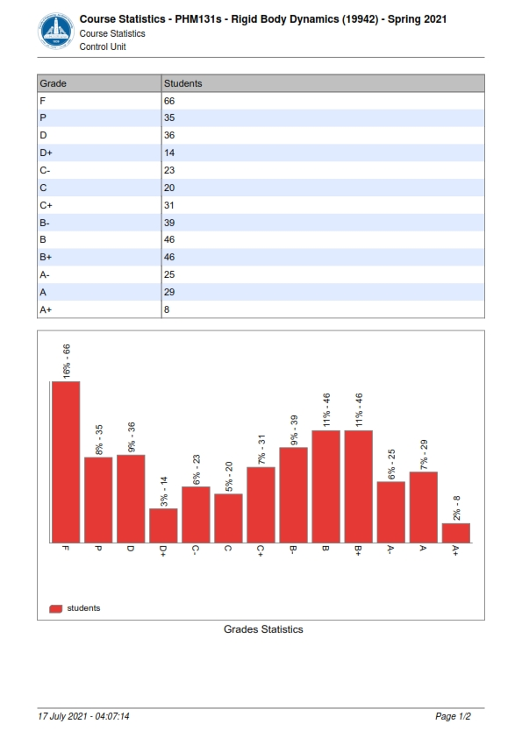

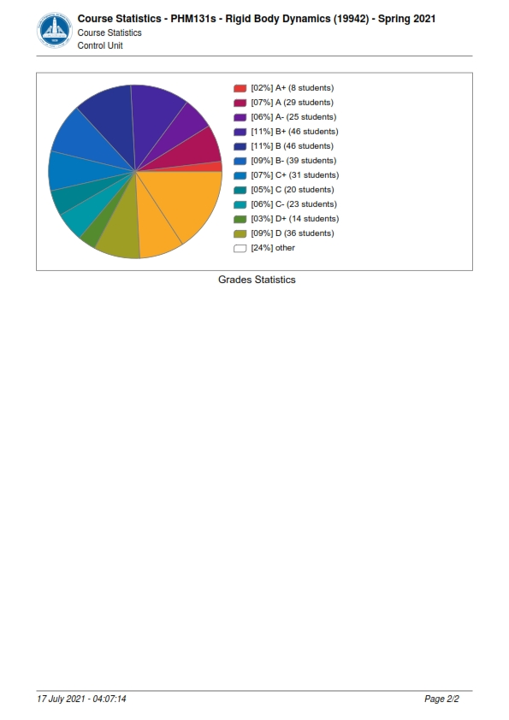

## Professional Information

1. **Course Teaching:**

|  |  |  |
| --- | --- | --- |
| **Course Content** | **Total No. of Hours** | **Lecturer** |
| Planar kinematics of a rigid body, Translation, rotation and general motion | 2 | *Dr. Eslam Nabil El-Ganzoury* |
| Rotation about a fixed axis. Angular measurements. | 2 | *Dr. Eslam Nabil El-Ganzoury* |
| Velocity analysis: Vector analysis. | 2 | *Dr. Eslam Nabil El-Ganzoury* |
| Velocity analysis: instantaneous center of rotation. | 2 | *Dr. Eslam Nabil El-Ganzoury* |
| Acceleration analysis. | 2 | *Dr. Eslam Nabil El-Ganzoury* |
| Kinematics of rolling motion: Theory and analysis | 2 | *Dr. Eslam Nabil El-Ganzoury* |
| Rolling motion: Applications (Slipping and no slipping). | 2 | *Dr. Eslam Nabil El-Ganzoury* |
| Kinetics of a rigid body. Force-Acceleration method. | 2 | *Dr. Eslam Nabil El-Ganzoury* |
| Equations of motion: translation, rotation. | 2 | *Dr. Eslam Nabil El-Ganzoury* |
| Equations of motion: general plane motion. | 2 | *Dr. Eslam Nabil El-Ganzoury* |
| Kinetics of rolling problems. | 2 | *Dr. Eslam Nabil El-Ganzoury* |
| Kinetics of a rigid body. Work-energy method. | 2 | *Dr. Eslam Nabil El-Ganzoury* |
| Conservative and non-conservative field of forces. | 2 | *Dr. Eslam Nabil El-Ganzoury* |
| Kinetics of a rigid body. Impulse-momentum method. | 2 | *Dr. Eslam Nabil El-Ganzoury* |
| Impact problems. | 2 | *Dr. Eslam Nabil El-Ganzoury* |
| **Total** | **30** |  |

**Topics taught as a percentage of the content specified:**

**>90 % $x$ 70-90 % <70%**

**Reasons in detail for not teaching any topic**

**N/A ………………………………………………………………………………………………**

**………………………………………………………………………………………………**

**………………………………………………………………………………………………**

**If any topics were taught which are not specified, give reasons in detail**

**N/A………………………………………………………………………………………….**

**………………………………………………………………………………………………**

**………………………………………………………………………………………………**

**Teaching and learning methods:**

**Lectures: $x$**

**Practical training/ laboratory:**

**Seminar/Workshop:**

**Class Activity: (Tutorials) X**

**Online details:**

# Teaching and Learning Methods as online

* + Teaching and in‐class discussion using “Microsoft Teams” online interactive program, by performing PowerPoint presentations with writing illustration.
  + Tutorial using “Microsoft Teams” online interactive program, by performing PowerPoint presentations with writing illustration.
  + The Quizzes were held online and written.
  + Assignments submitted online or written.
  + Final and Midterm exams are written on compus.

**All lectures videos and data were linked** **to** **the LMS of the faculty and YouTube channel:**

**1.LMS link**

<https://lms.eng.asu.edu.eg/course/view.php?id=7485>

**2.Microsoft teams link**

<https://teams.microsoft.com/l/team/19%3ad1dcfc8f237f485ab6d0395b67ccefbc%40thread.tacv2/conversations?groupId=f1a9ce08-3d78-4aaf-b474-b61678666f11&tenantId=ad2a8324-bef7-46a8-adb4-fe51b6613b24>

**3.YouTube channel**

<https://youtube.com/playlist?list=PLK3yhbMyGsXI1QFOj7F5goMzBTGyYs9Ag>

And the Power point lectures and tutorials are also uploaded with link:

<https://lms.eng.asu.edu.eg/course/view.php?id=7485>

**Case Study:**

**Other assignments/homework:**

**If teaching and learning methods were used other than those specified, list and give reasons:**

**………………………………………………………………………………………………**

**………………………………………………………………………………………………**

1. **Student assessment:**

|  |  |
| --- | --- |
| **Method of assessment** | **Percentage of total** |
| **Student activities** | **5 %** |
| **Quizzes** | **10 %** |
| **Midterm** | **25 %** |
| **Final** | **60 %** |
| **Total** | **100 %** |

* Formative Assessment Methods:
  + Teaching and in‐class discussion using “Microsoft Teams” online interactive program, with mutual communication.
* Summative Assessment Methods:
* Assignments delivered online to the LMS of the faculty and marked online.
* Two Quizzes and two repeated for excuses performed online on the LMS of the faculty and marked online.
* Mid-Term Exam performed written at the faculty.
* Final Exam performed written at the faculty.

**Members of examination committee**

**i–Dr. Eslam Nabil El-Ganzoury and Role of external evaluator**

**N/A………………………………………………………………………………………….**

**………………………………………………………………………………………………**

1. **Facilities and teaching materials:**

**Totally adequate**

**x**

**Adequate to some extent**

**Inadequate**

**List any inadequacies: N/A**

1. **Administrative constraints:**

**List any difficulties encountered**

***Participation of the students to the lectures online was lame and must be forced in future.***

1. **Student evaluation of the course:**

