Course Report
2020 - 2021
University: Ain Shams Faculty: Engineering Department: Design and Production Eng.
____________________________________________________________________________________

Course Report

A- Basic Information

1. Title and code: Mechanics of Machines (2) – MDP 352

2. Programme(s) on which this course is given: Mechanical Engineering, Power Section
3. Year/ Level of programmes: Fourth year, Second semester

4. Units/Credit hours: N.A.

Lectures Tutorial/Practical Total
4
6
2

5. Names of lecturers contributing to the delivery of the course
i Prof. Mohammed Taha Hedaya
ii Dr. Adel Moneeb Elsabbagh,
iii. Dr. Mohamed Ibrahim Khattab.

Course coordinator: Dr. Adel Elsabbagh
External evaluator: … … …

B- Statistical Information

No. of students attending the course: No.
43

No. of students completing the course: No.

43

C- Professional Information

1 – Course teaching
Topics actually taught | No. of hours | Lecturer
Introduction | 6 | Dr. M. T. Hedaya
Free Vibration of Undamped Single Degree of Freedom Systems | 6 | Dr. M. T. Hedaya
Free Vibration of Damped Single Degree of Freedom Systems | 8 | Dr. M. T. Hedaya
Harmonically Excited Vibration of Single Degree of Freedom Systems | 12 | Dr. M. T. Hedaya
Vibration of Undamped Two Degree of Freedom Systems | 12 | Dr. M. T. Hedaya
Vibration of Undamped Multidegree of Freedom Systems | 4 | Dr. M. T. Hedaya
Free Lateral Vibration of Beams and Critical Speeds of Rotating Shafts | 12 | Dr. M. T. Hedaya
Total | 60

Topics taught as a percentage of the content specified:

>90 % 70-90 % <70%
x

Reasons in detail for not teaching any topic
… … …

If any topics were taught which are not specified, give reasons in detail
… … …

2- Teaching and learning methods:
Online Lectures:
x
Tutorials in Campus:
x

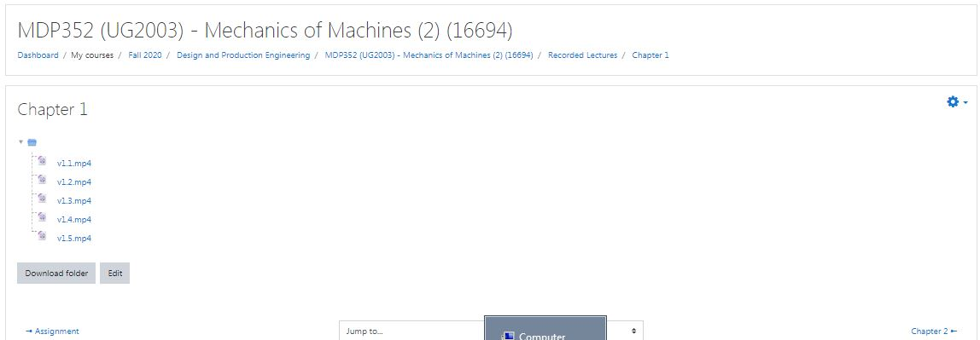

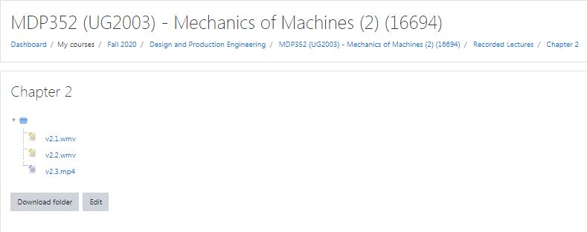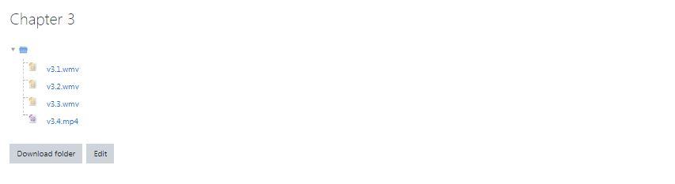

3- Student assessment:
Assessment method | Description | Week No | Weight
Written Exams | Mid-Semester Exam | Week 8 | 17 %
Assignments |  | All | 7
Quizzes | Quizzes | All | 3
Written Exams | Final Exam |  | 73 %
 | Total |  | 100 %

Members of examination committee
i Prof. Dr. M. T. Hedaya,
ii Dr. A. M. Elsabbagh,
iii Dr. M. I. Kattab,

Role of external evaluator
… … …

4- Facilities and teaching materials:
x
Totally adequate

Adequate to some extent

Inadequate

List any inadequacies
… … …

5- Administrative constraints:
… … …

6- Student evaluation of the course:
No feedback
Response of Course Team

7- Comments from external evaluator(s): Response of Course Team
… … … … … …

8- Course enhancement:

Progress on actions identified in the previous year’s action plan:
- According to the recommendations of the previous year report, three labs have been introduced to increase the practical content of the course and expose the students to new experiences in measuring and analyzing mechanical vibrations.

Free vibrations of a single degree of freedom system with friction damping.

- 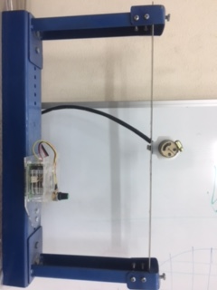
Forced vibrations of a single degree of freedom system.
Action
9- Action plan for academic year 2020– 2021
New Bylaw is established to overcome lab problems

Course coordinator: Adel Elsabbagh

Signature:

