*Course report of*

Engineering Economy – MDP231 – Spring 2021

University: Ain Shams Faculty: Engineering

**A- Basic Information**

1- Title and code:

Engineering Economy – MDP231

2- Program on which the course is given:

All

3- Year/Level of program:

All levels

1- Units/Credit Hours

|  |  |
| --- | --- |
| ( i ) Lecture : | 2 |
| ( ii ) Tutorial/Practical : | 1/0 |
| ( iii ) Total : | 3 |
| Credit hour | 2 |

2- Names of lecturers contributing to delivery of the course :

i - Dr. Ghada E. Shedeed

ii - Dr. Nessren M. Zamzam

iii -

Course coordinator: Dr. Ghada Shedeed and Dr. Nessren Zamzam

External evaluator: --- --- ---

**B- Statistical Information**

No. of students attending the MDP231 course: 215

|  |  |  |  |  |  |  |  |  |  |  |  |  |
| --- | --- | --- | --- | --- | --- | --- | --- | --- | --- | --- | --- | --- |
| **F** | **P** | **D** | **D+** | **C-** | **C** | **C+** | **B-** | **B** | **B+** | **A-** | **A** | **A+** |
| 12 | 17 | 6 | 11 | 12 | 9 | 15 | 18 | 24 | 36 | 24 | 24 | 7 |

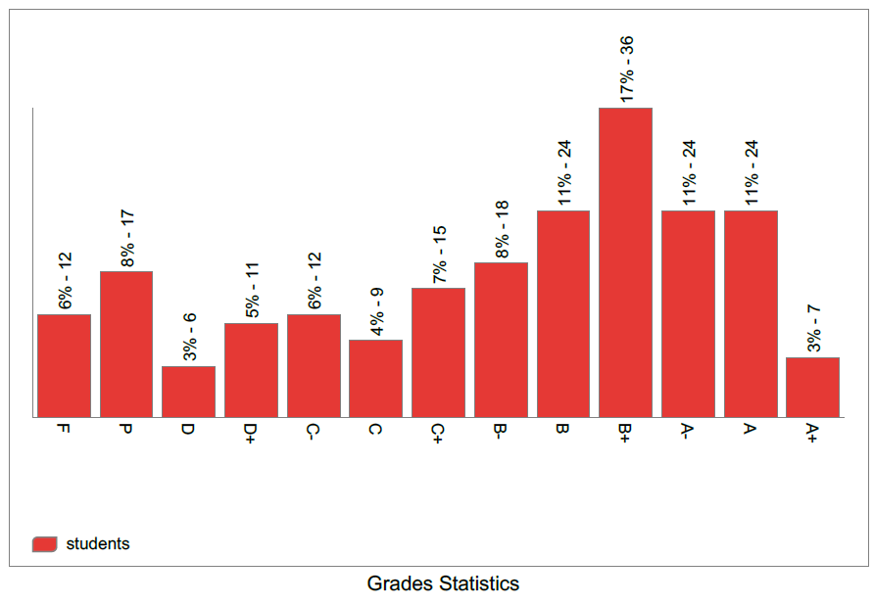

**C- Professional Information**

**1- Course Teaching:**

| **No** | **Course Content** | **Lectures** | **Lecturer** |
| --- | --- | --- | --- |
| **1** | Introduction, general discussion and new terminologies (time value of money) | **2** | Dr. Ghada E. Shedeed |
| **2** | Simple, compound interest rates, payment types, equivalence, and cash flow diagram representation. | **2** | Dr. Ghada E. Shedeed |
| **3** | Factors, effect of time and interest on money (F/P, P/F, P/A, A/P, F/A and A/F factors) | **2** | Dr. Ghada E. Shedeed |
| **4** | Combining factors, shifted series and single cash flows | **2** | Dr. Ghada E. Shedeed |
| **5** | Factors, effect of time and interest on money (P/G and A/G and Geometric gradient payments). | **2** | Dr. Ghada E. Shedeed |
| **6** | Combining factors for shifted gradient. | **2** | Dr. Ghada E. Shedeed |
| **7** | Nominal and effective interest rates (differences, terminologies, and different cases) | **2** | Dr. Nessren Zamzam |
| **8** | Nominal and effective interest rates (continuous compounding) and introduction to evaluating alternatives. | **2** | Dr. Nessren Zamzam |
| **9** | Evaluating Alternatives (present worth analysis using LCM and study periods) | **2** | Dr. Nessren Zamzam |
| **10** | Evaluating Alternatives (Future worth and annual worth analysis)andCapitalized cost. | **2** | Dr. Nessren Zamzam |
| **11** | Benefit and cost analysis for a single project**,** Incremental benefit and cost analysis for multiple projects | **2** | Dr. Nessren Zamzam |
| **12** | Breakeven analysis for a single and multiple projects. | **2** | Dr. Nessren Zamzam |

|  |  |
| --- | --- |
|  | Lecture and tutorial Microsoft Teams, ***sample*** of recorded activities |
| **For more details, you can access the course team:**  <https://teams.microsoft.com/l/team/19%3a55a434e67bca4c468e7acecdbb1d2fe1%40thread.tacv2/conversations?groupId=eefe328d-515d-412e-8b87-abcd43d5d778&tenantId=ad2a8324-bef7-46a8-adb4-fe51b6613b24> | |

**Topics taught as a percentage of the content specified:**

**>90 % X 70-90 % <70% Reasons in detail for not teaching any topic**

Due to COVID circumstances, this semester has been officially 13 weeks so last topics Payback, depreciation intro, ROR have not been given ……………………………………….

**If any topics were taught which are not specified, give reasons in detail**

N/A………………………………………………………………………………………….

**Teaching and learning methods:** Online Lectures: **X** Practical training/ laboratory:

Seminar/Workshop:

Online Class Activity: **(Tutorials) X**

Self-reading x

Interactive online sessions (lectures and tutorials) using Microsoft Teams, and video links to the recorded Microsoft videos beside using the LMS.

Other assignments/homework:

If teaching and learning methods were used other than those specified, list and give reasons:

………………………………………………………………………………………………

**2- Student assessment:**

| **Assessment method** | **No.** | **Description** | **Week no.** | **Weight** |
| --- | --- | --- | --- | --- |
| Assignments |  | (solving problems), participation, and report |  | 20 |
| Exam | 1 | Sit-in Mid-term | 7 | 25 |
| Written examination |  | Online Quizzes |  | 15 |
| Exam | 1 | Final Exam |  | 40 |
| Total | | | | 100 |

**Members of examination committee**

**Role of external evaluator**

………………………………………………………………………………………….

**3- Facilities and teaching materials:**

Totally adequate

Adequate to some extent **X**

Inadequate

List any inadequacies

**4- Administrative constraints:**

List any difficulties encountered

**5- Student evaluation of the course:**

Positive feedback and all above 50%.

**Response of Course Team**

**6- Comments from external evaluator(s): Response of course team**

……… ………………. ……………… ………….