*Course report of*

**Quality Systems - MDP323 spring 2021**

# University: Ain Shams Faculty: Engineering

**Basic Information**

1. **Title and code :**

Quality Systems - MDP323

1. **Programme on which the course is given :**

B. Sc. Mechanical Engineering (Production Engineering)

1. **Year/ Level of programmes :**

4th year, Second semester

* 1. **Units/Credit Hours**

( i ) Lecture :

|  |
| --- |
| 30 |
| 30 |
| 60 |

( ii ) Tutorial /Practical : ( iii ) Total :

1. **Names of lecturers contributing to the delivery of the course :**
   1. -

|  |
| --- |
| Dr Nessren Mohamed Zamzam |
|  |
| -------------------------------- |
|  |
| ------------------------------- |
|  |
| ------------------------------- |
|  |
| ------------------------------- |
|  |
| ------------------------------- |
|  |
| ------------------------------- |
|  |
| ------------------------------- |

* 1. -
  2. -
  3. -
  4. -
  5. -
  6. - viii -

**Course coordinator: External evaluator:**

Dr. Nessren Zamzam

---- ---- ----

# Statistical Information

No. of students attending the course:

37

|  |  |  |  |
| --- | --- | --- | --- |
|  | | **Number** | **Percentage (%)** |
| **Students completing the course** | |  |  |
| **Results** | Attend | 35 | 94.5% |
| Absent | 2 | 5.5% |
| **Grading Of successful students** | Excellent | 18 | 48% |
| Very Good | 11 | 29.7% |
| Good | 5 | 13.5% |
| Pass | 1 | 2% |

# Professional Information

**1-- Course Teaching:**

|  |  |  |  |  |
| --- | --- | --- | --- | --- |
| No | Course Content | lecture | tutorial | Total |
| 1 | basic concepts: definition; terminology of the quality system | 2 | 2 | 4 |
| 2 | quality function | 4 | 4 | 8 |
| 3 | development and design of systems | 2 | 2 | 4 |
| 4 | quality policies and objectives | 4 | 4 | 8 |
| 5 | Quality planning | 4 | 4 | 8 |
| 6 | Organization for quality | 4 | 4 | 8 |
| 7 | Quality costs | 4 | 4 | 8 |
| 8 | Quality tools | 2 | 2 | 4 |
| 9 | Quality manual (didn’t teach) | 0 | 0 | 0 |
| Total Hours | | 26 | 26 | 52 |

1. **Snapshot of Microsoft team**

<https://teams.microsoft.com/l/channel/19%3a175eadb8e2054411866d18a9893a0060%40thread.tacv2/General?groupId=f381ab37-5d68-49df-9972-4a80e5f46c99&tenantId=ad2a8324-bef7-46a8-adb4-fe51b6613b24>

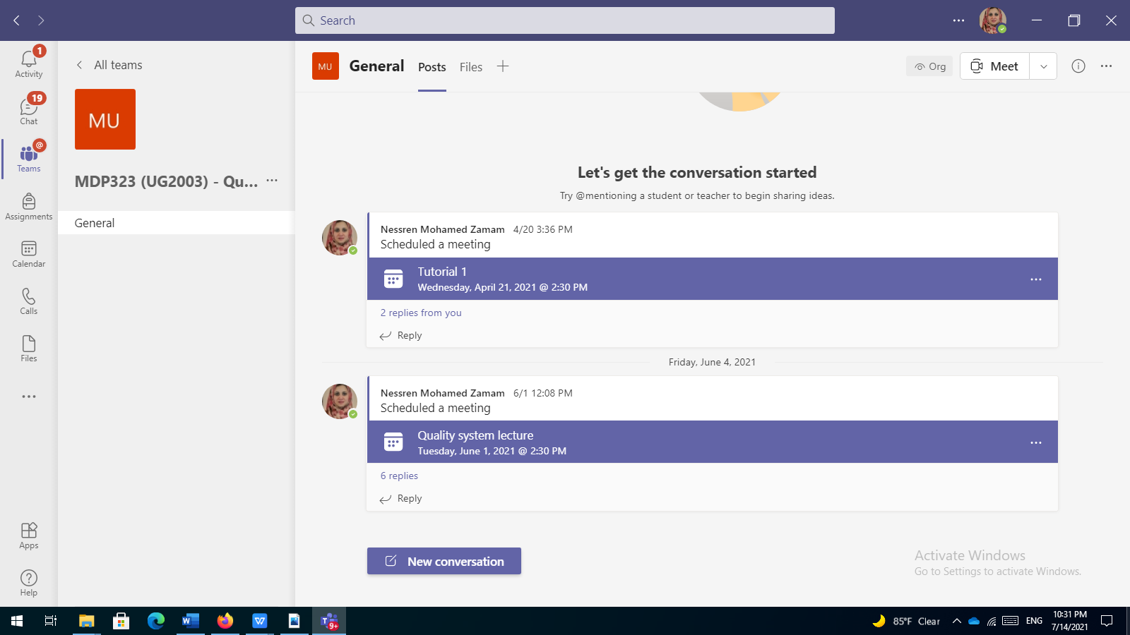

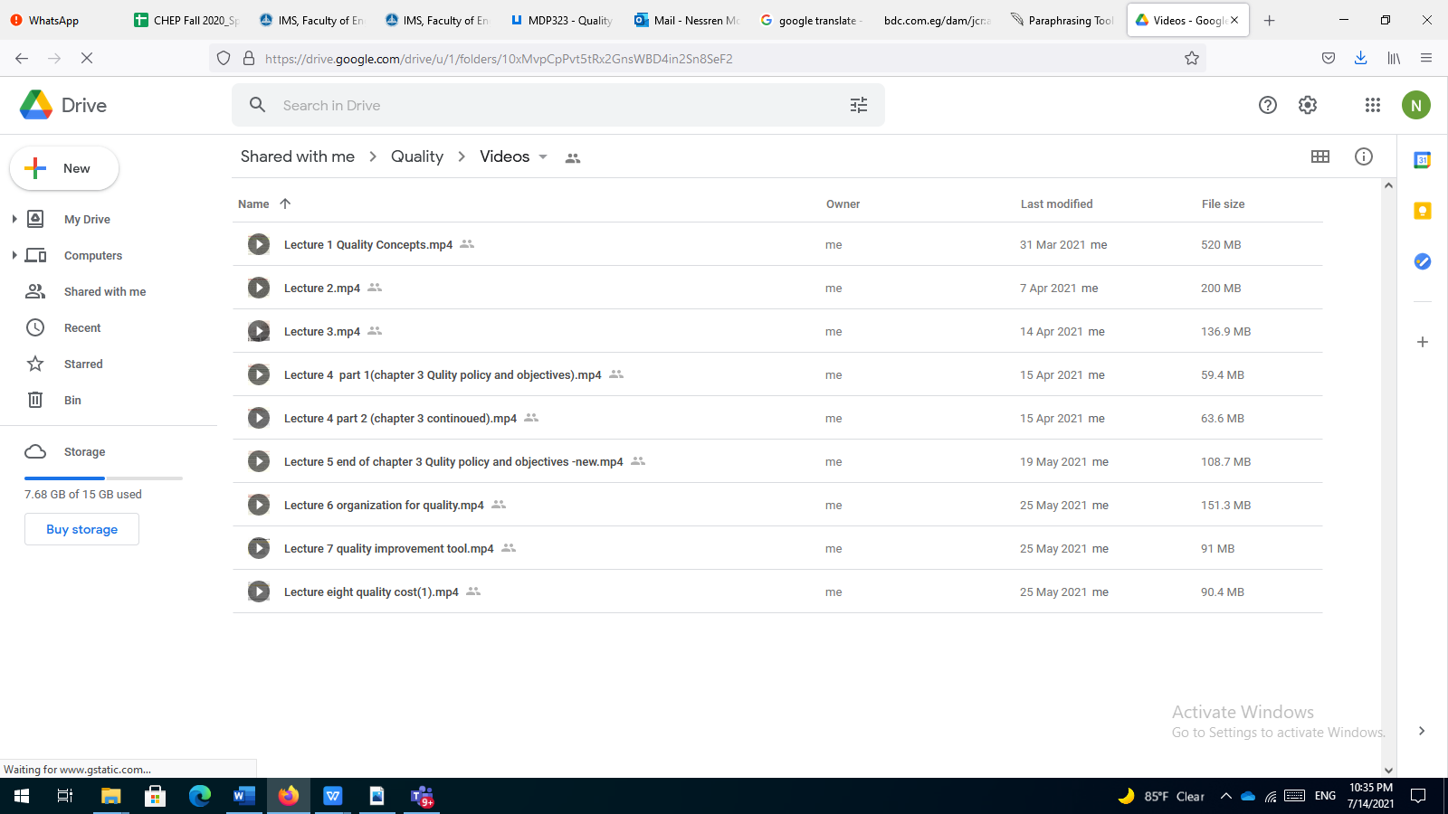

1. Snap shot of LMS

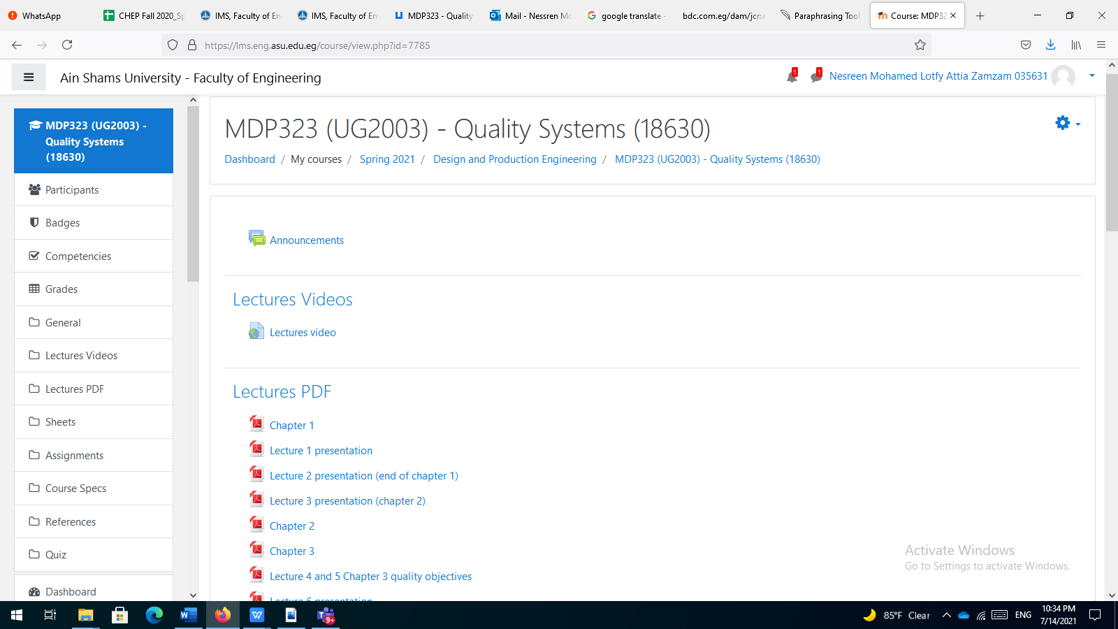

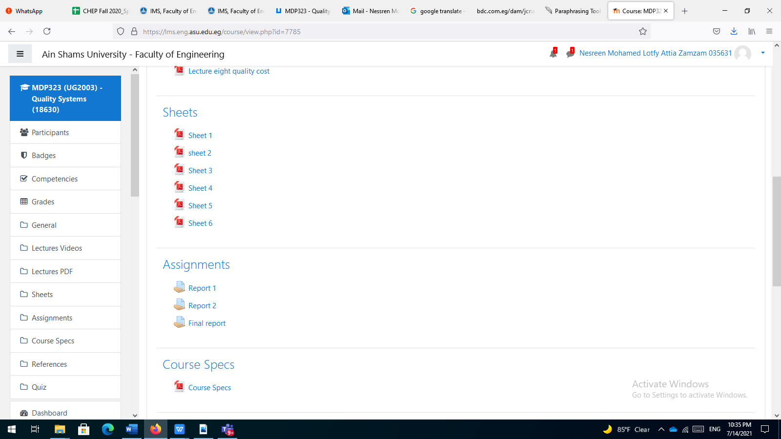

1. **Attendees list**

|  |  |  |  |
| --- | --- | --- | --- |
| Meeting Summary |  |  |  |
| Total Number of Participants | 29 |  |  |
| Meeting Title | General |  |  |
| Meeting Start Time | 4/21/2021, 2:28:40 PM |  |  |
| Meeting End Time | 4/21/2021, 4:11:17 PM |  |  |
|  |  |  |  |
| Full Name | Join Time | Leave Time | Duration |
| Nessren Mohamed Zamam | 4/21/2021, 2:28:40 PM | 4/21/2021, 3:44:40 PM | 1h 15m |
| Ahmed Hazem Mohamed Sayed Ghanem 1700051 | 4/21/2021, 2:28:54 PM | 4/21/2021, 3:46:17 PM | 1h 17m |
| Hana Adel Zaki Orabi 1701654 | 4/21/2021, 2:29:00 PM | 4/21/2021, 3:45:29 PM | 1h 16m |
| Amr Mohamed Mostafa Hassan 17T0099 | 4/21/2021, 2:29:06 PM | 4/21/2021, 3:45:03 PM | 1h 15m |
| Mostafa shaker ibrahim lawendy 1701428 | 4/21/2021, 2:29:13 PM | 4/21/2021, 3:44:49 PM | 1h 15m |
| Hagar Mostafa GadAlla Mahmoud 1701622 | 4/21/2021, 2:29:34 PM | 4/21/2021, 3:44:44 PM | 1h 15m |
| Kholoud Hamdy Mohammed 1600515 | 4/21/2021, 2:30:59 PM | 4/21/2021, 3:44:49 PM | 1h 13m |
| Ahmad Mohamed Salah Mohamed Shaheen 1700175 | 4/21/2021, 2:30:59 PM | 4/21/2021, 3:44:45 PM | 1h 13m |
| Khaled Abdelbasset Mohamed Ibrahim 1700478 | 4/21/2021, 2:31:19 PM | 4/21/2021, 3:44:44 PM | 1h 13m |
| Martina emad beshay 1701078 | 4/21/2021, 2:31:34 PM | 4/21/2021, 3:44:52 PM | 1h 13m |
| Martina emad beshay 1701078 | 4/21/2021, 3:47:12 PM | 4/21/2021, 3:47:18 PM | 6s |
| Fadwa alaa thabet elias 1700977 | 4/21/2021, 2:31:53 PM | 4/21/2021, 3:32:53 PM | 1h |
| Fadwa alaa thabet elias 1700977 | 4/21/2021, 3:34:57 PM | 4/21/2021, 3:44:45 PM | 9m 47s |
| Reem Khaled Mohamed Ahmed 1700549 | 4/21/2021, 2:32:00 PM | 4/21/2021, 2:54:14 PM | 22m 13s |
| Reem Khaled Mohamed Ahmed 1700549 | 4/21/2021, 3:20:44 PM | 4/21/2021, 3:21:39 PM | 54s |
| Muhammad Fathi Abdul Majeed Shaaban Hajar 1701265 | 4/21/2021, 2:32:06 PM | 4/21/2021, 2:33:22 PM | 1m 16s |
| Muhammad Fathi Abdul Majeed Shaaban Hajar 1701265 | 4/21/2021, 2:56:43 PM | 4/21/2021, 3:18:52 PM | 22m 9s |
| Abd el Rahman Essam Hussin Ismail 1700749 | 4/21/2021, 2:32:18 PM | 4/21/2021, 3:44:43 PM | 1h 12m |
| Mohamed Ashraf Abdalla Mohamed 17E0067 | 4/21/2021, 2:33:25 PM | 4/21/2021, 3:44:52 PM | 1h 11m |
| Salah Abdel-Moneim Abdel-Aziz Mohamed 1700697 | 4/21/2021, 2:35:13 PM | 4/21/2021, 3:26:46 PM | 51m 33s |
| Salah Abdel-Moneim Abdel-Aziz Mohamed 1700697 | 4/21/2021, 3:30:52 PM | 4/21/2021, 3:44:44 PM | 13m 51s |
| Omar fares eid yehia 17E0166 | 4/21/2021, 2:35:17 PM | 4/21/2021, 3:44:50 PM | 1h 9m |
| Omar fares eid yehia 17E0166 | 4/21/2021, 3:51:33 PM | 4/21/2021, 3:51:39 PM | 5s |
| Youssef Shawky Abd-Ellatif Khalil 1701726 | 4/21/2021, 2:35:26 PM | 4/21/2021, 3:44:43 PM | 1h 9m |
| Ahmed Fekry Salah Abdel-Rahman 1700141 | 4/21/2021, 2:36:33 PM | 4/21/2021, 3:20:35 PM | 44m 2s |
| Ahmed Fekry Salah Abdel-Rahman 1700141 | 4/21/2021, 3:22:57 PM | 4/21/2021, 3:45:03 PM | 22m 5s |
| Kirollos Nabil Mounir Ekladious 1701035 | 4/21/2021, 2:36:37 PM | 4/21/2021, 3:45:19 PM | 1h 8m |
| Bassam Alaa El-Din Abdel-Azim Abbas 1700361 | 4/21/2021, 2:37:49 PM | 4/21/2021, 3:06:27 PM | 28m 37s |
| Bassam Alaa El-Din Abdel-Azim Abbas 1700361 | 4/21/2021, 3:08:35 PM | 4/21/2021, 3:46:03 PM | 37m 27s |
| Abanoub Alkess Abram Abdelsayed Abdelmasseh 17T0319 | 4/21/2021, 2:37:59 PM | 4/21/2021, 3:44:46 PM | 1h 6m |
| Mohamed Said Mostafa Saad 15T0145 | 4/21/2021, 2:38:08 PM | 4/21/2021, 2:47:36 PM | 9m 27s |
| Philopateer Nagy Fakhri Georgie 1700996 | 4/21/2021, 2:39:07 PM | 4/21/2021, 3:45:19 PM | 1h 6m |
| Noura Gouda Mohamed Soliman Ahmed 1701594 | 4/21/2021, 2:39:24 PM | 4/21/2021, 3:44:53 PM | 1h 5m |
| Basil Hossam Saad Ahmed 1700352 | 4/21/2021, 2:41:54 PM | 4/21/2021, 3:49:54 PM | 1h 7m |
| 1700908 | 4/21/2021, 2:46:38 PM | 4/21/2021, 3:38:49 PM | 52m 10s |
| Omar Ismail Abd Elbaky Abo Kahf 18X0041 | 4/21/2021, 2:53:56 PM | 4/21/2021, 3:44:59 PM | 51m 3s |
| Omar shokry mahmoud mohamed 1700876 | 4/21/2021, 2:59:21 PM | 4/21/2021, 4:11:17 PM | 1h 11m |

**Topics Taught as a percentage of the content specified**

>90% 70% - 90% <70 %

**Reasons in detail for not teaching any topic**

**The last topics “quality manual” hadn’t been taught as a result of the short period of study from 15 weeks to 13 weeks**

**If any topics were taught which are not specified, give reasons in detail**

----- ------ ------ ------ ------ ------ ------ ------ ------ ------ ----

* 1. **Teaching and learning methods:**

Online Lectures: **X** Practical training/ laboratory:

Seminar/Workshop:

Online Class Activity: **(Tutorials) X**

Self-reading

Interactive online sessions (lectures and tutorials) using Microsoft Teams, and video links to the recorded Microsoft videos beside using the LMS.

**Case Study:**

Other assignments/homework

If teaching and learning methods were used other than, those specified, list and give reasons

.

* 1. **Student assessment:**

| Assessment method | Description | Weight (%) |
| --- | --- | --- |
| Assignment | 3 reports | 16% |
| Quiz | Quiz1 and 2 | 14% |
| Written exam | Final exam | 70% |
| 100% | | |

Members of examination committee

Dr Nessren Zamzam

Role of external evaluator:

------ ------ ------ ------ ------ ------

* 1. **Facilities and teaching materials:**

Totally adequate ‏ے

Adequate to some extent ‏ے

Inadequate ‏ے

List any inadequacies:

------ ------ ------ ------ ------ ------ ------ ------ ------ ------ -

----- ------ ------ ------ ------ ------ ------ ------ ------ ------ --

---- ------ ------ ------ ------ ------ ------ ------ ------ ----

* 1. **Administrative constraints:**

------ ------ ------ ------ ------ ------ ------ ------ ------ ------ ------ -

----- ------ ------ ------ ------ ------ ------ ------ ------ ------ ------ ---

--- ------ ------ ------ ------ ------ ------ ------ ------ ------ ------ -----

- ------ ------ ------ ------ ------ ------ ------ ------ ------ ------ ------

------ ------ ------ ------ ------ ------ ----

* 1. **Student evaluation of the course:**

There is no negative feedback for this course

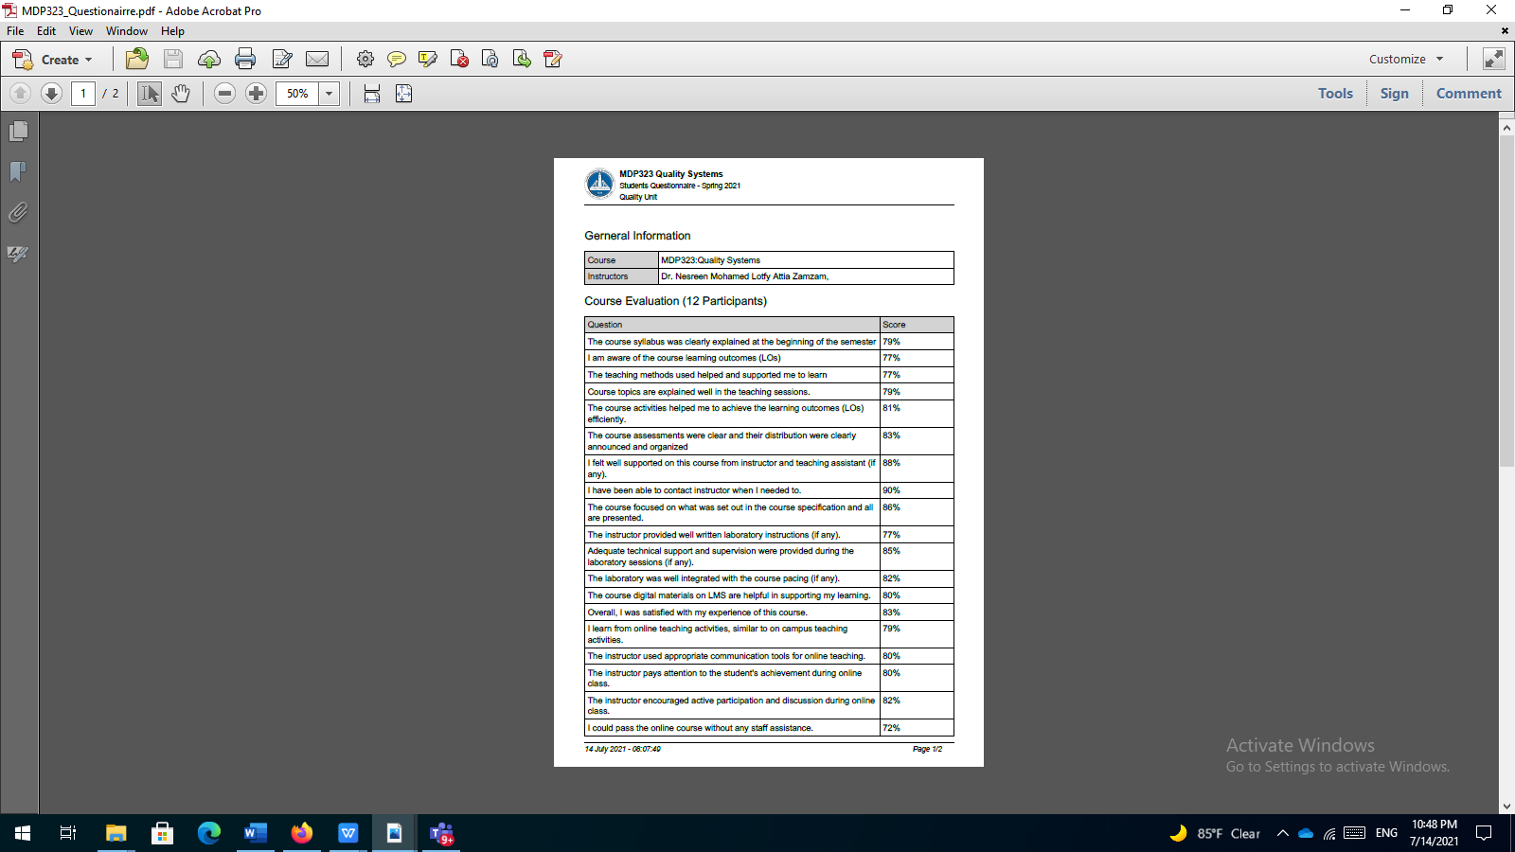

* 1. **Comments from instructors:**

**48% of the students got A and this is due to**

1. The small size of the number of the students facilitate the interaction between the students and me, it was easy to determine any confusing topics and repeat any misunderstood part.
2. The nature of the course as it doesn’t contain any complicated mathematical formula or complex problems
   1. **Course enhancement: Progress on actions identified in the previous year’s action plan:**

This year most of the course was taught online due to Covid 19, enhancement for the students activities and for the lectures are required