Course Reports

Work Study – MDP 322 2020-2021
University: Ain Shams Faculty: Engineering
Program on which the course is given: | Design and Production Engineering
Major or minor element of program: | N/A
Department offering the program : | Design and Production Engineering
Department Teaching the course: | Design and Production Engineering
Academic year/ Level: | Level Three
Date of specification approval:

- Basic Information
Title: | Work Study | Code: | MDP 322
Credit Hours: | 3 | Lecture: | 2
Tutorial: | 2 | Lab: | 0
Total: | 4

5. Names of lectures contributing to the delivery of the course
i …Dr. Mohammed M. El-Beheiry….

B – Statistical Information
38

92
No. of students attending the course: No. %
No. of students completing the course: No. %
35

Results:
32
91.4
3
8.6
Passed: No. % Failed: No. %
Grading of successful students:
12
7
32
9
4
24
Excellent: No. % Very Good: No. %
Good: No. % Pass: No. %
18
11

C – Professional Information
- Course teaching
Topic | No. of hours | Lecture
Standard of living and productivity | 2 | 2
Introduction to work study | 2 | 2
Introduction to method study | 1 | 1
The procedures of method study: Select | 1 | 1
The procedures of method study: Record (Outline process chart) | 4 | 4
The procedures of method study: Record (Flow process chart and diagram) | 3 | 3
The procedures of method study: Record (Man – Machine chart) | 4 | 4
The procedures of method study: Record (Two handed chart) | 4 | 4
The procedures of method study: Examine | 2 | 2
The procedures of method study: Measure, Install and Maintain. | 1 | 1
Introduction to Work measurement | 2 | 2
Establishment of standard time | 4 | 4
Synthetic time and rated activity sample | 4 | 4
Learning curves | 4 | 4
Incentive schemes | 1 | 1

Topics taught as a percentage of the content specified
X

>90% 70-90% <70%

Reasons in detail for not teaching any topic
……………………………………...
……………………………………...
if any topics were taught which are not specified, give reasons in detail
……………………………………..
……………………………………..

2- Teaching and learning methods:

Lectures:

Practical training/ laboratory:

Seminar/workshop:
X

X
Class Activity:

Case Study
Other assignments/homework:
If teaching and learning methods are used other than those specified, list and give reasons:
Online teaching is followed due to COVID-19 precautionary measures, were Microsoft Teams was used.
Teams Link:
https://teams.microsoft.com/l/team/19%3a007c6cc8980c430698fa83d5c1d02eef%40thread.tacv2/conversations?groupId=daee9bbd-3144-4e56-bb8a-df8f2bd22361&tenantId=ad2a8324-bef7-46a8-adb4-fe51b6613b24

Samples of Teams Activities:

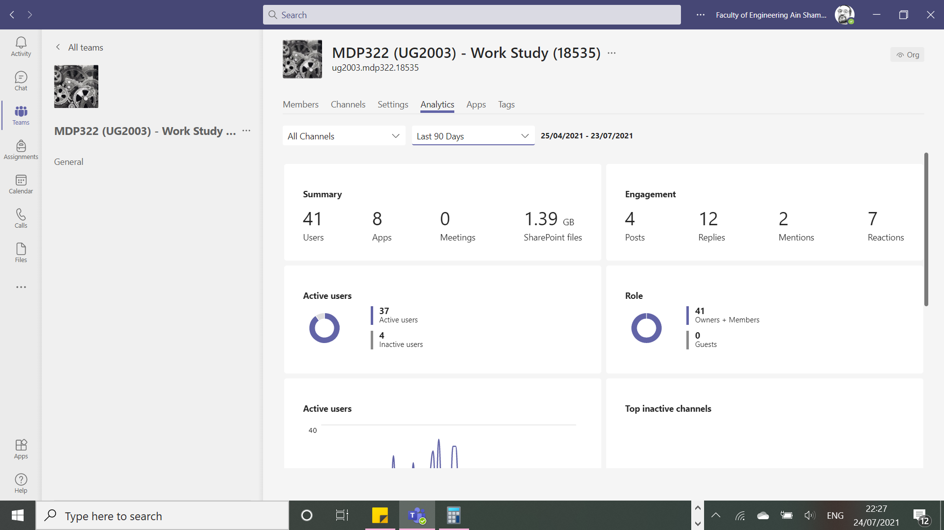
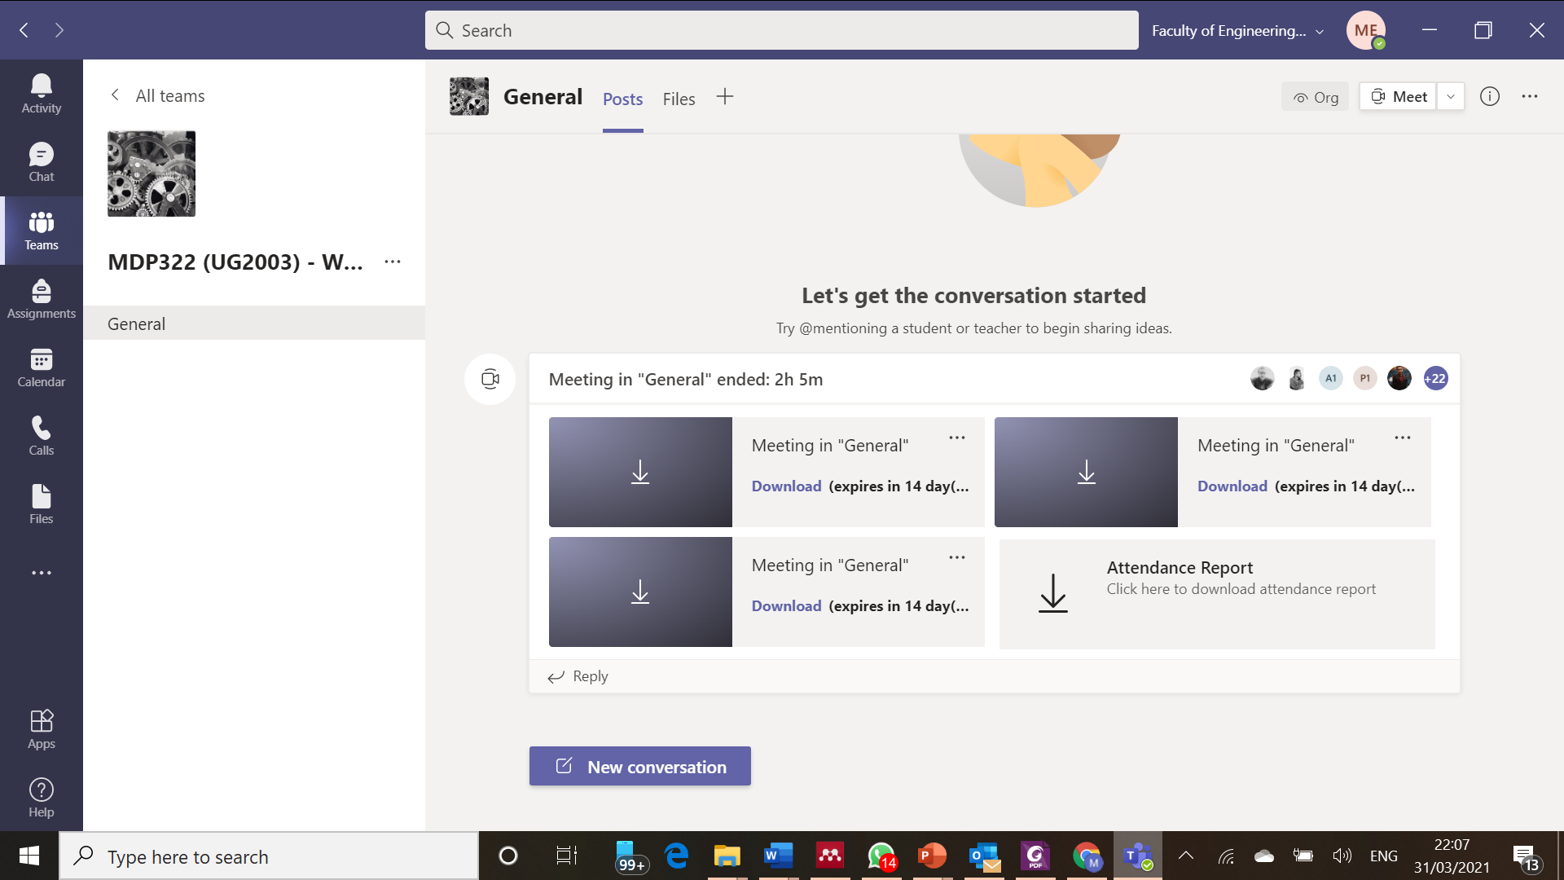

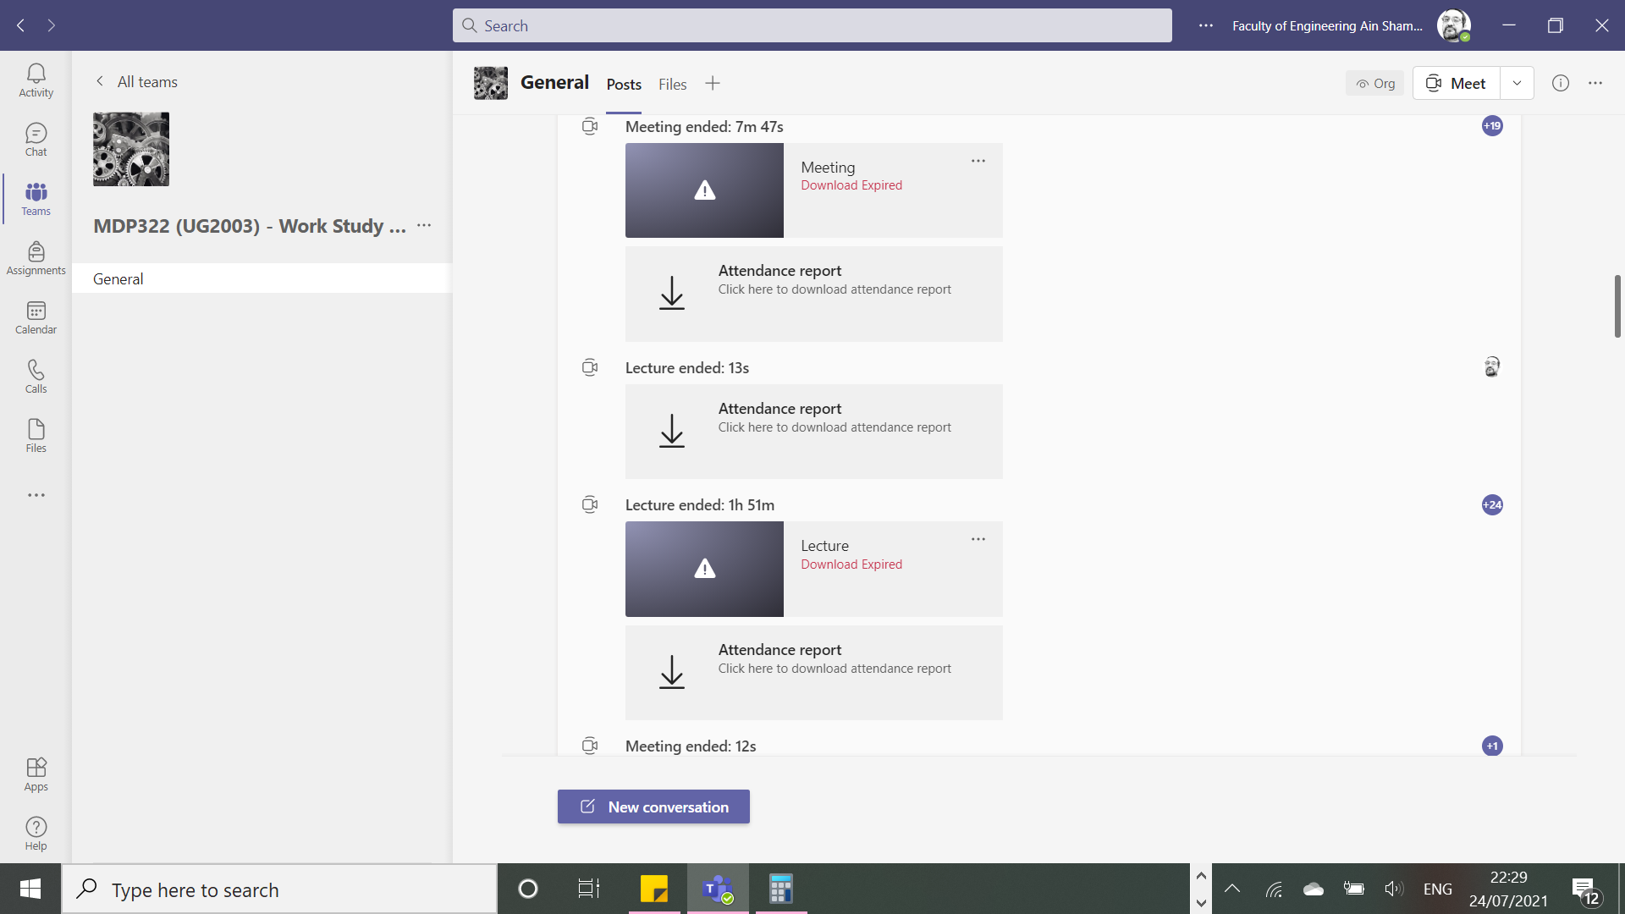
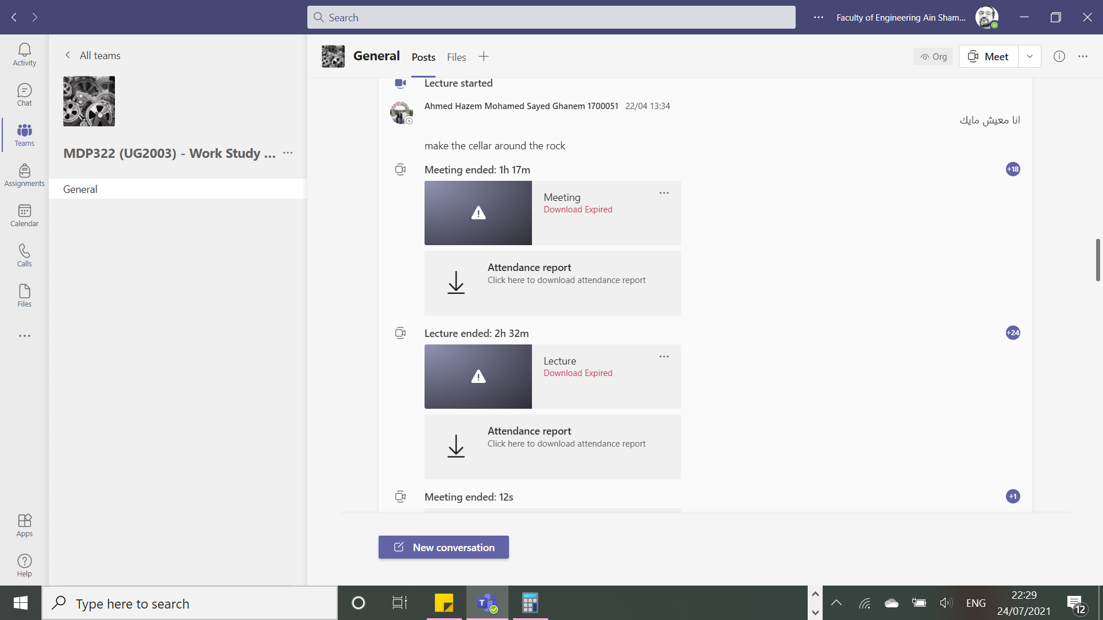
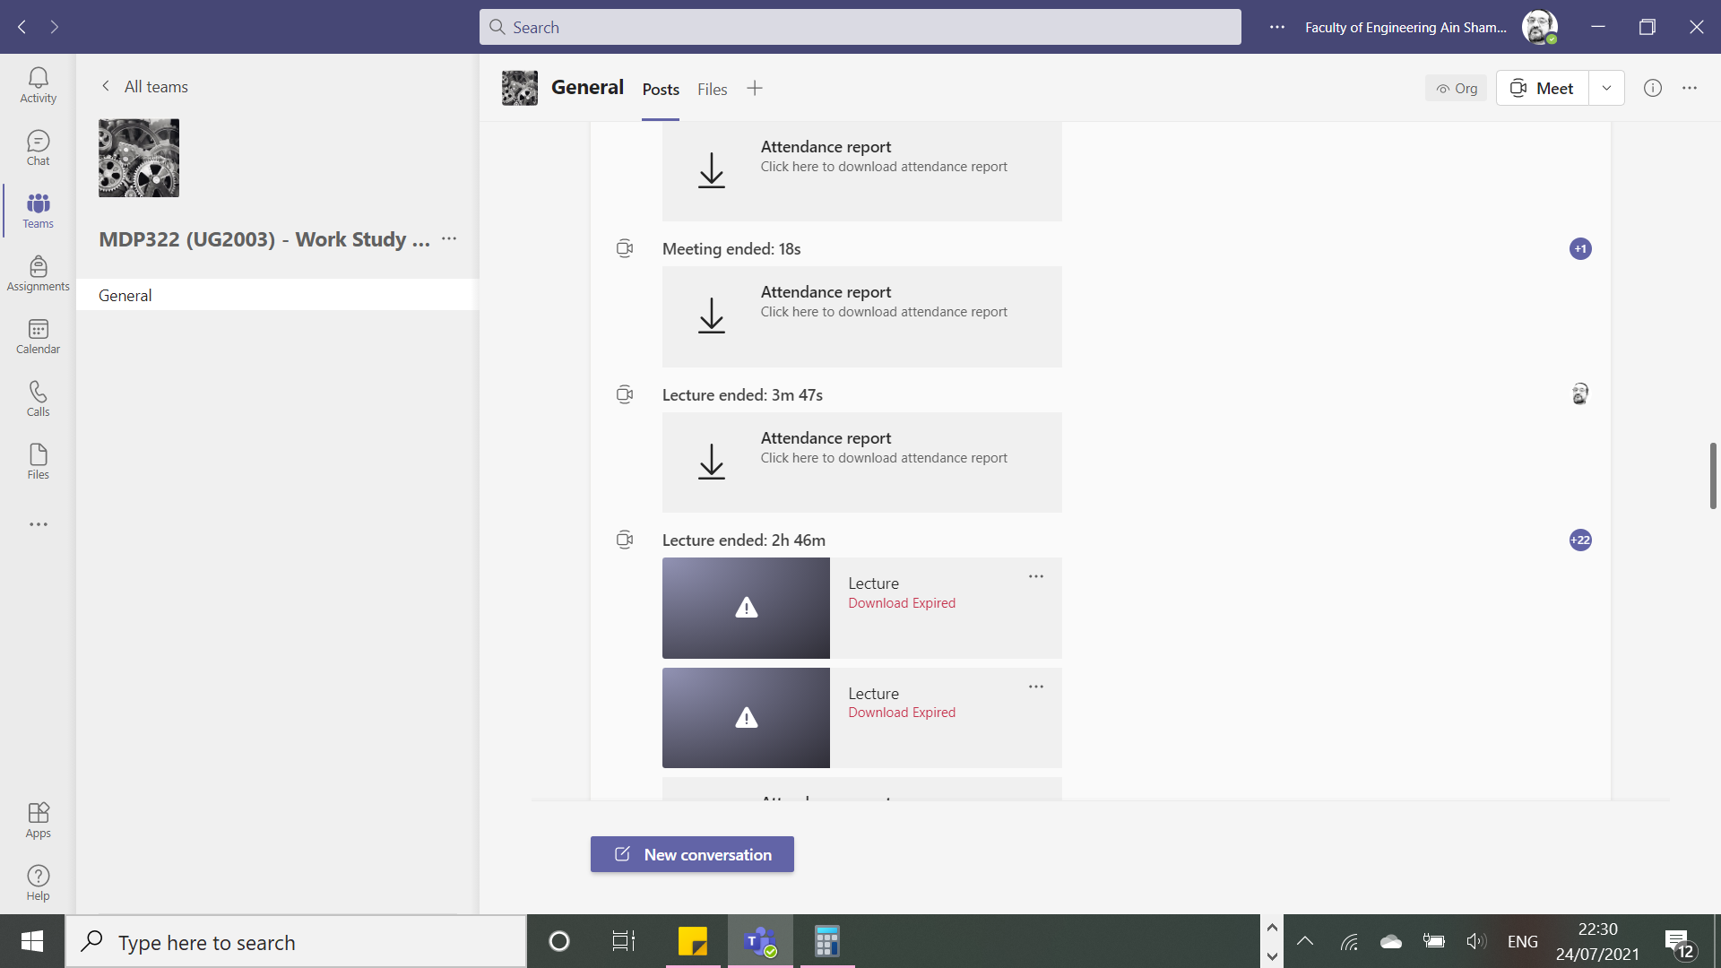
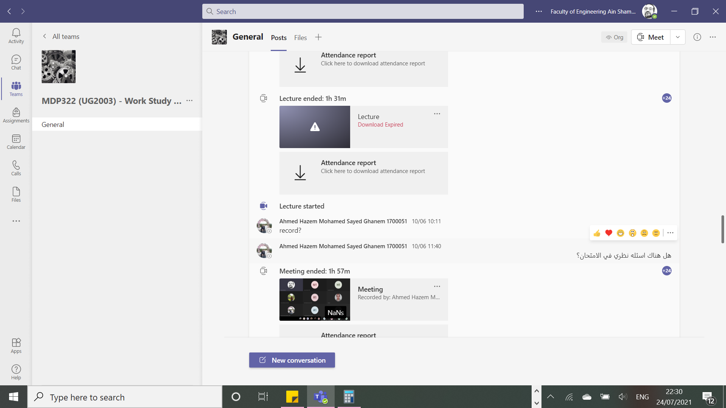

3 – Student assessment
Method of assessment Percentage of total

Final Written examination

Oral examination
70%

30%
Practical/laboratory work

Other assignments/class work

Total 100%

Members of examination committee
…Prof. Amin El-Kharbotly…..
…Prof. Nahid Afia…..
…Dr. Mohammed El-Beheiry…..

Role of external evaluator
………………………………….
………………………………….

4- Facilities and teaching materials
X

Totally adequate

Adequate to some extent

Inadequate
List any inadequacies
……………………………........

5- Administrative constraints

List any difficulties encountered
………………………………..
………………………………..

6- Student evaluation of the course: Response of Course Team

list any criticisms
“It would be better if the teaching assistant provided model answers for the sheets and assignments because in this specific course, students really need them. and there is a little bit of time that goes wasted in the sections for reading questions, this time could be benefited from and improve our experience.”

Reply: The teaching staff always encourage students to try to solve he assignment problems prior to the tutorial session so at the tutorial the time could be directed in answering the students’ questions.

“the course is very useful I understand the contact but I couldn't apply it on the problems.”

Reply: Most of the course problems are real case studies that are highly related to both the course content and the situation the students may face upon their graduation.

7- Comments from external evaluator(s): Response of Course Team
……………………………… ……………………..
……………………………… ……………………..
8- Course Enhancement:

Progress on actions identified in the previous year’s action plan:
Action | state whether or not completed and give reasons for non-completion
…………….. | ……………..

9- Action plan for academic year 2020 – 2021
Actions required | Completion Date | Person Responsible
Introduce Software in the course | 2021-2022 | Course coordinator
…………….. | …………….. | ……………..

Course coordinator:

Signature:

Date:

