|  |  |
| --- | --- |
| *Course report of* | |
| **Fundamentals of Engineering– ENG011– Fall 2020** | |
| University: Ain Shams | Faculty: Engineering |

## Basic Information

1. Title and code :

|  |
| --- |
| **Fundamentals of Engineering– ENG011** |

1. Program on which the course is given :

|  |  |
| --- | --- |
| |  | | --- | | All Programs | |

1. Year/Level of program :

|  |
| --- |
| 1st Level |

1. Units/Credit Hours

|  |  |
| --- | --- |
| ( i ) Lecture : | 2 |

|  |  |
| --- | --- |
| ( ii ) Tutorial/Practical : | 1+0 |

|  |  |
| --- | --- |
| ( iii ) Total : | 3 |

1. Names of lecturers contributing to delivery of the course :

|  |  |
| --- | --- |
| i - | Prof. Moussa ElSaied  Dr. Ismail Hafez Dr. Micha |

|  |  |
| --- | --- |
| ii - | Dr Shaimaa Fathy |
| iii - |  |
| iv - |  |
|  |  |

|  |  |
| --- | --- |
| Course coordinator: | Dr Samy Afifi |

|  |  |
| --- | --- |
| External evaluator: | --- --- --- |

## Statistical Information

|  |  |  |  |  |  |  |  |  |  |  |  |  |
| --- | --- | --- | --- | --- | --- | --- | --- | --- | --- | --- | --- | --- |
| **F** | **P** | **D** | **D+** | **C-** | **C** | **C+** | **B-** | **B** | **B+** | **A-** | **A** | **Grade** |
| 56 | 17 | 25 | 21 | 17 | 13 | 21 | 49 | 45 | 54 | 14 | 2 | **No. of students** |



## Professional Information

1. **Course Teaching:**

|  |  |  |  |
| --- | --- | --- | --- |
| **Week** | **Course Content** | **Total** | **Lecturer** |
| 1 | Introduction to Fundamentals of Engineering | 3 | All Lecturers |
| 2 | The Engineering Approach to Problem Solving | 3 | All Lecturers |
| 3 | Effective Study & Career Exploration | 3 | All Lecturers |
| 4 | Engineering Ethics and Critical Thinking | 3 | All Lecturers |
| 5 | International System of Units & Mathematical Branches | 3 | All Lecturers |
| 6 | General Disciplines (I) Introduction * | 3 | All Lecturers |
| 7 | General Specialization (I) Simple applications ** | 3 | All Lecturers |
| 8 | General Disciplines (II) Introduction * | 3 | All Lecturers |
| 9 | General Specialization (II) Simple applications ** | 3 | All Lecturers |
| 10 | General Disciplines (III) Introduction * | 3 | All Lecturers |
| 11 | General Specialization (III) Simple applications ** | 3 | All Lecturers |
| 12 | General Disciplines (IV) Introduction * | 3 | All Lecturers |
| 13 | General Specialization (IV) Simple applications ** | 3 | All Lecturers |

**Topics taught as a percentage of the content specified:**

**>90 % X 70-90 % <70%**

**Reasons in detail for not teaching any topic**

NA

**Teaching and learning methods:**

Asynchronous and Synchronous (Online) Lectures: **X**

Online Assignments: **X**

Technical Reports:

x

Distance Class Activity: **(Tutorials) X**

All methods were Distance Learning based.

Link for Course Team: <https://teams.microsoft.com/l/team/19%3a24351ebd21c14a29bccd16fa5c3fe8af%40thread.tacv2/conversations?groupId=fc332d44-bdf3-4e6c-9268-e7c0ed693c76&tenantId=ad2a8324-bef7-46a8-adb4-fe51b6613b24>

**Case Study:**

Other assignments/homework: **NA**

If teaching and learning methods were used other than those specified, list and give reasons:

1. **Student assessment:**

|  |  |
| --- | --- |
| **Method of assessment** | **Percentage of total** |
| Written examinations (final + midterm) | 65 % |
| Oral examination | 0 % |
| Practical/laboratory work | 0% |
| Other assignments/class work | 35 % |

**Members of examination committee**

i – Dr Mohamed El Banna

ii- Dr Samy Afifi

**Role of external evaluator**

N/A………………………………………………………………………………………….

1. **Facilities and teaching materials:**

x

Totally adequate

Adequate to some extent

Inadequate

List any inadequacies

1. **Administrative constraints:**

List any difficulties encountered

No difficulties

1. **Student evaluation of the course:**

| **Question** | **Score** |
| --- | --- |
| The course syllabus was clearly explained at the beginning of the semester | 82% |
| I am aware of the course learning outcomes (ILOs). | 79% |
| The teaching methods used helped and supported me to learn | 79% |
| Course topics are explained well in the teaching sessions. | 75% |
| The course activities helped me to achieve the learning outcomes (ILOs) efficiently. | 79% |
| The course assessments were clear and their distribution were clearly announced and organized. | 79% |
| I felt well supported on this course from instructor and teaching assistant (if any). | 75% |
| I have been able to contact instructor when I needed to. | 61% |
| The course focused on what was set out in the course specification and all are presented. | 78% |
| The instructor provided well written laboratory instructions (if any). | 79% |
| Adequate technical support and supervision were provided during the laboratory sessions (if any). | 71% |
| The laboratory was well integrated with the course pacing (if any). | 75% |
| The course digital materials on LMS are helpful in supporting my learning. | 72% |
| Overall, I was satisfied with my experience of this course. | 79% |
| I learn from online teaching activities, similar to on campus teaching activities. | 59% |
| The instructor used appropriate communication tools for online teaching. | 71% |
| The instructor pays attention to the student's achievement during online class. | 69% |
| The instructor encouraged active participation and discussion during online class. | 71% |
| I could pass the online course without any staff assistance. | 57% |
| The instructor respected to start / finish online lectures on scheduled times | 75% |

Small Sample

Written comments: One refused the distance learning, the other one is on the contrary and much appreciate this approach.

**Response of Course Team**

1. **Comments from external evaluator(s): Response of course team**

………**N/A** ………………. …………………………….

**Link to MS Teams:**

<https://teams.microsoft.com/l/team/19%3a24351ebd21c14a29bccd16fa5c3fe8af%40thread.tacv2/conversations?groupId=fc332d44-bdf3-4e6c-9268-e7c0ed693c76&tenantId=ad2a8324-bef7-46a8-adb4-fe51b6613b24>

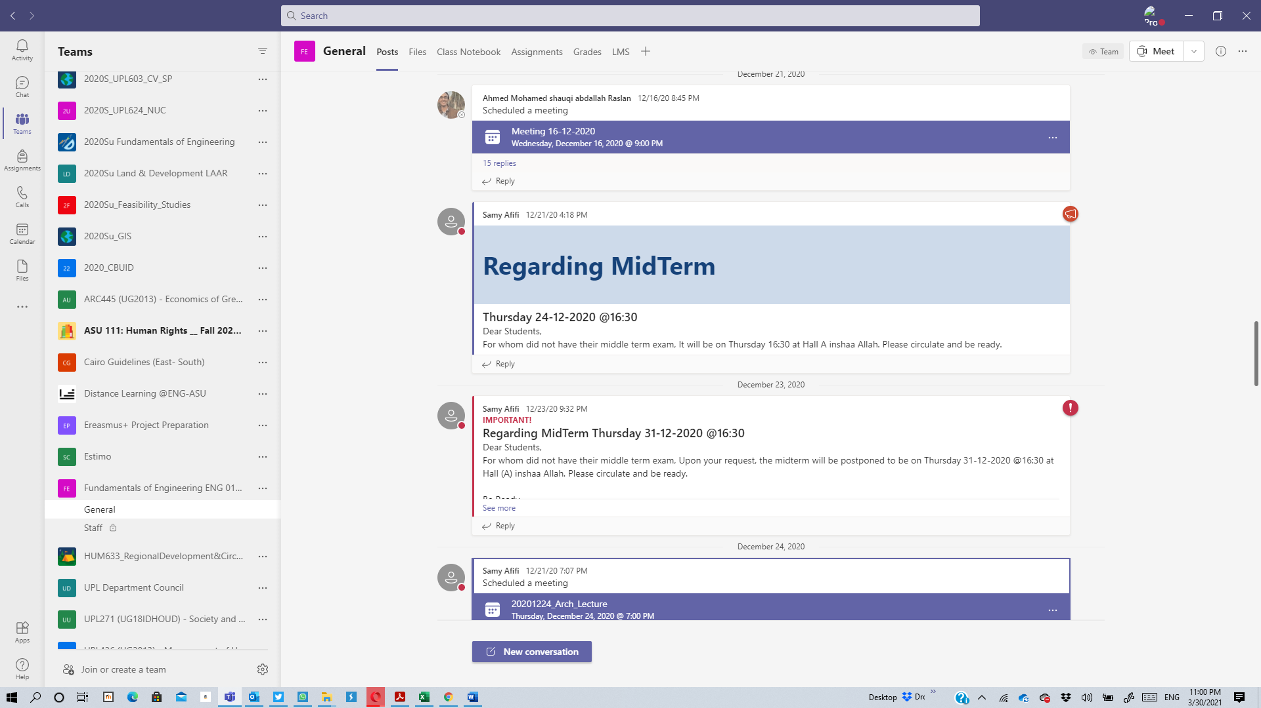

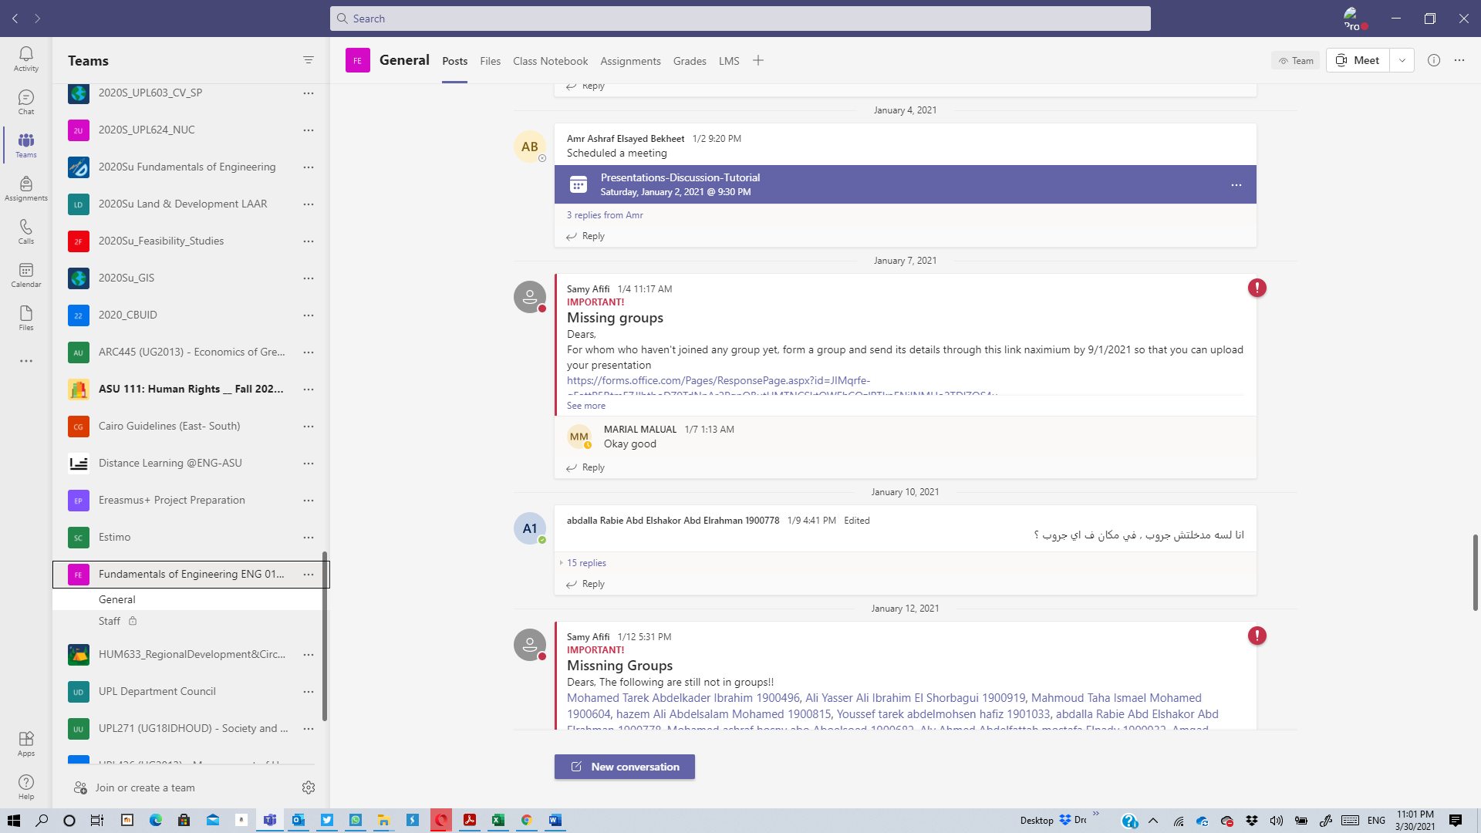

**Videos Samples**

Lectures (Synchronous)

<https://web.microsoftstream.com/video/684a7b48-5903-4eb4-ad15-691b5c2a21e5>

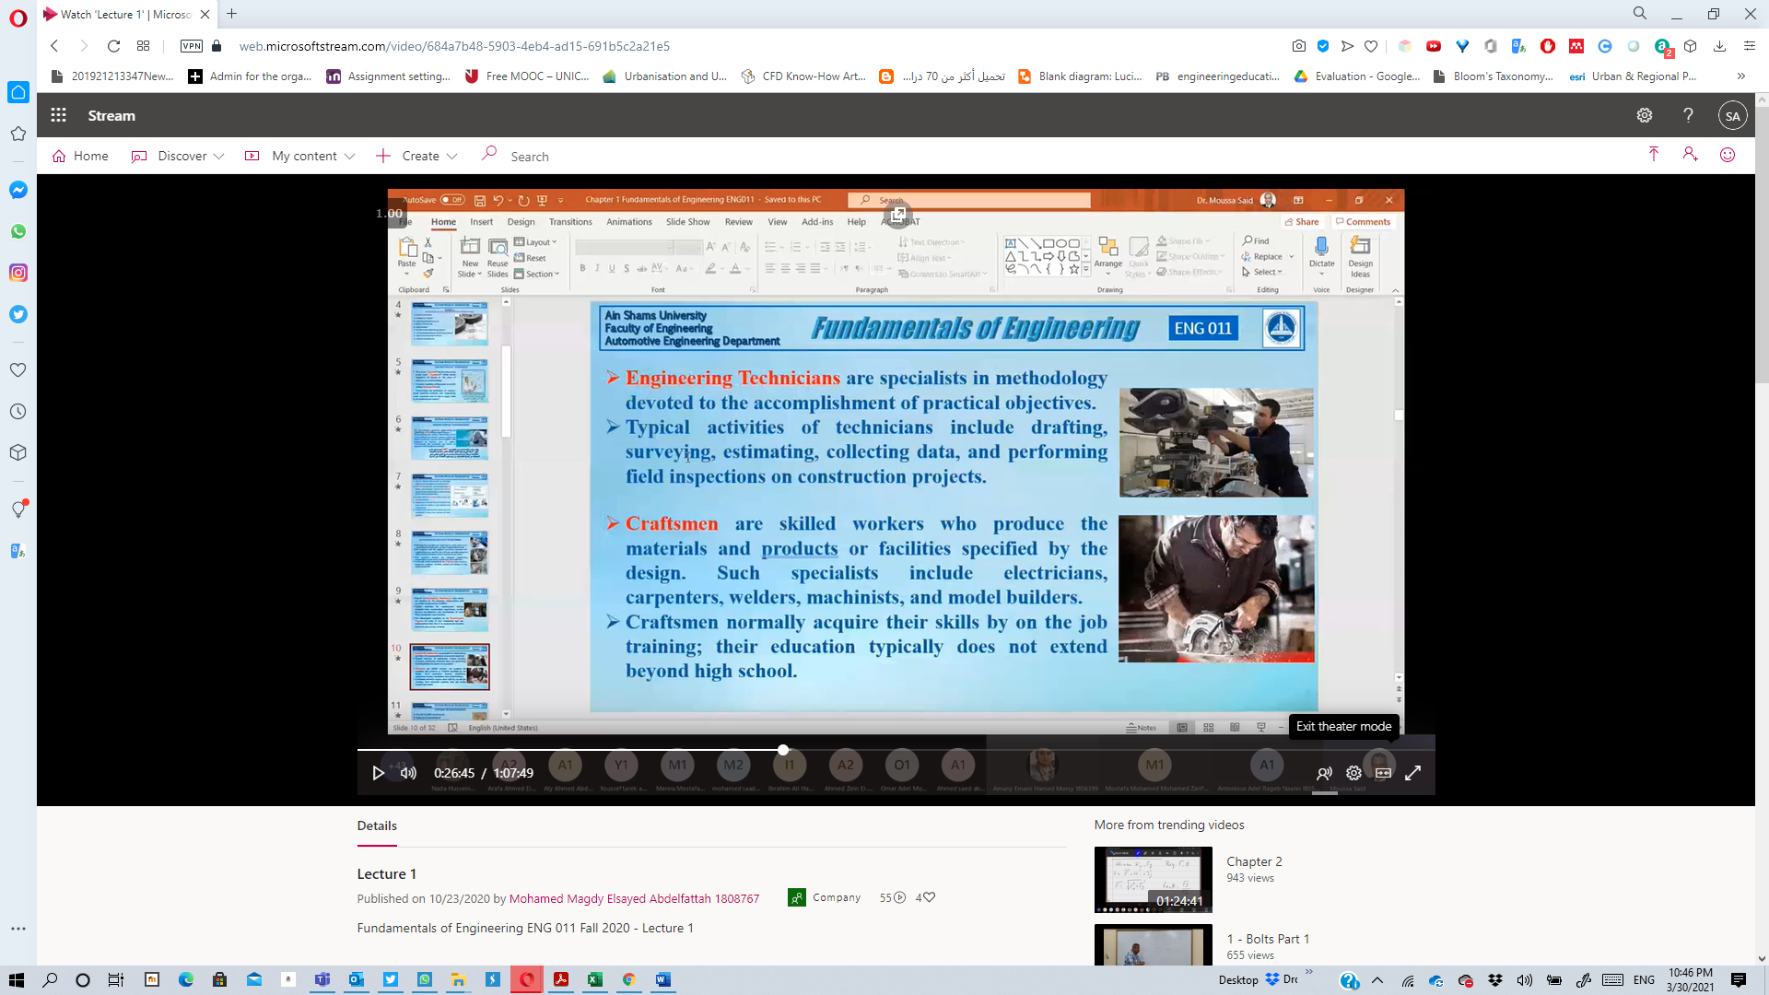

<https://web.microsoftstream.com/video/50ba4532-e1b3-47d1-a42b-295dbed2c7cf>

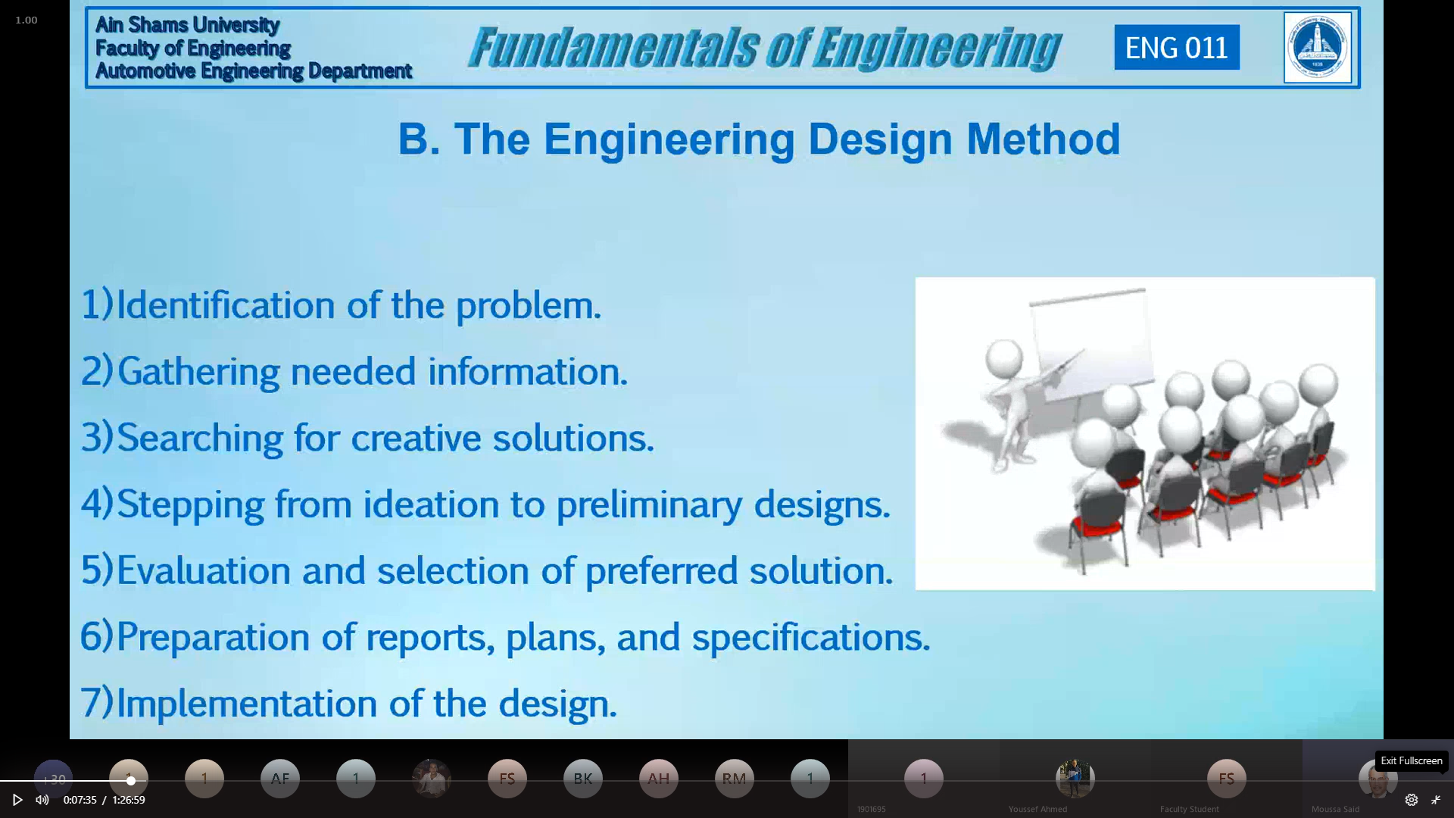

**Lectures (Asynchronous)**

<https://www.youtube.com/watch?v=qWdtJkAMaPY&ab_channel=MohamedAnwar>

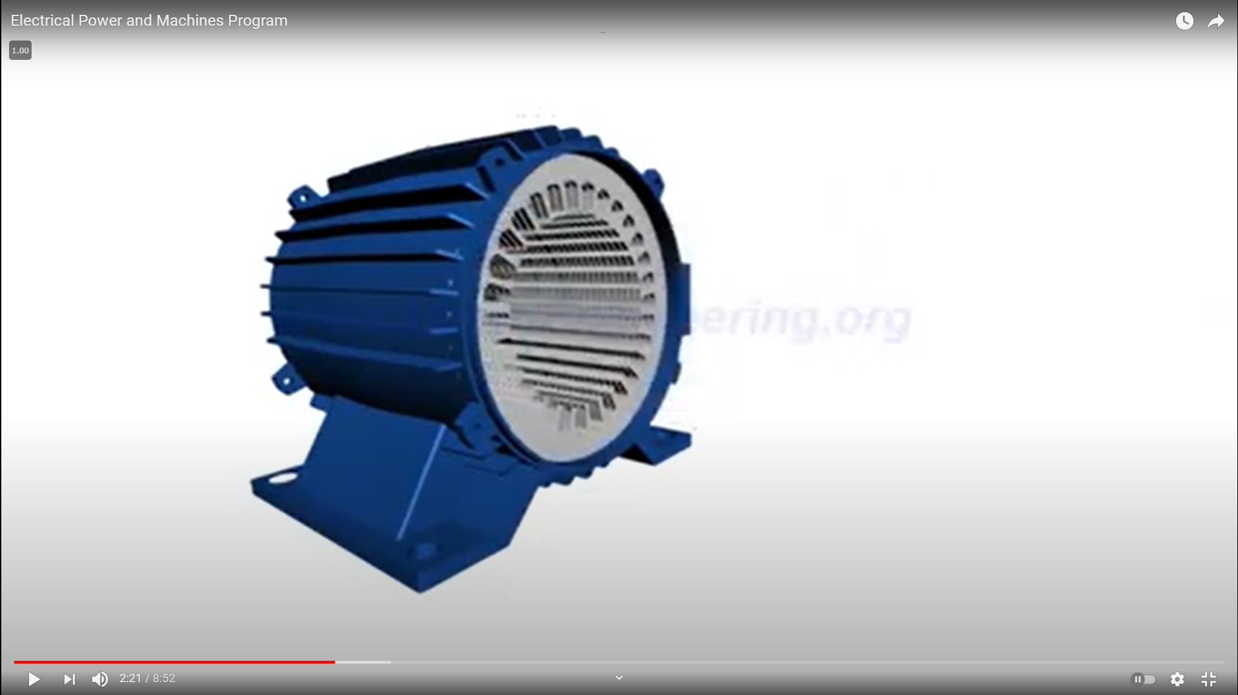

**Tutorial**

<https://web.microsoftstream.com/video/b8bf3034-8621-42b1-8b85-dd8af3ac93c3>

