**A. Basic Information**

|  |  |
| --- | --- |
| 1. **Title and Code:** | **Manufacturing Technology (3)** – **MDP 321** |
|  |  |
| 1. **Program in which the course is given:** | **Design and Production Engineering** |
|  |  |
| 1. **Year/ Level of program** | **Spring 2021 - Sophomore** |
|  |  |
| 1. **Units/ Credit Hours** 2. **Lecture** 3. **Tutorial** 4. **Lab** 5. **Total** | 4 hrs. per week  1 hr. per week  2 hrs. per week  7 hrs. per week |
|  |  |
| 1. **Lecture:** |  |
|  |  |
| 1. **Names of Lecturers contributing to the delivery of the course:** | Prof. Mohamed Hazem Abdellatif  Prof. Ahmed Moneed  Dr. Mohamed Adel Rizk  Dr. Mahmoud Zakaria |
|  |  |
| 1. **Course coordinator:** | Prof. Ahmed Moneeb |
|  |  |
| 1. **External Evaluator:** |  |

**B. Statistical Information**

|  |  |
| --- | --- |
| **No. of students attending the course** | 37 |

|  |  |  |  |
| --- | --- | --- | --- |
|  | | ***Number*** | ***Percentage/Attendee*** |
| **Students completing the course** | | 37 | 100% |
| **Results** | Passed | 28 | 75.68% |
| Failed | 9 | 24.32% |
| **Grading of students** | Excellent | 3 | 8.1% |
| Very Good | 10 | 27% |
| Good | 8 | 21.6% |
| Pass | 7 | 18.9% |
| Weak | 6 | 16.2% |
| Very Weak | 1 | 2.7% |
| Abscent | 2 | 5.5% |

**C. Professional Information**

1. **Course Teaching**
2. **Lectures:**

|  |  |  |  |
| --- | --- | --- | --- |
| **Week** | **Topics** | **Lecture hours** | ***Lecturer*** |
| 1 | General Machining Types | 4 | Prof. Mohamed Hazem Abdellatif  Prof. Ahmed Moneed  Dr. Mohamed Adel Rizk  Dr. Mahmoud Zakaria |
| 2 | Tolerances and Allowances | 4 |
| 3 | Capstan and Turret Lathes | 4 |
| 4 | Milling Operations | 4 |
| 5 | Gear Cutting Operations | 4 |
| 6 | Grinding Operations | 4 |
| 7 | Electrochemical and electro-discharge machining | 4 |
| 8 | Introduction to Forming Processes | 2 |
| 9 | Forging Processes | 2 |
| 10 | Roll Pass Design | 2 |
| 11 | Extrusion Processes | 2 |
| 12 | Drawing Processes | 2 |
| 13 | Forming methods for polymers | 4 |
| 14 | High energy rate forming processes | 6 |
| 15 | Powder metallurgy & Ceramic and composite materials | 6 |
|  | **TOTAL** | 60 |

1. **Tutorials:**

|  |  |  |  |  |
| --- | --- | --- | --- | --- |
| **Week** | **Exercise** | **Tutorial hours** | **Lab** | **Instructor** |
| 1 | Tolerances and Allowances | 3 |  | Prof. Mohamed Hazem Abdellatif  Prof. Ahmed Moneed  Dr. Mohamed Adel Rizk  Dr. Mahmoud Zakaria  Eng. Bassant Hany |
| 2 | Capstan and Turret Lathes |  | 6 |
| 3 | Milling Operations |  | 3 |
| 4 | Gear Cutting Operations |  | 6 |
| 5 | Grinding Operations |  | 3 |
| 7 | Introduction to Forming Processes | 3 |  |
| 8 | Forging Processes |  | 3 |
| 9 | Roll Pass Design | 3 |  |
| 10 | Extrusion Processes |  | 3 |
| 11 | Drawing Processes |  |  |
| 13 | High energy rate forming processes | 3 |  |
| 14 | Powder metallurgy | 3 |  |
| 15 | Ceramic and composite materials |  | 3 |
|  | **TOTAL** | **15** | 30 |

**Due to COVID-19, the lectures were taught 50% face-to-face and 50% online using Microsoft Teams platform. The labs and tutorials were taught physical in the campus.**

**Microsoft Teams link**

[**https://teams.microsoft.com/_?culture=en-us&country=US&lm=deeplink&lmsrc=homePageWeb&cmpid=WebSignIn#/school/conversations/General?threadId=19:d3dbbdb0a92e42868f09efb7554f4ad4@thread.tacv2&ctx=channel**](https://teams.microsoft.com/_?culture=en-us&country=US&lm=deeplink&lmsrc=homePageWeb&cmpid=WebSignIn#/school/conversations/General?threadId=19:d3dbbdb0a92e42868f09efb7554f4ad4@thread.tacv2&ctx=channel)

**LMS link**

[**https://lms.eng.asu.edu.eg/course/view.php?id=7702**](https://lms.eng.asu.edu.eg/course/view.php?id=7702)

**Topics Taught as a percentage of the content specified**

 

**Reasons in detail for not teaching any topic**



**If any topics were taught which are not specified, give reasons in detail**



1. **Teaching and learning methods:**









**Case Study:**

Other assignments/homework:

1. **Student assessment:**

|  |  |  |  |
| --- | --- | --- | --- |
| **Assessment method** | | **Week No** | **Weight (%)** |
| Assignments | | 2-10 | 5 |
| Quizzes | | 4,10 | 5 |
| Midterm Exam | | 7 | 15 |
| Oral Exam | | 14 | 15 |
| Final Exam | | 15 | 60 |
| 100% |

Members of examination committee: 1- Prof. [Mohamed](https://portal.eng.asu.edu.eg/users/287) Hazem Abdellatif

2- Prof. Ahmed Moneeb

3- Dr. [Mohamed](https://portal.eng.asu.edu.eg/users/259) Adel Rizk

4- Dr..Mahmoud Zakaria



Role of external evaluator:



1. **Facilities and teaching materials:**







**List any inadequacies:**

1. **Administrative constraints:**
2. **Comments from external evaluator(s)**

|  |  |
| --- | --- |
| ***Comment*** | ***Response of course Team*** |
|  |  |
|  |  |
|  |  |
|  |  |

1. **Course enhancement: Progress on actions identified in the previous year’s action plan:**

**Action plan**

|  |  |  |
| --- | --- | --- |
| ***Action required*** | ***Completion date*** | ***Person responsible*** |
|  |  |  |
|  |  |  |
|  |  |  |
|  |  |  |
|  |  |  |

1. **Questionnaire statistics:**

**Student evaluation of the course:**

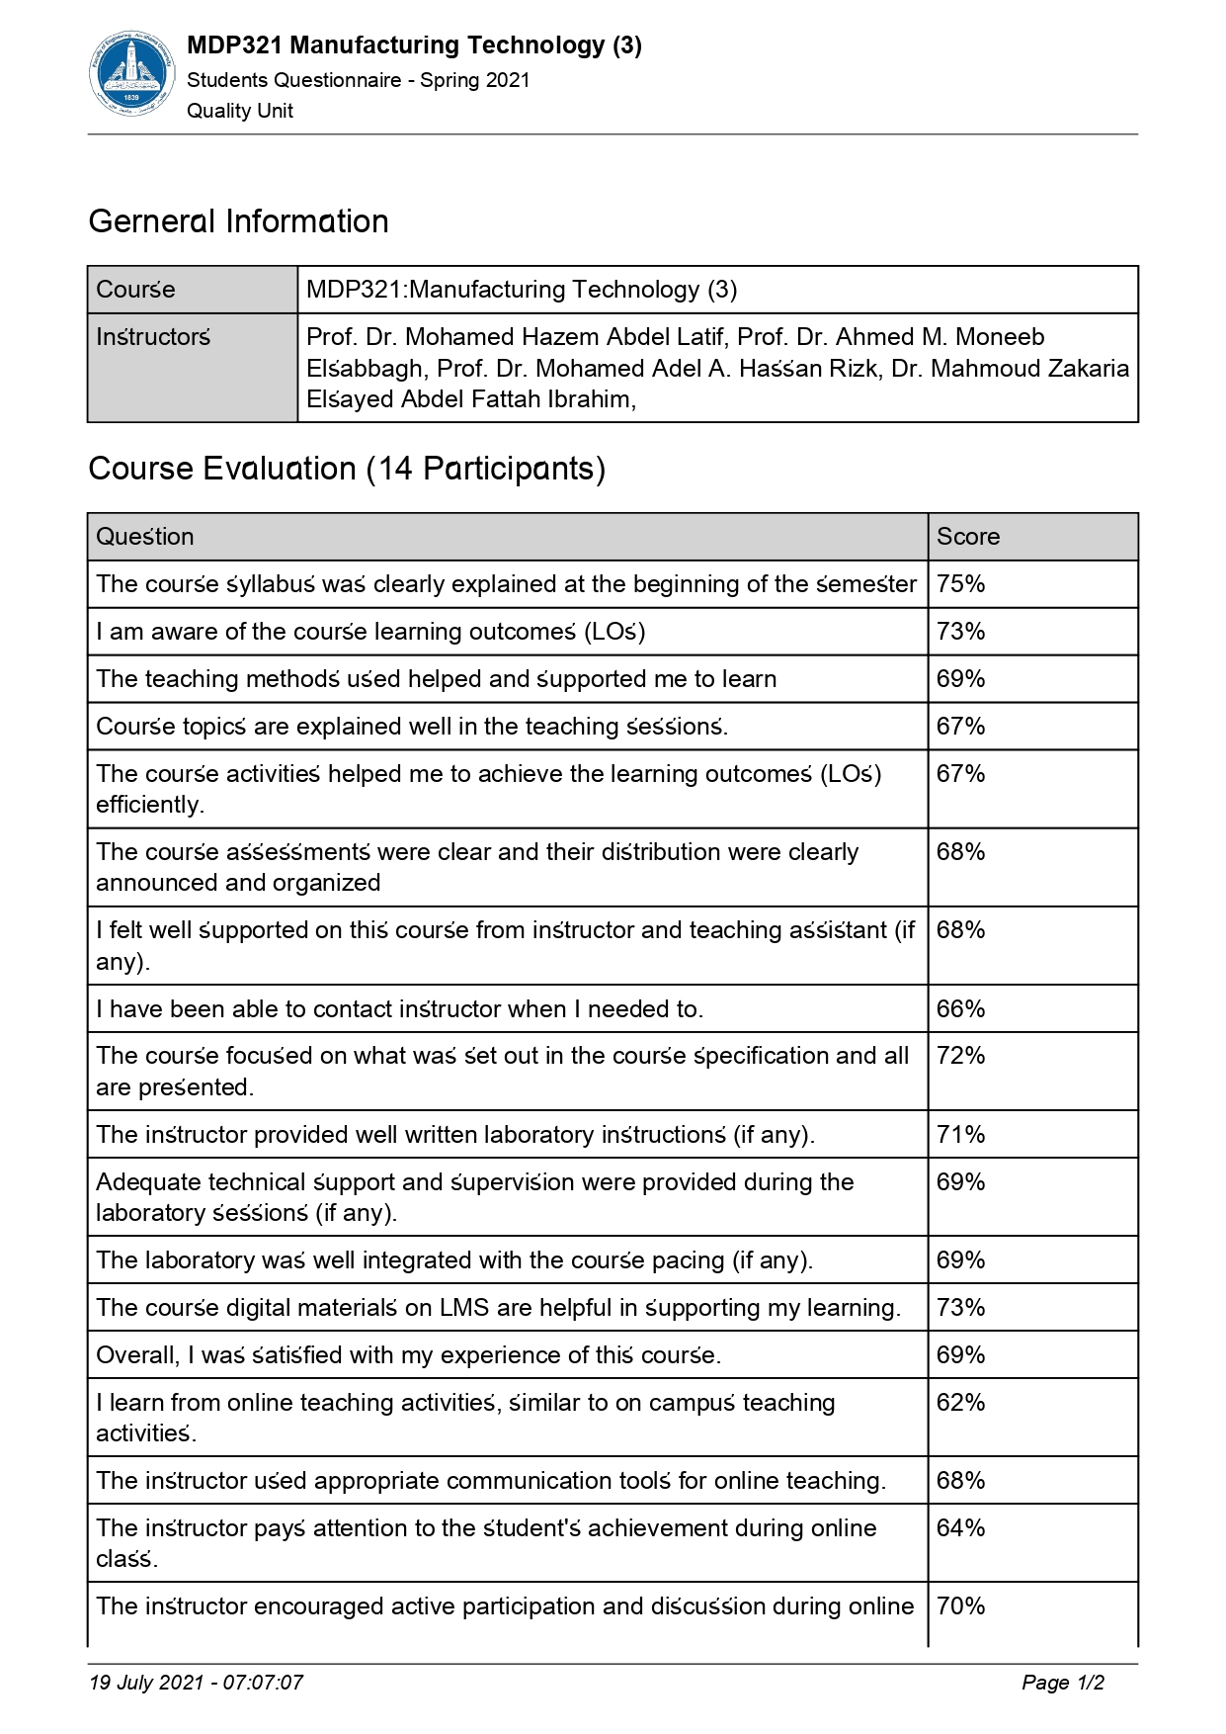

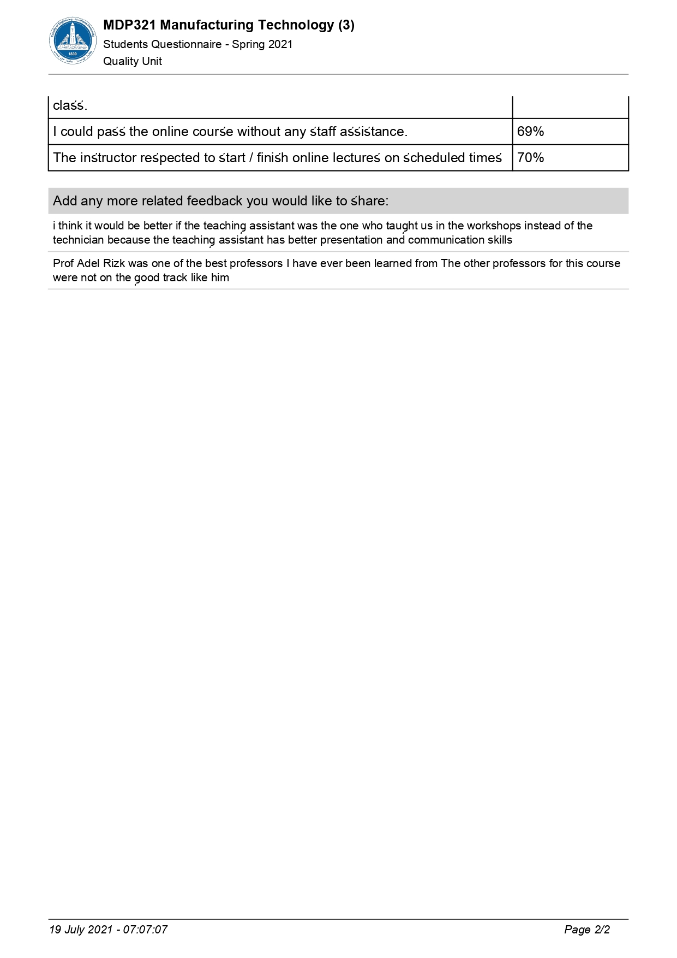

1. **Feedback:**

No item in the students’ questionnaire is below 50%.