|  |  |
| --- | --- |
| *Course report of* | |
| Computing in Engineering **– CSE031** – Summer 2020 | |
| University: Ain Shams | Faculty: Engineering |

## Basic Information

1. Title and code :

|  |
| --- |
| Computing in Engineering **– CSE031** |

1. Program on which the course is given :

|  |  |
| --- | --- |
| |  | | --- | | General | |

1. Year/Level of programs :

|  |
| --- |
| Prep. Year |

1. Units/Credit Hours

|  |  |
| --- | --- |
| ( i ) Lecture : | 2 |

|  |  |
| --- | --- |
| ( ii ) Tutorial/Practical : | 0 |

|  |  |
| --- | --- |
| ( iii ) Total : | 0 |

1. Names of lecturers contributing to delivery of the course :

|  |  |
| --- | --- |
|  | Dr. Mohamed Taher |
|  | Dr.[Hesham](https://portal.eng.asu.edu.eg/instructors/381) Mahmoud Farag |
|  | Dr. Manal Mourad Zaki |
|  | Dr. Hassan Shehatah Bedor |
| i - | Dr. Sahar Haggag |

|  |  |
| --- | --- |
| Course coordinator: | Dr. Mohamed Taher |

|  |  |
| --- | --- |
| External evaluator: | N/A |

## Statistical Information

|  |  |
| --- | --- |
| No. of students attending the course: | 1820 |

|  |  |  |  |
| --- | --- | --- | --- |
|  | | **Number** | **Percentage (%)** |
| **No. of students completing the course** | | 1820 | 100.00% |
| **Results** | Passed | 1532 | 84.18% |
| Failed | 288 | 15.82% |
| **Grading of successful students** | A+ | 0 | 0.00% |
| A | 12 | 0.66% |
| A- | 67 | 3.68% |
| B+ | 182 | 10.00% |
| B | 232 | 12.75% |
| B- | 240 | 13.19% |
| C+ | 174 | 9.56% |
| C | 181 | 9.95% |
| C- | 134 | 7.36% |
| D+ | 136 | 7.47% |
| D | 174 | 9.56% |

## Professional Information

1. **Course Teaching:**

|  |  |  |
| --- | --- | --- |
| **Week** | **Course Content** | **Lecture**  **Hours** |
| 1 | The components of a computer system | 4 |
| 2 | Data representation | 4 |
| 3 | Computer networks | 4 |
| 4 | Problem solving using computational techniques | 4 |
| 5 | Relational Database | 4 |
| 6 | Cloud Computing | 2 |
| 7 | Internet of things (IOT) | 2 |
| 8 | Virtual reality | 2 |
| 9 | Big Data | 2 |
| Total Number of Hours | | 28 |

**Topics taught as a percentage of the content specified:**

**>90 % ✓ 70-90 % <70%**

**Reasons in detail for not teaching any topic**

All topics were taught

**If any topics were taught which are not specified, give reasons in detail**

N/A

**Teaching and learning methods:**

On-Line Lectures: **✓**

Practical training/ laboratory:

Seminar/Workshop:

Class Activity: **(Tutorials)**

Microsoft teams was used to conduct on-line lectures and pop quizzes.

Two quizzes were elected to b graded, others were just like opendiscussion

Mid term exam was conducted using LMS and marked automatically

Assignments were announced and student response were via the LMS

Final Exam as a written exam.

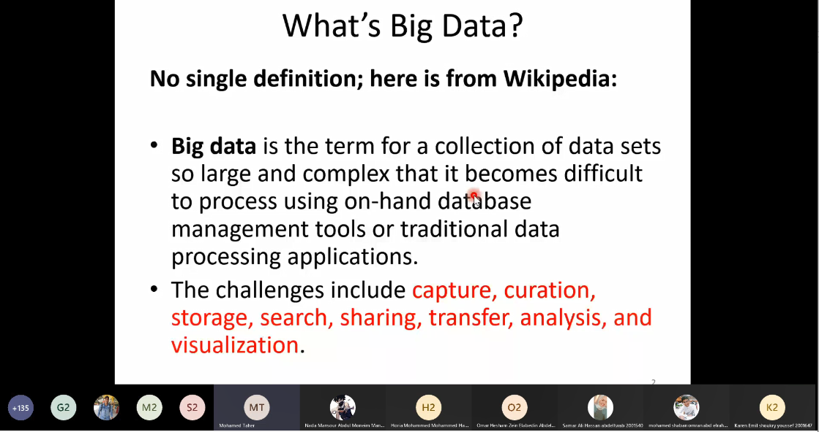

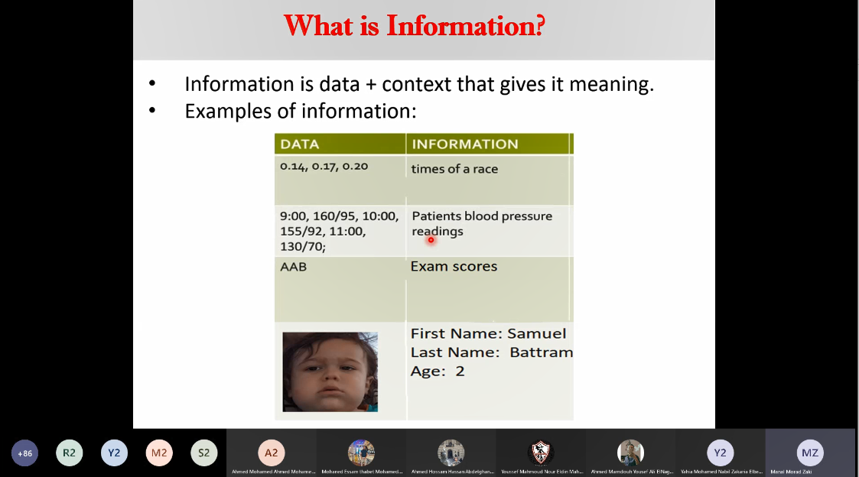

**Case Study:**

Other assignments/homework:

If teaching and learning methods were used other than those specified, list and give reasons:

………………………………………………………………………………………………

………………………………………………………………………………………………

1. **Student assessment:**

|  |  |
| --- | --- |
| **Method of assessment** | **Percentage of total** |
| Written examination | 60 % |
| Midterm examination | 25 % |
| Quizzes | 15 % |

**Members of examination committee**

|  |
| --- |
| Dr. Mohamed Taher |
| Dr.[Hesham](https://portal.eng.asu.edu.eg/instructors/381) Mahmoud Farag |
| Dr. Manal Mourad Zaki |
| Dr. Hassan Shehatah Bedor |
| Dr. Sahar Haggag |

**Role of external evaluator**

N/A………………………………………………………………………………………….

1. **Facilities and teaching materials:**

Totally adequate  **✓**

Adequate to some extent

Inadequate

List any inadequacies

1. **Administrative constraints:**

List any difficulties encountered

No difficulties

1. **Student evaluation of the course:**

Atached

1. **Comments from external evaluator(s): Response of course team**

………**N/A** ……………….