|  |  |
| --- | --- |
| *Course report of* | |
| |  | | --- | | Production Engineering – MDP 081- Fall 2020 | | |
| University: Ain Shams | Faculty: Engineering |

## Basic Information

1. Title and code :

|  |
| --- |
| Production Engineering – MDP 081 |

1. Program on which the course is given :

|  |  |
| --- | --- |
| |  | | --- | | All Programs | |

1. Year/Level of programs :

|  |
| --- |
| Freshmen |

1. Units/Credit Hours

|  |  |
| --- | --- |
| ( i ) Lecture : | 2 |

|  |  |
| --- | --- |
| ( ii ) Tutorial/Practical : | 3 |

|  |  |
| --- | --- |
| ( iii ) Total : | 5 |

1. Names of lecturers contributing to delivery of the course :

|  |  |
| --- | --- |
|  | Prof. Taher Abou El-Yazied |
| - | Dr. Mansour El-Bardisi |
|  | Prof. Hala Abd El-Hakim Hassan |
|  |  |

|  |  |
| --- | --- |
| Course coordinator: | **Prof. Taher Abou El-Yazied** |

|  |  |
| --- | --- |
| External evaluator: | --- --- --- |

## Statistical Information

|  |  |
| --- | --- |
| No. of students attending the course: | 1079 |

|  |  |  |  |  |  |  |  |  |  |  |  |  |  |
| --- | --- | --- | --- | --- | --- | --- | --- | --- | --- | --- | --- | --- | --- |
|  | A+ | A | A- | B+ | B | B- | C+ | C | C- | D+ | D | F | SUM |
| Students No. | 33 | 115 | 173 | 196 | 157 | 110 | 66 | 59 | 25 | 35 | 51 | 59 | 1079 |
| Percentage (%) | 3.05 | 10.65 | 16.0 | 18.17 | 14.56 | 10.19 | 6.12 | 5.48 | 2.32 | 3.24 | 4.73 | 5.48 |  |

## Professional Information

1. **Course Teaching:**

|  |  |  |  |  |
| --- | --- | --- | --- | --- |
| **No** | **Course Content** | **Lecture**  **(hours)** | **Lab.**  **(hours)** | **Total** |
| 1 | Introduction- materials classification and industrial safety | 2 | 3 |  |
| 2 | Carpentry Shop (machines- types of wood) | 2 | 3 |  |
| 3 | Sheet metal work | 2 | 3 |  |
| 4 | Bulk Forming | 2 | 3 |  |
| 5 | Casting | 2 | 3 |  |
| 6 | Welding | 2 | 3 |  |
| 7 | Polymers types and some manufacturing process | 2 | 3 |  |
| 8 | Hand Processes | 2 | 3 |  |
| 9 | Turning | 4 | 6 |  |
| 10 | Drilling | 2 | 3 |  |
| 11 | Shaping | 2 | 3 |  |
| 12 | Milling | 2 | 3 |  |
| 13 | Grinding | 2 | 3 |  |
| 14 | General discussion on advanced process | 2 | 3 |  |
|  | Total | 30 | **45** | **75** |

**Topics taught as a percentage of the content specified:**

**>90 % 70-90 % <70%**

**Reasons in detail for not teaching any topic**

**If any topics were taught which are not specified, give reasons in detail**

N/A………………………………………………………………………………………….

**Teaching and learning methods:**

Online meetings (lectures) via teams **X**

Practical training/ laboratory:

Seminar/Workshop (in campus): X

Class Activity: **(Tutorials)**

This semester, all the lectures were online while the workshops were in campus except the last two weeks after prime minister decision regarding remote teaching on Dec 31, 2020. The lectures were on teams, the team links are: <https://teams.microsoft.com/l/team/19%3a6c4640b7b3d74291b7f638e7d8ef07c1%40thread.tacv2/conversations?groupId=d7ca419c-bb8a-4aeb-aaae-69c13c2fa59b&tenantId=ad2a8324-bef7-46a8-adb4-fe51b6613b24>

<https://teams.microsoft.com/l/team/19%3ad615e3ca4d7c49c39bb7e705bb71b463%40thread.tacv2/conversations?groupId=d9b205fe-f2ac-4221-ae79-5bd5442bbe8a&tenantId=ad2a8324-bef7-46a8-adb4-fe51b6613b24>

<https://teams.microsoft.com/l/team/19%3ab8c61ae6813849edab4a2e6d2597f8bb%40thread.tacv2/conversations?groupId=9dd7e672-8751-4844-b0f4-75e45cd2e07e&tenantId=ad2a8324-bef7-46a8-adb4-fe51b6613b24>

**Sample of lectures via teams is shown below:**

The percentage of students attended online workshop was 80%. Two attendance files are attached.

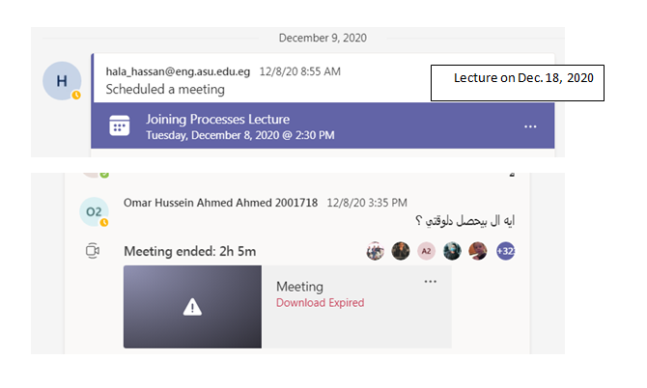

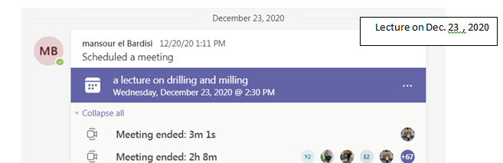

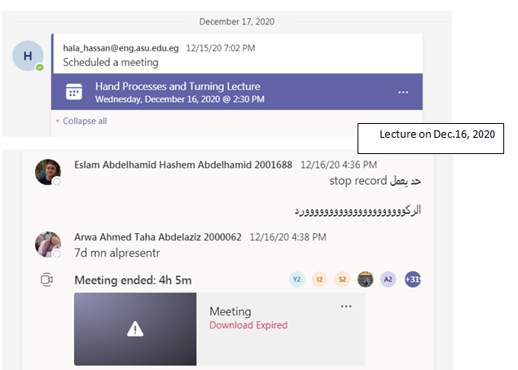

**Case Study:**

**Other assignments/homework:**

If teaching and learning methods were used other than those specified, list and give reasons:

**Student assessment:**

|  |  |
| --- | --- |
| **Method of assessment** | **Percentage of total** |
| Written examination ( In campus) | 50 % |
| Midterm Exam (In campus) | 15% |
| Practical/Oral examination ( In campus) | 10 % |
| Other (reports-quizzes) – project (In campus) | 25% |

**All assessments were in campus.**

**Members of examination committee**

i – **Prof. Taher Abou El-Yazied**

-Dr. Mansour El-Bardisi

-Prof. Hala Abd El-Hakim Hassan

**Role of external evaluator**

N/A………………………………………………………………………………………….

1. **Facilities and teaching materials:**

Totally adequate

Adequate to some extent

Inadequate

**Administrative constraints:**

List any difficulties encountered

**3-Student evaluation of the course:** **N/A**

**4-Comments from external evaluator(s):**

**Response of course team**……… **N/A** ……………….