*Course report of*

|  |
| --- |
| **Probability and Statistics - PHM 111s Spring 2021** |

|  |  |
| --- | --- |
| **University Ain Shams** | **Faculty** **Engineering** |

**A- Basic Information**

1. **Title and code:**

**Probability and Statistics - PHM 111s Spring 2021**

1. **Program(s) on which this course is given:**

**All 12 Engineering Programs**

**3. Year/ Level of programs:** 1st year – Level 1

**1. Units/Credit hours:**

1. Lectures 2 hours per week
2. Tutorial/Practical 2 hours per week
3. Total 4 hours per week

**2. Names of lecturers contributing to the delivery of the course**

Dr. Rabab Moustafa El-Hassani

Course coordinator: Dr. Rabab Moustafa El-Hassani

External evaluator ………N/A……………………

**B- Statistical Information**

No. of students attending the course: 218

|  |  |  |  |  |  |  |  |  |  |  |  |  |  |  |
| --- | --- | --- | --- | --- | --- | --- | --- | --- | --- | --- | --- | --- | --- | --- |
| Grade | A+ | A | A- | B+ | B | B- | C+ | C | C- | D+ | D | P | F | Sum |
| Students No. | 0 | 0 | 2 | 5 | 9 | 14 | 10 | 19 | 15 | 12 | 32 | 48 | 52 | 218 |
| Percentage | 0 | 0 | 1 | 2 | 4 | 6 | 5 | 9 | 7 | 6 | 15 | 22 | 24 | 100% |

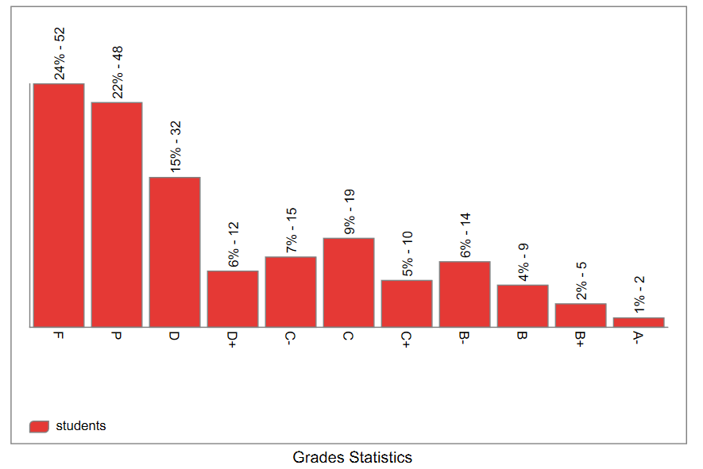

**C- Professional Information**

**C.1 – Course Lectures**

**Teaching using Online Learning tools**

|  |  |  |  |
| --- | --- | --- | --- |
| **Course Content (Part I)** | **Session Type**  **(Zoom, Team)** | **Lecture**  **Hours** | **Lecturer** |
| The Nature of Probability and Statistics: Data Collection and Sampling. | **Team** | **2** | Rabab Moustafa El-Hassani |
| Frequency Distributions and Graphs  (1): Organizing Data, Histograms. | **Team** | **3** | Rabab Moustafa El-Hassani |
| Frequency Distributions and Graphs  (2): Graphs. | **Team** | **2** | Rabab Moustafa El-Hassani |
| Data Description  (1): Measures of Central Tendency. | **Team** | **3** | Rabab Moustafa El-Hassani |
| Data Description  (2): Measures of Variation and  Position. | **Team** | **3** | Rabab Moustafa El-Hassani |
| Probability and Counting Rules  (1): Sample Spaces and Probability, Addition Rules. | **Team** | **2** | Rabab Moustafa El-Hassani |
| Probability and Counting Rules  (2): Multiplication Rules, Conditional Probability and Counting Rules. | **Team** | **2** | Rabab Moustafa El-Hassani |
| Discrete Random Variables and  Probability Distributions. | **Team** | **3** | Rabab Moustafa El-Hassani |
| Continuous Random Variables and Probability Distributions. | **Team** | **2** | Rabab Moustafa El-Hassani |
| Examples of Continuous Probability Distributions | **Team** | **2** | Rabab Moustafa El-Hassani |
| Joint Probability Distribution. | **Team** | **2** | Rabab Moustafa El-Hassani |
| Mathematical Expectation, Variance,  Covariance and Correlation of two  Random Variables. | **Team** | **2** | Rabab Moustafa El-Hassani |
| Total Lectures Hours |  | **28** |

**Topics taught as a percentage of the content specified:**

**>90 % X 70-90 % <70%**

Reasons in detail for not teaching any topic

N/A……………………………………….

……………………………………….

If any topics were taught which are not specified, give reasons in detail

N/A……………………..

………………………………………………

………………………………………………

………………………………………………

**2- Teaching and learning methods:**

Interactive Lectures

Practical training/ laboratory:

Seminar/Workshop:

Interactive Tutorials

## 

**Online Lectures using Microsoft Teams:**

Lec 1: <https://teams.microsoft.com/l/meetup-join/19%3ac1d13bb399ea4eb18a324c2bb8f126cc%40thread.tacv2/1616520034647?context=%7b%22Tid%22%3a%22ad2a8324-bef7-46a8-adb4-fe51b6613b24%22%2c%22Oid%22%3a%228c244c2c-820a-43c4-8834-b920016dc439%22%7d>

Lec 2: <https://teams.microsoft.com/l/meetup-join/19%3ac1d13bb399ea4eb18a324c2bb8f126cc%40thread.tacv2/1617095214202?context=%7b%22Tid%22%3a%22ad2a8324-bef7-46a8-adb4-fe51b6613b24%22%2c%22Oid%22%3a%228c244c2c-820a-43c4-8834-b920016dc439%22%7d>

Lec 3: <https://teams.microsoft.com/l/meetup-join/19%3ac1d13bb399ea4eb18a324c2bb8f126cc%40thread.tacv2/1617684012761?context=%7b%22Tid%22%3a%22ad2a8324-bef7-46a8-adb4-fe51b6613b24%22%2c%22Oid%22%3a%228c244c2c-820a-43c4-8834-b920016dc439%22%7d>

Lec 4: <https://teams.microsoft.com/l/meetup-join/19%3ac1d13bb399ea4eb18a324c2bb8f126cc%40thread.tacv2/1618306135516?context=%7b%22Tid%22%3a%22ad2a8324-bef7-46a8-adb4-fe51b6613b24%22%2c%22Oid%22%3a%228c244c2c-820a-43c4-8834-b920016dc439%22%7d>

Lec 5: <https://teams.microsoft.com/l/meetup-join/19%3ac1d13bb399ea4eb18a324c2bb8f126cc%40thread.tacv2/1618911563991?context=%7b%22Tid%22%3a%22ad2a8324-bef7-46a8-adb4-fe51b6613b24%22%2c%22Oid%22%3a%228c244c2c-820a-43c4-8834-b920016dc439%22%7d>

Lec 6: <https://teams.microsoft.com/l/meetup-join/19%3ac1d13bb399ea4eb18a324c2bb8f126cc%40thread.tacv2/1619526951300?context=%7b%22Tid%22%3a%22ad2a8324-bef7-46a8-adb4-fe51b6613b24%22%2c%22Oid%22%3a%228c244c2c-820a-43c4-8834-b920016dc439%22%7d>

Lec 7: <https://teams.microsoft.com/l/meetup-join/19%3ac1d13bb399ea4eb18a324c2bb8f126cc%40thread.tacv2/1621334826719?context=%7b%22Tid%22%3a%22ad2a8324-bef7-46a8-adb4-fe51b6613b24%22%2c%22Oid%22%3a%228c244c2c-820a-43c4-8834-b920016dc439%22%7d>

Lec 8 & 9& 10: <https://teams.microsoft.com/l/meetup-join/19%3ac1d13bb399ea4eb18a324c2bb8f126cc%40thread.tacv2/1621945514785?context=%7b%22Tid%22%3a%22ad2a8324-bef7-46a8-adb4-fe51b6613b24%22%2c%22Oid%22%3a%228c244c2c-820a-43c4-8834-b920016dc439%22%7d>

Lec 11& 12: <https://teams.microsoft.com/l/meetup-join/19%3ac1d13bb399ea4eb18a324c2bb8f126cc%40thread.tacv2/1622446728389?context=%7b%22Tid%22%3a%22ad2a8324-bef7-46a8-adb4-fe51b6613b24%22%2c%22Oid%22%3a%228c244c2c-820a-43c4-8834-b920016dc439%22%7d>

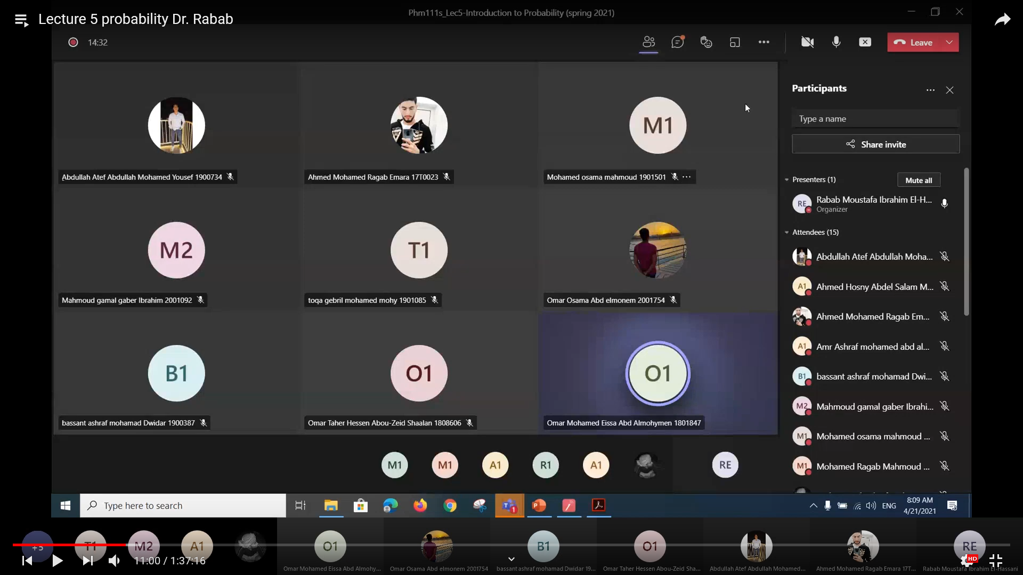

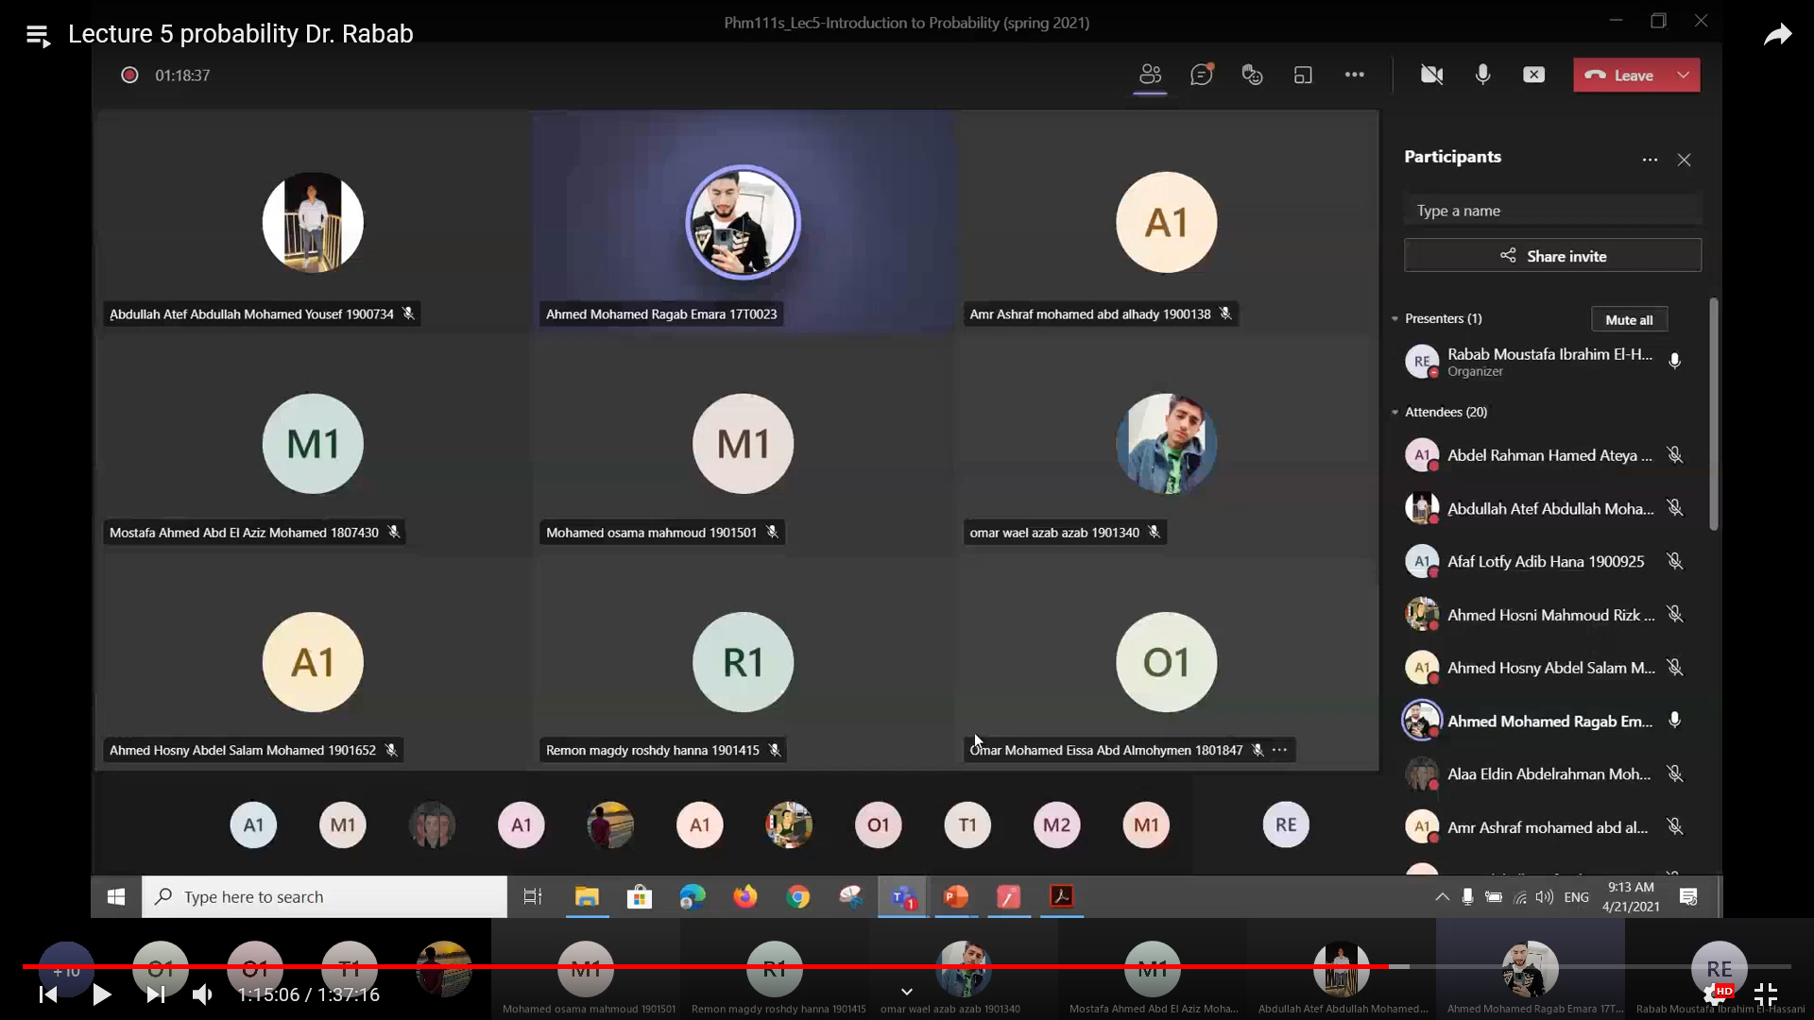

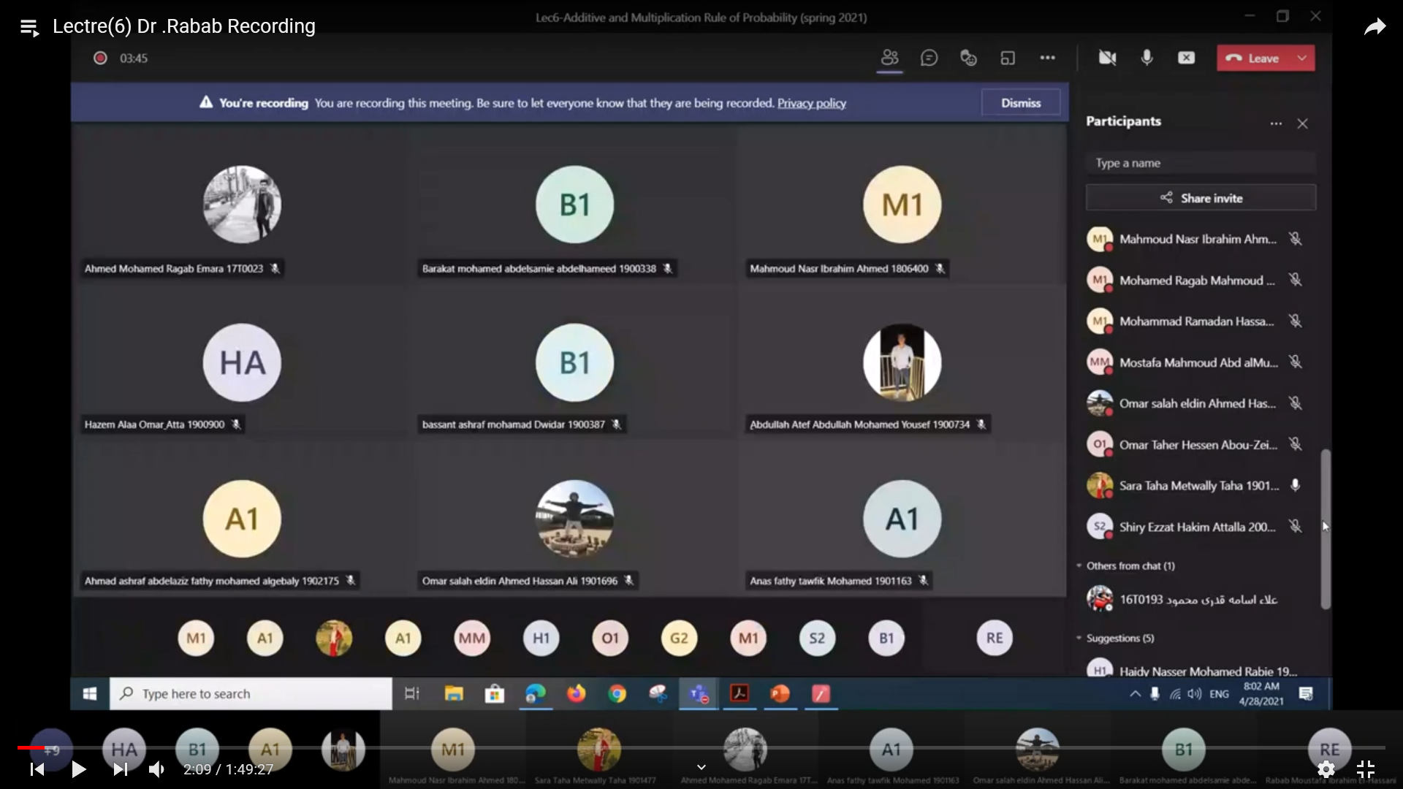

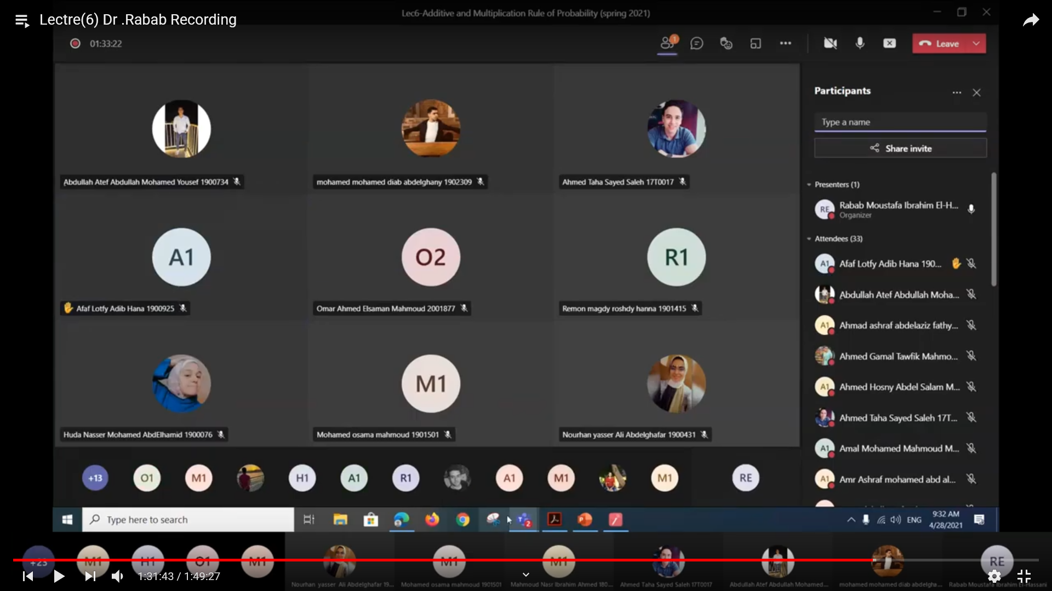

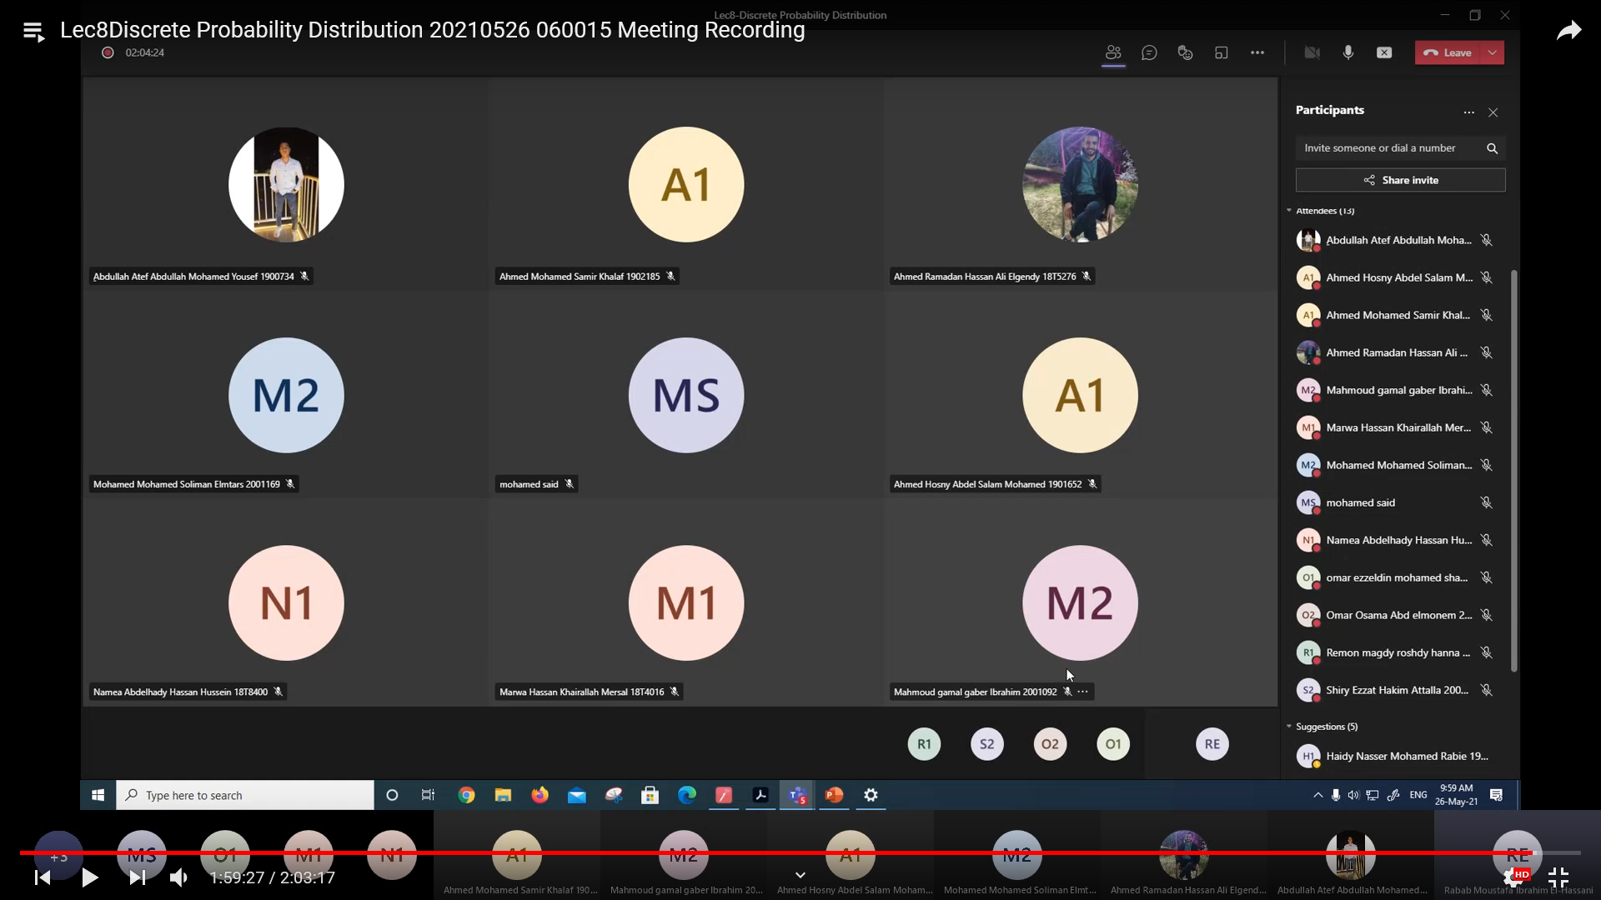

**Interactive Tutorials: (Microsoft Teams)**

**tutorials** **in Spring 2021**

[Mostafa Mahmoud Abd alMumin Mahmoud: Scheduled a meeting](https://teams.microsoft.com/l/message/19:d675e72f07f843aab3809275e50cb2e3@thread.tacv2/1617156158622?tenantId=ad2a8324-bef7-46a8-adb4-fe51b6613b24&groupId=19e40869-e203-4697-bef9-57b862cb6d71&parentMessageId=1617156158622&teamName=PHM111s%20(UG2018)%20-%20Probability%20and%20Statistics%20(18956)&channelName=Tutorial&createdTime=1617156158622)

posted in PHM111s (UG2018) - Probability and Statistics (18956) / Tutorial at Wednesday, March 31, 2021 4:02:38 AM (recurring every week)

[Mostafa Mahmoud Abd alMumin Mahmoud: Scheduled a meeting](https://teams.microsoft.com/l/message/19:d675e72f07f843aab3809275e50cb2e3@thread.tacv2/1623216288277?tenantId=ad2a8324-bef7-46a8-adb4-fe51b6613b24&groupId=19e40869-e203-4697-bef9-57b862cb6d71&parentMessageId=1623216288277&teamName=PHM111s%20(UG2018)%20-%20Probability%20and%20Statistics%20(18956)&channelName=Tutorial&createdTime=1623216288277)

posted in PHM111s (UG2018) - Probability and Statistics (18956) / Tutorial at Wednesday, June 9, 2021 7:24:48 AM

[Mostafa Mahmoud Abd alMumin Mahmoud: Scheduled a meeting](https://teams.microsoft.com/l/message/19:d675e72f07f843aab3809275e50cb2e3@thread.tacv2/1625159921403?tenantId=ad2a8324-bef7-46a8-adb4-fe51b6613b24&groupId=19e40869-e203-4697-bef9-57b862cb6d71&parentMessageId=1625159921403&teamName=PHM111s%20(UG2018)%20-%20Probability%20and%20Statistics%20(18956)&channelName=Tutorial&createdTime=1625159921403)

posted in PHM111s (UG2018) - Probability and Statistics (18956) / Tutorial at Thursday, July 1, 2021 7:18:41 PM

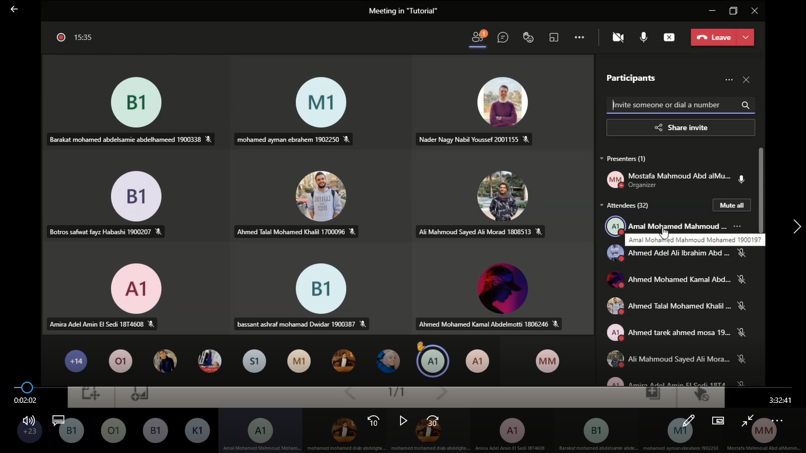

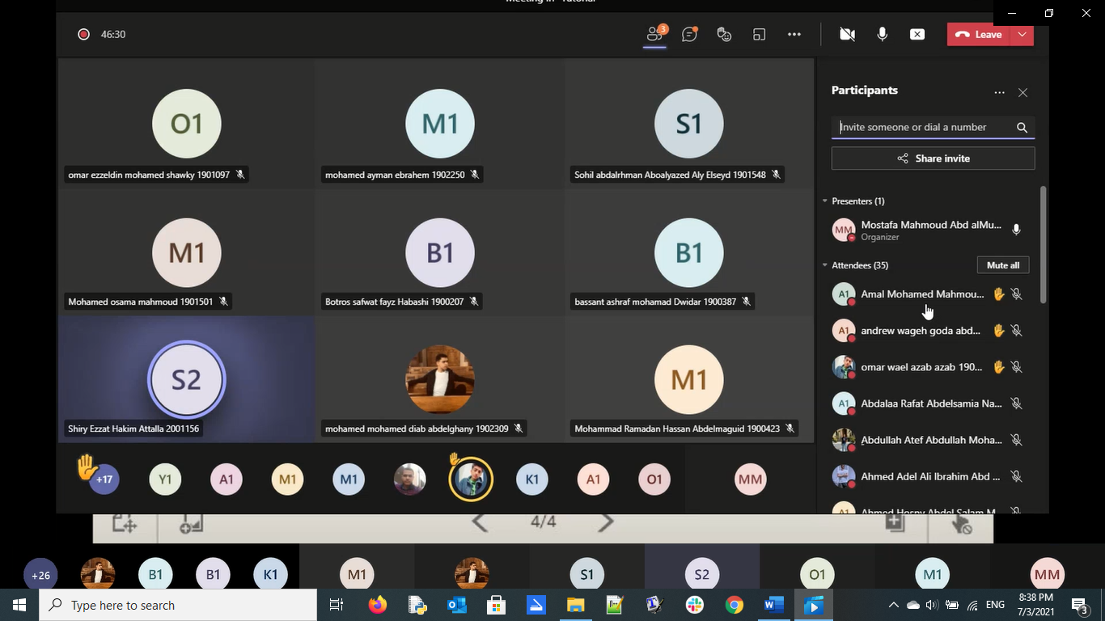

## Case Study:

Other assignments/homework:

If teaching and learning methods were used other than those specified, list and give reasons:

……………………………………………………………

……………………………………………………………

**3- Student assessment:**

Method of assessment Percentage of total

Written final examinations **60 %**

Practical/laboratory work  **0 %**

Mid-Term Exam  **20 %**

Online assignments/class work (Quizzes) **20%**

Total **100 %**

Members of examination committee

Dr. Rabab Moustafa El-Hassani

Role of external evaluator

…… **N/A** ………………………………

………………………………………

……………………………………....

**4- Facilities and teaching materials:**

**Facilities used for teaching and learning:**

* E-Learning Program (Moodle)
* Video conferencing tool (Team)

Totally adequate

Adequate to some extent

Inadequate

**5- Administrative constraints**

**6- Student evaluation of the course: Response of Course Team**

1. The time of exams and Quizzes is very little

**About 13 students in first Quiz and 23 in the second one takes full mark!!!**

1. ﺍﻭﻻ ﺍﻟﺪﻛﺘﻮﺭ ﻭﺍﻟﻤﻌﻴﺪ ﻓﻰ ﻏﺎﻳﻪ ﺍﻻﺣﺘﺮﺍﻡ ﻑ ﺍﻟﺘﻌﺎﻣﻞ ﻭﺍﻟﺸﺮﺡ ﻭﺑﻴﺴﺎﻋﺪﻭﺍ ﺟﺪﺍ ﺛﺎﻧﻴﺎ ﺍﻟﻤﺎﺩﺓ ﺳﻬﻠﺔ ﺍﻥ ﺍﺣﺰﺍ ﻧﻔﻬﻤﻬﺎ ﻭﻟﻜﻦ ﺍﻟﺘﻤﺎﺭﻳﻦ ﻗﻠﻴﻠﻪ ﻭﺍﻻﻣﺘﺤﺎﻥ ﻻ ﻳﻐﻄﻰ ﻣﻌﻈﻢ ﺍﻻﻓﻜﺎﺭ ﺑﺘﺒﻘﻲ ﻓﻰ ﺍﻓﻜﺎﺭ ﻻ ﻧﻘﺪﺭ ﻋﻠﻰ ﺍﺳﺘﻴﻌﺎﺑﻬﺎ ﺍﻭ ﻓﻬﻤﻬﺎ ﻭﺗﻮﺟﺪ ﺍﻓﻜﺎﺭ ﺟﺪﻳﺪﺓ ﻑ ﺍﻻﻣﺘﺤﺎﻥ ﻳﺮﺟﻲ ﺍﻥ ﻳﻜﻮﻥ ﻓﻰ ﻭﺳﻴﻠﺔ ﻧﻘﺪﺭ ﻧﺤﻞ ﻣﻨﻬﺎ ﻛﺘﻴﺮ ﺑﺤﻴﺚ ﻧﻜﻮﻥ ﻣﺘﺪﺭﺑﻴﻦ ﻛﻮﻳﺲ ﻗﺒﻞ ﺍﻻﻣﺘﺤﺎﻥ ﻻﻥ ﺍﻟﻠﻰ ﺑﻴﺤﺼﻞ ﺍﻥ ﺍﺣﻨﺎ ﺑﻨﺘﻔﺎﺟﺄ ﺑﺄﺳﺌﻠﺔ ﺟﺪﻳﺪﺓ ﻭﺍﻓﻜﺎﺭ ﺟﺪﻳﺪﺓ ﺑﺎﻟﻨﺴﺒﺔ

**تم طرح المراجع المستخدمة من بداية الترم فى المحاضرة الأولى وهى مليئة بالمسائل المجاب عنها والتى ممكن التدريب عليها!!!**

1. The content is very hard we can understand slowly but the exam is very hard and it s grades at last semester wasn’t good

**Contradict the previous feedback**

1. the midterm exam was too hard to be said it was average or anything of the like 2 we don t know why we are taking this course to begin with I would be an engineer in the future why would i need to study a subject from another faculty 3 we have too many more important subjects than this one yet we have to study this hard as the professor comes up with too good ideas that make some fail

**No Comment!!!**

1. Maybe should use more examples similar to which used in exames
2. اﻻﻣﺘﺤﺎﻥ ﺑﻴﻜﻮﻥ ﺍﻓﻜﺎﺭ ﺑﻌﻴﺪﻩ ﺟﺪﺍ ﻋﻦ ﻣﺎ ﺗﻢ ﺗﺪﺭﻳﺴﻪ ﻭﺣﻠﻪ ﻑ ﺍﻟﺴﻜﺎﺷﻦ ﻭﺍﻟﻤﺤﺎﺿﺮﺍﺕ ﻭﺍﻻﻣﺘﺤﺎﻥ mcq ﻭﺍﻻﺳﻴﻤﻨﺘﺎﺕ ﺭﻳﺘﻦ ﻭﺩﻩ ﺍﺳﻠﻮﺏ ﺑﻴﺸﺘﺘﻨﺎ ﺟﺪا
3. ﻣﻔﻴﺶ ﺍﺳﺌﻠﻪ ﻣﻮﺟﻮﺩﻩ ﺯﻱ ﺍﻟﻠﻲ ﺑﺘﻴﺠﻲ ﻑ ﺍﻻﻣﺘﺤﺎﻥ ﻑ ﺍﻟﻠﻲ ﺑﻨﺬﺍﻛﺮﻩ ﺣﺎﺟﻪ ﻭ ﺍﻟﻠﻲ ﺑﻨﺨﺶ ﺍﻟﻔﺎﻳﻨﺎﻝ ﺑﻨﻼﻗﻴﻪ ﻣﺨﺘﻠﻒ ﺗﻤﺎﻣﺎ

**هناك أسئلة مشابهة من المحاضرة ومن المرجع ولكن يجب وجود بعض الأفكار التى تميز الطلبة عن بعضها.**

**7- Comments from external evaluator(s): Response of course team**

**N/A** …………………….. …………………………….

……….……………..……. …………………………….

…………………………… …………………………….

……………………………. …………………………….

…………………………… …………………………….

**8- Course enhancement: Progress on actions identified in the previous year’s action plan:**

**N/A** …………………….. …………………………….

……….……………..……. …………………………….

…………………………… …………………………….

……………………………. …………………………….

…………………………… …………………………….

**9- Action plan**

**Actions required Completion date Person responsible**

……………………… ……………………… ………………………

……………………… ………………………

……………………… ……………………… ………………………