|  |  |
| --- | --- |
| *Course report of* | |
| **General Chemistry– PHM 041 – Fall 2020** | |
| University: Ain Shams | Faculty: Engineering |

## Basic Information

1. Title and code :

|  |
| --- |
| **General Chemistry – PHM 041** |

1. Programme on which the course is given :

|  |  |
| --- | --- |
| |  | | --- | | All Programs | |

1. Year/Level of programs :

|  |
| --- |
| 1stLevel |

1. Units/Credit Hours

|  |  |
| --- | --- |
| ( i ) Lecture : | 2 |

|  |  |
| --- | --- |
| ( ii ) Tutorial/Practical : | 1+2 |

|  |  |
| --- | --- |
| ( iii ) Total : | 5 |

1. Names of lecturers contributing to delivery of the course :

|  |  |
| --- | --- |
| i - | Dr. Amr Osman Mohamed Osman Habib |

|  |  |
| --- | --- |
| ii - | Dr. Mahmoud Salah Hafez |

|  |  |
| --- | --- |
| iii - | Dr. Alla Mohsen |

|  |  |
| --- | --- |
| iv - |  |

|  |  |
| --- | --- |
| Course coordinator: | Dr. . Mahmoud Salah Hafez |

|  |  |
| --- | --- |
| External evaluator: | --- --- --- |

## Statistical Information

|  |  |
| --- | --- |
| All Freshmen Students  No. of students attending the course: | 741 |

|  |  |  |  |  |  |  |  |  |  |  |  |  |  |
| --- | --- | --- | --- | --- | --- | --- | --- | --- | --- | --- | --- | --- | --- |
|  | A | A- | B+ | B | B- | C+ | C | C - | D+ | D | P | F | SUM |
| Students No. | 6 | 18 | 37 | 55 | 72 | 66 | 50 | 60 | 50 | 99 | 17 | 211 | 741 |
| Percentage (%) | 0.81 | 2.42 | 4.99 | 7.42 | 9.71 | 8.9 | 6.74 | 8.09 | 6.74 | 13.36 | 2.29 | 28.47 | 100 |

## Professional Information

1. **Course Teaching:**

|  |  |
| --- | --- |
| Course Content | No. of Hours  (Lec. & Tut.) |
| Gasses State | **8** |
| The Properties of Liquids and Solids | **8** |
| Thermo-chemistry and Thermodynamics | **12** |
| Electrochemistry and Corrosion of Metals | **8** |
| Water and its Treatment | **4** |
| Chemistry of Cement | **4** |
| Polymers Chemistry | **4** |
| Fuel Combustion | **4** |
| Properties of Solutions | **8** |
| Total | **60** |
| Lab. Experiments | **22.5** |

**Topics taught as a percentage of the content specified:**

**>90 %** √  **70-90 % <70%**

**Reasons in detail for not teaching any topic**

All topics were taught ……………………………………….

………………………………………………………………………………………………

**If any topics were taught which are not specified, give reasons in detail**

N/A………………………………………………………………………………………….

**Teaching and learning methods:**

Lectures: √ **videos from Microsoft team**

Practical training/ laboratory: √  **On campus**

Seminar/Workshop: ---

Class Activity: **(Tutorials)** √  **videos from Microsoft team**

assignments/homework √  **on LMS**

**Some Online Teaching Activities:**

[Click here to join the meeting](https://teams.microsoft.com/l/meetup-join/19%3ad5b7d7ae131c4196952c5eaf7d6869ed%40thread.tacv2/1603636016275?context=%7b%22Tid%22%3a%22ad2a8324-bef7-46a8-adb4-fe51b6613b24%22%2c%22Oid%22%3a%22a7dc1325-e72a-4348-85ae-8e281d730f60%22%7d)

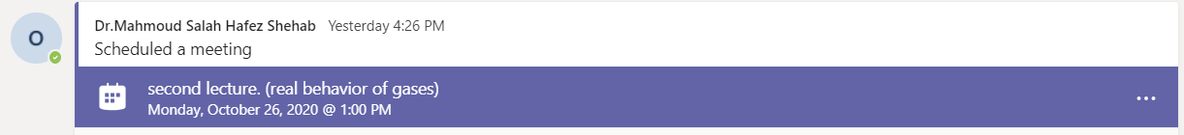

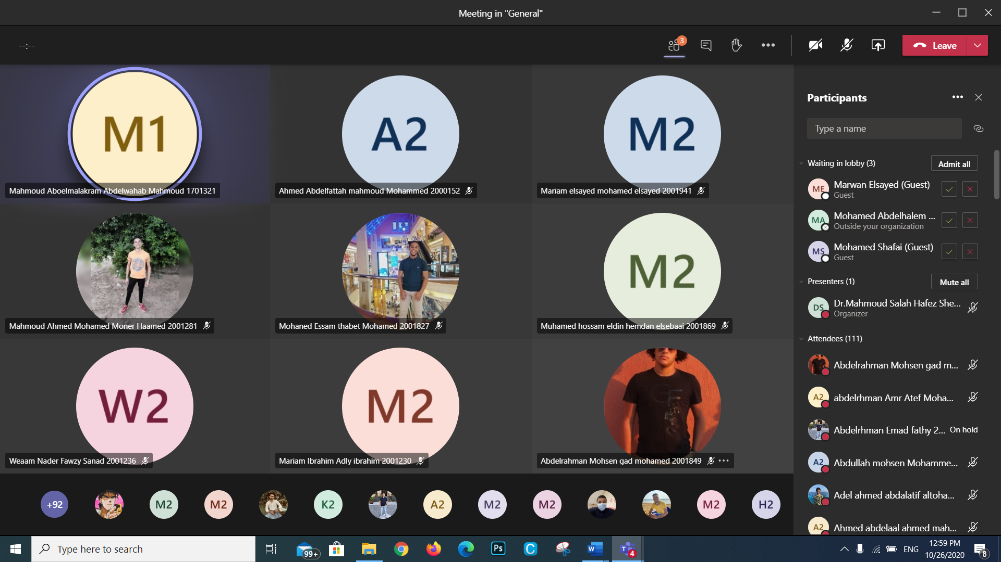

**Tutorial 1 - 31/10/2020**

[**https://teams.microsoft.com/l/meetup-join/19%3ad5b7d7ae131c4196952c5eaf7d6869ed%40thread.tacv2/1604038807826?context=%7b%22Tid%22%3a%22ad2a8324-bef7-46a8-adb4-fe51b6613b24%22%2c%22Oid%22%3a%22a7dc1325-e72a-4348-85ae-8e281d730f60%22%7d**](https://teams.microsoft.com/l/meetup-join/19%3ad5b7d7ae131c4196952c5eaf7d6869ed%40thread.tacv2/1604038807826?context=%7b%22Tid%22%3a%22ad2a8324-bef7-46a8-adb4-fe51b6613b24%22%2c%22Oid%22%3a%22a7dc1325-e72a-4348-85ae-8e281d730f60%22%7d)

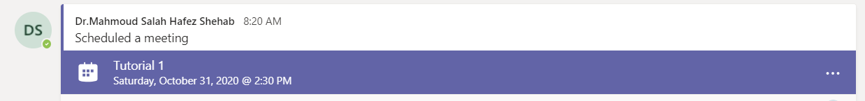

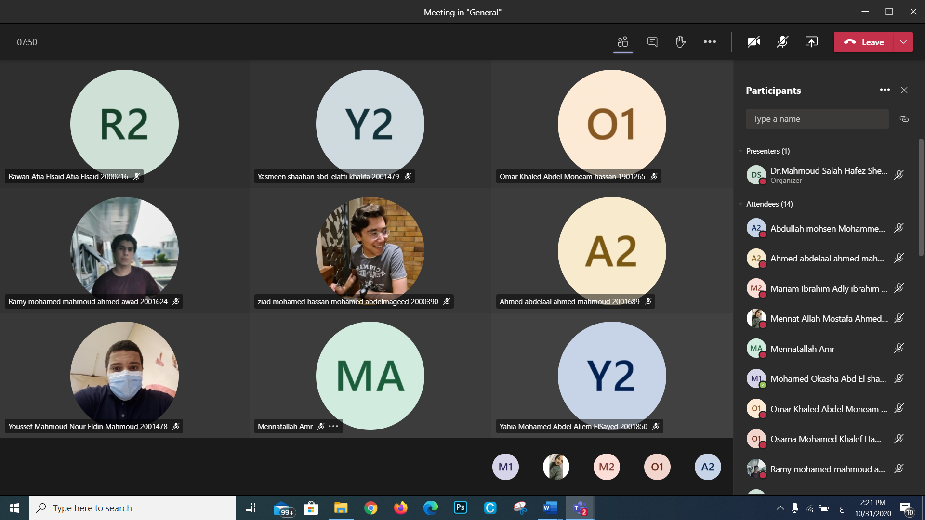

**Lecture 4 – 9/11/2020**

[**https://teams.microsoft.com/l/meetup-join/19%3ad5b7d7ae131c4196952c5eaf7d6869ed%40thread.tacv2/1604856066225?context=%7b%22Tid%22%3a%22ad2a8324-bef7-46a8-adb4-fe51b6613b24%22%2c%22Oid%22%3a%22a7dc1325-e72a-4348-85ae-8e281d730f60%22%7d**](https://teams.microsoft.com/l/meetup-join/19%3ad5b7d7ae131c4196952c5eaf7d6869ed%40thread.tacv2/1604856066225?context=%7b%22Tid%22%3a%22ad2a8324-bef7-46a8-adb4-fe51b6613b24%22%2c%22Oid%22%3a%22a7dc1325-e72a-4348-85ae-8e281d730f60%22%7d)

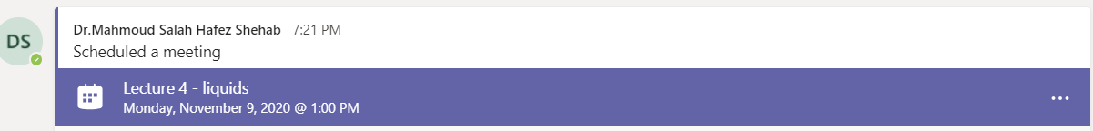

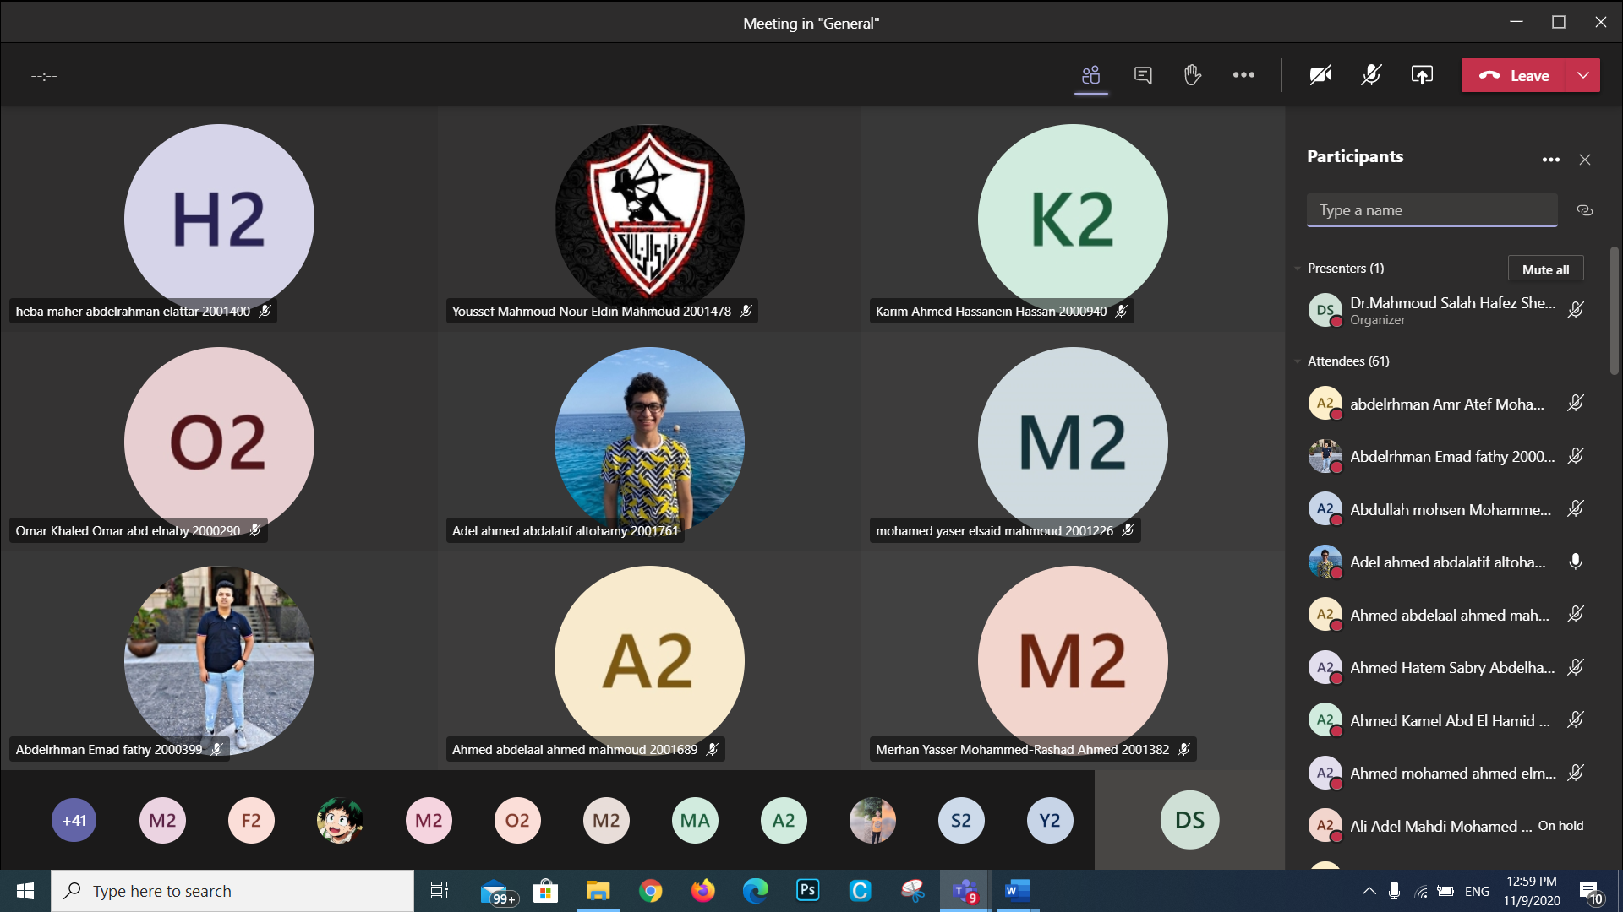

**Tutorial 2 – 14/11/2020**

[**https://teams.microsoft.com/l/meetup-join/19%3ad5b7d7ae131c4196952c5eaf7d6869ed%40thread.tacv2/1605259561221?context=%7b%22Tid%22%3a%22ad2a8324-bef7-46a8-adb4-fe51b6613b24%22%2c%22Oid%22%3a%22a7dc1325-e72a-4348-85ae-8e281d730f60%22%7d**](https://teams.microsoft.com/l/meetup-join/19%3ad5b7d7ae131c4196952c5eaf7d6869ed%40thread.tacv2/1605259561221?context=%7b%22Tid%22%3a%22ad2a8324-bef7-46a8-adb4-fe51b6613b24%22%2c%22Oid%22%3a%22a7dc1325-e72a-4348-85ae-8e281d730f60%22%7d)

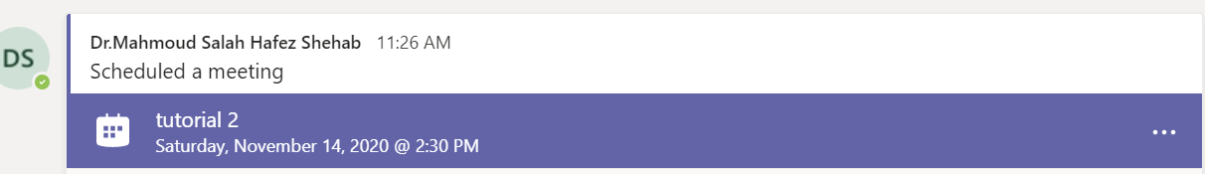

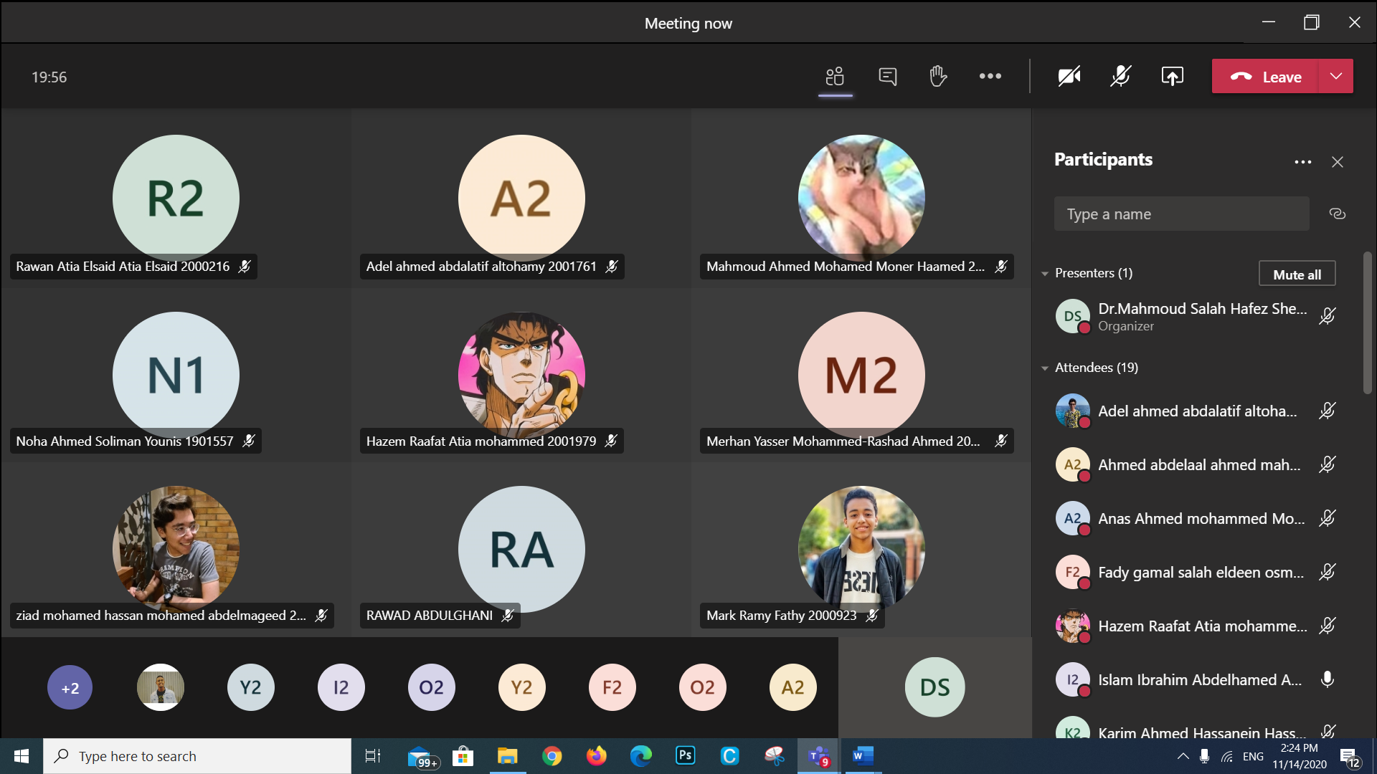

**Lecture 8 – 14/12/2020**

[**https://teams.microsoft.com/l/meetup-join/19%3ad5b7d7ae131c4196952c5eaf7d6869ed%40thread.tacv2/1607870579892?context=%7b%22Tid%22%3a%22ad2a8324-bef7-46a8-adb4-fe51b6613b24%22%2c%22Oid%22%3a%22a7dc1325-e72a-4348-85ae-8e281d730f60%22%7d**](https://teams.microsoft.com/l/meetup-join/19%3ad5b7d7ae131c4196952c5eaf7d6869ed%40thread.tacv2/1607870579892?context=%7b%22Tid%22%3a%22ad2a8324-bef7-46a8-adb4-fe51b6613b24%22%2c%22Oid%22%3a%22a7dc1325-e72a-4348-85ae-8e281d730f60%22%7d)

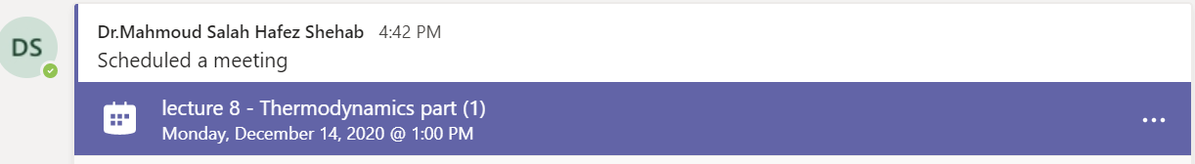

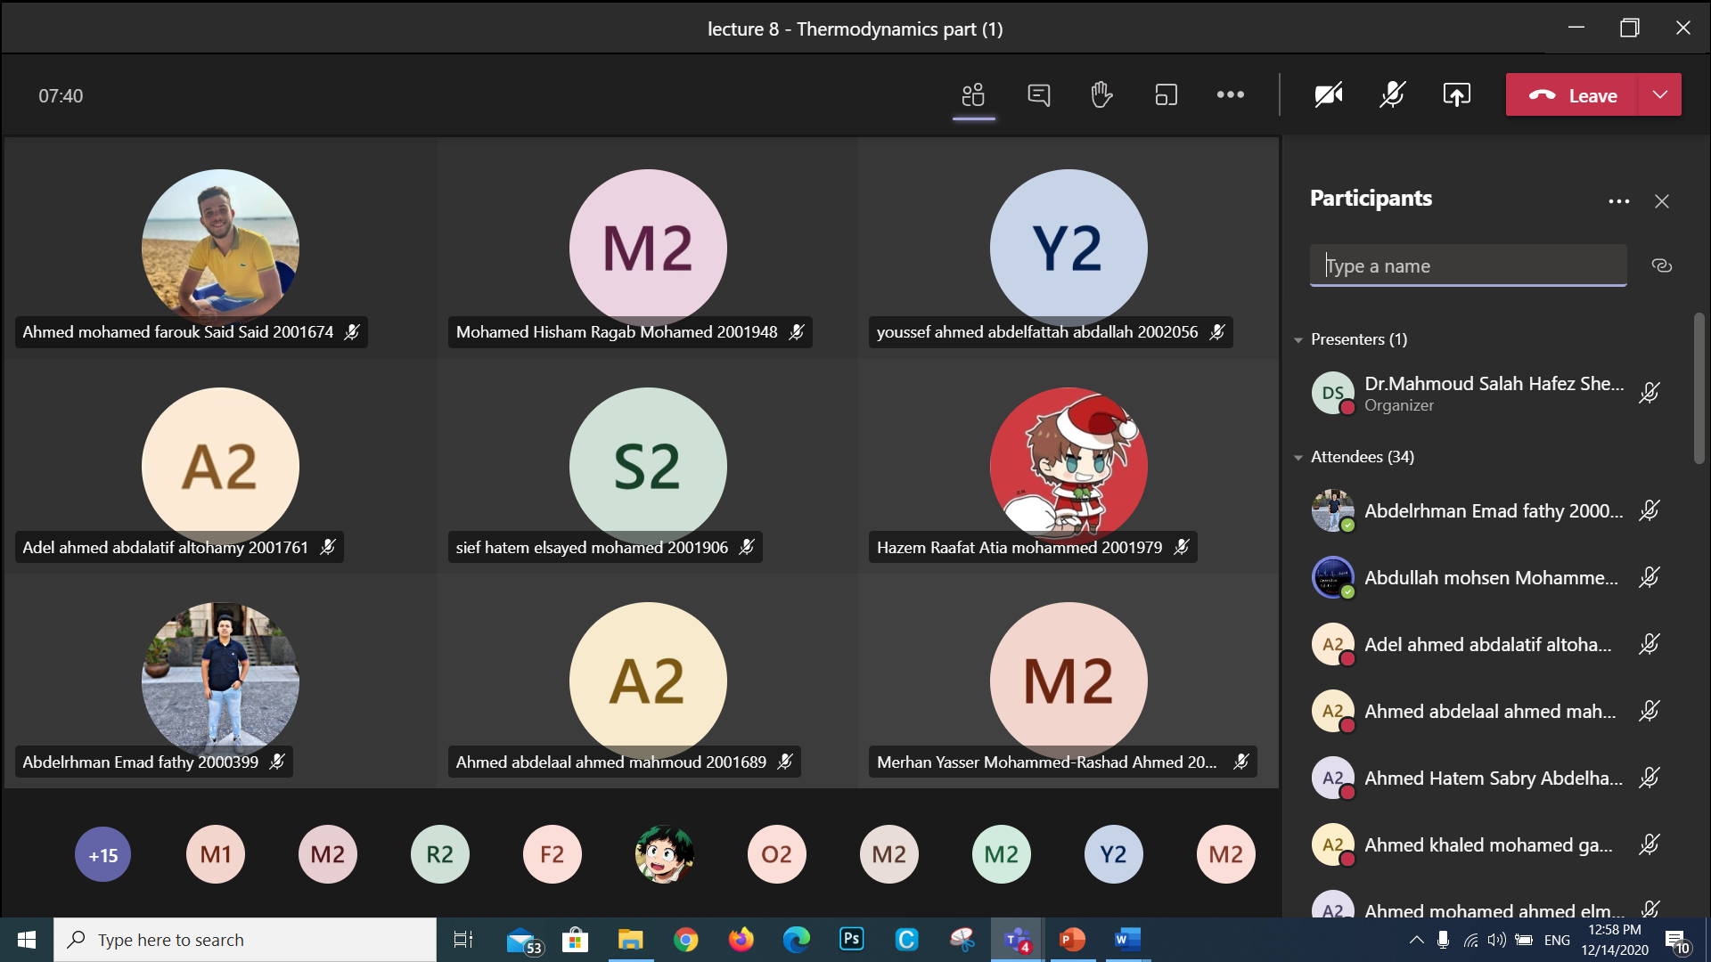

Tutorial 2/1/2021

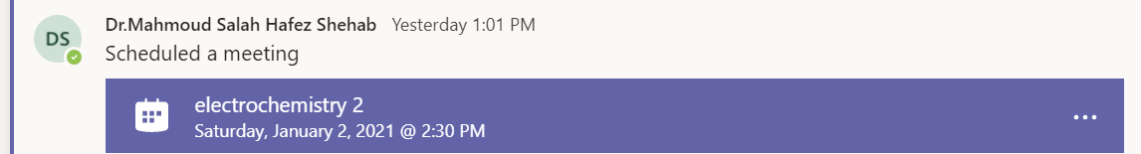

<https://teams.microsoft.com/l/meetup-join/19%3ad5b7d7ae131c4196952c5eaf7d6869ed%40thread.tacv2/1609498914333?context=%7b%22Tid%22%3a%22ad2a8324-bef7-46a8-adb4-fe51b6613b24%22%2c%22Oid%22%3a%22a7dc1325-e72a-4348-85ae-8e281d730f60%22%7d>

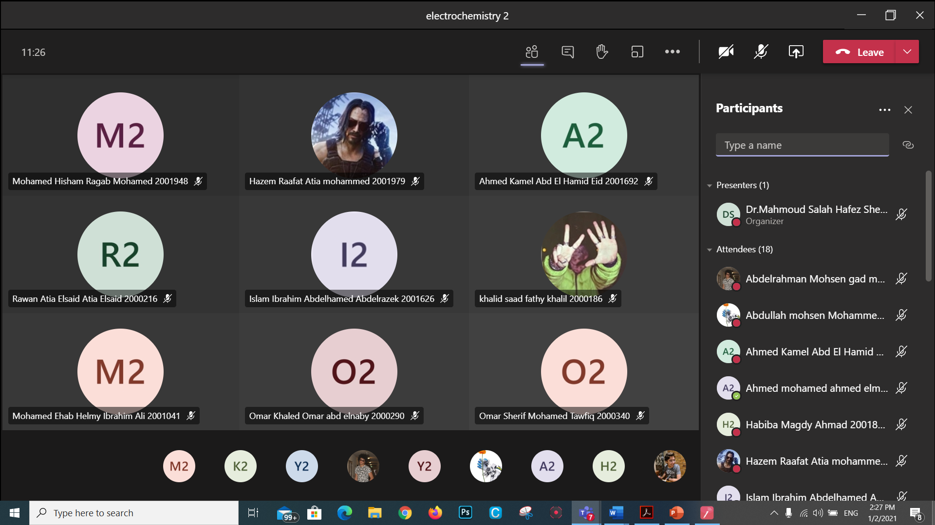

1. **Student assessment:**

|  |  |
| --- | --- |
| **Method of assessment** | **Percentage of total** |
| Written Final examination | 40 % |
| Mid-Term examination | 25 % |
| Practical/laboratory work | 15 % |
| Quizzes | 10 % |
| assignments | 5 % |
| Participation | 5 % |

**Members of examination committee**

**Role of external evaluator**

N/A………………………………………………………………………………………….

………………………………………………………………………………………………

1. **Facilities and teaching materials:**

Totally adequate

Adequate to some extent √

Inadequate

List any inadequacies

1. **Administrative constraints:**

List any difficulties encountered

No difficulties

1. **Student evaluation of the course:**

**Response of Course Team**

List any criticisms

…No criticism.…….………..……………………………….

1. **Comments from external evaluator(s): Response of course team**

………**N/A** ………………. …………………………….