|  |  |
| --- | --- |
| *Course report of* | |
| **Dynamics – PHM_032s – Spring 2021** | |
| University: Ain Shams | Faculty: Engineering |

## Basic Information

1. **Title and code :**

|  |
| --- |
| **Dynamics – PHM_032s** |

1. **Program on which the course is given :**

|  |  |
| --- | --- |
| |  | | --- | | **All Programs** | |

1. **Year/Level of programs :**

|  |
| --- |
| **1stLevel** |

1. **Units/Credit Hours**

|  |  |
| --- | --- |
| **( i ) Lecture :** | **2** |

|  |  |
| --- | --- |
| **( ii ) Tutorial/Practical :** | **2+1** |

|  |  |
| --- | --- |
| **( iii ) Total :** | **5** |

1. **Names of lecturers contributing to delivery of the course :**

|  |  |
| --- | --- |
| **i -** | **Dr. Hussein Elsayed Mohamed** |

|  |  |
| --- | --- |
| **Course coordinator:** | **Dr. Hussein Elsayed Mohamed Hussein** |

|  |  |
| --- | --- |
| **External evaluator:** | **--- --- ---** |
|  |  |
|  |  |

## Statistical Information

## For the PHM_ 032s students

|  |  |
| --- | --- |
| **No. of students attending the course:** | **1361** |

|  |  |  |  |  |  |  |  |  |  |  |  |  |  |  |
| --- | --- | --- | --- | --- | --- | --- | --- | --- | --- | --- | --- | --- | --- | --- |
| **Grade** | **A+** | **A** | **A-** | **B+** | **B** | **B-** | **C+** | **C** | **C-** | **D+** | **D** | **P** | **F** | **SUM** |
| **Students No.** | **28** | **112** | **128** | **225** | **180** | **176** | **112** | **68** | **81** | **47** | **60** | **17** | **127** | **1361** |
| **Percentage %** | **2** | **8** | **9** | **17** | **13** | **13** | **8** | **5** | **6** | **3** | **4** | **1** | **9** | **100** |

## Professional Information

1. **Course Teaching:**

|  |  |  |
| --- | --- | --- |
| **Course Content** | **Total No. of Hours** | **Lecturer** |
| **Kinematics of particles** | **20** | **Dr. Hussein Elsayed** |
| **Relative Motion** | **4** | **Dr. Hussein Elsayed** |
| **Kinetics and Newton's second law of motion.** | **8** | **Dr. Hussein Elsayed** |
| **Midterm Exam** | **4** | **Dr. Hussein Elsayed** |
| **Work and Energy** | **8** | **Dr. Hussein Elsayed** |
| **Impulse and Momentum** | **16** | **Dr. Hussein Elsayed** |
| **Total** | **60** | **Dr. Hussein Elsayed** |

Dynamics PHM_032s

Spring 2021

|  |  |  |
| --- | --- | --- |
| **Week** | **Experiment** | **Laboratory** |
| **1** | Introduction to Dynamics Experiments | 1 |
| **2** | The Gravity Acceleration Exp | 1 |
| **3** | The Gravity Acceleration Exp | 1 |
| **4** | Verification of Newton's Law Exp. | 1 |
| **5** | Verification of Newton's Law Exp. | 1 |
| **6** | X, t Exp. | 1 |
| **7** | X, t Exp. | 1 |
| **8** | Average and Inst. Velocity Part(3) | 1 |
| **9** | Average and Inst. Velocity Part(3) | 1 |
| **10** | Average Acceleration Exp. | 1 |
| **11** | Average Acceleration Exp. | 1 |
| **12** | Projectiles Velocity Exp. | 1 |
| **13** | Projectiles Velocity Exp. | 1 |
| **14** | Trajectory graph and maximum height | 1 |
| **15** | Trajectory graph and maximum height | 1 |
|  | Total number of hours | 15 |

The lab exam was conducted by discussing the students orally in the experiments and the results obtained

# Online Activities

1. The online activities in this semester include all lectures and tutorials by using Microsoft teams and the meetings with the students have been recorded and uploaded to LMS
2. Also all of the experiments of the lab. Part have been recorded as video show and also uploaded to the students
3. The Quizzes was held online
4. LMS link:

<https://lms.eng.asu.edu.eg/course/view.php?id=7426>

1. Microsoft teams link

<https://teams.microsoft.com/l/team/19%3acad11c3bf94f4166a21155a6f3b2abbf%40thread.tacv2/conversations?groupId=6515445b-b867-492a-9094-84020361491f&tenantId=ad2a8324-bef7-46a8-adb4-fe51b6613b24>

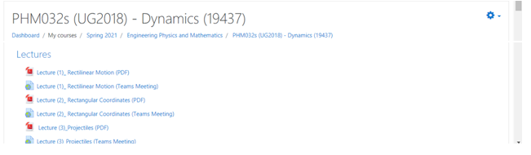

With Microsoft stream links:

[**https://web.microsoftstream.com/video/3ef9a0bf-311e-4990-a342-0ea46909a8cb**](https://web.microsoftstream.com/video/3ef9a0bf-311e-4990-a342-0ea46909a8cb)

[**https://web.microsoftstream.com/video/fb9b8371-0c1d-4f65-8c64-4c84e61ea25e**](https://web.microsoftstream.com/video/fb9b8371-0c1d-4f65-8c64-4c84e61ea25e)

[**https://web.microsoftstream.com/video/bed438f7-0a4a-4beb-a01c-3206ed438377**](https://web.microsoftstream.com/video/bed438f7-0a4a-4beb-a01c-3206ed438377)

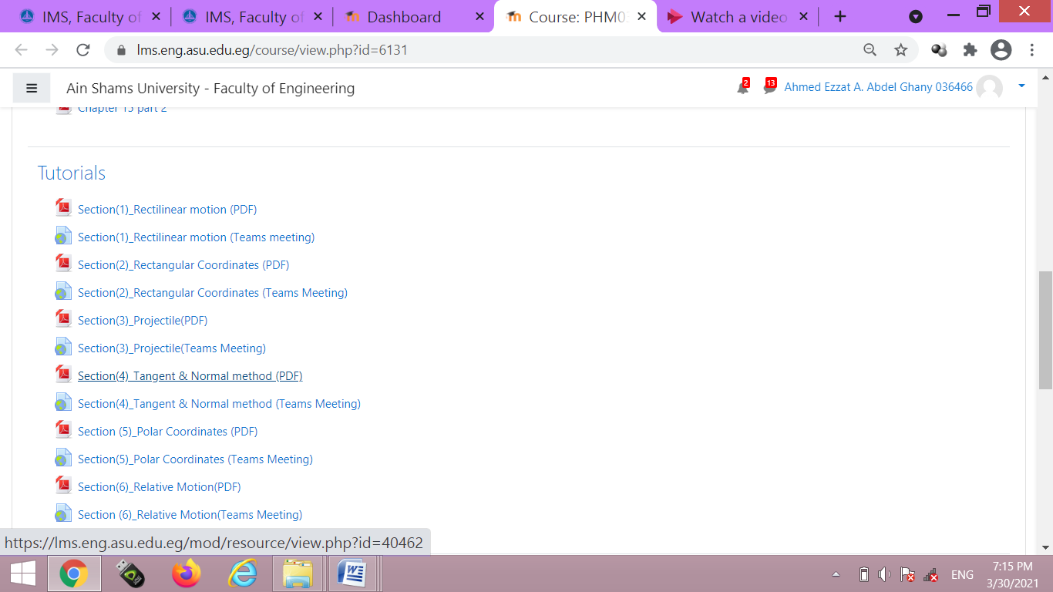

[**https://web.microsoftstream.com/video/43d11d2b-ccb6-43c8-98ec-d39854077637**](https://web.microsoftstream.com/video/43d11d2b-ccb6-43c8-98ec-d39854077637)

[**https://web.microsoftstream.com/video/fe792893-9a56-4508-b2f0-82805eec4193?list=studio**](https://web.microsoftstream.com/video/fe792893-9a56-4508-b2f0-82805eec4193?list=studio)

[**https://web.microsoftstream.com/video/76cb2954-ed06-453f-8075-d55ecb9a1cd8**](https://web.microsoftstream.com/video/76cb2954-ed06-453f-8075-d55ecb9a1cd8)

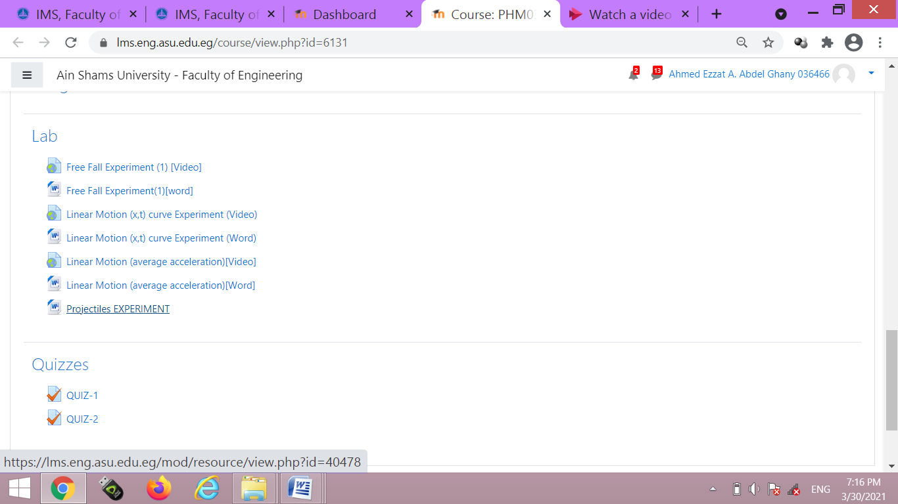

[**https://www.youtube.com/watch?v=6UQx8CaVubk**](https://www.youtube.com/watch?v=6UQx8CaVubk)

[**https://www.youtube.com/watch?v=zWI2UfcwVtE**](https://www.youtube.com/watch?v=zWI2UfcwVtE)

[**https://www.youtube.com/watch?v=3bci8ldeI9Y**](https://www.youtube.com/watch?v=3bci8ldeI9Y)

**Topics taught as a percentage of the content specified:**

**>90 % X 70-90 % <70%**

**Reasons in detail for not teaching any topic**

**N/A………………………………………………………………………………………….**

**………………………………………………………………………………………………**

**………………………………………………………………………………………………**

**If any topics were taught which are not specified, give reasons in detail**

**N/A………………………………………………………………………………………….**

**………………………………………………………………………………………………**

**………………………………………………………………………………………………**

**Teaching and learning methods:**

**Online Lectures: X**

**Practical training/ laboratory: X**

**Seminar/Workshop:**

**Class Activity: (Online Tutorials) X**

**Online Lectures and Tutorials were by using Microsoft teams and uploaded to LMS**

**Case Study:**

**Other assignments/homework:**

**If teaching and learning methods were used other than those specified, list and give reasons:**

**………………………………………………………………………………………………**

**………………………………………………………………………………………………**

1. **Student assessment:**

|  |  |
| --- | --- |
| **Method of assessment** | **Percentage of total** |
| **Written examination (Final+ mid-term)** | **85 %** |
| **Quizzes + Lab** | **10 %** |
| **Other assignments/class work** | **5 %** |

**Members of examination committee**

**i–Dr. Hussein Elsayed Mohamed Hussein ii-Dr. Ahmed Ezzat**

**Role of external evaluator**

**N/A………………………………………………………………………………………….**

**………………………………………………………………………………………………**

1. **Facilities and teaching materials:**

**Totally adequate**

**Adequate to some extent X**

**Inadequate**

**List any inadequacies**

1. **Administrative constraints:**

**List any difficulties encountered**

**No difficulties**

1. **Student evaluation of the course:**

##### Questionnaire of PHM_032s

###### **Questionnaire Details**

|  |  |
| --- | --- |
| **Committee** | [PHM032s (UG2018):Dynamics.](https://portal.eng.asu.edu.eg/study/courses/4040?committee_id=19437) |
| **Instructors** | [Ahmed Ezzat A. Abdel Ghany](https://portal.eng.asu.edu.eg/instructors/491), [Amal Mahmoud Abdel Hafez](https://portal.eng.asu.edu.eg/instructors/495), [Hussein Elsayed M. Hussein](https://portal.eng.asu.edu.eg/instructors/500), [Ahmed Mohamed Hamid Eldesouky](https://portal.eng.asu.edu.eg/instructors/546), [Eslam Nabil Shawki El-Ganzoury](https://portal.eng.asu.edu.eg/instructors/550), [Alaa Mohamed Ahmed Ismail](https://portal.eng.asu.edu.eg/instructors/555), [Ali Shehab shams El Deen Abo Elyazeed](https://portal.eng.asu.edu.eg/instructors/556), [Omar Mohamed Saber Hafez](https://portal.eng.asu.edu.eg/instructors/1213), [Hamada Galal Taha Asker](https://portal.eng.asu.edu.eg/instructors/165606), |

* 72%

#### 1004

Participants

[Course Evaluation (1004 Participants)](https://portal.eng.asu.edu.eg/quality/questionnaires/students/17609#collapseCard)

72 %

| **Question** | **Score** |
| --- | --- |
| The course syllabus was clearly explained at the beginning of the semester | 75% |
| I am aware of the course learning outcomes (LOs) | 74% |
| The teaching methods used helped and supported me to learn | 73% |
| Course topics are explained well in the teaching sessions. | 75% |
| The course activities helped me to achieve the learning outcomes (LOs) efficiently. | 71% |
| The course assessments were clear and their distribution were clearly announced and organized | 73% |
| I felt well supported on this course from instructor and teaching assistant (if any). | 73% |
| I have been able to contact instructor when I needed to. | 71% |
| The course focused on what was set out in the course specification and all are presented. | 75% |
| The instructor provided well written laboratory instructions (if any). | 74% |
| Adequate technical support and supervision were provided during the laboratory sessions (if any). | 74% |
| The laboratory was well integrated with the course pacing (if any). | 71% |
| The course digital materials on LMS are helpful in supporting my learning. | 71% |
| Overall, I was satisfied with my experience of this course. | 73% |
| I learn from online teaching activities, similar to on campus teaching activities. | 65% |
| The instructor used appropriate communication tools for online teaching. | 74% |
| The instructor pays attention to the student's achievement during online class. | 73% |
| The instructor encouraged active participation and discussion during online class. | 74% |
| I could pass the online course without any staff assistance. | 63% |
| The instructor respected to start / finish online lectures on scheduled times | 76% |

**6- Student evaluation of the course: Response of Course Team**

Online teaching is not suitable. Lectures and tutorials are interactive lectures using hand writing technique with complete voice discussion for all questions.

MCQ exams were too long Since a considerable ratio of students achieve high A-level grades, this reflects that the exam’s duration is suitable.

Online quizzes have Technical problems The quizzes were repeated for the students and approximately the results were not changed.

**Response of Course Team**

All lectures and tutorials are performed in acceptable level according to the online teaching conditions and criteria. The evaluation MCQ exams achieve balanced natural results that are suitable for time and scientific content.

**7- Comments from external evaluator(s): Response of course team**

**N/A** …………………….. …………………………….

……….……………..……. …………………………….

**8- Course enhancement: Progress on actions identified in the previous year’s action plan:**

**N/A** …………………….. …………………………….

……….……………..……. …………………………….

**9- Action plan**

**Actions required Completion date Person responsible**

**N/A** ………………… ……………………… ………………………

……………………… ………………………