|  |  |
| --- | --- |
| *Course report of* | |
| **Statics – PHM_031s – Fall 2020** | |
| University: Ain Shams | Faculty: Engineering |

## Basic Information

1. **Title and code :**

|  |
| --- |
| **(Statics) – PHM_031s** |

1. **Program on which the course is given :**

|  |  |
| --- | --- |
| |  | | --- | | **All Programs** | |

1. **Year/Level of programs :**

|  |
| --- |
| **1stLevel** |

1. **Units/Credit Hours**

|  |  |
| --- | --- |
| **( i ) Lecture :** | **2** |

|  |  |
| --- | --- |
| **( ii ) Tutorial/Practical :** | **2+1** |

|  |  |
| --- | --- |
| **( iii ) Total :** | **5** |

1. **Names of lecturers contributing to delivery of the course :**

|  |  |
| --- | --- |
| **i -** | **Dr. Hussein Elsayed Mohamed Hussein** |

|  |  |
| --- | --- |
| **Course coordinator:** | **Dr. Hussein Elsayed Mohamed Hussein** |

|  |  |
| --- | --- |
| **External evaluator:** | **--- --- ---** |

## Statistical Information

## For the PHM_ 031 and PHM 032 students

|  |  |
| --- | --- |
| **No. of students attending the course:** | **1698** |

|  |  |  |  |  |  |  |  |  |  |  |  |  |  |  |
| --- | --- | --- | --- | --- | --- | --- | --- | --- | --- | --- | --- | --- | --- | --- |
| **Grade** | **A+** | **A** | **A-** | **B+** | **B** | **B-** | **C+** | **C** | **C-** | **D+** | **D** | **P** | **F** | **SUM** |
| **Students No.** | **27** | **65** | **101** | **188** | **143** | **154** | **114** | **118** | **116** | **96** | **160** | **1** | **415** | **1698** |
| **Percentage %** | **2** | **4** | **6** | **11** | **8** | **9** | **7** | **7** | **7** | **6** | **9** | **0** | **24** | **100** |

## Professional Information

1. **Course Teaching:**

|  |  |  |
| --- | --- | --- |
| **Course Content** | **No. of Hours** | **Lecturer** |
| **Statics of Particles** | **12** | **Dr. Hussein Elsayed** |
| **Rigid Bodies :Equivalent Systems of Forces** | **12** | **Dr. Hussein Elsayed** |
| **Equilibrium of Rigid Bodies** | **8** | **Dr. Hussein Elsayed** |
| **Analysis of Structure: Frames** | **8** | **Dr. Hussein Elsayed** |
| **Analysis of Structure:Trusses** | **8** | **Dr. Hussein Elsayed** |
| **Centroid-Center of Mass** | **8** | **Dr. Hussein Elsayed** |
| **Mass Moment of Inertia** | **4** | **Dr. Hussein Elsayed** |

|  |  |  |
| --- | --- | --- |
| **Week** | **Title of Experiment** | **Laboratory**  **Hours** |
| 1 | Introduction to mechanics Lab | 1 |
| 2 | Introduction to Measuring Instruments | 1 |
| 3 | Determination of the gravitational acceleration | 1 |
| 4 | Determination of the gravitational acceleration (Repeat) | 1 |
| 5 | Determination of a spring stiffness | 1 |
| 6 | Determination of a spring stiffness (Repeat) | 1 |
| 7 | Force analysis ( Equilibrium of a of a particle) | 1 |
| 8 | Force analysis ( Equilibrium of a of a particle) (Repeat) | 1 |
| 9 | Friction on a leveled plane | 1 |
| 10 | Friction on a leveled plane (Repeat) | 1 |
| 11 | Friction on an inclined plane | 1 |
| 12 | Friction on an inclined plane (Repeat) | 1 |
| 13 | Center of gravity | 1 |
| 14 | Center of gravity (Repeat) | 1 |
| 15 | General Revision | 1 |
| Total Number of Hours | | 15 |

The lab exam was conducted by discussing the students orally in the experiments and the results obtained

# Online Activities

1. The online activities in this semester include all lectures and (tutorials by 50%) using Microsoft teams and the meetings with the students have been recorded and uploaded to LMS
2. Also all of the experiments of the lab. have been recorded as video show and also uploaded to the students
3. The Quizzes were held online

Team link:

<https://teams.microsoft.com/l/team/19%3ad1f4d9cdde6d4d86ada4e2b9572ec835%40thread.tacv2/conversations?groupId=03b0b2e6-1d91-4109-a004-e27ef7f6cabc&tenantId=ad2a8324-bef7-46a8-adb4-fe51b6613b24>

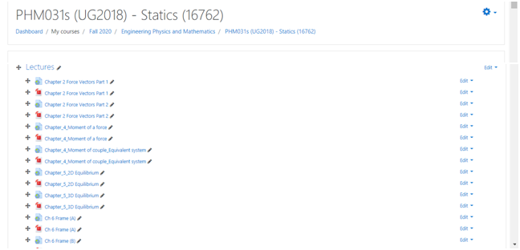

Lecture

<https://web.microsoftstream.com/video/8fa9206a-1a5d-4d76-bb82-08cdb8abcc89>

<https://web.microsoftstream.com/video/77dad58a-9c24-4ee6-aeda-7d9e81f739d5>

<https://web.microsoftstream.com/video/fc3a726f-ad05-44f7-90cb-1b18da7823af>

<https://web.microsoftstream.com/video/166b32c4-d841-4e75-ac23-c33ab6669370>

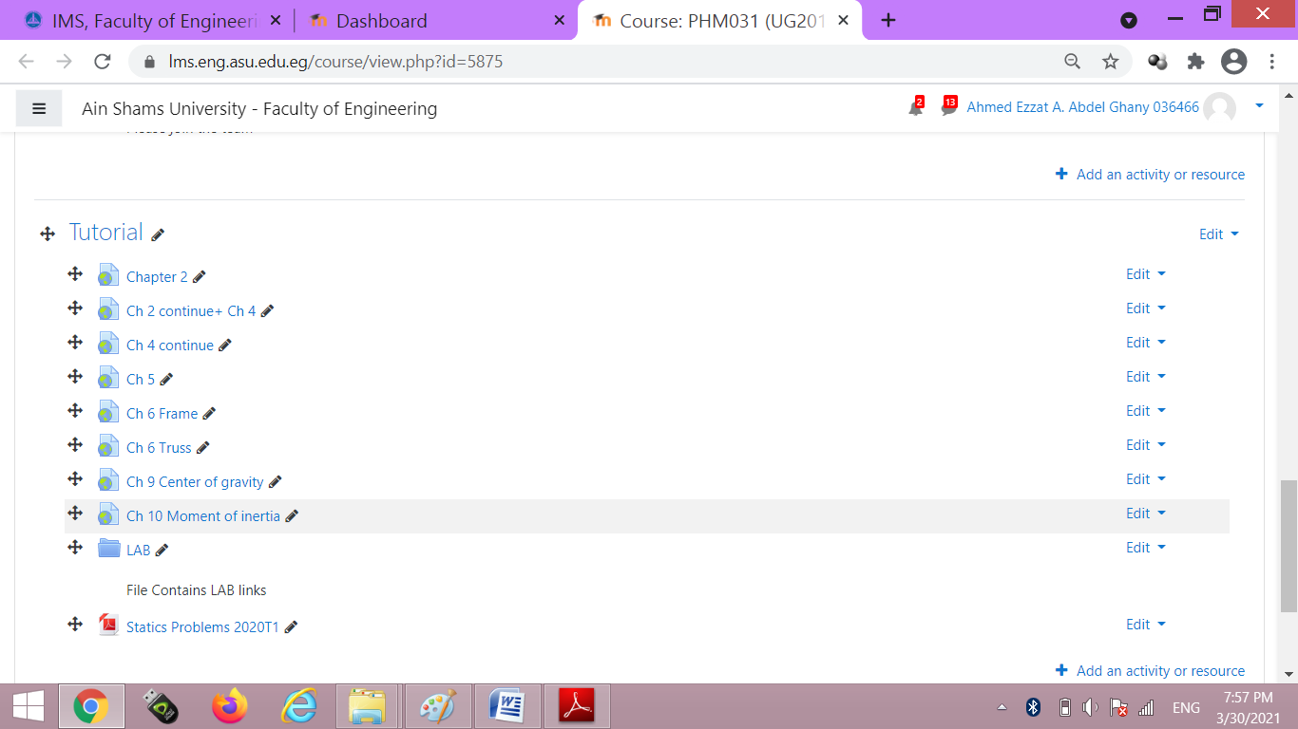

Tutorial

<https://web.microsoftstream.com/video/de8f07dc-2af8-4e63-acb3-d2d56856fff0>

<https://web.microsoftstream.com/video/f92c7c27-55f4-42ef-9371-0ae5b724cdd3>

<https://web.microsoftstream.com/video/fab70cab-eee5-40a9-baf4-1ac4a4add64f>

Lab.

<https://youtu.be/DccPGhW8MtY>

<https://youtu.be/03FJXub3ai4>

<https://youtu.be/-ixV0N7SUgw>

<https://youtu.be/y-VxgVt7ELA>

**Topics taught as a percentage of the content specified:**

**>90 % X 70-90 % <70%**

**Reasons in detail for not teaching any topic**

**……………………………………….**

**………………………………………………………………………………………………**

**………………………………………………………………………………………………**

**………………………………………………………………………………………………**

**If any topics were taught which are not specified, give reasons in detail**

**N/A………………………………………………………………………………………….**

**………………………………………………………………………………………………**

**………………………………………………………………………………………………**

**Teaching and learning methods:**

**Lectures: X**

**Practical training/ laboratory:**

**Seminar/Workshop:**

**Class Activity: (Tutorials) X**

**Case Study:**

**Other assignments/homework:**

**If teaching and learning methods were used other than those specified, list and give reasons:**

**………………………………………………………………………………………………**

**………………………………………………………………………………………………**

1. **Student assessment:**

|  |  |
| --- | --- |
| **Method of assessment** | **Percentage of total** |
| **Written examination (Final+ mid-term)** | **85 %** |
| **Quizzes (Online) + Lab** | **10 %** |
| **Other assignments/class work** | **5 %** |

**Members of examination committee**

**i–Dr. Hussein Elsayed Mohamed Hussein , ii- Dr. Ahmed Ezzat**

**Role of external evaluator**

**N/A………………………………………………………………………………………….**

**………………………………………………………………………………………………**

1. **Facilities and teaching materials:**

**Totally adequate**

**Adequate to some extent X**

**Inadequate**

**List any inadequacies**

1. **Administrative constraints:**

**List any difficulties encountered**

**No difficulties**

1. **Student evaluation of the course:**

##### Questionnaire of PHM_031s

###### **Questionnaire Details**

[Send to Quality](https://portal.eng.asu.edu.eg/quality/questionnaires/students/16242)

General Information

|  |  |
| --- | --- |
| **Committee** | [PHM031s (UG2018):Statics.](https://portal.eng.asu.edu.eg/study/courses/4039?committee_id=16762) |
| **Instructors** | [Ahmed Ezzat A. Abdel Ghany](https://portal.eng.asu.edu.eg/instructors/491), [Amal Mahmoud Abdel Hafez](https://portal.eng.asu.edu.eg/instructors/495), [Hussein Elsayed M. Hussein](https://portal.eng.asu.edu.eg/instructors/500), [Eslam Nabil Shawki El-Ganzoury](https://portal.eng.asu.edu.eg/instructors/550), [Hamada Galal Taha Asker](https://portal.eng.asu.edu.eg/instructors/165606), |

* 74%

#### 193

Participants

[Course Evaluation (193 Participants)](https://portal.eng.asu.edu.eg/quality/questionnaires/students/16242#collapseCard)

74 %

| **Question** | **Score** |
| --- | --- |
| The course syllabus was clearly explained at the beginning of the semester | 78% |
| I am aware of the course learning outcomes (ILOs). | 77% |
| The teaching methods used helped and supported me to learn | 74% |
| Course topics are explained well in the teaching sessions. | 79% |
| The course activities helped me to achieve the learning outcomes (ILOs) efficiently. | 71% |
| The course assessments were clear and their distribution were clearly announced and organized. | 73% |
| I felt well supported on this course from instructor and teaching assistant (if any). | 77% |
| I have been able to contact instructor when I needed to. | 74% |
| The course focused on what was set out in the course specification and all are presented. | 78% |
| The instructor provided well written laboratory instructions (if any). | 75% |
| Adequate technical support and supervision were provided during the laboratory sessions (if any). | 74% |
| The laboratory was well integrated with the course pacing (if any). | 71% |
| The course digital materials on LMS are helpful in supporting my learning. | 72% |
| Overall, I was satisfied with my experience of this course. | 76% |
| I learn from online teaching activities, similar to on campus teaching activities. | 63% |
| The instructor used appropriate communication tools for online teaching. | 76% |
| The instructor pays attention to the student's achievement during online class. | 75% |
| The instructor encouraged active participation and discussion during online class. | 75% |
| I could pass the online course without any staff assistance. | 62% |
| The instructor respected to start / finish online lectures on scheduled times | 79% |