|  |  |
| --- | --- |
| *Course report of* | |
| **Electricity and Magnetism – PHM022s– Fall 2020** | |
| University: Ain Shams | Faculty: Engineering |

## Basic Information

1. Title and code:

|  |
| --- |
| **Electricity and Magnetism – PHM022s** |

1. Program on which the course is given :

|  |  |
| --- | --- |
| |  | | --- | | All Programs | |

1. Year/Level of program :

|  |
| --- |
| 1st Level |

1. Units/Credit Hours

|  |  |
| --- | --- |
| ( i ) Lecture : | 3 |

|  |  |
| --- | --- |
| ( ii ) Tutorial/Practical: | 1/1 |

|  |  |
| --- | --- |
| ( iii ) Total : | 5 |

1. Names of lecturers contributing to delivery of the course :

|  |  |
| --- | --- |
| i - | Dr.Waleed Zein  Dr. Ismail Hafez Dr. Micha |

|  |  |
| --- | --- |
| ii - |  |

|  |  |
| --- | --- |
| iii - |  |

|  |  |
| --- | --- |
| Course coordinator: | Dr.Waleed Zein |

|  |  |
| --- | --- |
| External evaluator: | --- --- --- |
|  |  |

## Statistical Information

|  |  |  |  |  |  |  |  |  |  |  |  |  |  |  |
| --- | --- | --- | --- | --- | --- | --- | --- | --- | --- | --- | --- | --- | --- | --- |
| **Grade** | **A+** | **A** | **A-** | **B+** | **B** | **B-** | **C+** | **C** | **C-** | **D+** | **D** | **P** | **F** | **Total** |
| **No. of students** | 0 | 0 | 0 | 0 | 0 | 1 | 2 | 2 | 7 | 2 | 12 | 21 | 76 | 123 |
| **% of students** | 0 | 0 | 0 | 0 | 0 | 0.81 | 1.62 | 1.62 | 5.69 | 1.62 | 9.75 | 17.07 | 61.82 | 100 |

**Justification of high percentage of failed students**

* 1. **There are a lot of absent students in the final exam 13 out of 123 (10.57%)**
  2. **Most of students comes from technical schools and institutes or Arabic equivalent and they are very weak in Math and English.**
  3. **Students registered the course as pass/fail course and did not make any effort to success.**

## Professional Information

1. **Course Teaching:**

|  |  |  |  |  |  |
| --- | --- | --- | --- | --- | --- |
| **No.** | **Course Content** | **Lecture**  **Hours** | **Tutorial**  **Hours** | **Laboratory**  **Hours** | **Total** |
| 1 | Introduction and Vectors | 3 | 1 | 1 | 5 |
| 2 | Electric force & Electric field | 3 | 1 | 1 | 5 |
| 3 | Electric Flux | 3 | 1 | 1 | 5 |
| 4 | Gauss’s Law | 3 | 1 | 1 | 5 |
| 5 | Applications of Gauss’s Law | 3 | 1 | 1 | 5 |
| 6 | Electric potential | 3 | 1 | 1 | 5 |
| 7 | Capacitors and dielectrics. | 3 | 1 | 1 | 5 |
| 8 | Current, Resistance and RC Circuits | 3 | 1 | 1 | 5 |
| 9 | Magnetic force. | 3 | 1 | 1 | 5 |
| 10 | Biot-Savart Law | 3 | 1 | 1 | 5 |
| 11 | Ampere’s Law | 3 | 1 | 1 | 5 |
| 12 | Faraday-Lenz law | 3 | 1 | 1 | 5 |
| 13 | Self and Mutual Inductance | 3 | 1 | 1 | 5 |
| 14 | Magnetic materials and Magnetic Circuits | 3 | 1 | 1 | 5 |
| 15 | AC circuits | 3 | 1 | 1 | 5 |
| Total Number of hours | | 45 | 15 | 15 | 75 |

**2. Lab Experiments**

|  |  |  |
| --- | --- | --- |
| **No.** | **Title of Experiment** | **Laboratory**  **Hours** |
| 1 | Introduction to Lab Instruction and Safety rules | 1 |
| 2 | Determination of the time constant of an RC circuit. Part I | 1 |
| 3 | Determination of the time constant of an RC circuit. Part II | 1 |
| 4 | Determination of unknown capacitance and inductance using  phasor diagrams and A.C circuits: Part I | 1 |
| 5 | Determination of unknown capacitance and inductance using  phasor diagrams and A.C circuits: Part II | 1 |
| 6 | Determination of unknown capacitance and inductance using  phasor diagrams and A.C circuits: Part III | 1 |
| 7 | Temperature Coefficient of Resistance Part I | 1 |
| 8 | Temperature Coefficient of Resistance Part II | 1 |
| 9 | Ampere's law Part I | 1 |
| 10 | Ampere's law Part II | 1 |
| 11 | Biot-Savart's lawPart I | 1 |
| 12 | Biot-Savart's lawPart II | 1 |
| 13 | General Revision | 1 |
| 14 | General Revision | 1 |
| 15 | Lab Exam | 1 |
| Total Number of Hours | | 15 |

**Topics taught as a percentage of the content specified:**

**>90 % X 70-90 % <70%**

**Reasons in detail for not teaching any topic**

**Teaching and learning methods:**

* Interactive Lectures using Microsoft Teams + Uploaded Videos **X**
* Interactive Tutorials using Microsoft Teams: **X**
* Self-learning  **x**
* Online Practical using Microsoft teams and e-Lab



Figure : Screenshot of PHM022s main page on LMS

**Link to Microsoft Team**

<https://teams.microsoft.com/l/team/19%3a21c313cc6a9e4cf3b60af72e26368df6%40thread.tacv2/conversations?groupId=d029dc0b-f694-4aa0-82c5-f38d4b164ce3&tenantId=ad2a8324-bef7-46a8-adb4-fe51b6613b24>

**Link to Microsoft Stream channel**

<https://web.microsoftstream.com/channel/41cd9f82-8197-4490-802a-e57a7c7cd478>

**Links to Video Lectures**

1. [**https://web.microsoftstream.com/video/cfa25f49-f13b-4834-8d62-a4c5d1e0fded**](https://web.microsoftstream.com/video/cfa25f49-f13b-4834-8d62-a4c5d1e0fded)
2. [**https://web.microsoftstream.com/video/c9313ea2-6fe0-4962-8917-1550d867ac31**](https://web.microsoftstream.com/video/c9313ea2-6fe0-4962-8917-1550d867ac31)
3. [**https://web.microsoftstream.com/video/ebdd0558-66d3-4046-a66a-ebbf77a815a1**](https://web.microsoftstream.com/video/ebdd0558-66d3-4046-a66a-ebbf77a815a1)
4. [**https://web.microsoftstream.com/video/4b3eafa7-72d6-4cda-a6b3-94df3560c7a6**](https://web.microsoftstream.com/video/4b3eafa7-72d6-4cda-a6b3-94df3560c7a6)
5. [**https://web.microsoftstream.com/video/69be260f-7ce5-482d-ba1c-af63f8506e41**](https://web.microsoftstream.com/video/69be260f-7ce5-482d-ba1c-af63f8506e41)
6. [**https://web.microsoftstream.com/video/3572bdf8-c626-499f-a589-efb66117832c**](https://web.microsoftstream.com/video/3572bdf8-c626-499f-a589-efb66117832c)
7. [**https://web.microsoftstream.com/video/5252c821-e472-4f14-a4ea-66c2a56fab03**](https://web.microsoftstream.com/video/5252c821-e472-4f14-a4ea-66c2a56fab03)
8. [**https://web.microsoftstream.com/video/699825e3-ac03-4722-a664-e63a4392fbab**](https://web.microsoftstream.com/video/699825e3-ac03-4722-a664-e63a4392fbab)
9. [**https://web.microsoftstream.com/video/b10168f0-737e-430b-a985-657dd45a8562**](https://web.microsoftstream.com/video/b10168f0-737e-430b-a985-657dd45a8562)
10. <https://web.microsoftstream.com/video/fda2b0f1-ff4b-40a7-aede-99ca8e23a1e0>
11. <https://web.microsoftstream.com/video/551fec5f-0ecb-4d1a-bdb1-d4372f516907>
12. <https://web.microsoftstream.com/video/ff09812b-a526-4b2f-a37e-03b0c092b477>
13. <https://web.microsoftstream.com/video/15ab508b-92a6-4f4c-957a-821135fff03b>
14. <https://web.microsoftstream.com/video/056fed15-288c-4670-8cad-4489664c17b1>
15. <https://web.microsoftstream.com/video/e3347467-0c93-40c9-b712-e2edee71344c>
16. <https://web.microsoftstream.com/video/0368e5e9-6043-4736-8bc3-4bb6dc413d53>
17. <https://web.microsoftstream.com/video/d12e32a2-638a-4298-92db-1a701b84e975>
18. <https://web.microsoftstream.com/video/01a38288-10cc-40fb-9dbf-9a04edef0d7c>
19. <https://web.microsoftstream.com/video/768b4ef3-9e76-45bf-b862-f3ed8b95321d>
20. <https://web.microsoftstream.com/video/6370a774-33d6-482d-bb20-13b124850228>
21. <https://web.microsoftstream.com/video/2b4cb0b4-9229-4f96-b70d-6b127bf10f39>

**Links to Microsoft Teams meetings PHM022s**

**Lecture 3**

[https://teams.microsoft.com/l/meetup-](https://teams.microsoft.com/l/meetup-join/19%3a21c313cc6a9e4cf3b60af72e26368df6%40thread.tacv2/1604065168048?context=%7b%22Tid%22%3a%22ad2a8324-bef7-46a8-adb4-fe51b6613b24%22%2c%22Oid%22%3a%22f7ed2be7-37dd-4993-9138-5ef5b4d0bf24%22%7d) [join/19%3a21c313cc6a9e4cf3b60af72e26368df6%40thread.tacv2/1604065168048?context=%7b%2](https://teams.microsoft.com/l/meetup-join/19%3a21c313cc6a9e4cf3b60af72e26368df6%40thread.tacv2/1604065168048?context=%7b%22Tid%22%3a%22ad2a8324-bef7-46a8-adb4-fe51b6613b24%22%2c%22Oid%22%3a%22f7ed2be7-37dd-4993-9138-5ef5b4d0bf24%22%7d)

[2Tid%22%3a%22ad2a8324-bef7-46a8-adb4-fe51b6613b24%22%2c%22Oid%22%3a%22f7ed2be7-](https://teams.microsoft.com/l/meetup-join/19%3a21c313cc6a9e4cf3b60af72e26368df6%40thread.tacv2/1604065168048?context=%7b%22Tid%22%3a%22ad2a8324-bef7-46a8-adb4-fe51b6613b24%22%2c%22Oid%22%3a%22f7ed2be7-37dd-4993-9138-5ef5b4d0bf24%22%7d)

[37dd-4993-9138-5ef5b4d0bf24%22%7d](https://teams.microsoft.com/l/meetup-join/19%3a21c313cc6a9e4cf3b60af72e26368df6%40thread.tacv2/1604065168048?context=%7b%22Tid%22%3a%22ad2a8324-bef7-46a8-adb4-fe51b6613b24%22%2c%22Oid%22%3a%22f7ed2be7-37dd-4993-9138-5ef5b4d0bf24%22%7d)

**Lecture 4**

[https://teams.microsoft.com/l/meetup-](https://teams.microsoft.com/l/meetup-join/19%3a21c313cc6a9e4cf3b60af72e26368df6%40thread.tacv2/1605278789345?context=%7b%22Tid%22%3a%22ad2a8324-bef7-46a8-adb4-fe51b6613b24%22%2c%22Oid%22%3a%22f7ed2be7-37dd-4993-9138-5ef5b4d0bf24%22%7d) [join/19%3a21c313cc6a9e4cf3b60af72e26368df6%40thread.tacv2/1605278789345?context=%7b%2](https://teams.microsoft.com/l/meetup-join/19%3a21c313cc6a9e4cf3b60af72e26368df6%40thread.tacv2/1605278789345?context=%7b%22Tid%22%3a%22ad2a8324-bef7-46a8-adb4-fe51b6613b24%22%2c%22Oid%22%3a%22f7ed2be7-37dd-4993-9138-5ef5b4d0bf24%22%7d)

[2Tid%22%3a%22ad2a8324-bef7-46a8-adb4-fe51b6613b24%22%2c%22Oid%22%3a%22f7ed2be7-](https://teams.microsoft.com/l/meetup-join/19%3a21c313cc6a9e4cf3b60af72e26368df6%40thread.tacv2/1605278789345?context=%7b%22Tid%22%3a%22ad2a8324-bef7-46a8-adb4-fe51b6613b24%22%2c%22Oid%22%3a%22f7ed2be7-37dd-4993-9138-5ef5b4d0bf24%22%7d)

[37dd-4993-9138-5ef5b4d0bf24%22%7d](https://teams.microsoft.com/l/meetup-join/19%3a21c313cc6a9e4cf3b60af72e26368df6%40thread.tacv2/1605278789345?context=%7b%22Tid%22%3a%22ad2a8324-bef7-46a8-adb4-fe51b6613b24%22%2c%22Oid%22%3a%22f7ed2be7-37dd-4993-9138-5ef5b4d0bf24%22%7d)

**Lecture 5**

[https://teams.microsoft.com/l/meetup-](https://teams.microsoft.com/l/meetup-join/19%3a21c313cc6a9e4cf3b60af72e26368df6%40thread.tacv2/1605701130961?context=%7b%22Tid%22%3a%22ad2a8324-bef7-46a8-adb4-fe51b6613b24%22%2c%22Oid%22%3a%22f7ed2be7-37dd-4993-9138-5ef5b4d0bf24%22%7d) [join/19%3a21c313cc6a9e4cf3b60af72e26368df6%40thread.tacv2/1605701130961?context=%7b%2](https://teams.microsoft.com/l/meetup-join/19%3a21c313cc6a9e4cf3b60af72e26368df6%40thread.tacv2/1605701130961?context=%7b%22Tid%22%3a%22ad2a8324-bef7-46a8-adb4-fe51b6613b24%22%2c%22Oid%22%3a%22f7ed2be7-37dd-4993-9138-5ef5b4d0bf24%22%7d)

[2Tid%22%3a%22ad2a8324-bef7-46a8-adb4-fe51b6613b24%22%2c%22Oid%22%3a%22f7ed2be7-](https://teams.microsoft.com/l/meetup-join/19%3a21c313cc6a9e4cf3b60af72e26368df6%40thread.tacv2/1605701130961?context=%7b%22Tid%22%3a%22ad2a8324-bef7-46a8-adb4-fe51b6613b24%22%2c%22Oid%22%3a%22f7ed2be7-37dd-4993-9138-5ef5b4d0bf24%22%7d)

[37dd-4993-9138-5ef5b4d0bf24%22%7d](https://teams.microsoft.com/l/meetup-join/19%3a21c313cc6a9e4cf3b60af72e26368df6%40thread.tacv2/1605701130961?context=%7b%22Tid%22%3a%22ad2a8324-bef7-46a8-adb4-fe51b6613b24%22%2c%22Oid%22%3a%22f7ed2be7-37dd-4993-9138-5ef5b4d0bf24%22%7d)

**Lecture 6**

[https://teams.microsoft.com/l/meetup-](https://teams.microsoft.com/l/meetup-join/19%3a21c313cc6a9e4cf3b60af72e26368df6%40thread.tacv2/1607344702775?context=%7b%22Tid%22%3a%22ad2a8324-bef7-46a8-adb4-fe51b6613b24%22%2c%22Oid%22%3a%22f7ed2be7-37dd-4993-9138-5ef5b4d0bf24%22%7d) [join/19%3a21c313cc6a9e4cf3b60af72e26368df6%40thread.tacv2/1607344702775?context=%7b%2](https://teams.microsoft.com/l/meetup-join/19%3a21c313cc6a9e4cf3b60af72e26368df6%40thread.tacv2/1607344702775?context=%7b%22Tid%22%3a%22ad2a8324-bef7-46a8-adb4-fe51b6613b24%22%2c%22Oid%22%3a%22f7ed2be7-37dd-4993-9138-5ef5b4d0bf24%22%7d)

[2Tid%22%3a%22ad2a8324-bef7-46a8-adb4-fe51b6613b24%22%2c%22Oid%22%3a%22f7ed2be7-](https://teams.microsoft.com/l/meetup-join/19%3a21c313cc6a9e4cf3b60af72e26368df6%40thread.tacv2/1607344702775?context=%7b%22Tid%22%3a%22ad2a8324-bef7-46a8-adb4-fe51b6613b24%22%2c%22Oid%22%3a%22f7ed2be7-37dd-4993-9138-5ef5b4d0bf24%22%7d)

[37dd-4993-9138-5ef5b4d0bf24%22%7d](https://teams.microsoft.com/l/meetup-join/19%3a21c313cc6a9e4cf3b60af72e26368df6%40thread.tacv2/1607344702775?context=%7b%22Tid%22%3a%22ad2a8324-bef7-46a8-adb4-fe51b6613b24%22%2c%22Oid%22%3a%22f7ed2be7-37dd-4993-9138-5ef5b4d0bf24%22%7d)

**Lecture 7**

[https://teams.microsoft.com/l/meetup-](https://teams.microsoft.com/l/meetup-join/19%3a21c313cc6a9e4cf3b60af72e26368df6%40thread.tacv2/1607689108514?context=%7b%22Tid%22%3a%22ad2a8324-bef7-46a8-adb4-fe51b6613b24%22%2c%22Oid%22%3a%22f7ed2be7-37dd-4993-9138-5ef5b4d0bf24%22%7d) [join/19%3a21c313cc6a9e4cf3b60af72e26368df6%40thread.tacv2/1607689108514?context=%7b%2](https://teams.microsoft.com/l/meetup-join/19%3a21c313cc6a9e4cf3b60af72e26368df6%40thread.tacv2/1607689108514?context=%7b%22Tid%22%3a%22ad2a8324-bef7-46a8-adb4-fe51b6613b24%22%2c%22Oid%22%3a%22f7ed2be7-37dd-4993-9138-5ef5b4d0bf24%22%7d)

[2Tid%22%3a%22ad2a8324-bef7-46a8-adb4-fe51b6613b24%22%2c%22Oid%22%3a%22f7ed2be7-](https://teams.microsoft.com/l/meetup-join/19%3a21c313cc6a9e4cf3b60af72e26368df6%40thread.tacv2/1607689108514?context=%7b%22Tid%22%3a%22ad2a8324-bef7-46a8-adb4-fe51b6613b24%22%2c%22Oid%22%3a%22f7ed2be7-37dd-4993-9138-5ef5b4d0bf24%22%7d)

[37dd-4993-9138-5ef5b4d0bf24%22%7d](https://teams.microsoft.com/l/meetup-join/19%3a21c313cc6a9e4cf3b60af72e26368df6%40thread.tacv2/1607689108514?context=%7b%22Tid%22%3a%22ad2a8324-bef7-46a8-adb4-fe51b6613b24%22%2c%22Oid%22%3a%22f7ed2be7-37dd-4993-9138-5ef5b4d0bf24%22%7d)

**Lecture 8**

[https://teams.microsoft.com/l/meetup-](https://teams.microsoft.com/l/meetup-join/19%3a21c313cc6a9e4cf3b60af72e26368df6%40thread.tacv2/1608137925723?context=%7b%22Tid%22%3a%22ad2a8324-bef7-46a8-adb4-fe51b6613b24%22%2c%22Oid%22%3a%22f7ed2be7-37dd-4993-9138-5ef5b4d0bf24%22%7d) [join/19%3a21c313cc6a9e4cf3b60af72e26368df6%40thread.tacv2/1608137925723?context=%7b%2](https://teams.microsoft.com/l/meetup-join/19%3a21c313cc6a9e4cf3b60af72e26368df6%40thread.tacv2/1608137925723?context=%7b%22Tid%22%3a%22ad2a8324-bef7-46a8-adb4-fe51b6613b24%22%2c%22Oid%22%3a%22f7ed2be7-37dd-4993-9138-5ef5b4d0bf24%22%7d)

[2Tid%22%3a%22ad2a8324-bef7-46a8-adb4-fe51b6613b24%22%2c%22Oid%22%3a%22f7ed2be7-](https://teams.microsoft.com/l/meetup-join/19%3a21c313cc6a9e4cf3b60af72e26368df6%40thread.tacv2/1608137925723?context=%7b%22Tid%22%3a%22ad2a8324-bef7-46a8-adb4-fe51b6613b24%22%2c%22Oid%22%3a%22f7ed2be7-37dd-4993-9138-5ef5b4d0bf24%22%7d)

[37dd-4993-9138-5ef5b4d0bf24%22%7d](https://teams.microsoft.com/l/meetup-join/19%3a21c313cc6a9e4cf3b60af72e26368df6%40thread.tacv2/1608137925723?context=%7b%22Tid%22%3a%22ad2a8324-bef7-46a8-adb4-fe51b6613b24%22%2c%22Oid%22%3a%22f7ed2be7-37dd-4993-9138-5ef5b4d0bf24%22%7d)

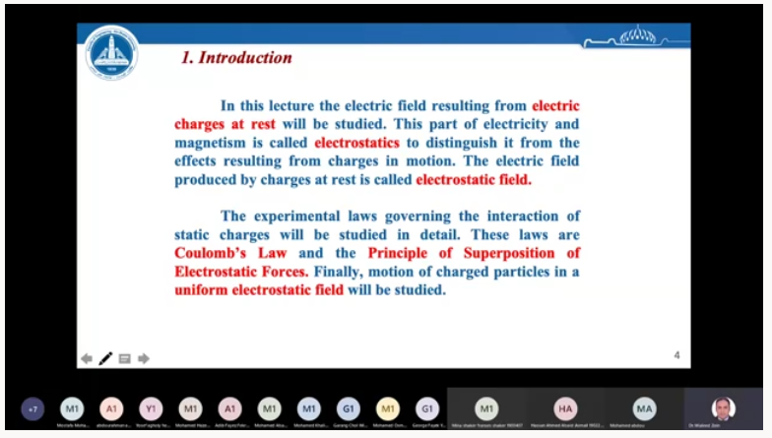

Figure 2: Screenshot of Interactive Lect. on Microsoft Teams

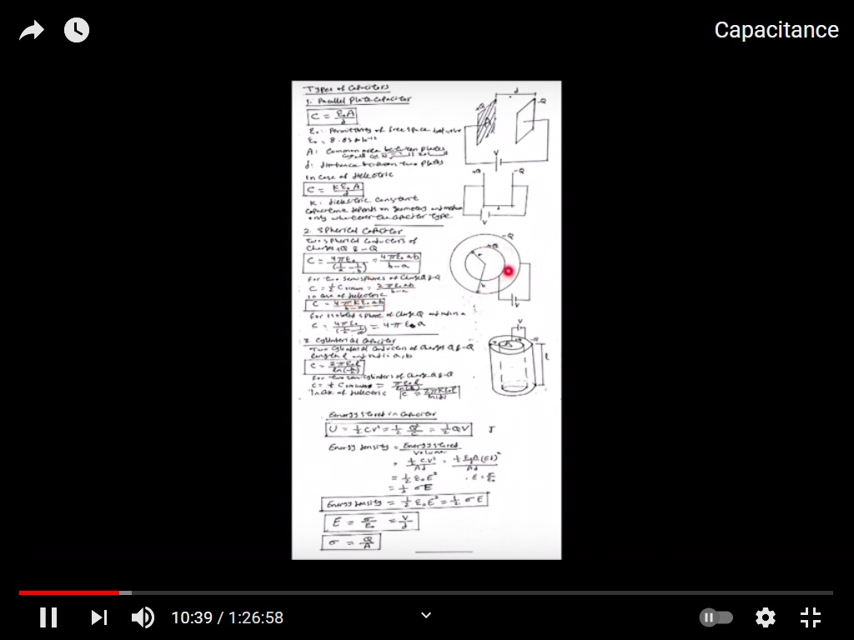

Figure 3: Screenshot Tutorial

**Links to tutorials videos**

* 1. <https://youtu.be/Lli6EkSzIDQ>
  2. <https://youtu.be/hQtQuuSJaO4>
  3. <https://youtu.be/E070wtEDvXY>
  4. <https://youtu.be/5wy-bWTEneU>

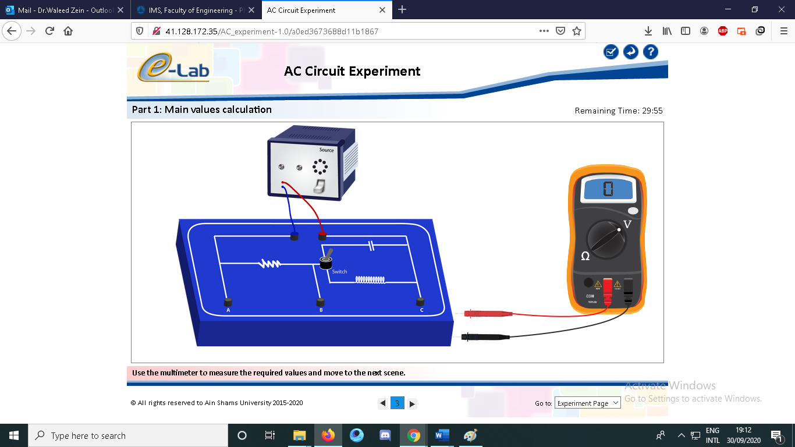

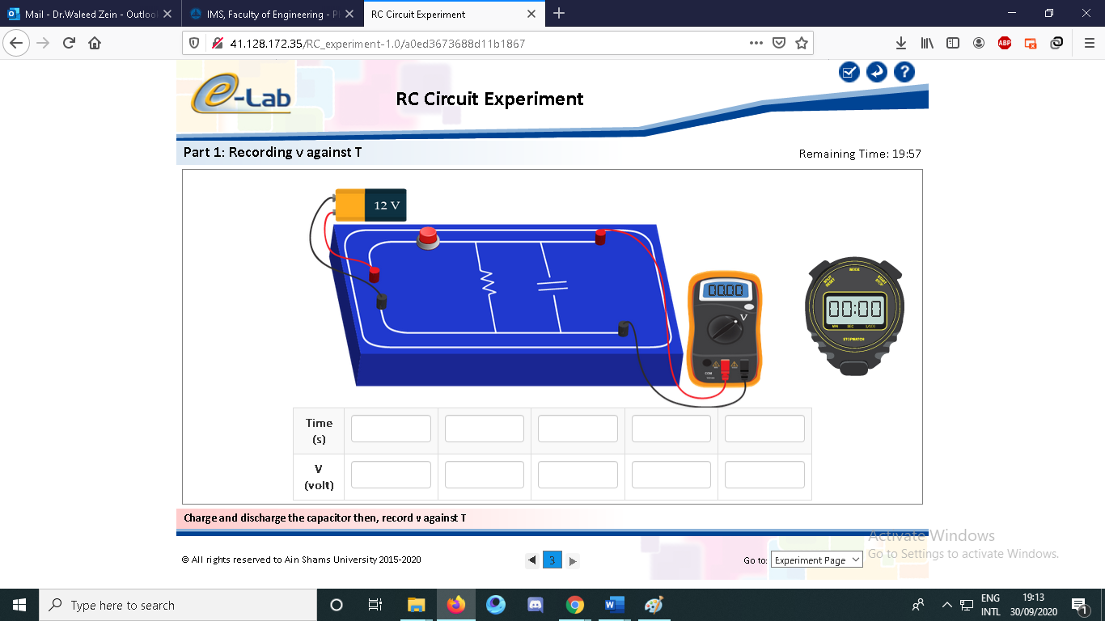

Figure 4: Screenshot of Online electronic Laboratory

**Case Study:**

Other assignments/homework: **NA**

**Student assessment:**

|  |  |
| --- | --- |
| **Method of assessment** | **Percentage of total** |
| Written examinations (final + midterm) | 75 % |
| Online Quizzes | 6 % |
| Lab Reports | 4 % |
| Lab Exam | 15% |

**Members of examination committee**

i – Dr.Waleed Zein

**Role of external evaluator**

N/A………………………………………………………………………………………….

1. **Facilities and teaching materials:**

Totally adequate

Adequate to some extent

**x**

Inadequate

List any inadequacies

1. **Administrative constraints:**

List any difficulties encountered

No difficulties

1. **Student evaluation of the course:**

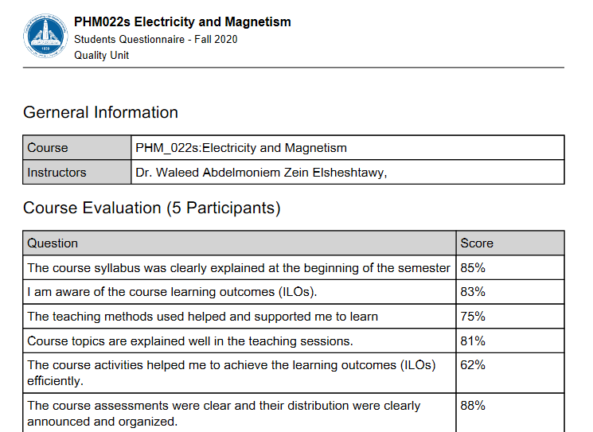

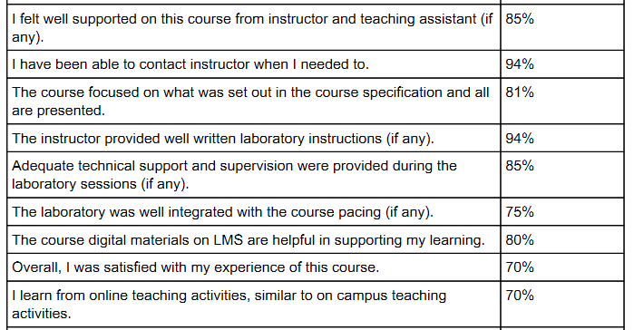

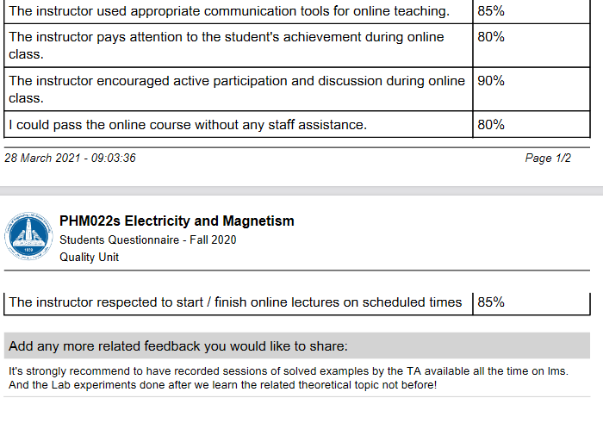

**Response of Course Team**

1. **Comments from external evaluator(s): Response of course team**

………**N/A** ………………. …………………………….