|  |  |
| --- | --- |
| *Course report of* | |
| **Mathematics (2) – PHM 013s Fall 2020** | |
| University: Ain Shams | Faculty: Engineering |

## Basic Information

1. Title and code :

|  |
| --- |
| **Mathematics (2) – PHM 013s** |

1. Program on which the course is given :

|  |  |
| --- | --- |
| |  | | --- | | All Programs | |

1. Year/Level of programs :

|  |
| --- |
| 1st Level |

1. Units/Credit Hours

|  |  |
| --- | --- |
| ( i ) Lecture : | 3 |

|  |  |
| --- | --- |
| ( ii ) Tutorial/Practical : | 2 |

|  |  |
| --- | --- |
| ( iii ) Total : | 5 |

1. Names of lecturers contributing to delivery of the course :

|  |  |
| --- | --- |
| i - | Professor Dr. Niveen Badra |

|  |  |
| --- | --- |
| ii - | Dr. Hussain Abd ElSalam |

|  |  |
| --- | --- |
| iii - |  |

|  |  |
| --- | --- |
| Course coordinator: | Professor Dr. Niveen Badra |

|  |  |
| --- | --- |
| External evaluator: | --- --- --- |

## Statistical Information

|  |  |
| --- | --- |
| No. of students attending the course: | 208 |

|  |  |  |  |  |  |  |  |  |  |  |  |  |  |  |  |
| --- | --- | --- | --- | --- | --- | --- | --- | --- | --- | --- | --- | --- | --- | --- | --- |
|  | A+ | A | A- | B+ | B | B- | C+ | C | C- | D+ | D | F | --- | SUM | |
| Students No. | 1 | 2 | 4 | 15 | 14 | 13 | 10 | 14 | 11 | 13 | 41 | 75 | --- | 208 | |
| Percentage (%) | 0.5 | 1 | 2 | 7 | 7 | 6 | 5 | 7 | 5.5 | 6 | 19 | 35 | --- |  |

## C-Professional Information

1. **Course Teaching:**

|  |  |  |
| --- | --- | --- |
| Course Content | No. of Hours | Lecturer |
| Lectures and Online Tutorials 1-4:  Functions of Several Variables-Partial Derivatives | **20** | Dr. Hussain |
| Lectures and Online Tutorials 5-7:  Double Integration and Applications | **15** | Dr. Hussain |
| Lectures and Online Tutorials 8-9:  Triple Integration – Line Integrals | **10** | Dr. Hussain |
| Lecture and Online Tutorial 10:  Matrix Algebra and Applications | **5** | Dr. Hussain |
| Lectures and Online Tutorials 11-12:  Eigen values and Eigen vectors | **10** | Dr. Hussain |
| Lecture and Online Tutorial 13:  Eigen values and Eigen vectors and General Revision | **5** | Dr. Hussain |
| **Total** | **65** |  |

**Topics taught as a percentage of the content specified:**

**>90 % X 70-90 % <70%**

**Reasons in detail for not teaching any topic**

All topics were taught ……………………………………….

………………………………………………………………………………………………

………………………………………………………………………………………………

**If any topics were taught which are not specified, give reasons in detail**

N/A………………………………………………………………………………………….

………………………………………………………………………………………………

………………………………………………………………………………………………

**Teaching and learning methods:**

Lectures: (Face to Face) **X**

Practical training/ laboratory:

Seminar/Workshop:

Class Activity: **(Tutorials) (Online)** **X**

**Case Study:**

Other assignments/homework:

If teaching and learning methods were used other than those specified, list and give reasons:

………………………………………………………………………………………………

………………………………………………………………………………………………

1. **Student assessment:**

|  |  |
| --- | --- |
| **Method of assessment** | **Percentage of total** |
| Online Assignments 1 – 5 | 10 |
| Online Attendance and Participation | 5 |
| Online Quizzes 1-2 | 5 |
| Written Mid Term | 20 |
| Written Final Term Exam | 60 |

**Members of examination committee**

i - Professor Dr. Niveen Badra

ii – Dr. Hussain Abd El-Salam

**Role of external evaluator**

N/A………………………………………………………………………………………….

………………………………………………………………………………………………

1. **Facilities and teaching materials:**

Totally adequate **X**

Adequate to some extent

Inadequate

List any inadequacies

1. **Administrative constraints:**

List any difficulties encountered

No difficulties

1. **Student evaluation of the course:**

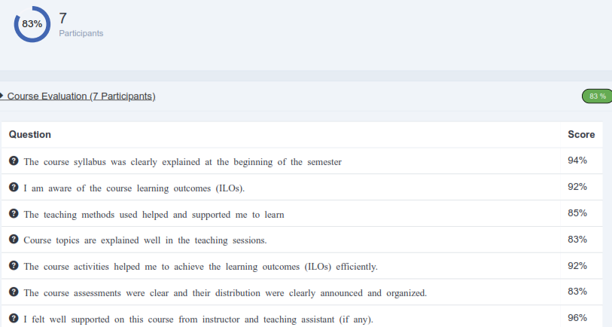

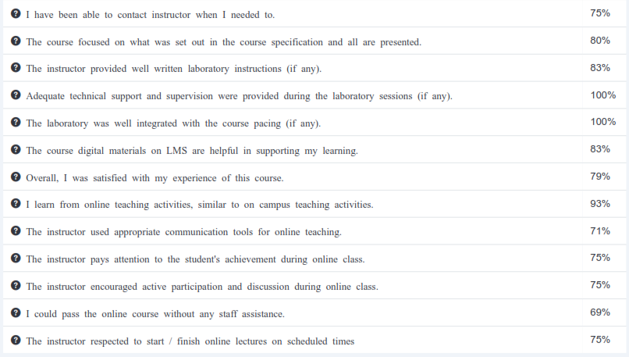

**Response of Course Team**

List any criticisms

…No criticism.…….………..……………………………….

………………………………………………………………………………………………

1. **Comments from external evaluator(s): Response of course team**

………**N/A** ………………. …………………………….

……….……………..……. …………………………….