|  |  |
| --- | --- |
| *Course report of* | |
| **Mathematics (1) – PHM 012s Fall 2020** | |
| University: Ain Shams | Faculty: Engineering |

## Basic Information

1. Title and code :

|  |
| --- |
| **Mathematics (1) – PHM 012s** |

1. Program on which the course is given :

|  |  |
| --- | --- |
| |  | | --- | | All Programs | |

1. Year/Level of programs :

|  |
| --- |
| 1st Level |

1. Units/Credit Hours

|  |  |
| --- | --- |
| ( i ) Lecture : | 3 |

|  |  |
| --- | --- |
| ( ii ) Tutorial/Practical : | 2 |

|  |  |
| --- | --- |
| ( iii ) Total : | 5 |

1. Names of lecturers contributing to delivery of the course :

|  |  |
| --- | --- |
| i - | Professor Dr. Niveen Badra – Dr. Hussain - Dr. Fayza Selim |

|  |  |
| --- | --- |
| ii - | Dr. Nadia Anwar – Dr. Ashraf Kattab – Dr. Betty Nagy |

|  |  |
| --- | --- |
| iii - |  |

|  |  |
| --- | --- |
| Course coordinator: | Professor Dr. Niveen Badra |

|  |  |
| --- | --- |
| External evaluator: | --- --- --- |

## Statistical Information

|  |  |
| --- | --- |
| No. of students attending the course: | 1708 |

|  |  |  |  |  |  |  |  |  |  |  |  |  |  |  |  |
| --- | --- | --- | --- | --- | --- | --- | --- | --- | --- | --- | --- | --- | --- | --- | --- |
|  | A+ | A | A- | B+ | B | B- | C+ | C | C- | D+ | D | F | --- | SUM | |
| Students No. | 198 | 158 | 192 | 213 | 144 | 166 | 98 | 96 | 88 | 66 | 95 | 193 | --- | 1708 | |
| Percentage (%) | 12 | 9 | 11 | 12 | 8 | 10 | 6 | 6 | 5 | 4 | 6 | 11 | --- |  |

## The Ratio A+ , A , A- 32% as the students were interesting in Online Teaching with both instructors and TA.

## Professional Information

1. **Online Course Teaching:**

|  |  |  |
| --- | --- | --- |
| Course Content | No. of Hours | Lecturer |
| Online Lectures and Tutorials 1-3:  Differentiation and Integration Formulas – Fundamental Theorem of Calculus | **15** | Prof. Niveen Badra  Dr. Fayza Selim  Dr. Nadia Anwar  Dr. Ashraf Kattab  Dr. Betty Nagy |
| Online Lectures and Tutorials 4-7:  Inverse Functions – Inverse Trig Functions- Hyperbolic Functions | **20** | Prof. Niveen Badra  Dr. Fayza Selim  Dr. Nadia Anwar  Dr. Ashraf Kattab  Dr. Betty Nagy |
| Online Lectures and Tutorials 8-11:  L’Hopital Rule -Techniques of Integrations | **20** | Prof. Niveen Badra  Dr. Fayza Selim  Dr. Nadia Anwar  Dr. Ashraf Kattab  Dr. Betty Nagy |
| Online Lecture and Tutorial 12-13: Conic Sections and General Revision | **10** | Prof. Niveen Badra  Dr. Fayza Selim  Dr. Nadia Anwar  Dr. Ashraf Kattab  Dr. Betty Nagy |
| **Total** | **65** |  |

**Topics taught as a percentage of the content specified:**

**>90 % X 70-90 % <70%**

**Reasons in detail for not teaching any topic**

All topics were taught ……………………………………….

………………………………………………………………………………………………

………………………………………………………………………………………………

**If any topics were taught which are not specified, give reasons in detail**

N/A………………………………………………………………………………………….

………………………………………………………………………………………………

**Teaching and learning methods:**

Lectures: (Online Sessions) **X**

Practical training/ laboratory:

Seminar/Workshop:

Class Activity: **(Tutorials) (Online)** **X**

**Case Study:**

Other assignments/homework:

If teaching and learning methods were used other than those specified, list and give reasons:

………………………………………………………………………………………………

1. **Student Assessments:**

|  |  |
| --- | --- |
| **Method of assessment** | **Percentage of total** |
| Assignments 1 – 5 | 10 |
| Attendance and Participation | 5 |
| Online Quizzes 1-2 | 5 |
| Written Mid Term | 20 |
| Written Final Term Exam | 60 |

**Members of examination committee**

i - Professor Dr. Niveen Badra

ii – Dr. Hussain Abd El-Salam

iii – Dr. Fayza Selim

iv – Dr. Nadia Anwar

v – Dr. Ashraf Kattab

vi – Dr. Betty Nagy

**Role of external evaluator**

N/A………………………………………………………………………………………….

………………………………………………………………………………………………

1. **Facilities and teaching materials:**

Totally adequate **X**

Adequate to some extent

Inadequate

List any inadequacies

1. **Administrative constraints:**

List any difficulties encountered

No difficulties

1. **Student evaluation of the course:**

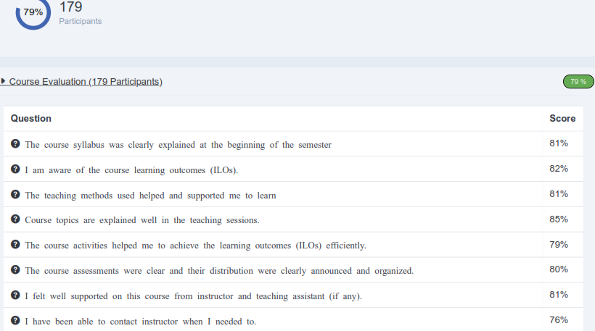

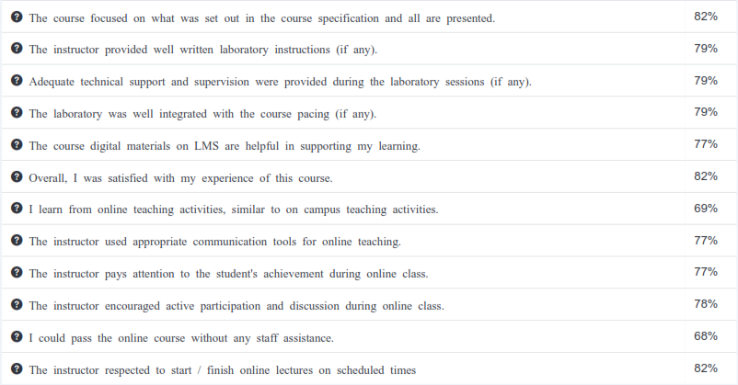

**Response of Course Team**

List any criticisms

…No criticism.…….………..……………………………….

………………………………………………………………………………………………

1. **Comments from external evaluator(s): Response of course team**

………**N/A** ………………. …………………………….

……….……………..……. …………………………….