Course Reports

ASU336: Business Administration Spring 2021
University: Ain Shams Faculty: Engineering
Program on which the course is given: | University Requirement – All Programs
Major or minor element of program: | N/A
Department offering the program: | Basic Science
Department Teaching the course: | Design and Production Engineering
Academic year/ Level: | 1-4
Date of specification approval:

- Basic Information
Title: | Business Administration | Code: | ASU 336
Credit Hours: | 2 | Lecture: | 2
Tutorial: | 0 | Lab: | 0
Total Contact: | 2

Names of lectures contributing to the delivery of the course
i Dr. Mohammed M. El-Beheiry….

B – Statistical Information
97.3%

112
No. of students attending the course: No. %
No. of students completing the course: No. %
109

Results:
Grade | No. | Percentage
Passed | 11 | 10%
Failed | 25 | 22%
A | 11 | 10%
B | 37 | 33%
C | 14 | 15%
D | 11 | 10%
Total | 109 | 100.00%

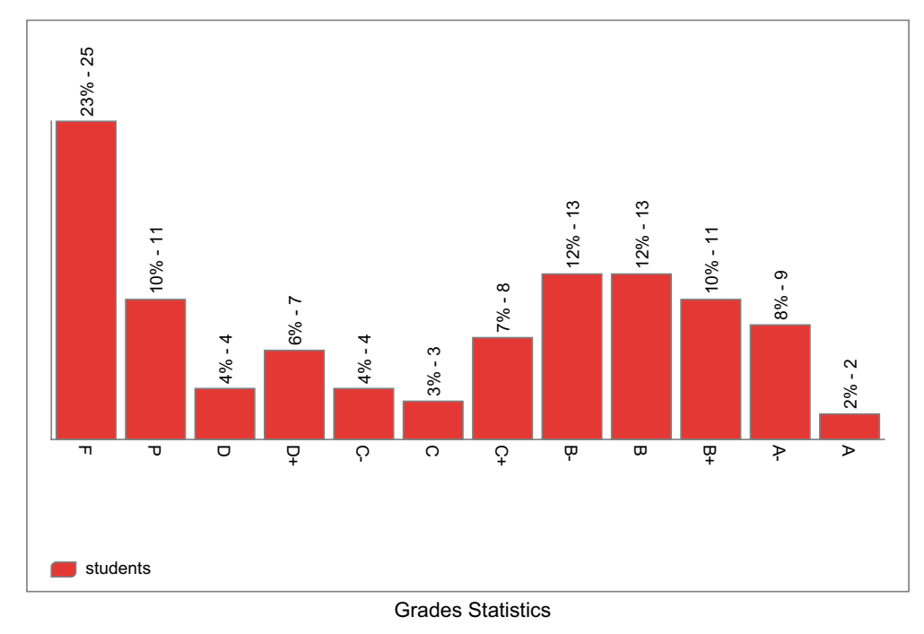
N.B. The ‘F’ include the absent students and the percentages are from the total registered

C – Professional Information
- Course teaching
Week | Course Content | Lecture  Hours | Tutorial  Hours
1 | Types of Businesses | 2 | 0
2 | Business Challenges | 2 | 0
3 | Value Chain | 2 | 0
4 | Value Proposition | 2 | 0
5 | Business Models | 2 | 0
6 | Business Model Canvas | 2 | 0
7 | Business Model Canvas (Cont.) | 2 | 0
8 | How to formulate a business Vision | 2 | 0
9 | How to formulate a business Mission | 2 | 0
10 | Development of Management | 2 | 0
11 | Management functions | 2 | 0
12 | Planning- & Organizing | 2 | 0
13 | Leading and Controlling | 2 | 0
14 | Organization Structures | 2 | 0
15 | Organization Structures (Cont.) | 2 | 0
Total Number of Hours |  | 30

Topics taught as a percentage of the content specified

X
>90% 70-90% <70%

Reasons in detail for not teaching any topic
……………………………………...
……………………………………...
if any topics were taught which are not specified, give reasons in detail
……………………………………..
……………………………………..

2- Teaching and learning methods:

Lectures:
Online Lectures: | √
Practical training/ laboratory:
Seminar/workshop:
Class Activity:
Case Study | √

All lectures were online using Microsoft Teams with the following link for the team:

https://teams.microsoft.com/l/team/19%3a6fbaed6883504c7b9fa820bfb9953629%40thread.tacv2/conversations?groupId=7322b1df-3561-417e-be46-573257a35448&tenantId=ad2a8324-bef7-46a8-adb4-fe51b6613b24

Samples of the Teams Meetings:
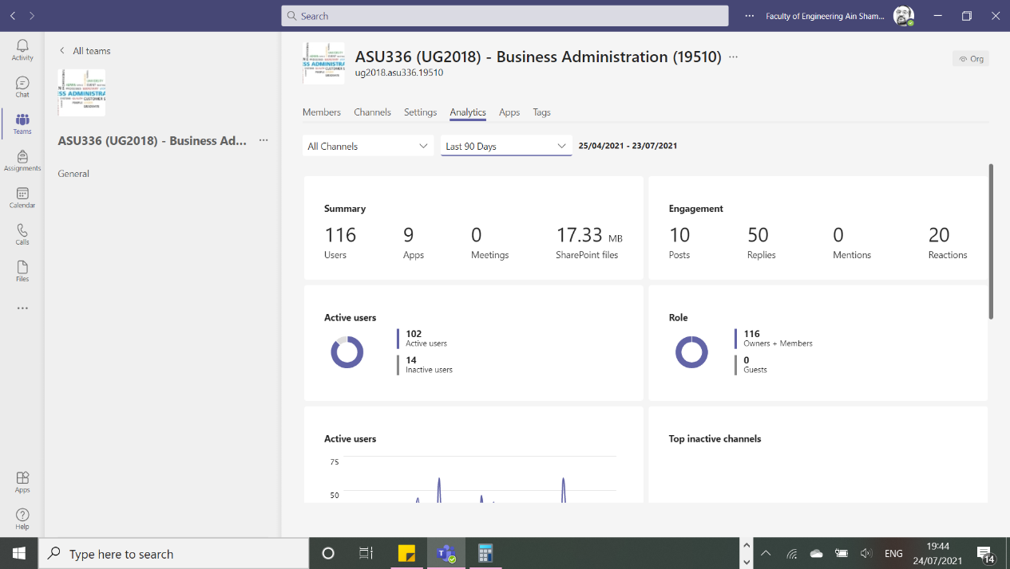
24th of March 2021 Lecture:
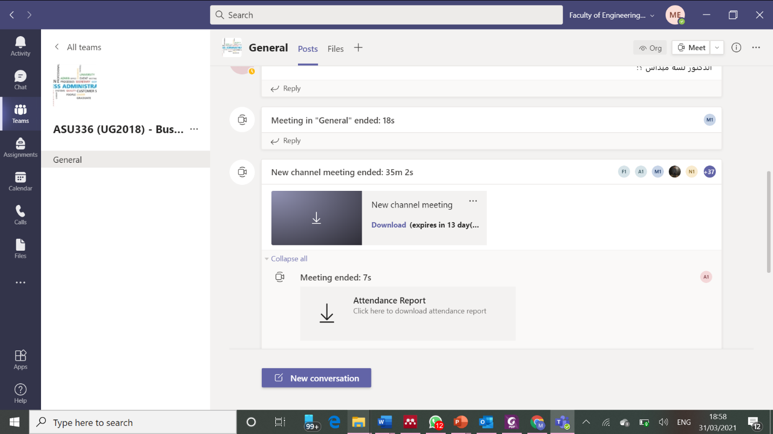
7th of April
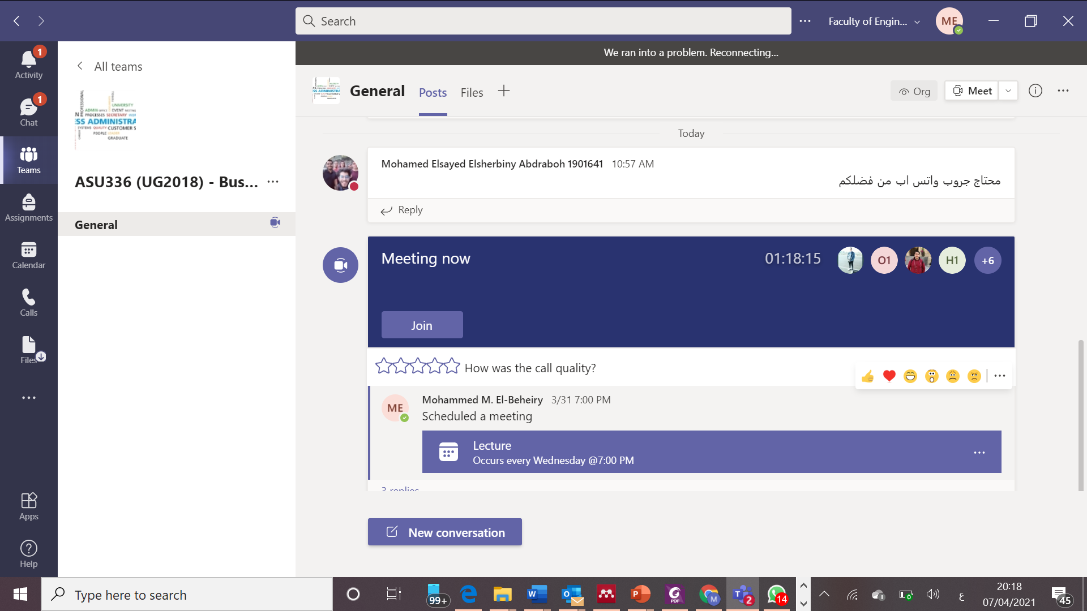
14th of April
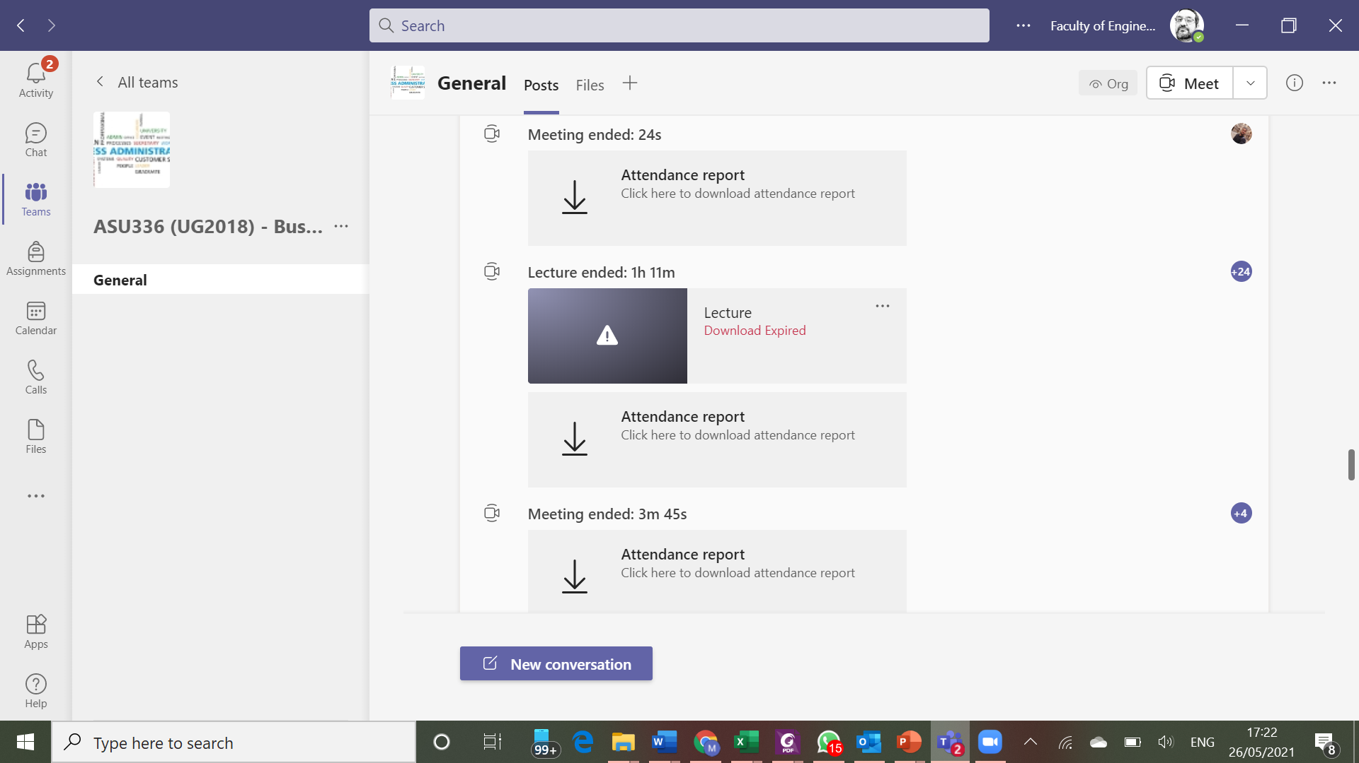
19th of May
2nd of June Lecture
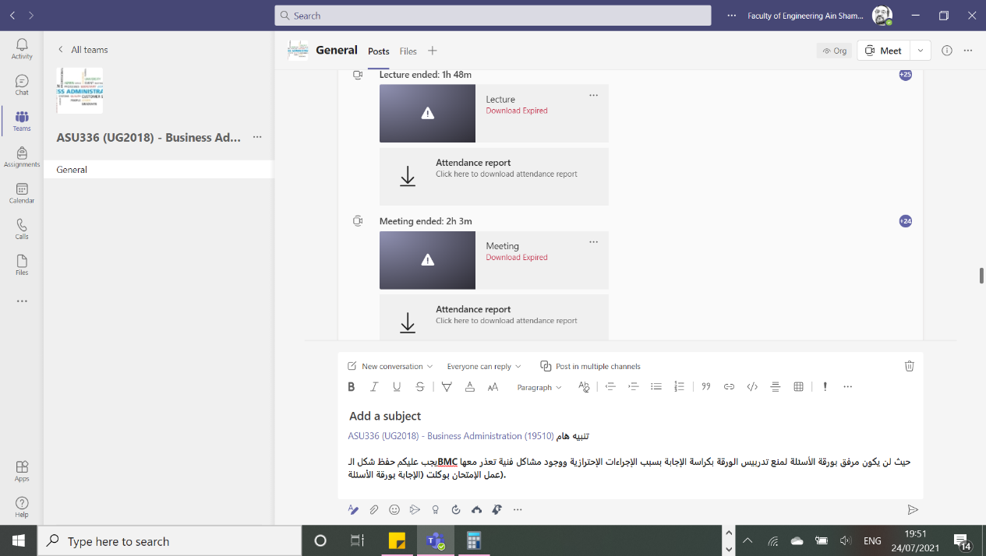
6th of July
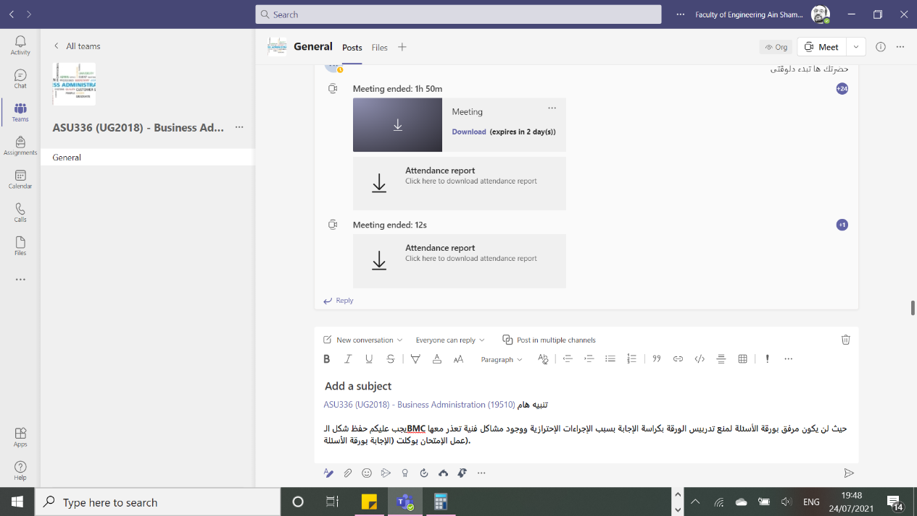

Other assignments/homework:
If teaching and learning methods are used other than those specified, list and give reasons:
……………………………………………………............................
3 – Student assessment
Method of assessment | Percentage of total
Written examination  2 Quizzes  Final Exam | 100%  20% (10% Each)  80%
Project Work | N/A
Practical/laboratory work | N/A
Other assignments/class work | N/A
Total | 100%

Members of examination committee
…Prof. Nahid Afia…..
…Dr. Mohammed El-Beheiry…..

Role of external evaluator
………………………………….

4- Facilities and teaching materials

X

Totally adequate

Adequate to some extent

Inadequate
List any inadequacies
……………………………........

5- Administrative constraints

List any difficulties encountered
None

6- Student evaluation of the course: Response of Course Team

list any criticisms
None

7- Comments from external evaluator(s): Response of Course Team
……………………………… ……………………..
……………………………… ……………………..
8- Course Enhancement:

Progress on actions identified in the previous year’s action plan:
Action | state whether or not completed and give reasons for non-completion
The Course implementation is still under evaluation and the first planned action is due at the academic year 21-22

9- Action plan for academic year 2020 – 2021
Actions required | Completion Date | Person Responsible
Revise the sequence of the delivery of the course content | 2021- 2022 | Course coordinator

Course coordinator: Dr. Mohammed El-Beheiry

Signature:

Date: 24-07-2021

