*Course report of*

|  |
| --- |
| **Engineering History & Technology – ASU 324 Fall 2020** |

|  |  |
| --- | --- |
| **University Ain Shams** | **Faculty** **of** **Engineering** |

**A- Basic Information**

1. **Title and code:**

**Engineering History & Technology – ASU 324**

1. **Program(s) on which this course is given: All Programs**

**3. Year/ Level of programs: All Levels**

**1. Units/Credit hours:**

1. Lectures **2 hours per week**
2. Tutorial/Practical **1 hours per week**
3. Total **2 hours per week**

**2. Names of lecturers contributing to the delivery of the course**

1. Dr Ahmed Hassan Yakout
2. Course coordinator: Dr Ahmed Hassan Yakout

External evaluator ………N/A……………………

**B- Statistical Information**

|  |  |
| --- | --- |
| No. of students attending the course: | 705 |

|  |  |  |  |  |  |  |  |  |  |  |  |  |  |  |  |
| --- | --- | --- | --- | --- | --- | --- | --- | --- | --- | --- | --- | --- | --- | --- | --- |
|  | A+ | A | A- | B+ | B | B- | C+ | C | C- | D+ | D | P | F | SUM | |
| Students No. | 0 | 5 | 9 | 20 | 12 | 20 | 14 | 7 | 7 | 8 | 14 | 23 | 46 | 185 | |
| Percentage (%) | 0 | 3 | 5 | 11 | 6 | 11 | 8 | 4 | 4 | 4 | 8 | 12 | 24 |  |

**C- Professional Information**

**C.1 – Course Lectures**

|  |  |  |
| --- | --- | --- |
| **Course Content** | **No. of Hours** | **Lecturer** |
| **Introduction to Engineering** | **3** | **Dr. Ahmed Hassan Yakout** |
| **Prehistoric Engineering** | **6** | **Dr. Ahmed Hassan Yakout** |
| **Ancient Engineering** | **6** | **Dr. Ahmed Hassan Yakout** |
| **Medieval Engineering** | **6** | **Dr. Ahmed Hassan Yakout** |
| **Renascent Engineering** | **6** | **Dr. Ahmed Hassan Yakout** |
| **Expansive Engineering** | **9** | **Dr. Ahmed Hassan Yakout** |
| **Modern Engineering** | **6** | **Dr. Ahmed Hassan Yakout** |
| **Total** | **42** |  |

**Topics taught as a percentage of the content specified:**

**>90 % X 70-90 % <70%**

Reasons in detail for not teaching any topic

**N/A**……………………………………….

If any topics were taught which are not specified, give reasons in detail

**N/A**……………………..

**2- Teaching and learning methods:**

Lectures **(100% online)**

Practical training/ laboratory:

Seminar/Workshop:

Class Activity: **(100% online)**

## 

## Case Study:

Other assignments/homework: **Preparing a Report & Delivering a Presentation (Team Work)**

If teaching and learning methods were used other than those specified, list and give reasons:

**To enhance students research, and communication Skills**

**3- Student assessment:**

|  |  |
| --- | --- |
| **Method of assessment** | **Percentage of total** |
| **Written examination (Final+ mid-term)** | **80 %** |
| **Report** | **10 %** |
| **Presentation** | **10%** |

Members of examination committee

1. Dr. Ahmed Hassan Yakout

Role of external evaluator

…… **N/A** ………………………………

………………………………………

**4- Facilities and teaching materials:**

Totally adequate

Adequate to some extent

Inadequate

Microsoft teams Recorded Lectures and notes are available at the following Link on LMS

https://drive.google.com/drive/folders/1crXaARstJjHGg1VRORE3cc4sUAkRHeFy

Samples of print screens from online Lectures

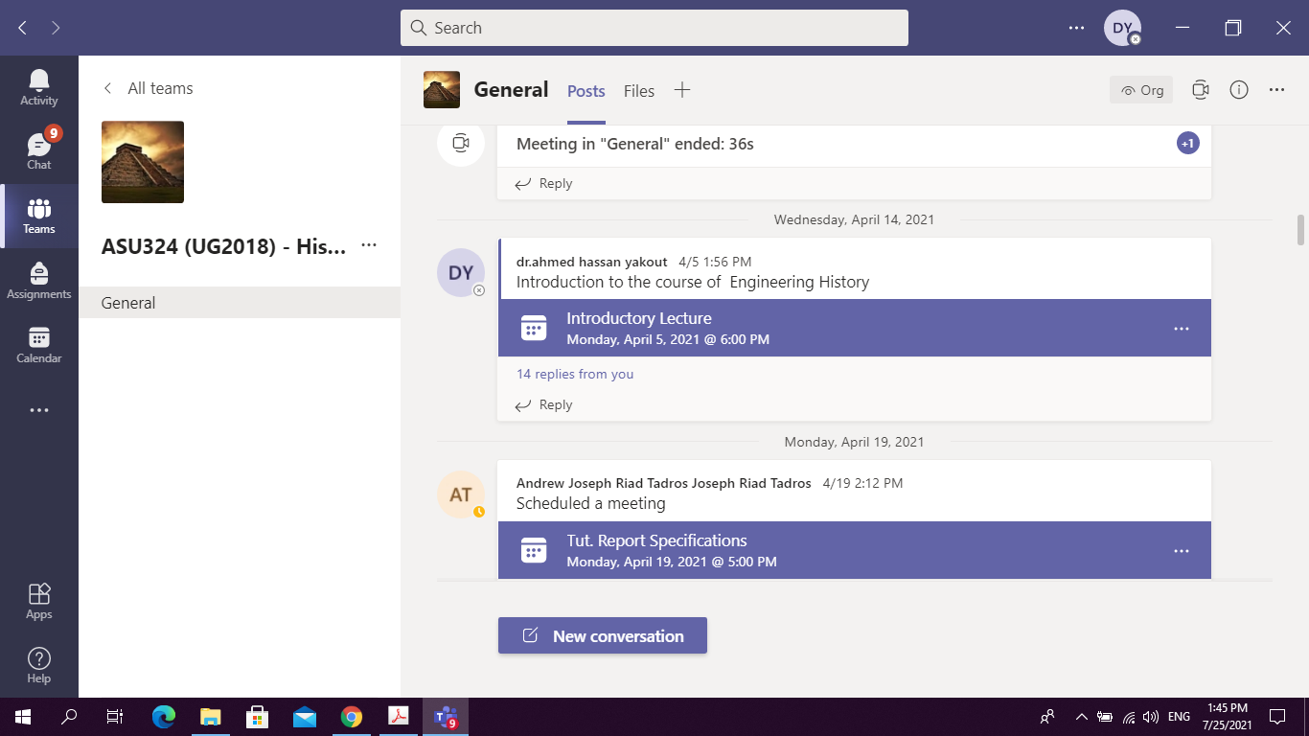

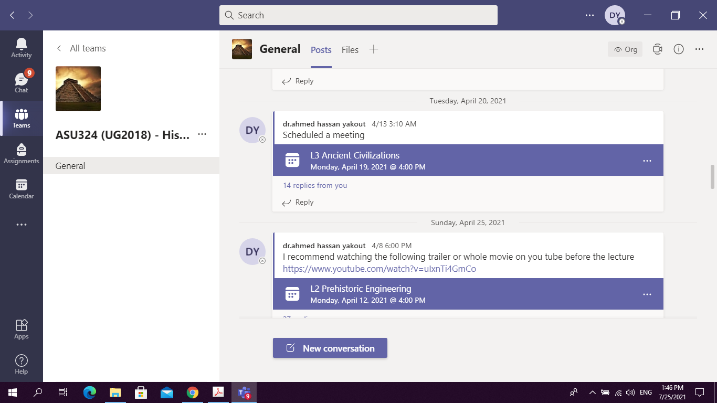

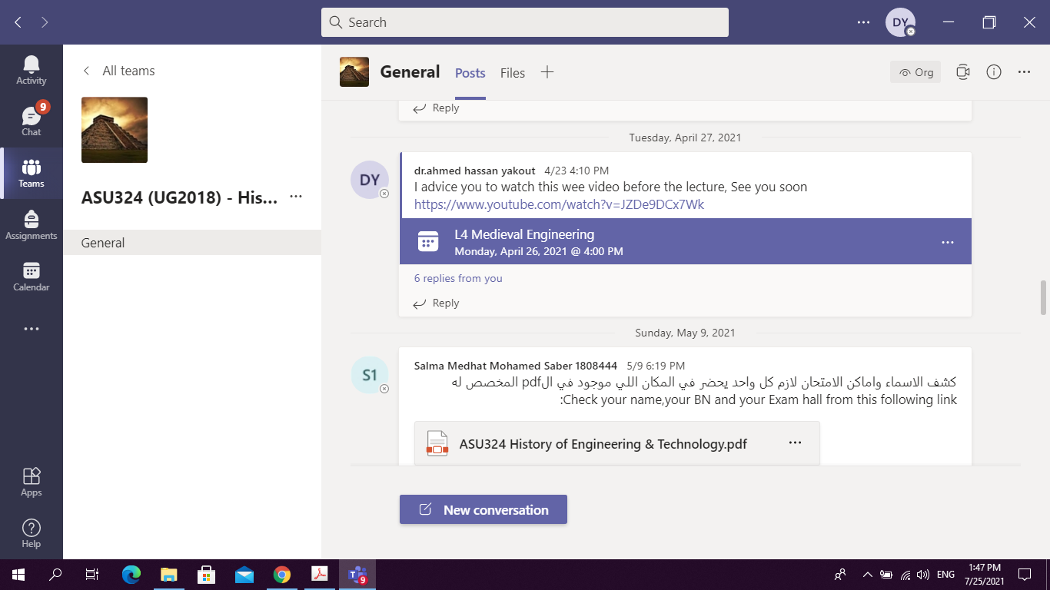

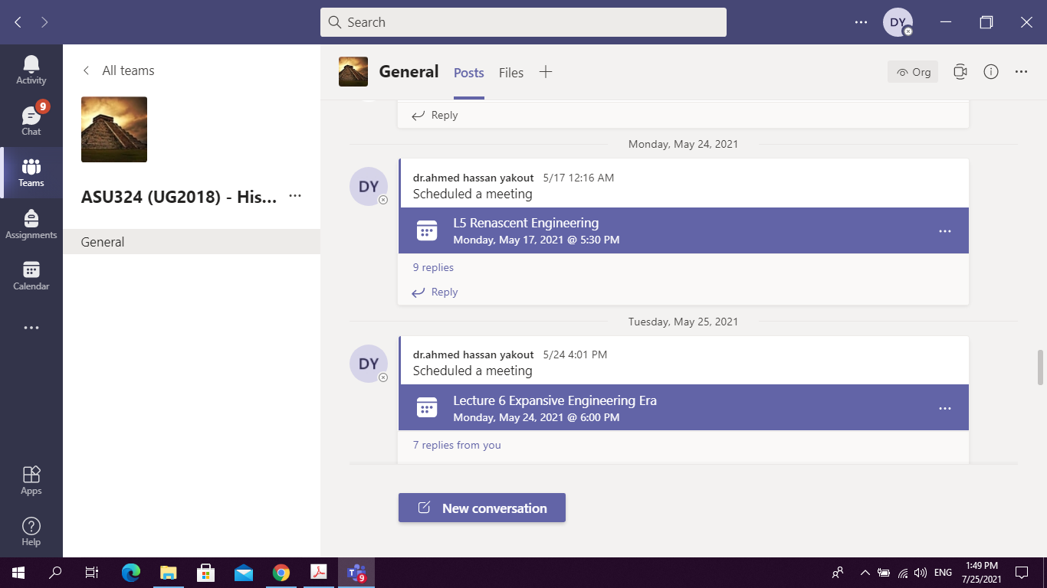

**5- Administrative constraints**

List any difficulties encountered

**No difficulties**

**6- Student evaluation of the course:**



**Response of Course Team:**

**No response required (All comments are above 50 %)**

**7- Comments from external evaluator(s): Response of course team**

**N/A** …………………….. …………………………….

……….……………..……. …………………………….

…………………………… …………………………….

……………………………. …………………………….

…………………………… …………………………….

**8- Course enhancement: Progress on actions identified in the previous year’s action plan:**

**N/A** …………………….. …………………………….

……….……………..……. …………………………….

…………………………… …………………………….

……………………………. …………………………….

…………………………… …………………………….

**9- Action plan**

**Actions required Completion date Person responsible**

……………………… ……………………… ………………………

……………………… ………………………

……………………… ……………………… ………………………