Course report of
Engineering Economy- HUM 111 Spring 2021
University: Ain Shams Faculty: Engineering
Basic Information

Engineering Economy- HUM 111

Freshmen Students

Second year

  - Units/Credit Hours

2
2/0
4

  - Names of lecturers contributing to the delivery of the course :
Dr. Nabil M. Hamed

- Statistical Information
51
Grad Letter No. of Students % of Total
A+ 1 1.96
A 4 7.84
A- 8 15.69

B+ 12 23.53
B 7 13.73
B- 5 9.8
C+ 3 5.88
C 1 1.96
C- 1 1.96
D+ 0 0
D 1 1.96
F 8 15.69
P 0 0
- Professional Information

1-- Course Teaching:
No | Course Content | Lecture  (hours) | Tutorial | Total
1 | Foundations of engineering economy; Factors: how time and interest affect money | 1 | 3 | 4
2 | Combining factors | 3 | 3 | 6
3 | Nominal and effective interest rates | 2 | 2 | 4
4 | Present-worth evaluations | 3 | 3 | 6
5 | Future worth and capitalized cost evaluations | 3 | 3 | 6
6 | Equivalent-annual worth analysis and review | 3 | 2 | 5
7 | Rate of return analysis of single alternative | 3 | 3 | 6
8 | Rate of return evaluations for multiple alternatives | 3 | 3 | 6
9 | Benefit cost analysis and public sector economics | 3 | 3 | 6
10 | Replacement analysis | 3 | 3 | 6
11 | Breakeven analysis | 3 | 2 | 5
 | Total | 30 | 30 | 60

Topics Taught as a percentage of the content specified

Reasons in detail for not teaching any topic

NA

If any topics were taught which are not specified, give reasons in detail
NA
2- Teaching and learning methods:

Case Study:
Other assignments/homework
If teaching and learning methods were used other than, those specified, list and give reasons
3- Student assessment:
Assessment Method | Description | Week No | Weight (%)
Assignments and Reports # | Solving selected problems and reports | Week 2-8 | 20
Written Exams  (Midterm # 01 & # 02) | Midterm Term Exams | Week 4 | 25
Quizzes | Quiz | Week 3,6 | 10
Attendance & participation | Participation in class | Week 1-9 | 5
Written Exams (Final Term) | Final Term Exam | Week 9 | 40
 |  | Total | 100

Members of examination committee

Role of external evaluator:
4- Facilities and teaching materials:

List any inadequacies:
5-Administrative constraints:
6-Student evaluation of the course:
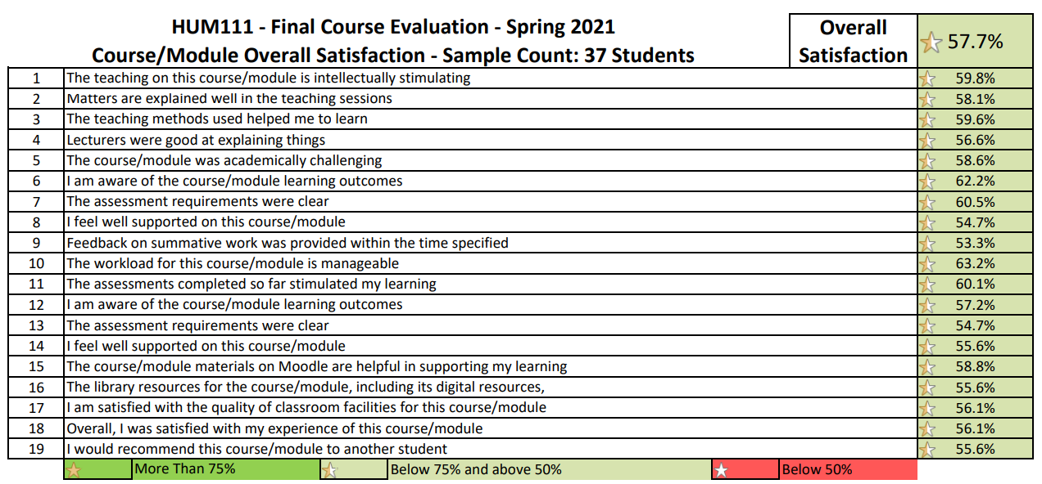

7-Comments from external evaluator(s)
NA
8- Course enhancement: Progress on actions identified in the previous year’s action plan:
NA
9- Action plan
NA
10- Online lectures and tutorials
https://drive.google.com/drive/folders/1NrySGzf_qlp6RGKnQckou4jI4s-JjZiN?usp=sharing
link to Microsoft teams
https://teams.microsoft.com/l/team/19%3af8cf83d310d54b3c9cb4461a31ff254f%40thread.tacv2/conversations?groupId=3a8bcc74-1e89-4743-addf-173f6e8eedbd&tenantId=ad2a8324-bef7-46a8-adb4-fe51b6613b24

