|  |  |
| --- | --- |
| *Course report of* | |
| **Professional Ethics and Legislation – ASU113– Fall 2020** | |
| University: Ain Shams | Faculty: Engineering |

## Basic Information

1. Title and code:

|  |
| --- |
| **Professional Ethics and Legislation – ASU113** |

1. Program on which the course is given:

|  |  |
| --- | --- |
| |  | | --- | | All | |

1. Year/Level of program:

|  |
| --- |
| 1st Level |

1. Units/Credit Hours

|  |  |
| --- | --- |
| ( i ) Lecture : | 2 |

|  |  |
| --- | --- |
| ( ii ) Tutorial: | 2 |

|  |  |
| --- | --- |
| ( iii ) Total : | 4 |

1. Names of lecturers contributing to delivery of the course:

|  |  |
| --- | --- |
| i - | Prof. Adel Agib Wassif  Dr. Ismail Hafez Dr. Micha |

|  |  |
| --- | --- |
| ii - |  |

|  |  |
| --- | --- |
| iii - |  |

|  |  |
| --- | --- |
| Course coordinator: | Prof. Adel Agib Wassif |

|  |  |
| --- | --- |
| External evaluator: | --- --- --- |
|  |  |

## Statistical Information

|  |  |  |  |  |  |  |  |  |  |  |  |  |  |  |
| --- | --- | --- | --- | --- | --- | --- | --- | --- | --- | --- | --- | --- | --- | --- |
| **Grade** | **A+** | **A** | **A-** | **B+** | **B** | **B-** | **C+** | **C** | **C-** | **D+** | **D** | **F** | **P** | **Total** |
| **No. of students** | 0 | 8 | 100 | 243 | 128 | 68 | 22 | 11 | 8 | 5 | 2 | 30 | 6 | 631 |
| **% of students** | 0 | 1.26 | 15.8 | 38.5 | 20.28 | 10.7 | 3.48 | 17.43 | 12.6 | 0.79 | 0.31 | 4.75 | 0.95 | 100 |

## Professional Information

|  |  |  |  |
| --- | --- | --- | --- |
| Course Content | Lectures | Tutorial | Lecturer |
| *مقدمة عامة* | **2** | 2 | Prof. Adel Agib |
| *مراحل المشروع الهندسى* | **2** | 2 | Prof. Adel Agib |
| *مراحل المشروع الهندسى* | **2** | 2 | Prof. Adel Agib |
| *مراحل المشروع الهندسى* | **2** | 2 | Prof. Adel Agib |
| *العقـــود الهندسية وأنواعها Types of Engineering Contracts* | **2** | 2 | Prof. Adel Agib |
| *العقـــود الهندسية وأنواعها Types of Engineering Contracts* | **2** | 2 | Prof. Adel Agib |
| *العقـــود الهندسية وأنواعها Types of Engineering Contracts* | **2** | 2 | Prof. Adel Agib |
| *المطالبات والمنازعات و طرق حلها Claims and Disputes* | **2** | 2 | Prof. Adel Agib |
| *المطالبات والمنازعات و طرق حلها Claims and Disputes* | **2** | 2 | Prof. Adel Agib |
| النزاهه | **2** | 2 | Prof. Adel Agib |
| النزاهه | **2** | 2 | Prof. Adel Agib |
| معلومات عامة عن نقابة المهندسين | **2** | 2 | Prof. Adel Agib |
| معلومات عامة عن نقابة المهندسين | **2** | 2 | Prof. Adel Agib |
| معلومات عامة عن اتحاد المقاولين المصريين | **2** | 2 | Prof. Adel Agib |
| معلومات عامة عن اتحاد المقاولين المصريين | **2** | 2 | Prof. Adel Agib |

1. **Course Teaching:**

**Topics taught as a percentage of the content specified:**

**>90 % X 70-90 % <70%**

**Reasons in detail for not teaching any topic**

**Teaching and learning methods:**

Interactive Lectures using Microsoft Teams + Uploaded Videos: **X**

* Interactive Tutorials using Microsoft Teams: **X**
* Self-learning  **x**

**Case Study:**

Other assignments/homework: **Assignment about advanced device physics**

**Student assessment:**

|  |  |
| --- | --- |
| **Method of assessment** | **Percentage of total** |
| Final written examination | 60 % |
| Midterm | 20% |
| Online Quiz | 0 |
| Other assignments/class work | 20% (Assignment) |

**Because of Corona Virus, no quizzes were done. All grades were on assignment**

**Members of examination committee**

i – Prof. Adel Agib

**Role of external evaluator**

N/A………………………………………………………………………………………….

1. **Facilities and teaching materials:**

Totally adequate

Adequate to some extent

x

Inadequate

List any inadequacies

1. **Administrative constraints:**

List any difficulties encountered

No difficulties

1. **Student evaluation of the course:**

**Quality questionnaire uploaded**

**Response of Course Team**

1. **Comments from external evaluator(s): Response of course team**

………**N/A** ………………. …………………………….

**Details about online teaching**

This course was 100% delivered online using Microsoft Teams and LMS

Details are shown below

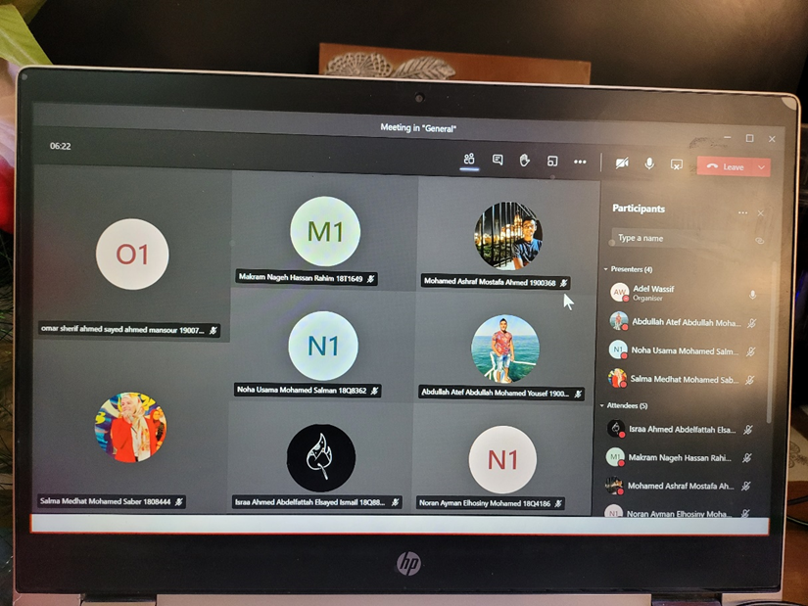

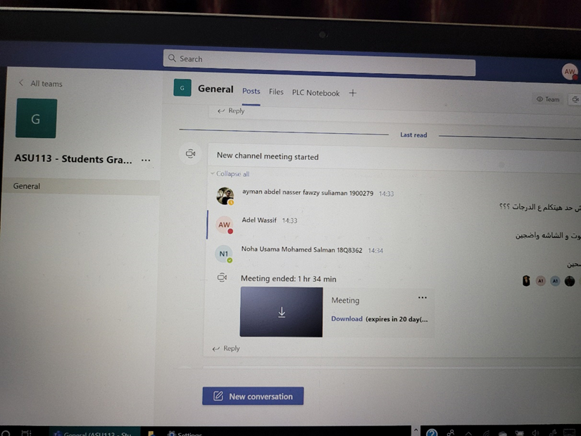

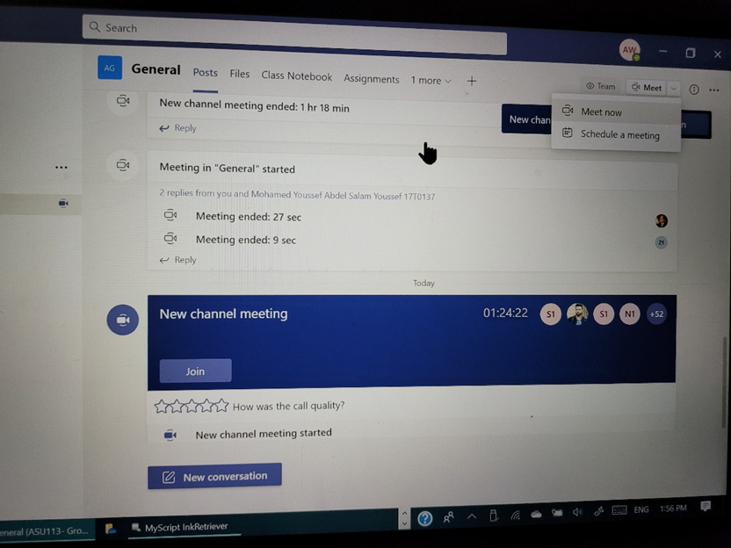

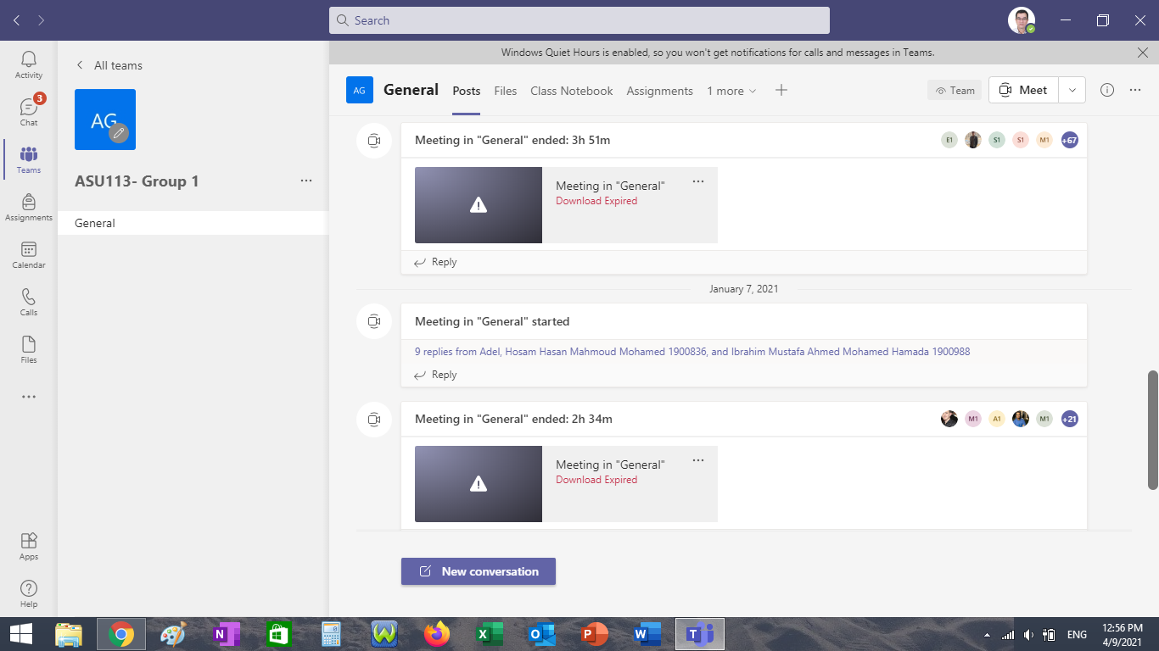

**Action Plan**

1- Improving the quality of the videos

2- Increasing the student interactions