Course report of

Technical Report Writing – ASU112_SOPHOMORE Spring 2021

University Ain Shams | Faculty Engineering

A- Basic Information

Title and code:

Technical Report Writing – ASU112_SOPHPOMORE

Program(s) on which this course is given:

Civil-electrical-architecture-mechanical students- Freshman
3. Year/ Level of programs: from 1-st to 5th Year

1. Units/Credit hours:

Lectures 2 hours per week

Tutorial/Practical 2hours per week

Total 4 hours per week

2. Names of lecturers contributing to the delivery of the course

Prof. Dr. Aly N. El-Bahrawy
    - Dr. Shaimaa Fathy
    - Dr. Marwa Mahmoud Aboulnasr
    - Diaa Abdelmonem Mahmoud Abidou
    - Dr. Hadeer Arab

Course coordinator Prof. Dr. Aly N. El-Bahrawy
External evaluator ………N/A……………………

B- Statistical Information

No. of students attending the course: 477

C- Professional Information

1 – Course teaching
Week | Course Content | Lecture  Hours
1 | Technical Writing Style | 2
2 | Content and Appearance | 2
3 | Content and Appearance | 2
4 |  | 2
  Typography and Writing
5 |  | 2
  Formal Technical Report
6 | Letter, memo, and email | 2
7 | Engineering Reports | 2
8 | Social Media and Higher Education | 2
9 | Social Media and Higher Education | 2
10 | Comunication skills | 2
11 | Presentation skills | 2
12 | Presentation skills | 2
Total Number of Hours |  | 30

Topics taught as a percentage of the content specified:

>90 % X 70-90 % <70%

Reasons in detail for not teaching any topic

Some topics were reduced or were not taught exactly as planned due to holidays on lectures days (scheduled lecture day) during the second semester.

If any topics were taught which are not specified, give reasons in detail
N/A……………………..
………………………………………………
………………………………………………
………………………………………………

2- Teaching and learning methods:
E-Learning (using Microsoft Teams & LMS)
√
Due to Corona virus the teaching was online and every lectures and material was uploaded to the LMS and MS teams

Microsoft teams link:
https://teams.microsoft.com/l/channel/19%3a54d108630d214d1eb1fc2df9eab0c73e%40thread.tacv2/General?groupId=f3c1d426-8c3e-4365-9d84-1a06e6f75adb&tenantId=ad2a8324-bef7-46a8-adb4-fe51b6613b24
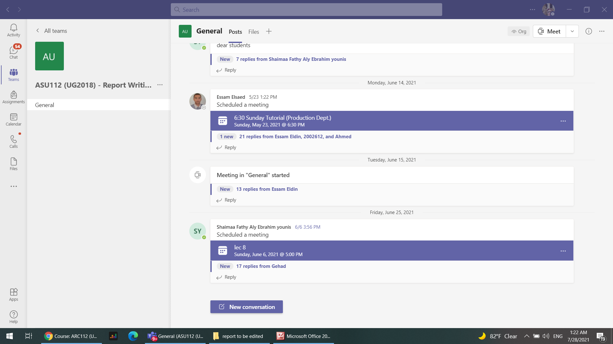
LMS Link: https://lms.eng.asu.edu.eg/course/view.php?id=7408
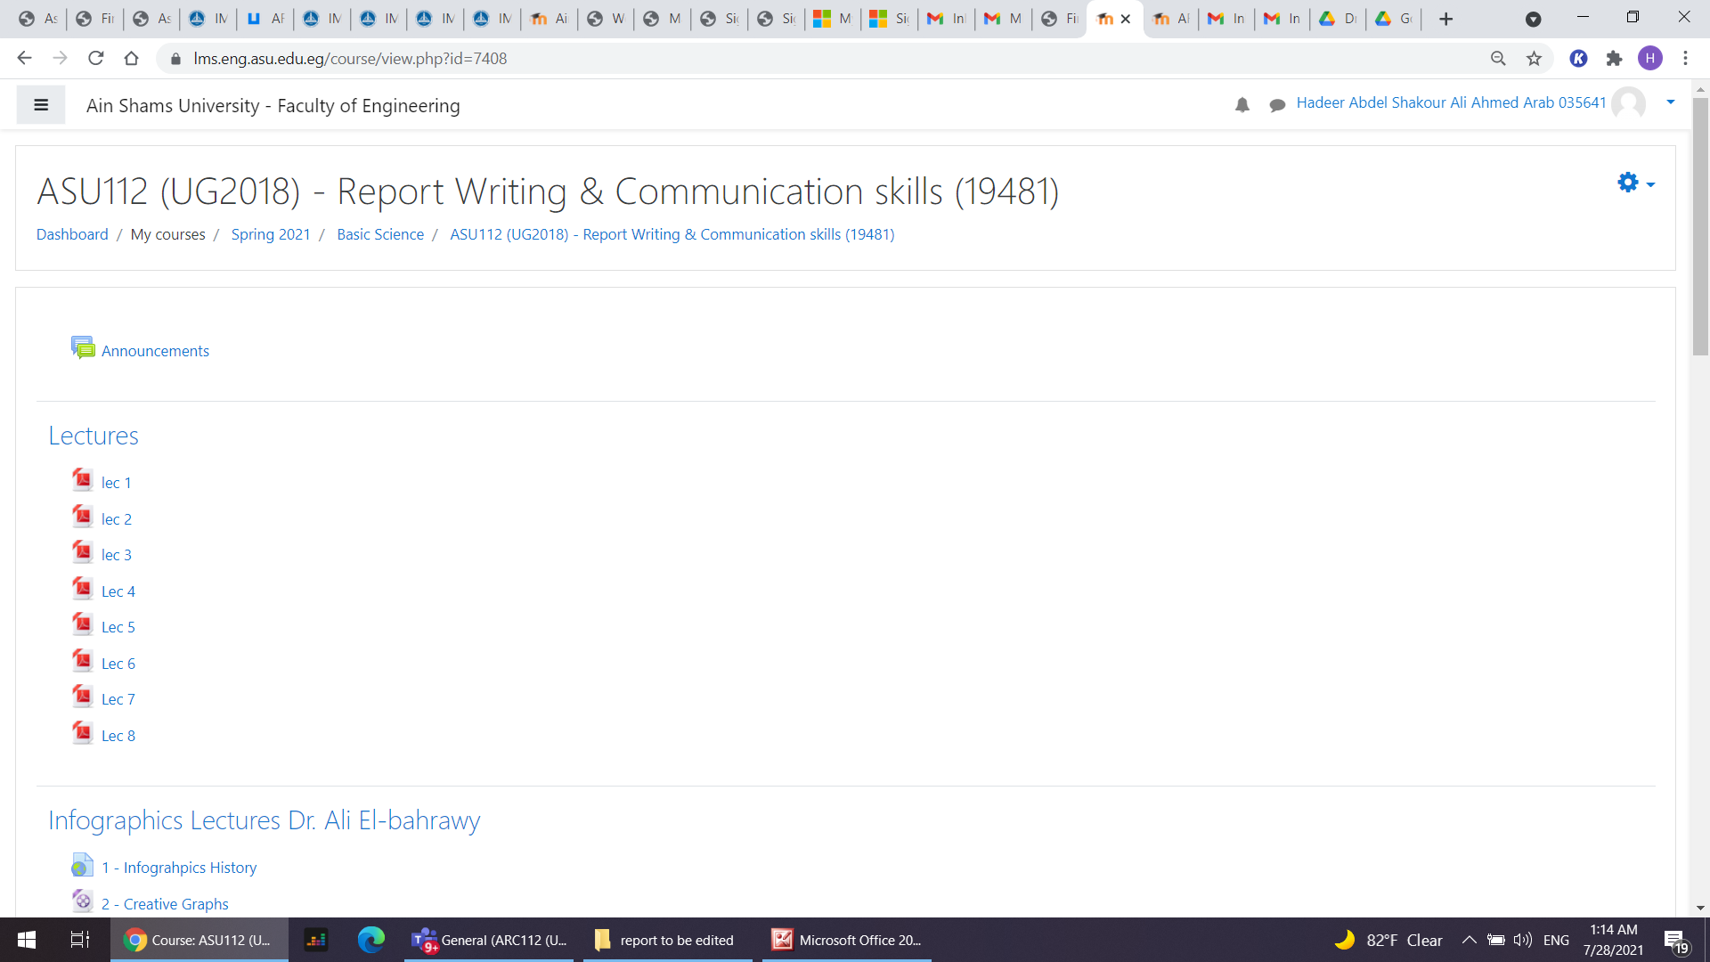

Case Study:
Other assignments/homework:
If teaching and learning methods were used other than those specified, list and give reasons:
Reports to give a room for team building and teach the students how to work in group and also to measure their performance and ability to carry out a scientific research

3- Student assessment:
Method of assessment Percentage of total

Written final examinations 60 %

Mid term exam 20%

Other assignments/class work 20%

Total 100 %

Members of examination committee

Prof. Dr. Aly N. El-Bahrawy
- Dr. Shaimaa Fathy
- Dr. Marwa Mahmoud Aboulnasr
- Diaa Abdelmonem Mahmoud Abidou
- Dr. Hadeer Arab

Role of external evaluator
…… N/A ………………………………
………………………………………
……………………………………....

4- Facilities and teaching materials:

5- Administrative constraints
- Timetable for some tutorials is not satisfactory.
- Lecture halls are not well equipped.

6- Student evaluation of the course:

Response of Course Team:

We will try to take the students comments into account in the upcoming semesters.

7- Comments from external evaluator(s): Response of course team
N/A …………………….. …………………………….
……….……………..……. …………………………….
…………………………… …………………………….
……………………………. …………………………….
…………………………… …………………………….

8- Course enhancement:
The course refrences had been updated

Progress on actions identified in the previous year’s action plan:

- Updating Lecture Notes
- Adding more details to be discussed with students
- More Exercises

9- Action plan
Try to do more practical work with students

