Course Report
- Basic Information

- Programme Title | Basic Science _ All Program
- Course Name @ (ASU) | Human Right
- Module/Course Code | -- / ASU_111
- Level UEL/ASU | --/ 1-4
- ASU Credit Rating | 2 Credits
- Contact Hours | Lecture: | 2 Hrs. | Tutorial: | 1 Hrs. | Lab: | 0 Hrs.
B- Course Teaching Information:
- Semester: |  |  | Fall 2020
- Module Leader: |  |  | --
- Course coordinator: |  |  | - Professor Dr. Moustafa A. chaaban
- Teaching Staff: |  |  | - Professor Dr. Moustafa A. chaaban  - Dr. Mohamed Lotfy Attia Zamzam
Course teaching Progression
- Topics taught _as a percentage_ considering the course tentative teaching plan:
■ | >90% | □ |  | 70% - 90% | □ | <70 %
- In case of teaching less than 90%, List in the following space the reasoning
N/A
- In case of teaching less than 90%, List in the following space the action plan:
N/A

Course Assessment
B8- Assessments Weights
Final exam | 80% | Mid-term exam | 0% | S.A. | 15%
Quizzes | 0% |  |  | Participation | 5%
For this semester_(COVID-19)
Final exam | 80% |  |  | S.A.  (applied for this semester) | 10%
Quizzes  (not allowed for this semester)  COVID-19 |  |  |  | Participation/presentation | 10%

Course teaching strategy
B9- Teaching and learning methods
Lectures | ■ | Class Activity | ■ | Project
Seminar/Workshop |  | Case Study |  | Other | ■
For this semester (COVID-19)
On Line Lecture | ■ | On Line Class Activity | ■ | Project | □
Seminar/Workshop | □ | Case Study: | □ | Other | ■
https://teams.microsoft.com/l/channel/19%3afa9c12fb885946d889ec04ea508ef9fd%40thread.tacv2/General?groupId=05eebb01-8ccb-4f68-9503-e3db60649433&tenantId=ad2a8324-bef7-46a8-adb4-fe51b6613b24

B10-Topics taught as planed:
1 | A general introduction to international human rights, as well as an overview of some specific topics in this field.
2 | An introduction to basic notions of public ethics,
3 | History of Human Rights, international instruments
4 | Categories of rights
5 | Human Rights violations, protection and responsibility thereof
6 | Continue, Human Rights violations, protection and responsibility thereof
7 | Continue, Human Rights violations, protection and responsibility thereof
8 | Deals with current issues in the human rights agenda such as: Rights of women,
9 | Rights of the child, rights of indigenous peoples,
10 | Armed conflicts and terrorism,
11 | The environment,
12 | Transitional justice
13 | Sexual minorities

- Course Assessment Information:

ASU Scale | A+ | A | A- | B+ | B | B- | C+ | C | C- | D+ | D | P | F | Tota
 | 4 | 10 | 29 | 30 | 22 | 14 | 12 | 14 | 12 | 03 | 17 | 37 | 54 | 259
% | 1.5  % | 3.8  % | 11.1  % | 11.5  % | 8.5  % | 5.4  % | 4.6  % | 5.4  % | 4.6  % | 1.1  % | 6.5  % | 14.2  % | 20.8  % | 100%

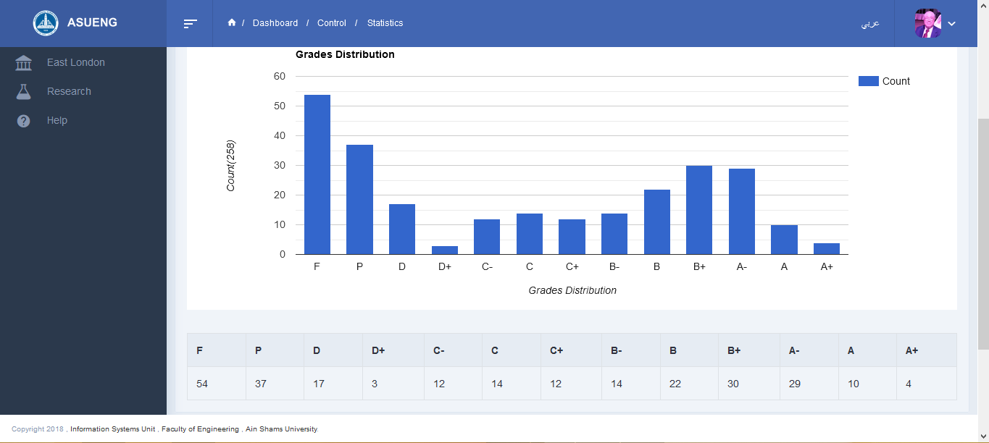

- In case of non-Gaussian curve distribution _ Please fill the following:
- Use the following space to explain and justify: -
The reason of high fail percentage are
- A) The course tutorial and lecture were taught online according to the faculty council dissection.
- B) The students did not attend the online lectures and tutorial classes for different reasons some of them for highly costs and other for net problem. (they lost up to 10 degrees for this reasons)
- Use the following space to list the action plan and corrective steps.
The states was unnormal case all over the world (COVID-19)
- Course Review:
- Staff Feedback: use the following space to list your feedback regarding teaching facilities and any other issues need to be improved in the future
No feed back
- D1-Students’ feedback
- This course is mentally exhausting, for multiple reasons. The instructor stresses the need for word-for-word answers.
- The final exam counts towards 80% of the final score, which is exceedingly unfair.
- it is really hard to memorize things because it is English as the course contains a lot of (strong definitions) so it would be much easier to be taught in Arabic also there isn`t enough sources to exercise the questions
- I`m requesting administration to establish English program (language )so that international get to used since some international students don’t get Arabic
- Correction actions: use the following space to list the main correction actions already have been taken in semester to fix, whatever is available, considering midterm feedback.
In the coming semester, more than 50% MCQ. questions will take a shear in the assignment to be established in the final exam.
- Enhancement action plan: use the following space to list the enhancement action plan that will be applied in the future.
In the coming semester, a new plan will be applied to moderate a part of the tutorial duration to as a discussion session around the reading material topics and the human right moves.

- Some Screen Shoots
