|  |  |
| --- | --- |
| *Course report of* | |
| **Fundamentals of Engineering– ENG011– Fall 2019** | |
| University: Ain Shams | Faculty: Engineering |

## Basic Information

1. Title and code :

|  |
| --- |
| **Fundamentals of Engineering– ENG011** |

1. Program on which the course is given :

|  |  |
| --- | --- |
| |  | | --- | | All Programs | |

1. Year/Level of program :

|  |
| --- |
| 1st Level |

1. Units/Credit Hours

|  |  |
| --- | --- |
| ( i ) Lecture : | 2 |

|  |  |
| --- | --- |
| ( ii ) Tutorial/Practical : | 1+0 |

|  |  |
| --- | --- |
| ( iii ) Total : | 3 |

1. Names of lecturers contributing to delivery of the course :

|  |  |
| --- | --- |
| i - | Prof. Moussa ElSaied  Dr. Ismail Hafez Dr. Micha |

|  |  |
| --- | --- |
| ii - | Dr Shaimaa Fathy |
| iii - | Dr. Ihab El-Aghory |
| iv - | Dr. Ahmad Balahh |
|  | Others |

|  |  |
| --- | --- |
| Course coordinator: | Dr Samy Afifi |

|  |  |
| --- | --- |
| External evaluator: | --- --- --- |

## Statistical Information

|  |  |  |  |  |  |  |  |  |  |  |  |
| --- | --- | --- | --- | --- | --- | --- | --- | --- | --- | --- | --- |
| **F** | **D** | **D+** | **C-** | **C** | **C+** | **B-** | **B** | **B+** | **A-** | **A** | **Grade** |
| 106 | 67 | 54 | 80 | 93 | 116 | 184 | 270 | 210 | 73 | 8 | **No. of students** |

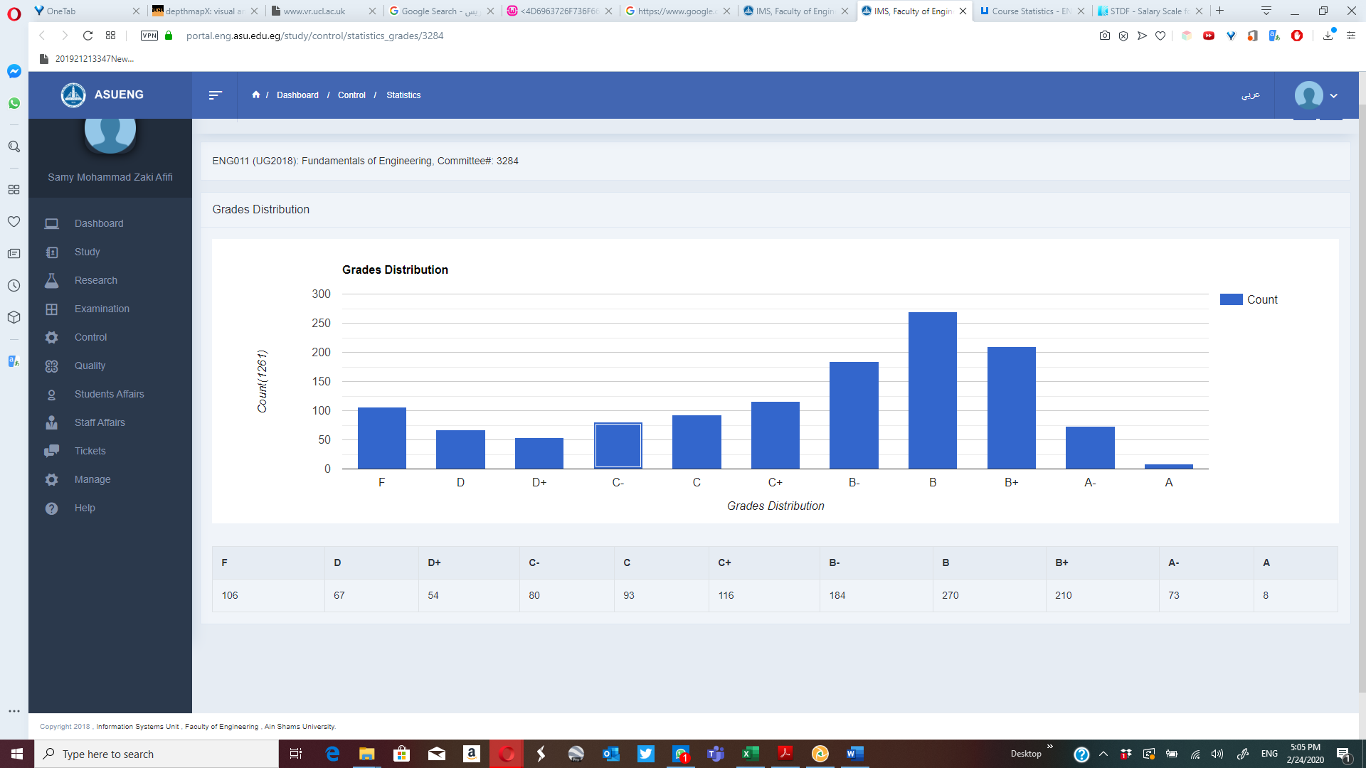

## Professional Information

1. **Course Teaching:**

|  |  |  |  |
| --- | --- | --- | --- |
| **Week** | **Course Content** | **Total** | **Lecturer** |
| 1 | Introduction to Fundamentals of Engineering | 3 | All Lecturers |
| 2 | Effective Study | 3 | All Lecturers |
| 3 | The Engineering Approach to Problem Solving | 3 | All Lecturers |
| 4 | Career Exploration | 3 | All Lecturers |
| 5 | Engineering Ethics and Critical Thinking | 3 | All Lecturers |
| 6 | International System of Units & Mathematical Branches | 3 | All Lecturers |
| 7 | Infographics | 3 | All Lecturers |
| 8 | General Disciplines (I) Introduction * | 3 | All Lecturers |
| 9 | General Specialization (I) Simple applications ** | 3 | All Lecturers |
| 10 | General Disciplines (II) Introduction * | 3 | All Lecturers |
| 11 | General Specialization (II) Simple applications ** | 3 | All Lecturers |
| 12 | General Disciplines (III) Introduction * | 3 | All Lecturers |
| 13 | General Specialization (III) Simple applications ** | 3 | All Lecturers |
| 14 | General Disciplines (IV) Introduction * | 3 | All Lecturers |
| 15 | General Specialization (IV) Simple applications ** | 3 | All Lecturers |
| Total Number of Hours | | 45 |  |

**Topics taught as a percentage of the content specified:**

**>90 % X 70-90 % <70%**

**Reasons in detail for not teaching any topic**

NA

**Teaching and learning methods:**

Lectures: **X**

Assignments: **X**

Technical Reports:

x

Class Activity: **(Tutorials) X**

**Case Study:**

Other assignments/homework: **NA**

If teaching and learning methods were used other than those specified, list and give reasons:

1. **Student assessment:**

|  |  |
| --- | --- |
| **Method of assessment** | **Percentage of total** |
| Written examinations (final + midterm) | 65 % |
| Oral examination | 0 % |
| Practical/laboratory work | 0% |
| Other assignments/class work | 35 % |

**Members of examination committee**

i – Dr Mohamed El Banna

ii- Dr Samy Afifi

**Role of external evaluator**

N/A………………………………………………………………………………………….

1. **Facilities and teaching materials:**

x

Totally adequate

Adequate to some extent

Inadequate

List any inadequacies

1. **Administrative constraints:**

List any difficulties encountered

No difficulties

1. **Student evaluation of the course:**

attached

**Response of Course Team**

1. **Comments from external evaluator(s): Response of course team**

………**N/A** ………………. …………………………….