*Course Report of*

**CSE 031- Computing in Engineering – Fall 2019**

**University: Ain Sham University Faculty: Engineering**

**A. Basic Information**

1. **Title and code:**

**Computing in Engineering – CSE 031**

1. **Program on which the course is given:**

**All Programs**

|  |  |
| --- | --- |
| 1. **Year/Level of program:** | **Freshmen** |

* 1. **Unit/Credit Hours**

|  |  |
| --- | --- |
| **(i) Lecture** | **2** |
| **(ii) Tutorial/Practical** | **0** |
| **(iii) Total** | **2** |

* 1. **Names of lecturer contributing to the delivery of the course:**

|  |  |
| --- | --- |
| **i -** | **Dr. Manal Murad** |
| **ii -** | **Dr. Hasan Shehata** |
| **iii -** | **Dr. Hosam Hasan** |
| **iv -** | **Dr. Mohamed Sobh** |
| **v -** | **Dr. Mohamed Taher** |
| **vi -** |  |
| **vii -** |  |
| **vii -** |  |

|  |  |
| --- | --- |
| **Course Coordinator:** | **Dr. Mohamed Taher** |
| **External Evaluator:** | **- - - - - - - - - - - - -** |

**B. Statistical Information**

|  |  |
| --- | --- |
| No. of students attending the course | 1805 |

|  |  |  |  |
| --- | --- | --- | --- |
|  | | **Number** | **Percentage (%)** |
| **No. of students completing the course** | | 1805 | 100.00% |
| **Results** | Passed | 1725 | 95% |
| Failed | 80 | 5% |
| **Grading of successful students** | A+ | 0 | 0.00% |
| A | 12 | 0.66% |
| A- | 209 | 12% |
| B+ | 508 | 28% |
| B | 353 | 20% |
| B- | 248 | 14% |
| C+ | 133 | 7% |
| C | 93 | 5% |
| C- | 73 | 4% |
| D+ | 53 | 3% |
| D | 43 | 2.5% |

**C. Professional Information**

1. **Course Teaching:**

|  |  |  |
| --- | --- | --- |
| **Topic** | **No. of Hours** | **Lecturer** |
| The components of a computer system | 4 | Dr.Hosam Hasan |
| Data representation | 6 | Dr. Mohamed Sobh |
| Computer Networks | 2 | Dr. Mohamed Sobh |
| Internet Operations | 2 | Dr. Hasan Sehata |
| Advanced Computer Principals | 2 | Dr. Hasan Sehata |
| Flowcharts | 4 | Dr. Manal Murad |
| Introduction to programming | 4 | Dr. Manal Murad |
| Operating Systems | 6 | Dr. Mohamed Taher |

**Topics Taught as a percentage of the content specified**

**Screen Shot 2015-02-23 at 2.41.55 PM.png**

**Reasons in details for not teaching any topic**

**If any topics were taught which are not specified, give reasons in detail.**

1. **Teaching and learning methods:**

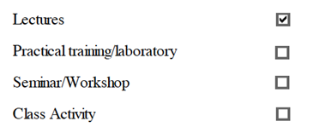

Case study:

**- - - - - - - - - - - - - - - - - - - - - - - - - - - - - - - - - - - - - - - - - - - - - - - - - - - - - - - - - - - - - - - - - - - - -**

Other assignments/homework  
If teaching and learning methods were used other than, those specified, list and give reasons

**- - - - - - - - - - - - - - - - - - - - - - - - - - - - - - - - - - - - - - - - - - - - - - - - - - - - - - - - - - - - - - - - - - - - -**

**Student assessment:**

|  |  |
| --- | --- |
| **Method of assessment** | **Percentage of total** |
| Quizzes | 5% |
| Assignments | 10% |
| Midterm written exam | 25% |
| Final written exam | 60% |
|  |  |

**Members of examination committee:**

1. Dr. Manal Murad
2. Dr. Hasan hehata
3. Dr. Hosam Hasan
4. Dr. Mohamed sobh
5. Dr. Mohamed Taher

**Role of external evaluator:**

**- - - - - - - - - - - - - - - - - - - - - - - - - - - - - - - - - - - - - - - - - - - - - - - -**

1. **Facilities and teaching materials:**

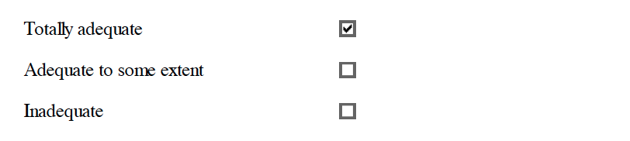

**List any inadequacies:**

**- - - - - - - - - - - - - - - - - - - - - - - - - - - - - - - - - - - - - - - - - - - - - - - - - - - - - - - - - - - - - - - - - - - - - - - - - - - - - - - - - - - - - - - - - - - - - - - - - - - - - - - - - - - - - - - - - - - - - - - - - - - - - - - - - - - - - - - - - - - - - - - - - - - - - - - - - - - - - - - - - - - - - - - - - - - - - - - - - - - - - - - - - - - - -**

1. **Administrative constraints:**

**- - - - - - - - - - - - - - - - - - - - - - - - - - - - - - - - - - - - - - - - - - - - - - - - - - - - - - - - - - - - - - - - - - - - - - - - - - - - - - - - - - - - - - - - - - - - - - - - - - - - - - - - - - - - - - - - - - - - - - - - - - - - - - - - - - - - - - - - - - - - - - - - - - - - - - - - - - - - - - - - - - - - - - - - - - - - - - - - - - - - - - - - - - - - -**

1. **Student evaluation of the course:**