Course Report
- Basic Information
- Programme Title | Basic Science _ All Program
- Course Name | Human Right
- Course Code | ASU_111
- Level | 1-4
- ASU Credit Rating | 2 Credits
- Contact Hours | Lecture: | 2 Hrs. | Tutorial: | 1 Hrs. | Lab: | 0 Hrs.
- Course Teaching Information:
- Semester: |  |  |  |  |  | Fall 2019
- Module Leader: |  |  |  |  |  | --
- Course coordinator: |  |  |  |  |  | - Professor Dr. Moustafa A. chaaban
- Teaching Staff: |  |  |  |  |  | - Professor Dr. Moustafa A. chaaban  - Dr. Mohamed Lotfy Attia Zamzam
Course teaching Progression
- Topics taught _as a percentage_ considering the course tentative teaching plan:
■ |  | >90% |  | □ |  |  | 70% - 90% |  |  | □ | <70 %
- In case of teaching less than 90%, List in the following space the reasoning
N/A
- In case of teaching less than 90%, List in the following space the action plan:
N/A
Course Assessment
- Assessments Weights
Final exam |  |  | 80% |  | Mid-term exam |  |  | 0% | S.A. |  |  | 20%
Quizzes |  |  | 0% |  |  |  |  |  | Participation |  |  | 0%
Course teaching strategy
- Teaching and learning methods
Lecture |  |  | ■ |  | Class Activity |  |  | ■ | Project |  |  | □
Seminar/Workshop |  |  | □ |  | Case Study: |  |  | □ | Other |  |  | ■
- Topics taught:
1 | A general introduction to international human rights, as well as an overview of some specific topics in this field.
2 | An introduction to basic notions of public ethics,
3 | History of Human Rights, international instruments
4 | Categories of rights
5 | Human Rights violations, protection and responsibility thereof
6 | Continue, Human Rights violations, protection and responsibility thereof
7 | Continue, Human Rights violations, protection and responsibility thereof
8 | Deals with current issues in the human rights agenda such as: Rights of women,
9 | Rights of the child, rights of indigenous peoples,
10 | Armed conflicts and terrorism,
11 | The environment,
12 | Transitional justice
13 | Sexual minorities

- Course Assessment Information:
- Examination Committee
i. Professor Dr. Moustafa A. chaaban
- Dr. Mohamed Lotfy Attia Zamzam
 |  |  |  |  |  |  |  |  |  |  |  |  | Total
Total number of students enrolled in the course at the semester beginning |  |  |  |  |  |  |  |  |  |  |  |  | 344
Total number of students withdrew the course |  |  |  |  |  |  |  |  |  |  |  |  | 0
Total number of students completed the course until the final exam |  |  |  |  |  |  |  |  |  |  |  |  | 344
- In case of abnormal withdrawal status, use the following space to explain and justify this
N/A
- Detailed Students’ grades in all summative assessments:
- Appendix (1) lists the detailed students ‘grades in all summative assessments (assignments, quizzes, lab activities, midterm & final Examination, and so on.
- All Students’ Results Statistics (Considering ASU and UEL Grading Scale)
ASU Scale | A+ | A | A- | B+ | B | B- | C+ | C | C- | D+ | D | F |  | Total
 | 1 | 7 | 10 | 41 | 42 | 46 | 35 | 36 | 32 | 28 | 29 | 37 |  | 344
% | 0.29 | 2.03 | 2.9 | 11.92 | 12.21 | 13.37 | 10.17 | 10.47 | 9.31 | 8.14 | 8.43 | 10.76 |  | 100%
- Results Graph for The Total Cohort
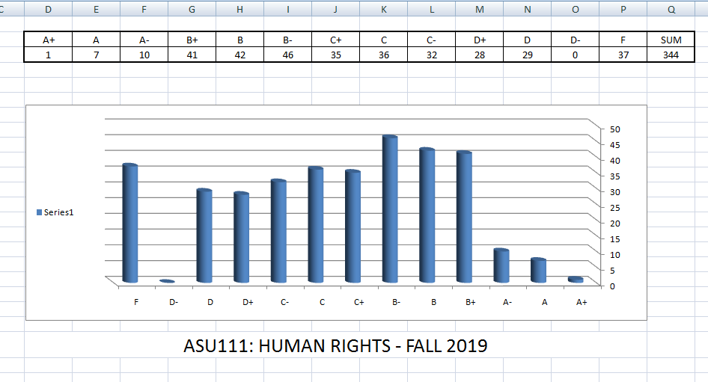

- In case of non-Gaussian curve distribution _ Please fill the following:
- Use the following space to explain and justify: -
- Use the following space to list the action plan and corrective steps.
N/A
- Course Review:
- Staff Feedback: use the following space to list your feedback regarding teaching facilities and any other issues need to be improved in the future
- Students’ feedback: use the following space to list the most important points of students’ feedback
- Correction actions: use the following space to list the main correction actions already have been taken in semester to fix, whatever is available, considering midterm feedback.
- Enhancement action plan: use the following space to list the enhancement action plan that will be applied in the future.
In the coming semester, a new plan will be applied to moderate a part of the tutorial duration to as a discussion session around the reading material topics and the human right moves.

