Course report of
University: Ain Shams (fall Spring 2020) Faculty: Engineering
Basic Information

  - Units/Credit Hours

  - Names of lecturers contributing to the delivery of the course:

- Statistical Information

Students completing the course  (Research) |  | Number | Percentage %
Results | Passed | 1002+ 1 student with grade C | 98.72%
Results | Failed | 13 | 1.28%
Grading Of  successful students | Excellent
Grading Of  successful students | Very Good
Grading Of  successful students | Good
Grading Of  successful students | Pass
Students completing the course (Improving) |  | Number | Percentage %
Results | Passed | 7 | 77.78%
Results | Failed | 2 | 22.22%
Grading Of  successful students | A | 1 | 11.11%
Grading Of  successful students | B⁺ | 1 | 11.11%
Grading Of  successful students | B⁻ | 1 | 11.11%
Grading Of  successful students | C⁺ | 1 | 11.11%
Grading Of  successful students | D | 3 | 33.33%
Grading Of  successful students | F | 2 | 22.22%

Statistics for Improvements

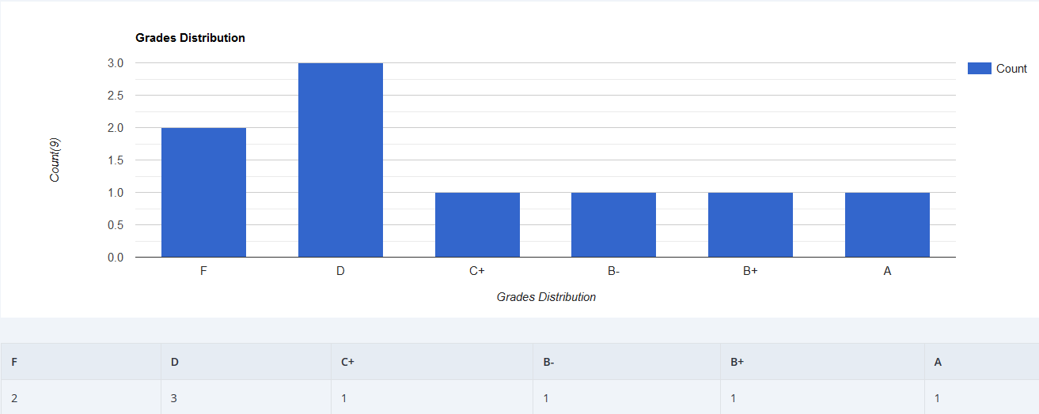
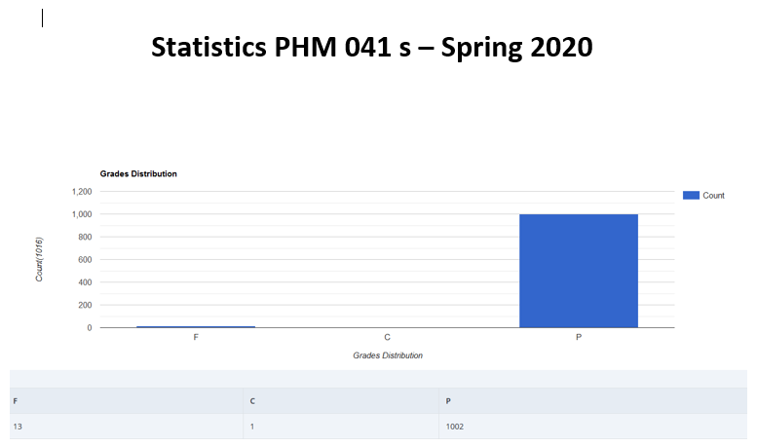

Statistics for Research

- Professional Information

1-- Course Teaching:
Topic | No. of Hours | Lecturer
 |  | Prof. Dr. G. Bassioni& Dr. A. A. Mahmoud & Dr. A. O.Habib& Dr. M. S. Shehab& Dr. A. Mohsen
Fuels and combustion | 4 | Prof. Dr. G. Bassioni&Dr. A. A. Mahmoud & Dr. A. O. Habib& Dr. M. S. Shehab& Dr. A. Mohsen

Topics Taught as a percentage of the content specified

Reasons in detail for not teaching any topic
Because of COVID-19 circumstances, all lectures and tutorials after March 15, 2020 were recorded as videos and uploaded on LMS. Moreover, Active sessions were organized through Microsoft Team to cover students’ questions or any other obstacles.
For labs, all experiments were recorded as videos and uploaded on LMS. These videos include the experiments theoretical background and steps.

If any topics were taught which are not specified, give reasons in detail

2- Teaching and learning methods:
videos on LMS due to Covid-19
videos on LMS due to Covid-19
Microsoft team due to Covid-19

Case Study:
Other assignments/homework
If teaching and learning methods were used other than, those specified, list and give reasons

3- Student assessment: due to Covid-19
Methods of assessment | Percentage of total
Research Projects

Members of examination committee

Prof. Dr Gada Bassioni, A. Mahmoud, Dr. A. O. Habib & Dr. M. S. Shehab & Dr. A. Mohsen

Role of external evaluator:

4- Facilities and teaching materials:

List any inadequacies:

5-Administrative constraints:

6-Student evaluation of the course:
اجمالى الأراء الايجابية | Comment | Response of course Team

7-Comments from external evaluator(s)
Comment | Response of course Team

8- Course enhancement: Progress on actions identified in the previous year’s action plan:

9- Action plan
Action required | Completion date | Person responsible

