|  |  |
| --- | --- |
| *Course report of* | |
| |  | | --- | | **Stress Analysis – MDP 221 – 2018/2019** | | |
| University: Ain Shams | Faculty: Engineering |

## Basic Information

1. Title and code:

|  |
| --- |
| **Stress Analysis – MDP221** |

1. Programme on which the course is given:

|  |  |
| --- | --- |
| |  | | --- | | B. Sc. Mechanical Engineering (Production Engineering) | |

1. Year/Level of programmes:

|  |
| --- |
| 3rd year, First semester |

1. Units/Credit Hours

|  |  |
| --- | --- |
| ( i ) Lecture: | 2 |

|  |  |
| --- | --- |
| ( ii ) Tutorial/Practical: | 2 |

|  |  |
| --- | --- |
| ( iii ) Total: | 4 |

1. Names of lecturers contributing to delivery of the course:

|  |  |
| --- | --- |
| i - | Assoc. Prof. Wagdy El-Desouki Abdel-Ghany |

|  |  |
| --- | --- |
| ii - |  |

|  |  |
| --- | --- |
| Course coordinator: | Assoc. Prof. Wagdy El-Desouki Abdel-Ghany |

|  |  |
| --- | --- |
| External evaluator: | --- --- --- |

## Statistical Information

|  |  |
| --- | --- |
| No. of students attending the course: |  |

**The results are not announced up to 01 Feb 2019.**

|  |  |  |  |  |  |  |  |
| --- | --- | --- | --- | --- | --- | --- | --- |
|  | Excellent | Very Good | Good | Pass | Poor | Very Poor | SUM |
| Students No. |  |  |  |  |  |  |  |
| Percentage (%) |  |  |  |  |  |  |  |

## Professional Information

1. **Course Teaching:**

|  |  |  |  |  |  |
| --- | --- | --- | --- | --- | --- |
| **No** | **Course Content** | **Lecture**  **(hrs)** | **Tutorial**  **(hrs)** | **Total**  **(hrs)** | **Lecturer** |
| **1** | Mechanical Stresses | **15** | **15** | **30** | Dr. Wagdy El-Desouki |
| **2** | Deflections and deformations | **5** | **5** | **10** | Dr. Wagdy El-Desouki |
| **3** | Pressure Vessels | **5** | **5** | **10** | Dr. Wagdy El-Desouki |
| **4** | Thermal Stresses | **5** | **5** | **10** | Dr. Wagdy El-Desouki |
|  | Total | **30** | **30** | **60** |  |

**Topics taught as a percentage of the content specified:**

**>90 % X 70-90 % <70% 6**

**Reasons in detail for not teaching any topic**

Nearly all topics were taught

**If any topics were taught which are not specified, give reasons in detail**

……………………………………………………………………………

**Teaching and learning methods:**

Lectures: **X**

Practical training/ laboratory:

Seminar/Workshop:

Class Activity: **(Tutorials)**  **X**

**Case Study:**

Other assignments/homework:

If teaching and learning methods were used other than those specified, list and give reasons:

1. **Student assessment:**

|  |  |
| --- | --- |
| **Method of assessment** | **Percentage of total** |
| Written examination | 70 % |
| Oral examination | 0 % |
| Practical/laboratory work | 0 % |
| Other assignments/class work | 30 % |

**Members of examination committee**

i - Prof. Samy J. Ebeid

ii - Assoc. Prof. Wagdy El-Desouki Abdel-Ghany

**Role of external evaluator**

N/A……………….

1. **Facilities and teaching materials:**

Totally adequate

**X**

Adequate to some extent

Inadequate

List any inadequacies:

1. **Administrative constraints:**

List any difficulties encountered

No difficulties

1. **Student evaluation of the course:**

All evaluations are above 50%.

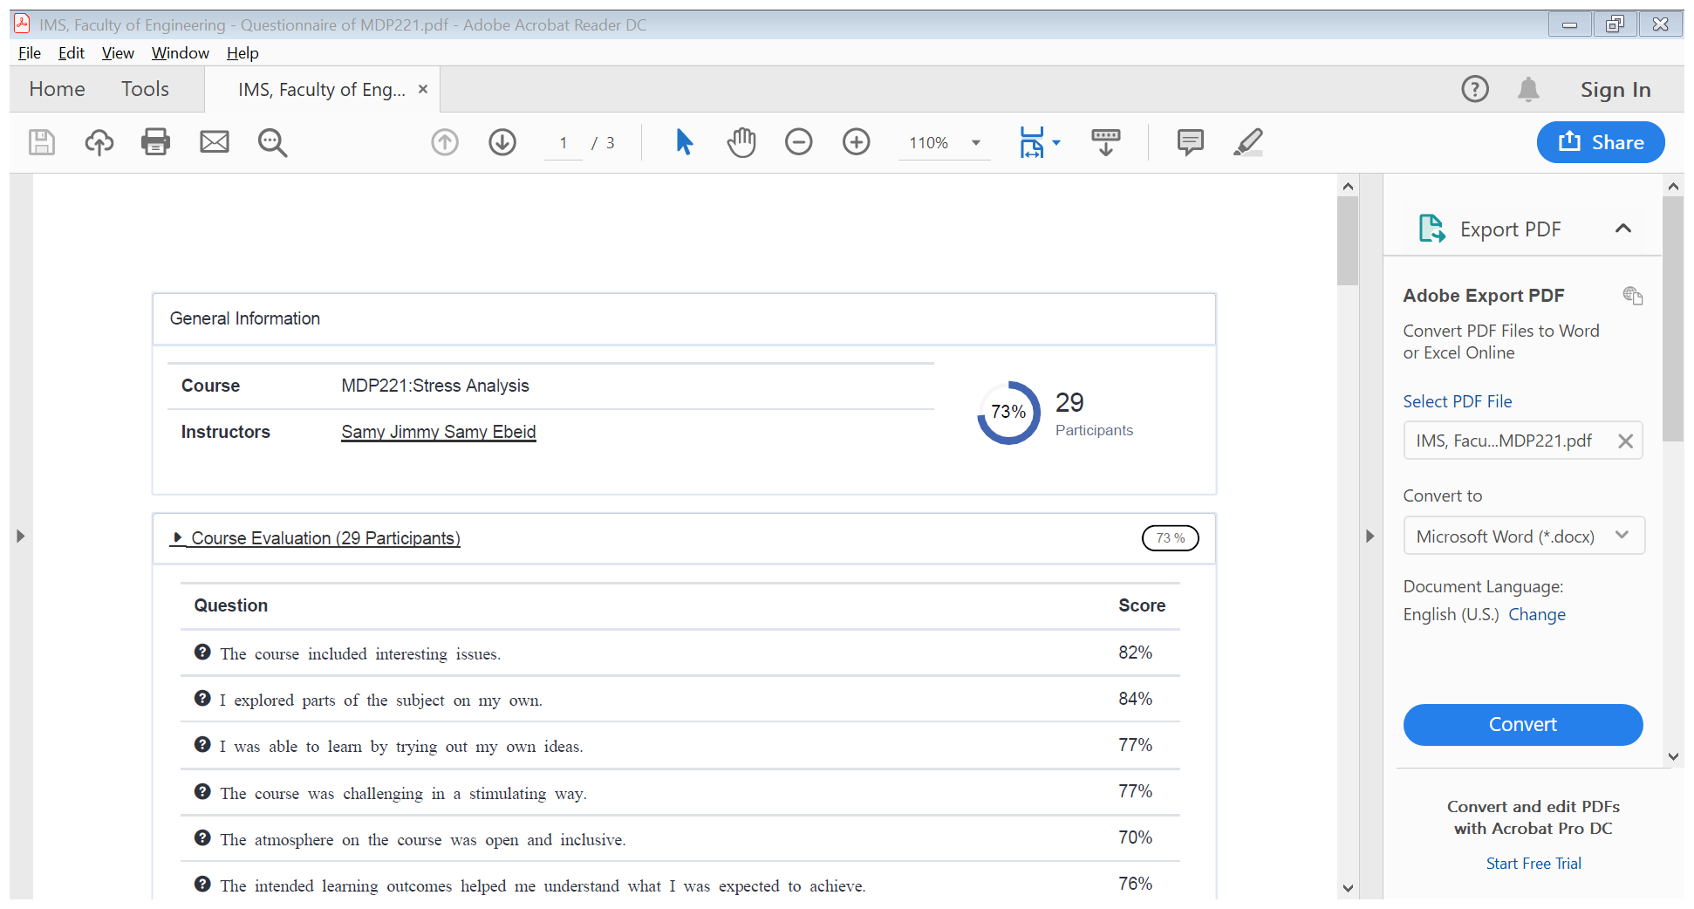

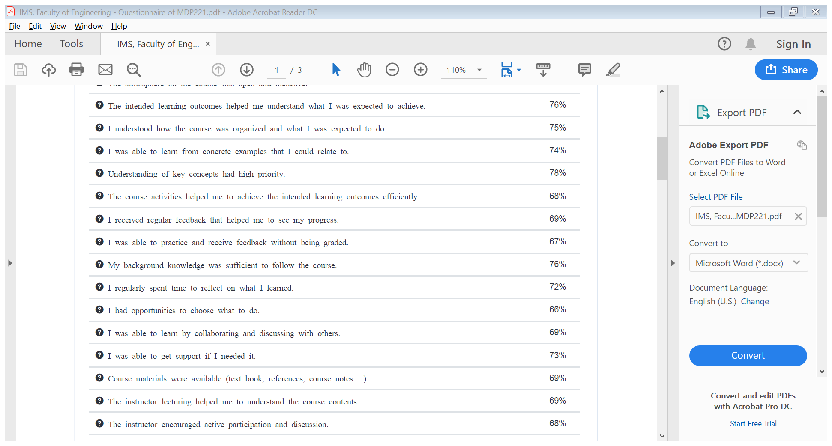

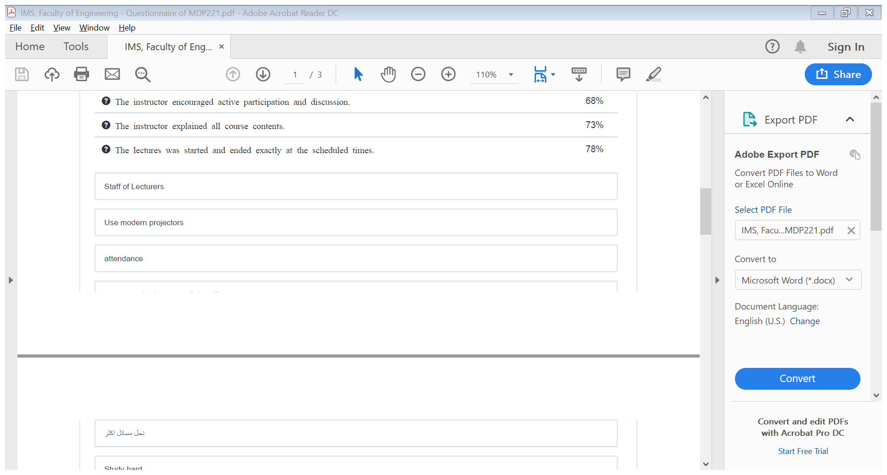

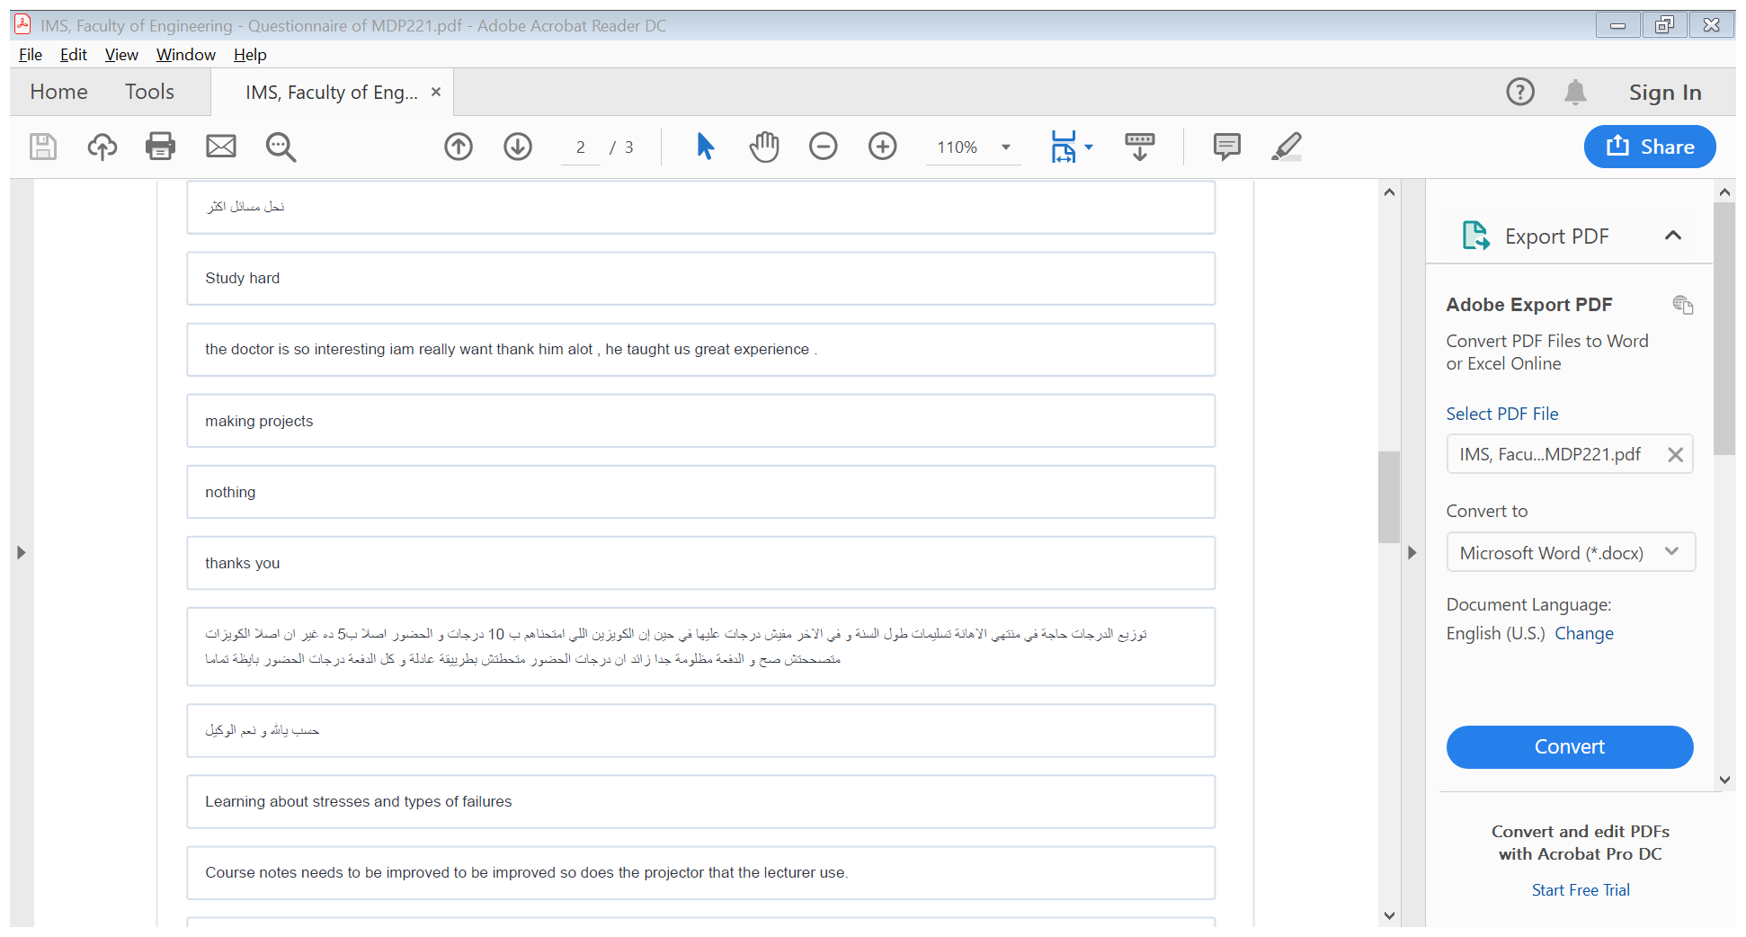

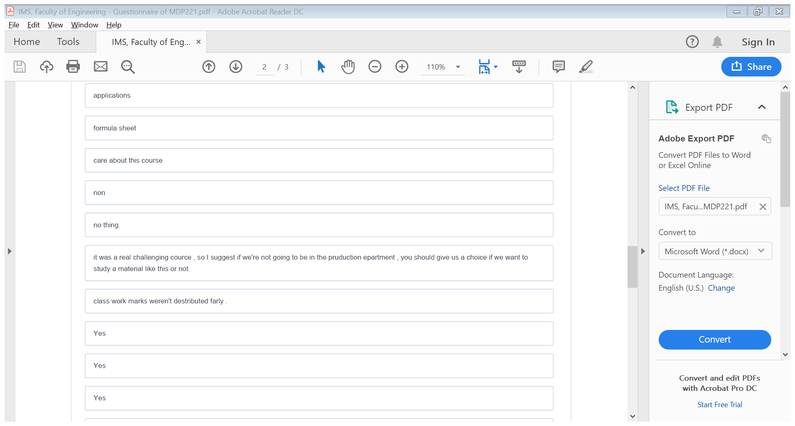

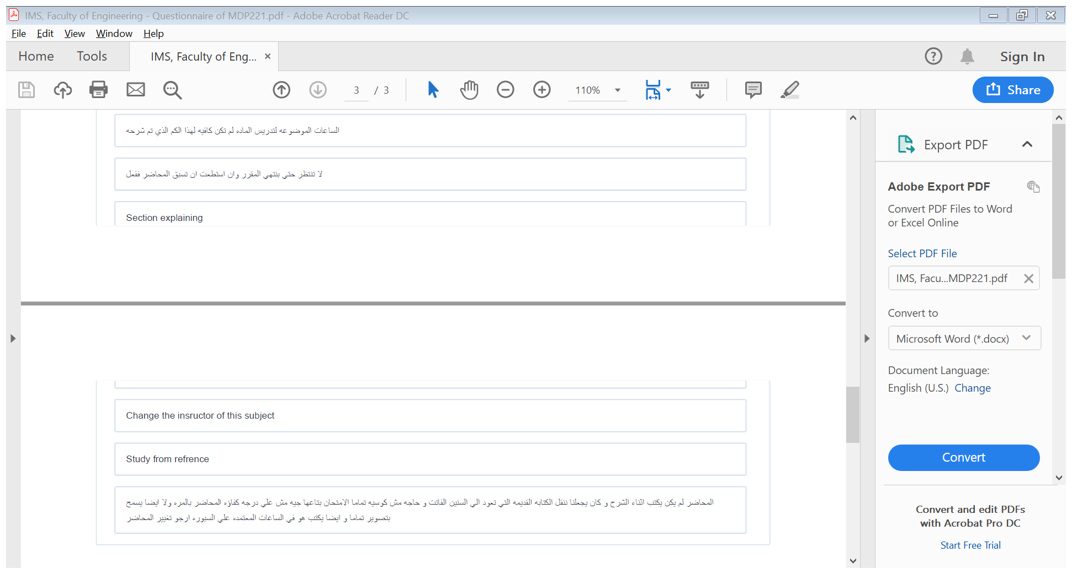

**Response of Course Team**

List any criticisms

Teaching facilities: The available facilities were the computer and data show.

1. **Comments from external evaluator(s): Response of course team**

………**N/A** ………………. …………………………….