Course Report of Thermodynamics – MEP 111– Spring 2019
University: Ain Shams Faculty: Engineering

Basic Information

Title and code:

Thermodynamics – MEP 111

Program on which the course is given:

Mechanical Power Engineering

  - Year / Level of program(s) 2018-2019 / 1st year Mechanical Engineering Students.

Units / Credit Hours:

i. | Lecture: | 3
ii. Tutorial / Practical: 1.5
iii. Total: 4.5

- Names of lecturers contributing to the delivery of the course:

Dr. Walid Aboelsoud
Dr. Nashwa Abbas

Course coordinator: Dr. Walid Aboelsoud

External evaluator: -------------

1

Statistical Information

No of students attending the course: 445

 |  | Number | Percentage (%)
Students completing the course
Results | Passed
 | Failed
Grading of successful students | Percentage | Number | Percentage (%)
Excellent
Very Good
Good
Passed
Weak
Very weak

Professional Information

1- Course Teaching:

No | Course Content | Lecture  (hours) | Tutorial  (hours) | Total
1 | Introduction and basic concepts (Chapter 1). | 3 | 1.5 | 4.5
2 | Energy, energy transfer and energy analysis (Chapter 2). | 3 | 1.5 | 4.5
3 | First law of thermodynamics (Chapter 2). | 3 | 1.5 | 4.5
4 | Properties of pure substances: phase change,  property diagrams, property tables, EES software and the ideal-gas | 6 | 3 | 9
5 | Energy analysis of closed systems: energy balance, internal | 9 | 4.5 | 13.5
6 | Mass and energy analysis of control volumes:  conservation of  mass, flow work, energy analysis of steady-flow | 9 | 4.5 | 13.5
7 | Thermodynamics’ applications (Chapter 5). | 9 | 4.5 | 13.5
8 | Simple-ideal power cycles (Chapter 9&10). | 3 | 1.5 | 4.5
 | Total | 45 | 22.5 | 67.5

Topics taught as percentage of the content specified:

ʘ > 90% Ο 70% - 90%
Ο < 70%

Reasons in details for not teaching any topic:

If any topics were taught which are not specified, give reasons in details:

None

  - Teaching and learning methods:

Lectures
√

Practical training/laboratory

Seminar / workshop

Class activity √

Case study:

Other assignments / homework

If teaching and learning methods were used other than those specified, list and give reasons: N/A - - - - - - - - - - - - - - - - - - - - - - - - - - - - - - - - - - - - - - - - - - - - - - - - - - - - - - - - - - - - -

Student assessment:

Method of assessment | Percentage of total
Assignments | 5 %
Written midterm exam | 15 %
Participation in class | 10 %
Written final exam | 70%
Total | 100%

Members of examination committee:

Dr. Walid Aboelsoud

Dr. Nashwa Abbas

Role of the external evaluator

To express his views on the course - - - - - - - - - - - NONE- - - - - - - - - - - -
- - - - - - - - - - - - - - - - - - - - - - - - - - - - - - - - - - - - - - - - - - - - - - - - - - - - - - - - - - - - - - - -

Facilities and teaching materials:

Totally adequate

Adequate to some extent √

Inadequate

List any inadequacies

  - Administrative constraints

List any difficulties encountered

None - - - - - - - - - - - - - - - - - - - - - - - - - - - - - - - - - - - - - - - - - - - - - - - - - -
- - - - - - - - - - - - - - - - - - - - - - - - - - - - - - - - - - - - - - - - - - - - - - - - - - - - - -

Student evaluation of the course:

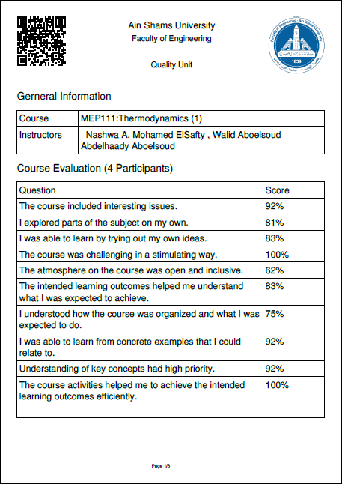

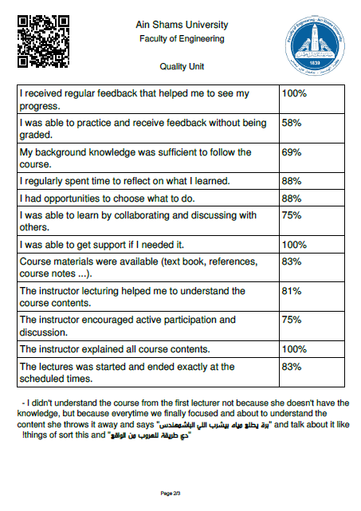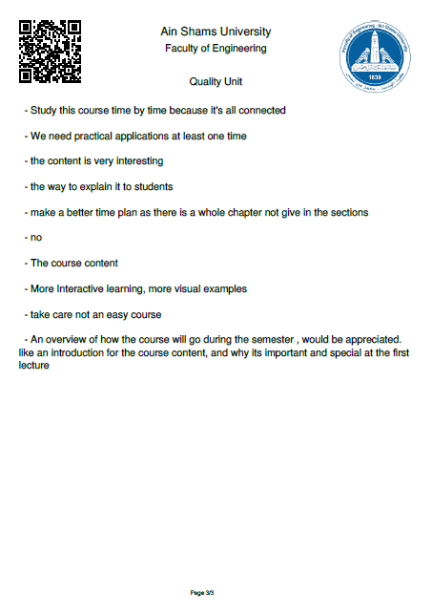

Comments from external evaluator(s)

Comments | Response of Course team
- - - - - - - - - - - - - - - - - - - - - - - - - - - | - - - - - - - - - - - - - - - - - - - - - - - - - - -
- - - - - - - - - - - - - - - - - - - - - - - - - - - | - - - - - - - - - - - - - - - - - - - - - - - - - - -
- - - - - - - - - - - - - - - - - - - - - - - - - - - | - - - - - - - - - - - - - - - - - - - - - - - - - - -
- - - - - - - - - - - - - - - - - - - - - - - - - - - | - - - - - - - - - - - - - - - - - - - - - - - - - - -
- - - - - - - - - - - - - - - - - - - - - - - - - - - | - - - - - - - - - - - - - - - - - - - - - - - - - - -
- - - - - - - - - - - - - - - - - - - - - - - - - - - | - - - - - - - - - - - - - - - - - - - - - - - - - - -
- - - - - - - - - - - - - - - - - - - - - - - - - - - | - - - - - - - - - - - - - - - - - - - - - - - - - - -
- - - - - - - - - - - - - - - - - - - - - - - - - - - | - - - - - - - - - - - - - - - - - - - - - - - - - - -

Course enhancement:

Progress on actions identified in the previous year's action plane:

Action | State whether or not completed and give reasons for any non-completion
N/A - - - - - - - - - - - - - - - - - - - - - -  - - - - - - - - - - - - - - - - - - - - - - - - - -  - - - - - - - - - - - - - - - - - - - - - - - - - - | - - - - - - - - - - - - - - - - - - - - - - - - - - -  - - - - - - - - - - - - - - - - - - - - - - - - - - -  - - - - - - - - - - - - - - - - - - - - - - - - - - -

  - Action plan for academic year 2016-2017

Actions required | Completion date | Person responsible
- - - - - - - - - - - - - - - - - - - -  - - - - - - - - - - - - - - - - - | - - - - - - - - - - - - - - - - - -  - - - - - - - - - - - - - - - - - - - -  - - - - - - - - - - - - - - - - - - | - - - - - - - - - - - - - - - - - -  - - - - - - - - - - - - - - - - - - - -  - - - - - - - - - - - - - - - - -
Course Content/ILO Matrix

Course Content | a1 | a2 | a3 | a4 | a5 | a6 | b1 | b2 | b3 | c1 | c2 | d1 | d2 | d3
Introduction and basic concepts |  |  | • |  |  |  |  | •
Energy, energy transfer and energy analysis |  | • |  |  |  |  | •
First law of thermodynamics | • |  |  |  |  |  | • |  | • |  | • |  | •
Properties of pure substances: phase change,  property diagrams, property tables, EES  software and the ideal-gas equation of state |  |  |  | • |  | • |  | • |  | • | • | •
Energy analysis of closed systems: energy  balance, | • | • | • |  | • |  | • | • | • | • | •
Mass and energy analysis of control volumes:  conservation of mass, flow work, energy analysis of steady-flow systems | • | • | • |  | • |  | • | • | • | • | • | •
Thermodynamics’ applications | • | • | • | • | • | • | • | • | • | • | • |  | •
Simple-ideal power cycles | • | • | • | • | • | • | • | • | • | • |  | •

