Course report of
Hum_x31– Engineering Economy 2016/2017
University: Ain Shams Faculty: Engineering
Basic Information

Hum_x31- Engineering Economy

Mechanical Engineering Program

Third year/level 02

  - Units/Credit Hours
2
1
3

  - Names of lecturers contributing to the delivery of the course :
Dr. Ghada E. Shedid
Prof. Amin K. Elkharbotly

- Statistical Information:
No. of students attending the course: 387
Grade | Number | Percentage
Excellent | 56 | 15%
Very good | 48 | 12.9%
Good | 69 | 18.5%
Acceptable | 141 | 37.8%
Weak | 41 | 11%
Very weak | 18 | 4.8%
Total | 373

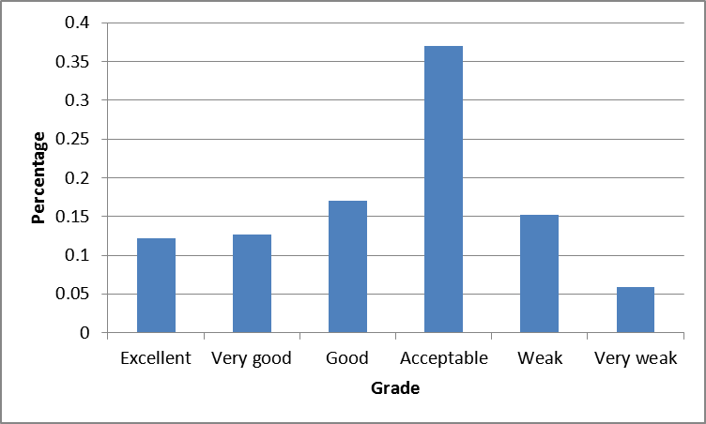

- Professional Information

1-- Course Teaching:

Calculation based on 15 weeks / Term
No | Course Content | Lectures | Tutorials | Total
1 | Introduction, general discussion and new terminologies (time value of money) | 2 | 1 | 3
2 | Simple, compound interest rates, payment types, equivalence, and cash flow diagram representation. | 2 | 1 | 3
3 | Factors, effect of time and interest on money (F/P, P/F, P/A, A/P, F/A and A/F factors) | 2 | 1 | 3
4 | Combining factors, Shifted series and single cash flows | 2 | 1 | 3
5 | Factors, effect of time and interest on money (P/G and A/G and Geometric gradient payments). | 2 | 1 | 3
6 | Combining factors for shifted gradient. | 2 | 1 | 3
7 | Nominal and effective interest rates (differences, terminologies, and different cases CP<PP) | 2 | 1 | 3
8 | Nominal and effective interest rates (continuous compounding) and introduction to evaluating alternatives. | 2 | 1 | 3
9 | Evaluating Alternatives (present worth analysis using LCM and study periods) | 2 | 1 | 3
10 | Evaluating Alternatives (Future worth and annual worth analysis) | 2 | 1 | 3
11 | Capitalized cost. | 2 | 1 | 3
12 | Benefit and cost analysis for single project | 2 | 1 | 3
13 | Incremental benefit and cost analysis for multiple projects | 2 | 1 | 3
14 | Breakeven analysis for single project. | 2 | 1 | 3
15 | Breakeven analysis for multiple projects. | 2 | 1 | 3
Total Hours |  | 30 | 15 | 45

Topics Taught as a percentage of the content specified

Reasons in detail for not teaching any topic

NA

If any topics were taught which are not specified, give reasons in detail
NA
2- Teaching and learning methods:

Case Study:
Other assignments/homework
If teaching and learning methods were used other than, those specified, list and give reasons
3- Student assessment:
Assessment method | No. | Description | Week no. | Weight
Assignment | 1 | Cash Flow Diagram, Combining Factors, and  Nominal and Effective interest Rates | 2-6 | -
Quiz | 1 | Cash Flow Diagram, Combining Factors | 6-7 | 3
Exam | 1 | Mid-term | 8 | 14
Assignment | 2 | Comparison between alternatives using:  Present Worth, Capitalized cost, Future Worth, and  Annual Worth Evaluation | 8-11 | -
Quiz | 2 | Nominal, Effective interest Rates, and comparisons | 12-13 | 3
Assignment | 3 | Benefit and Cost Ratio | 12-13 | -
Assignment | 4 | Breakeven Analysis | 14-15 | -
Exam | 1 | Final Exam |  | 50
Absence |  |  |  | 5
Total |  |  |  | 75

Members of examination committee:
Dr. Amin K. Elkharbotly, Dr. Mohamed Elbeheiry, and Dr. Ghada E. Shedid.

Role of external evaluator:
4- Facilities and teaching materials:

List any inadequacies: Students have only one door to enter and exit the lecture, in hall #1 in CHEP building.
5-Administrative constraints:
6-Student evaluation of the course:

No Comment
7-Comments from external evaluator(s)
NA
8- Course enhancement: Progress on actions identified in the previous year’s action plan:
NA
9- Action plan
NA

