|  |  |
| --- | --- |
| *Course report of* | |
| Mathematics (1) - PHM 011 2016-2017 | |
| University: Ain Shams | Faculty: Engineering |

## Basic Information

1. Title and code :

|  |
| --- |
| Mathematics (1) - PHM 011 |

1. Programme on which the course is given :

|  |
| --- |
| All programs ASU - FoE offers |

1. Year/Level of programmes :

|  |
| --- |
| Preparatory Year, 1st and 2nd semesters |

1. Units/Credit Hours

|  |  |
| --- | --- |
| ( i ) Lecture : | 4 |

|  |  |
| --- | --- |
| ( ii ) Tutorial/Practical : | 2 |

|  |  |
| --- | --- |
| ( iii ) Total : | 6 |

1. Names of lecturers contributing to delivery of the course :

|  |  |
| --- | --- |
| i - | Dr. Fayza. Mohamed. Ibrahim |

|  |  |
| --- | --- |
| ii - | Dr. Hesein. Abd El-Salam |

|  |  |  |  |
| --- | --- | --- | --- |
| iii - | | Dr. Ashraf Khattab | |
| iv - | Prof. Dr. Niveen Badra | |

1. Course Coordinator :

|  |  |
| --- | --- |
| i - | Prof. Dr. Niveen Badra |

1. External evaluator :

|  |  |
| --- | --- |
| i - | --- --- --- |

## Statistical Information

|  |  |
| --- | --- |
| No. of students attending the course: | 1883 |

|  |  |  |  |
| --- | --- | --- | --- |
|  | | Number | Percentage % |
| Students completing the course | | 1883 | 100.00 |
| Results | Passed | 1659 | 88.1 |
| Failed | 224 | 11.9 |
| Grading of Successful Students | Excellent | 243 | 12.9 |
| Very Good | 374 | 19.9 |
| Good | 390 | 20.7 |
| Pass | 652 | 34.6 |

## Professional Information

1. **Course Teaching:**

|  |  |  |
| --- | --- | --- |
| Topic | No. of Hours | Lecturer |
| Derivative and its applications. | 12 | Prof.Dr.Niveen Badra & Dr.Noha Medhat & Dr.Ashraf Khattab |
| Integration and its appliocations. | 6 | Prof.Dr.Niveen Badra & Dr.Noha Medhat & Dr.Ashraf Khattab |
| Integration and its appliocations. | 6 | Prof.Dr.Niveen Badra & Dr.Noha Medhat & Dr.Ashraf Khattab |
| Exponential and Logarithmic Functions. | 16 | Prof.Dr.Niveen Badra & Dr.Noha Medhat & Dr.Ashraf Khattab |
| Conic Sections. | 16 | Dr.Hussein Abd El Salam & Dr.Fayza Mohamed Ibrahim |
| Analytical Geometry in space. | 8 | Dr.Hussein Abd El Salam & Dr.Fayza Mohamed Ibrahim |
| Inverse Trigonometric functions | 6 | Prof.Dr.Niveen Badra & Dr.Noha Medhat & Dr.Ashraf Khattab |
| Hyperbolic and Inverse Hyperbolic functions | 4 | Prof.Dr.Niveen Badra & Dr.Noha Medhat & Dr.Ashraf Khattab |
| Methods of Integration | 10 | Prof.Dr.Niveen Badra & Dr.Noha Medhat & Dr.Ashraf Khattab |
| Application of Integration in polar coordinates. | 6 | Prof.Dr.Niveen Badra & Dr.Noha Medhat & Dr.Ashraf Khattab |
| Theory of Equations. | 9 | Dr.Hussein Abd El Salam & Dr.Fayza Mohamed Ibrahim |
| Matrices and Determinants. | 8 | Dr.Hussein Abd El Salam & Dr.Fayza Mohamed Ibrahim |
| Infinite Series. | 9 | Dr.Hussein Abd El Salam & Dr.Fayza Mohamed Ibrahim |

**Topics taught as a percentage of the content specified:**

**>90 % X 70-90 % <70%**

**Reasons in detail for not teaching any topic**

All topics were taught ……………………………………….

………………………………………………………………………………………………

………………………………………………………………………………………………

………………………………………………………………………………………………

**If any topics were taught which are not specified, give reasons in detail**

N/A………………………………………………………………………………………….

………………………………………………………………………………………………

………………………………………………………………………………………………

………………………………………………………………………………………………

1. **Teaching and learning methods:**

Lectures: **X**

Practical training/ laboratory: **X**

Seminar/Workshop:

Class Activity: **(Tutorials)**

**Case Study:**

Other assignments/homework:

If teaching and learning methods were used other than those specified, list and give reasons:

………………………………………………………………………………………………

………………………………………………………………………………………………

1. **Student assessment:**

|  |  |
| --- | --- |
| **Method of assessment** | **Percentage of total** |
| Written examination | 72 % |
| Oral examination | 14 % |
| Practical/laboratory work | 0 % |
| Other assignments/class work | 14 % |

**Members of examination committee**

i. Prof. Dr. Niveen Badra

ii. Dr. Hussein Abd El-Salam

iii. Dr. Fayza Seleem

iv. Dr. Ashraf Kattab

v. Dr. Noha Medhat

**Role of external evaluator**

N/A………………………………………………………………………………………….

………………………………………………………………………………………………

1. **Facilities and teaching materials:**

Totally adequate

Adequate to some extent **X**

Inadequate

List any inadequacies

1. **Administrative constraints:**

List any difficulties encountered

No difficulties

1. **Student evaluation of the course:**

**Response of Course Team**

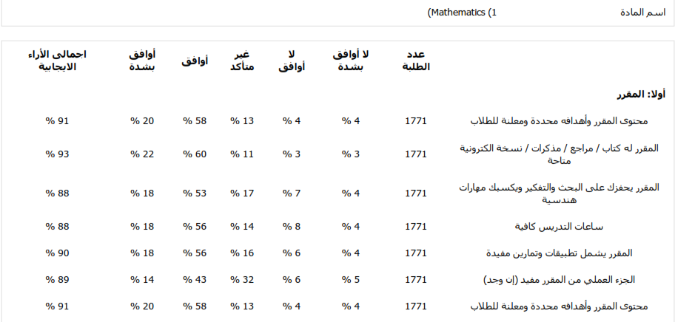

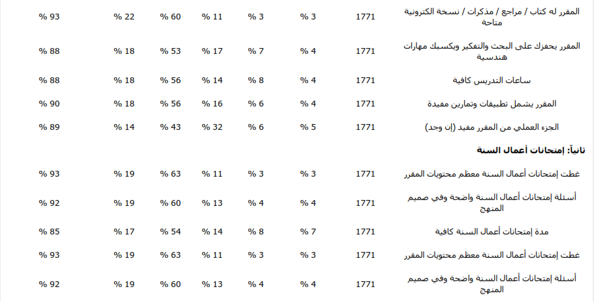



List any criticisms

…No criticism.…….………..……………………………….

………………………………………………………………………………………………

1. **Comments from external evaluator(s): Response of course team**

………**N/A** ………………. …………………………….

……….……………..……. …………………………….

…………………………… …………………………….

……………………………. …………………………….

…………………………… …………………………….

1. **Course enhancement: Progress on actions identified in the previous year’s action plan:**

………**N/A**.……….

1. **Action plan**

|  |  |  |
| --- | --- | --- |
| **Action required** | **Completion date** | **Person responsible** |
| ………**N/A** …….. | .…**N/A**…. | ….……**N/A**……… |