*Course Report of*

|  |
| --- |
| **Electrical & Electronic Engineering - EPM 112pr2 – 2015/2016**  **Electrical part** |

**University: Ain Shams** **Faculty: Engineering**

|  |
| --- |
|  |

**A- Basic Information**

1. **Title and code:**

|  |
| --- |
| Electrical & Electronic Engineering - EPM 112 |

1. **Program(s) on which this course is given:**

|  |
| --- |
| B.Sc. in Mechanical Power, Production, Automative, Mechatronics Departments and  Electrical Power and Machines Eng. |

|  |  |
| --- | --- |
| **3. Year/ Level of programs:** | 2nd year, Second Semester |

**4. Units/Credit Hours:**

|  |  |
| --- | --- |
| i. Lecture: | 2 Hrs/week |

|  |  |
| --- | --- |
| ii. Tutorial/Practical: | 1 Hrs/week |

|  |  |
| --- | --- |
| iii. Total: | 3 Hrs/week |

**5. Names of lecturers contributing to the delivery of the course:**

|  |  |
| --- | --- |
| i. | Dr. Khaled Abdel-Aty |
| ii. | Dr. Mahmoud Abdallah |
| iii. |  |
| iv. |  |

|  |  |
| --- | --- |
| **6. Course Coordinator:** | Dr. Khaled Abdel-Aty |

|  |  |
| --- | --- |
| **7. External Evaluator:** | **Prof.Dr. Sayed Warda** |

**B- Statistical Information**

|  |  |
| --- | --- |
| No. of Students attending the course: | **404** |

|  |  |  |  |
| --- | --- | --- | --- |
|  | | **Number** | **Percentage (%)** |
| **Students completing the course** | | 404 | 100 |
| **Results** | Passed | 306 | 75.74 |
| Failed | 98 | 24.26 |
| **Grading Of successful students** | Excellent | 39 | 9.7 |
| Very Good | 53 | 13.1 |
| Good | 69 | 17.1 |
| Pass | 145 | 35.9 |

**C- Professional Information**

**1 – Course Teaching:**

|  |  |  |
| --- | --- | --- |
| **Topics actually taught** | **No. of Hrs** | **Lecturer** |
| Basic Concepts | 4 | Dr. Khaled Abdelate |
| Basic circuit laws | 4 | Dr. Khaled Abdelate |
| Circuit analysis techniques | 6 | Dr. Khaled Abdelate  Dr. Mahmoud Abdallah |
| Sinusoidal steady state analysis | 6 | Dr. Mahmoud Abdallah |
| Electrical circuits theorems | 4 | Dr. Khaled Abdelate  Dr. Mahmoud Abdallah |
| AC analysis | 6 | Dr. Mahmoud Abdallah |
| **Total** | **30** |  |

**Topics taught as a percentage of the content specified:**

|  |  |  |  |  |  |
| --- | --- | --- | --- | --- | --- |
| **>90 %** |  | **70-90 %** | **√** | **<70%** |  |

**Reasons in detail for not teaching any topic**

**………………………………………**

If any topics were taught which are not specified, give reasons in detail

**N/A………………………………………**

**2- Teaching and learning methods:**

|  |  |
| --- | --- |
| Lectures: | **√** |
| Practical training/ laboratory: | **√** |
| Seminar/Workshop: | N/A |
| Class Activity: | **√** |

## Case Study: N/A

**3- Student assessment:**

|  |  |  |  |  |  |
| --- | --- | --- | --- | --- | --- |
| Assessment method | No | Description | Week No | Weight (%) |  |
| Assignments and  Quiz | 1 | Assignment 1 | Week 2 | 5 |
| Assignments and  Quiz | 2 | Assignment 2 | Week 4 | 5 |  |
| Assignments and  Quiz | 3 | Assignment 3 | Week 6 | 5 |  |
| Report | 4 | Reports | Week 7 | 10 |  |
| Written Exam | 5 | Mid Term Exam | Week 8 | 15 |  |
| Written Exam | 6 | Final Term Exam | Week 15 | 60 |  |
| Total | | | | 100 % |  |

Members of examination committee

i Prof. Dr. Mahmoud Abd-elHamid

ii. Prof. Dr. Tarek Saad

iii. Dr. Khaled Abdelate

iv. Dr. Nabil Hamed

ii Dr. Mahmoud Abdallah

**4- Facilities and teaching materials:**

|  |  |
| --- | --- |
| Totally adequate |  |
|  |  |
| Adequate to some extent | **√** |
| Inadequate |  |

List any inadequacies

……………………………………………

……………………………………………

**5- Administrative constraints**

………………………………..

………………………………..

**6- Student evaluation of the course: Response of Course Team**

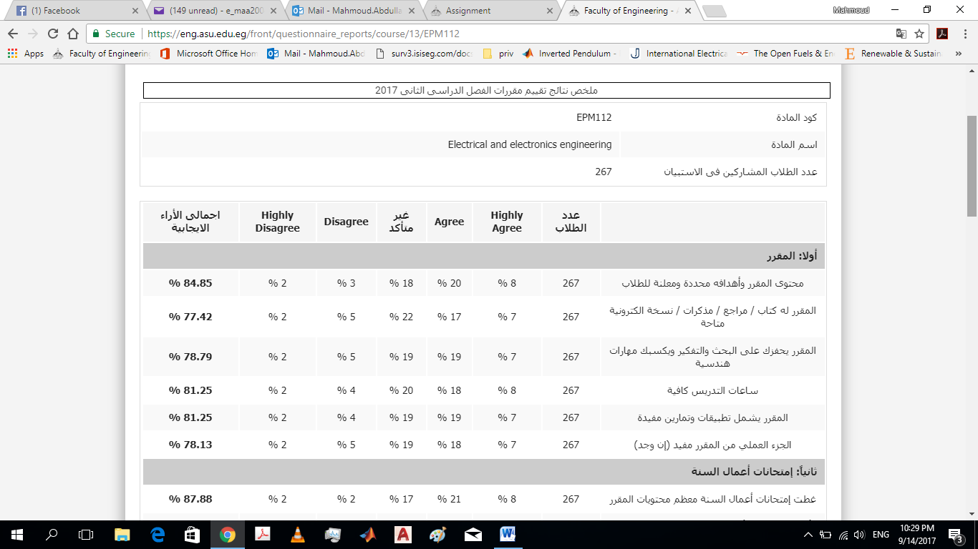

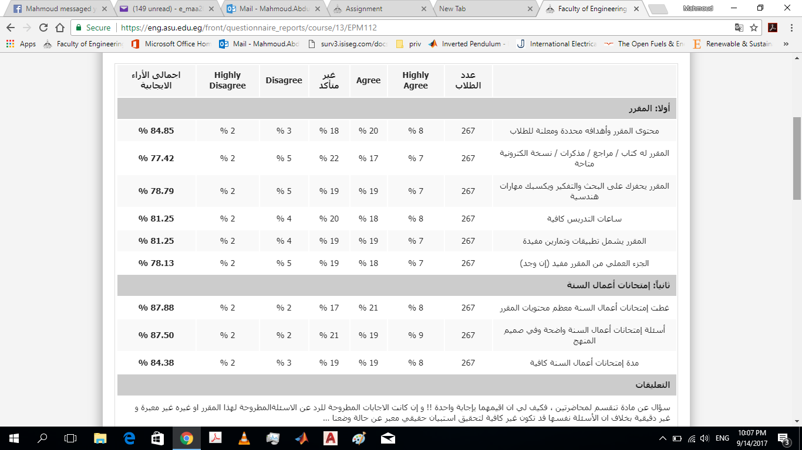

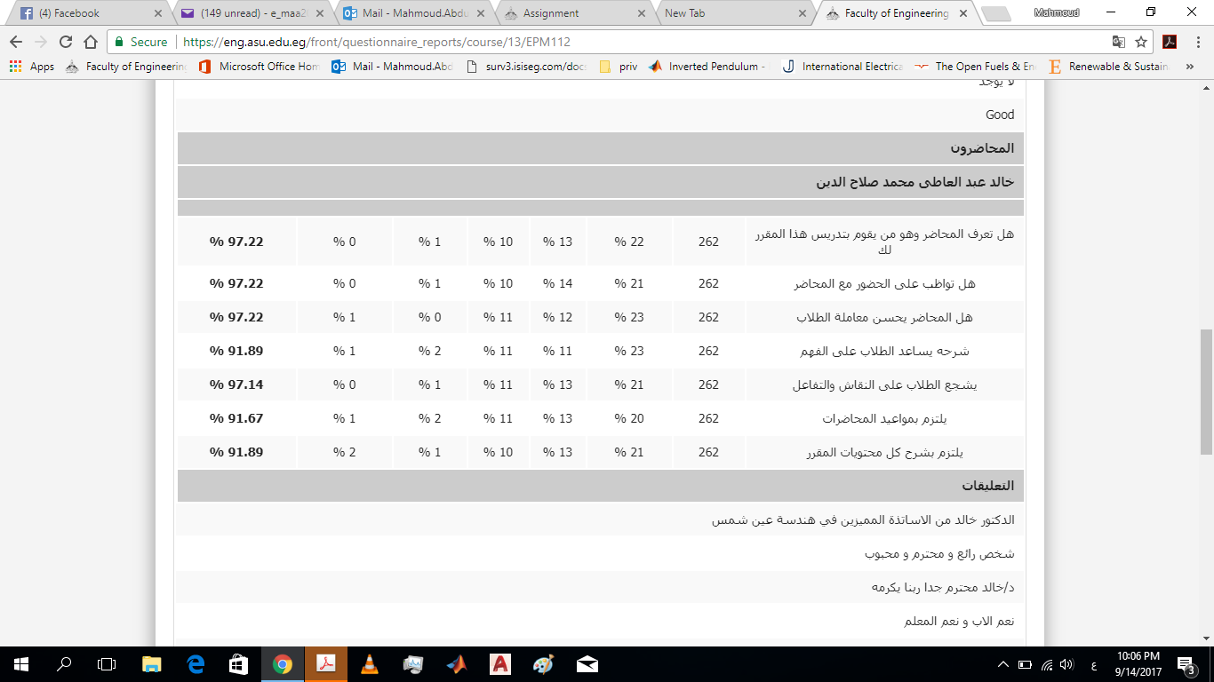

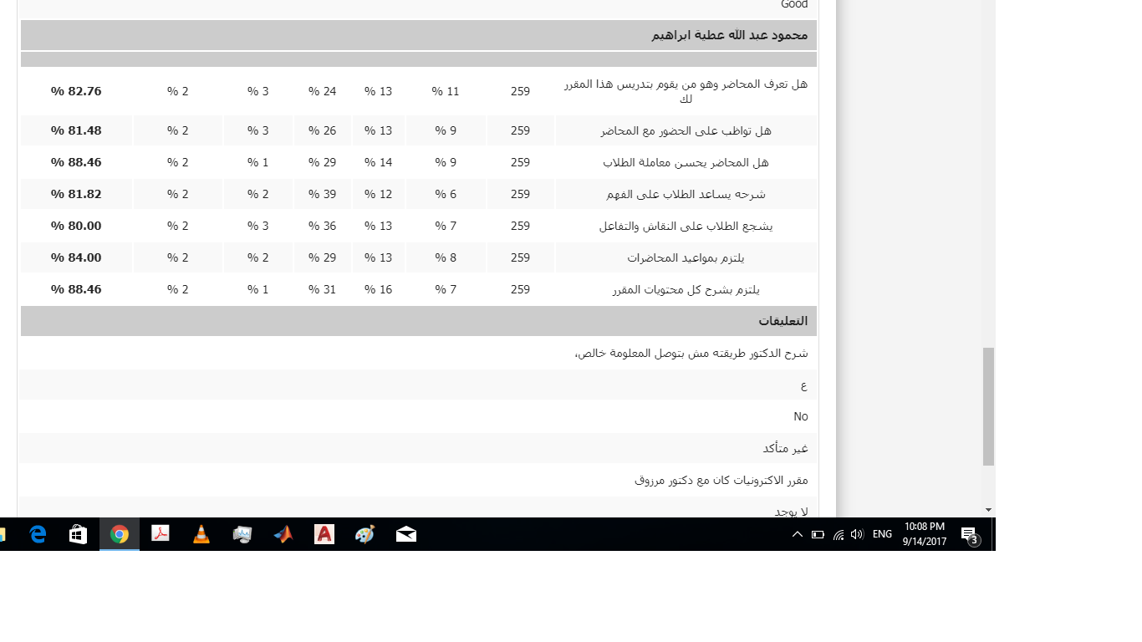

**7- Comments from external evaluator(s): Response of course team**

N/A……………………… …………………………….

……….……………..……. …………………………….

**8- Course enhancement:**

**8.1 Progress on actions identified in the previous year’s action plan:**

**Action State whether or not completed and give reasons for any non-completion**

……………………………. …………………………….

**8.2 Action plan for academic year 2017 – 2018**

|  |  |  |
| --- | --- | --- |
| **Actions required** | **Completion date** | **Person responsible** |
| --- |  | -- |

**Course coordinator:** Dr. Khaled Abdel-Aty

**Signature:**

Date: