Course report of
Mechanics (2) – PHM132 2015/2016
University: Ain Shams Faculty: Engineering

Basic Information
Mechanics (2) – PHM132

- All Mechanics Departments

1 st year Mechanics

  - Units/Credit Hours

  - Names of lecturers contributing to the delivery of the course :
Dr. Ahmed Ezzat

- Statistical Information
407
 |  | Number | Percentage (%)
Students completing the course |  | 407 | 100%
Results | Passed | 339 | 83.29%
Results | Failed | 68 | 16.71%
Grading Of successful students | Excellent | 33 | 8.1%
Grading Of successful students | Very Good | 69 | 17.0%
Grading Of successful students | Good | 103 | 25.3%
Grading Of successful students | Pass | 134 | 32.9%

- Professional Information

1-- Course Teaching:
Topic | No. of Hours | Lecturer
Kinematics of Rigid body | 10 | All
Center of Mass and Centroid | 8 | All
Moment of Inertia | 8 | All
Kinetics of Rigid Body: Force and  Acceleration Method | 10 | All
Kinetics of Rigid Body:Work and  Energy Method | 12 | All
Kinetics of Rigid Body:Impulse and  Momentum Method | 12 | All
Topics Taught as a percentage of the content specified

Reasons in detail for not teaching any topic

If any topics were taught which are not specified, give reasons in detail

2- Teaching and learning methods:

Case Study:
Other assignments/homework
If teaching and learning methods were used other than, those specified, list and give reasons

3- Student assessment:
Methods of assessment | Percentage of total
Written examination | 70 %
Oral examination | 0 %
Practical/laboratory work | 10 %
Other assignments/class work | 20 %

Members of examination committee

Role of external evaluator:

4- Facilities and teaching materials:

List any inadequacies:

5-Administrative constraints:

6-Student evaluation of the course:
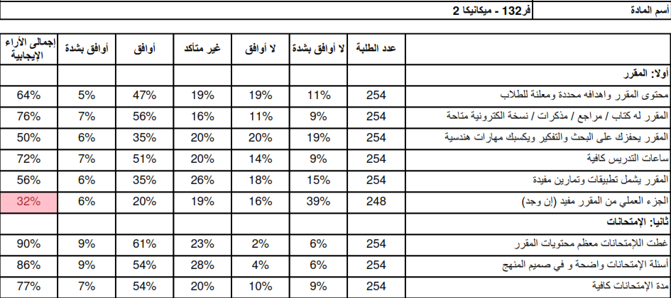
7-Comments from external evaluator(s)
Comment | Response of course Team
No Comment
8- Course enhancement: Progress on actions identified in the previous year’s action plan:

9- Action plan
Action required | Completion date | Person responsible

