Course report of
University: Ain Shams Faculty: Engineering

Basic Information

  - Units/Credit Hours

  - Names of lecturers contributing to the delivery of the course :

- Statistical Information

 |  | Number | Percentage (%)
Students completing the course
Results | Passed
Results | Failed
Grading Of successful students | Excellent
Grading Of successful students | Very Good
Grading Of successful students | Good
Grading Of successful students | Pass

- Professional Information

1-- Course Teaching:
Topic | No. of Hours | Lecturer
Fuels and combustion | 2 | Dr. G. Bassuoni & Dr. A. A. Mahmoud & Dr. A. O. Habib& Dr. M. S. Shehab

Topics Taught as a percentage of the content specified

Reasons in detail for not teaching any topic

If any topics were taught which are not specified, give reasons in detail

2- Teaching and learning methods:

Case Study:
Other assignments/homework
If teaching and learning methods were used other than, those specified, list and give reasons

3- Student assessment:
Methods of assessment | Percentage of total
Written examination
Oral examination
Practical/laboratory work
Other assignments/class work

Members of examination committee

Role of external evaluator:

4- Facilities and teaching materials:

List any inadequacies:

5-Administrative constraints:

6-Student evaluation of the course:
اجمالى الأراء الايجابية | Comment | Response of course Team
الدرجة 87 % | محتوى المقرر وأهدافه محددة ومعلنة للطلاب
الدرجة 93 % | المقرر له كتاب / مراجع مذكرات / نسخة الكترونية متاحة /
الدرجة 82 % | المقرر يحفزك على البحث والتفكير ويكسبك مهارات هندسية
الدرجة 83 % | المقرر يشمل تطبيقات وتمارين مفيدة
الدرجة 82 % | المقرر يشمل تطبيقات وتمارين مفيدة
الدرجة 82 % | الجزء العملي من المقرر مفيد (ان وجد) | لايوجد جزء عملي على الاطلاق يدرس من خلال هذا المقرر
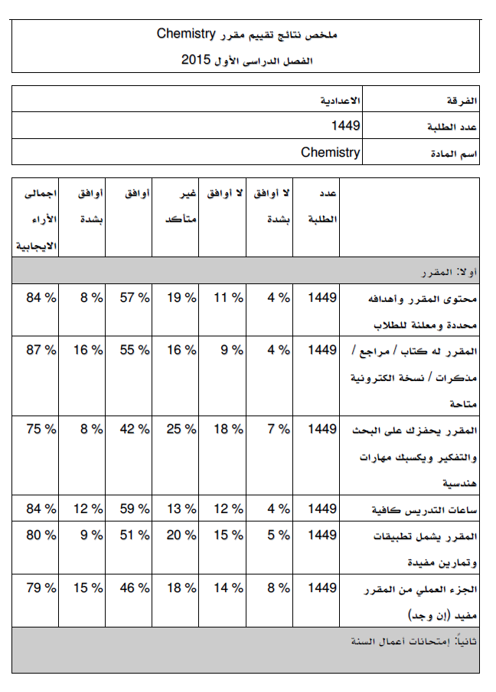
7-Comments from external evaluator(s)
Comment | Response of course Team

8- Course enhancement: Progress on actions identified in the previous year’s action plan:

9- Action plan
Action required | Completion date | Person responsible

